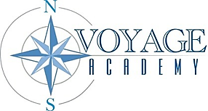

Voyage Academy Board of Directors Meeting Agenda
Date: April 9, 2026
Time: Public Session 6:00pm
Location: Virtual Microsoft Teams Link

Mission Statement
Voyage Academy is dedicated to cultivating student growth through Expeditionary Learning. Our mission is to promote responsibility, integrity, and the development of essential life skills, guiding students toward becoming respectful, compassionate, and motivated lifelong learners.

Attendees
Courtnie Moore, Danielle Pedersen, Janae Howell, Valerie Hulsey, Dennis Henry, Blaire Barker, Kami Coleman, Nicole Jones, Roger Simpson

Agenda

OPening business
The meeting will formally commence with the call to order and roll call.

Public comment
Please limit comments to 3 minutes

Consent agenda ITEMS
Approval of March 12, 2026, Board Meeting Minutes and Closed Session Statement

Discussion and action Items
- Award Request for Proposals for Speech Therapy Services and approval of contracted price up to amount.
- Review Erate Resolution and Report

Calendaring
The next Board Meeting is scheduled for May 14, 2026.

Adjournment
The meeting will adjourn upon completion of all agenda items.

