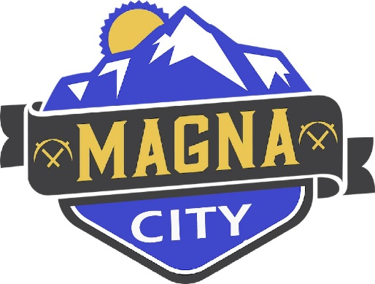
NOTICE OF CANCELLATION
The Magna Traffic Safety Committee meeting for April 7, 2026 has been canceled.

A copy of this notice may be viewed or obtained from the following:
- Utah Public Notice Website: https://www.utah/gov/pmn

