Housing and Transit Reinvestment Zone Committee
Summit County - Kimball Junction Proposal

GOEO Offices, Third Floor, 60 E South Temple, Salt Lake City, UT 84111
Canyonlands Conference Room
March 23, 2026 ∙ 2:00 PM – 3:15 AM

Meeting Minutes
Committee Members Attending: Senator Wayne Harper, Senator Kirk Cullimore (remote), Representative Jim Dunnigan (remote), Chairman Kamron Dalton (GOEO), Shayne Scott (Summit County), Jim Evans (remote - Transportation Commission), Kirt Slaugh (State Treasurer’s Office), Beth Holbrook (UTA Board of Trustees), Kersten Swinyard (SL County), Meredith Reed (Park City SD), Randy Upton (remote - Park City SD), Chief Peter Emery(Park City Fire District)

Excused Member: Representative Stephen Whyte

Summit County presenters: Jeff Jones, Peter Barnes, Matt Leavitt, Dave Thomas

GOEO Staff Attending: Shauna Memoryl, Kelly Akins, Allison James-Garcia

Guests Attending: Susie Becker (ZPFI), Todd Jenson (AG’s Office), Jason Gardner (Utah Tax Commission)
MPO representatives: Laniece Davenport (MAG), Miranda Cox Jones (remote - WFRC)
Other attendees: Madlyn McDonough (Summit County Housing Authority), Sam Hartman (remote - D.A. Davidson Companies), Steve Borup (Dakota Pacific)

- Welcome & Introductions
Mr. Kamron Dalton of the Governor’s Office of Economic Opportunity welcomed all to the HTRZ meeting. This meeting is occurring because Summit County submitted an application for the creation of an HTRZ.
This is the second HTRZ proposal submitted by Summit County. The first Summit County proposal was reviewed by the Committee in October 2023. The motion approved by the Committee was to table the issue while Summit County looked into the possibility to increase the scope of the project.
- Oath of Office
Ms. Shauna Memory, GOEO staff, administered the oath of office to new members, including: Mr. Shayne Scott (Summit County), Ms. Meredith Reed (Park City SD) and Chief Peter Emery (PC Fire District. All three members were present in-person in order to receive the oath of office.
Chair Kamron Dalton and Mr. Randy Upton (Park City SD) were given the oath of office by Ms. Shauna Memory prior to the meeting.
Jim Evans, Kirt Slaugh, Senator Wayne Harper, Senator Kirk Cullimore, Representative Dunnigan, and Beth Holbrook all performed their oath of office at an earlier date. Because of this, they did not need to be sworn in again.

- Approval of Minutes
The minutes from the last HTRZ Committee (Sandy Cairns), which took place on September 22, 2025, were approved unanimously. The motion to approve was made by Mr. Jim Evans and seconded by Ms. Beth Holbrook.
- Overview of Proposal
Mr. Jeff Jones, Summit County Economic Development Director, provided an overview of the Kimball Junction HTRZ proposal. Mr. Jones began with metrics for Summit County and Kimball Junction, highlighting what makes this area unique to other potential HTRZ sites. Mr. Jones provided historical context to this area and project which goes back to 2008 when the Summit Research Park was approved. He reviewed S.B. 26 from the 2025 Legislative Session which amended Utah Code 63N-3-603, which had the effect of rezoning this area. Mr. Jones indicated there are two pending agreements that should be finalized soon: a public-private partnership agreement between Summit County, High Valley Transit District, and Park City Junction LLC and a Summit County-LIHTC Joint Venture Partnership agreement.
The presentation then provided an overview of the project, divided into two parts: the Residential Project and the P-3 Project. The Residential Project will be developed with a mix of workforce units, attainable units, and market rate units. This part of the project is reliant on the execution of the second part. The P-3 project is a mixed-use development and will include various uses, including 225 workforce housing units. Other aspects of the theP-3 project include re-location of the Summit County Library to the County services building, a park and amphitheater, new, expanded transit center, parking podium (1000 stalls), new public plaza surrounded by mixed uses, senior care facility, medical facility, and a pedestrian bridge connection to the east side of SR 224, providing a new, welcoming entrance to Park City.
Summary of proposed housing affordability across the project:
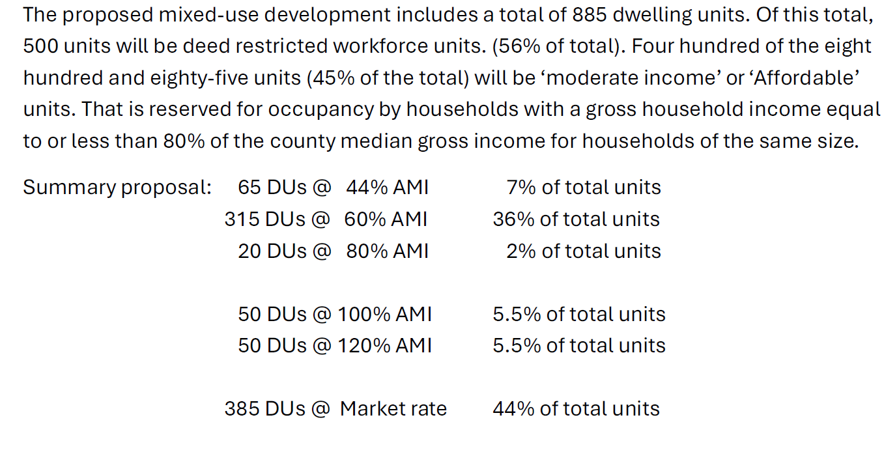
Mr. Jones highlighted that the developers are not seeking any increment revenue for their portion of the project, primarily the Residential Project.. The increment revenue would go towards the P-3 project which involves significant investment of public funds under the 2025 administrative development agreement.

- Review of Zions Public Finance Gap Analysis
Ms. Susan Becker with Zions Public Finance, Inc. (ZPFI) reviewed the independent gap analysis. Ms. Becker highlighted the uniqueness of this proposal as the increment will be going to the County not a developer. She reviewed the costs for infrastructure and workforce housing for the County. She indicated that the gap analysis found the tax increment generated for this project is within the realm outlined by the applicant: Applicant = $35 million; ZPFI = $39 million. Ms. Becker provided details of the gap analysis from a developer perspective and compared that to a no profit perspective, which would be the case in this situation.
Ms. Becker provided context to a potential financing approach for this project: $10 million ensures that the value of the project to the County show a 0% profit margin, $18 million ensures that the value of the project to the County show a 15% profit margin which would allow the project to be sold to a private investor, and $26 million (NPV) considers the financing coste (P+I_ for the COunty and covers these costs after the NOI has been applied. It leaves the County with an asset valued at $46 million after bond payments are made.
- Deliberation
Discussion went to the committee for comments and questions. Ms. Holbrook asked about the mix of the number of bedrooms per unit. She also asked about the management of the transit center moving forward.
Mr. Slaugh thanked the applicants for the focus on affordable housing and inquired about if the project was looking to include LIHTC or other tax credits. Mr. Slaugh discussed resources through the PAB Board, etc. and how that could impact discussion for approving HTRZ. Mr. Slaugh clarified that the County would receive any tax credits for this project, not a developer. He is more comfortable with a county receiving this instead of a developer. This issue has been brought up previously and it was discussed that Ms. Becker could provide a scenario with LIHTC funds in future gap analyses.
Senator Harper had a question about the increment not going to the developer. Summit County indicated that the developer does benefit from the County portion of the mixed-used development. Otherwise the developer’s part of the development would not happen, but for the support and infrastructure of the County’s project. In return, the developer has also agreed to decrease the rent of some of their units as outlined in the proposal.
Senator Harper also noticed an error in the taxing entity slide where the school district was left off. It was clarified that the school district is included in the calculation of the increment.
Ms. Holbrook asked about the pedestrian bridge connecting the two sides of SR 224. Senator Harper also asked why it was decided to do an overpass instead of an underpass since an overpass is more to maintain, especially during winter months. Summit County discussed the opposition to this project and discussed how the pedestrian bridge would be an entry feature for the area, a “crown jewel.”
Ms. Holbrook asked about access to grocery. Summit County did consider this in developing the project as grocery trips now outtracks trips to work as the number one trip generator. They highlighted that Kimball Junction is the hub for grocery in the area as Smith’s, Whole Foods, and Wal-mart are there.
Senator Harper indicated that he is extremely impressed with this applicant and acknowledges that it goes above what is outlined in S.B. 26. He appreciates the focus on workforce and affordable housing and knows it is a needed project in Summit County.
Chief Peter Emery brought up an error in the proposal where the fire tax rate is incorrect. It appears the mosquito abatement tax rate was incorrectly copied into the fire district calculation. Both Ms. Becker and Summit County did recalculations. It was also acknowledged that the multicounty assessing and collecting levy was also included erroneously.
Mr. Scott with Summit County brought up the upcoming Olympics and how this project will be a nice advantageous position for Olympic planning.
Motion: The Housing and Transit Reinvestment Zone Committee approves the Kimball Junction HTRZ project, as presented to the committee, located within 1/3 mile of the Kimball Junction Transit Center, with the following conditions:
- Duration of 25 consecutive years over a 45-year period;
- Maximum capture of 80% property tax increment, and 15% sales and use tax increment;
- Property tax increment from the multicounty assessing and collecting levy will be not be included as outlined in the proposal;
- 45% of the dwelling units as affordable housing;
- Affordable and attainable housing units will be deed restricted for their respective 25-year tax increment collection period; and
- Estimated at $37 million.
The motion was made by Ms. Holbrook and seconded by Senator Harper.
Roll call vote:
Chairman Kamron Dalton - Yes
Jim Evans (remote) - Yes
Beth Holbrook- Yes
Kirt Slaugh- Yes
Senator Wayne Harper - Yes
Senator Kirk Cullimore (remote) - Yes
Representative Jim Dunnigan (remote) - Yes
Shayne Scott - Yes
Meredith Reed - Yes
Randy Upton (remote) - Yes
Chief Peter Emery - Yes

The motion passes unanimously .

- Adjourn

