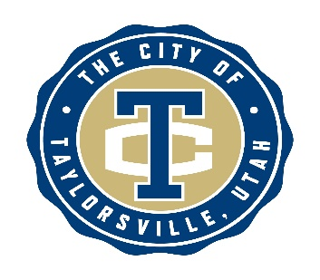
City of Taylorsville
Planning Commission Meeting

NOTICE

The Taylorsville Planning Commission meeting scheduled for
April 14, 2026 has been cancelled.

The next Planning Commission meeting
is scheduled for April 28, 2026.

An agenda for that meeting will be published and notifications made.

If there are any questions, please contact:
Taylorsville Community Development Department at 801-963-5400.

