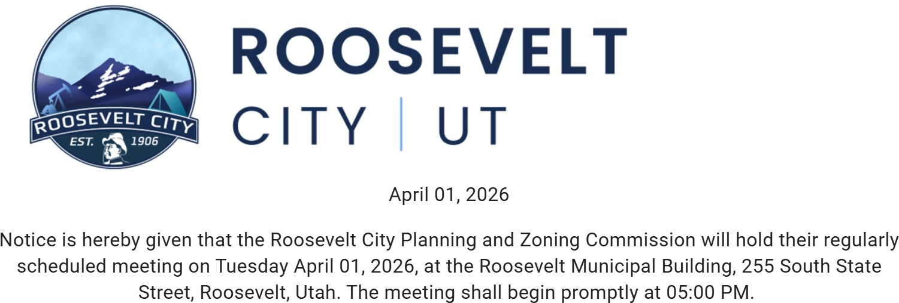

- CALL TO ORDER
- ROLL CALL
**Conflicts of Interests – All Planning and Zoning Members who have a conflict with any item on the agenda please state concern.

- APPROVAL OF PREVIOUS MINUTES
  - MEETING MINUTES FROM 12.3.26 AND 3.4.26
- PUBLIC HEARINGS
  - CONDITIONAL USE PROPOSAL/ HANKS DIESEL/ UTAH ENERGY PROCESSING LLC, DREW ESCHLER
- ACTION ITEMS
  - CONDITIONAL USE PROPOSAL/ HANKS DIESEL/ UTAH ENERGY PROCESSING LLC, DREW ESCHLER
  - RBS SITE PLAN PROPOSAL, DREW ESCHLER
  - 100 E AND 200 E ROAD EASEMENT DISCUSSION, DREW ESCHLER
  - FEMA MAP ADOPTION, DREW ESCHLER

- PLANNING AND ZONING DIVISION MANAGER REPORT
- ITEMS FOR FUTURE DISCUSSION
- ADJOURN
Further information can be obtained by contacting Sierra Wisener at (435) 401-8198. In compliance with the Americans with Disabilities Act, individuals needing special accommodations (including auxiliary communicative aids and services) during these hearings should notify Sierra Wisener at 255 South State Street, Roosevelt, Utah, 84066, at least three days prior to the hearing to be attended.

