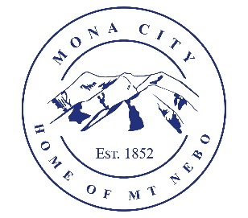
Mona City
435-623-4913
www.monautah.gov
20 West Center Street, Mona, Utah

Mona City Council Meeting Agenda
Tuesday, March 10, 2026
Mona City Building – 20 West Center
7:00 p.m.

Pledge
Prayer
Approval of February 24, 2026, City Council Meeting Minutes
Action Items
  - Approval of Resolution 2026-6: Update to Mona City Personnel Policy
Miscellaneous Items
  - CentraCom service project
Land Use
- Herman Young & Sons/Brothersen Home – Building Permit – 278 East 300 N
Secretary
Finance
  - Approval of Finances
Recorder
Gas & Water & Roads
Sewer
Council Reports
Public Comment
Adjournment

CERTIFICATE OF POSTING
This agenda is hereby properly advertised on this 9th day of March, 2026, by posting copies in the following places: the Mona City Office, on the Mona City website at monautah.gov, at the United States Post Office Mona City Branch, and on the Utah Public Notice Website at www.utah.gov/pmn/index.html.

___________________________________
Alicia Hills, Mona City Recorder

Upon Request, in compliance with the Americans with Disabilities Act, reasonable accommodations for individuals with disabilities will be provided. For assistance, please call 435-623-4913.

