MEMORANDUM

DATE: Friday, March 27 2026
TO: Marlo Oaks, State Treasurer and Utah Charter School Finance Authority Board
FROM: Japheth McGee, Vice President and Johnathan Ward, Senior Vice President of Zions Public Finance
RE: Syracuse Arts Academy Application to the Utah Charter School Finance Authority and Credit Enhancement Program

Conflicts of Interest

In general, Zions Bancorporation, National Association is made up of many departments and provides various services. Some of those services and departments can be involved on the same transaction. Zions Public Finance Inc. and Zions Corporate Trust are affiliated entities operating under Zions Bancorporation and we all benefit from a strong stock price derived from strong performance by the company and its component members and affiliates across the country. Zions Public Finance does not receive financial or other benefits in association with transactions performed by Zions Corporate Trust who may act as Trustee on charter school transactions. Likewise, Zions Public Finance operates separately from commercial loan divisions of the Bancorporation who may have provided private financing to developers or charter schools to construct the school initially. Zions Public Finance is not aware of the circumstances where this occurs unless told when a charter school applies. Zions Public Finance does not receive financial or other benefits that could result from actions taken by the Charter School Finance Authority outside of the agreed upon fees for services rendered to the Authority.

Zions’ entities engaged with the School:

Zions Public Finance: | Yes. (Advisor to the Authority)
Zions Corporate Trust: | No
Zions Commercial Involvement: | No

Executive Summary

Borrower: | Syracuse Arts Academy
Management Company: | Business Manager: AW Services (fma Academica West)
Municipal Advisor: | LRB Public Finance Advisors, Inc.: David Robertson
Borrower’s Counsel: | Dorsey & Whitney: Nate Canova
Lead Underwriter: | DA Davidson: Eric Duran
Co-Managing Underwriter: | Raymond James: Wes Olson
Bond Counsel: | Gilmore & Bell: Jacob Carlton
Issuer’s Counsel: | Chapman & Cutler: Eric Hunter
Trustee: | US Bank: Laurel Bailey
Par Amount: | $77,980,000 in tax-exempt bonds.
Enhancement Requested: | Yes
Purpose: | Fund an expansion to the School’s Antelope Campus, purchase the South Campus, restructure the Series 2017 bonds, fund capitalized interest, fund a debt service reserve fund, and pay costs of issuance.
Structure: | Bonds will be repaid with a roughly level amortization of principal and interest over 35 years after a capitalized interest period. The bonds will carry a fixed rate of interest.
Term: | Final maturity in 2061. Bonds will likely carry an 8 to 10-yr call feature.
Rating: | S&P Global Ratings: BBB-
Costs of Issuance Estimate: | $500,500
Underwriter Fee Estimate: | $3.90/$1,000 (est. $311,181)
Litigation: | None of which we are aware.
Summary: | The School is issuing a significant amount of new debt while restructuring an already significant debt profile. Syracuse Academy will be the largest single issuer of debt within the Credit Enhancement Program. The School is reliant on expanded enrollment to meet the increase in debt service. The School has a moderate waitlist it can draw on to meet this new debt and significant liquidity on which it can rely. Recent bond issuances created a murky financial picture that clouds how successful the School might be. The most recent fiscal year did not have expenditures related to bond issues and showed a strong financial position that, when coupled with current liquidity, would allow the School to operate for some time without issues.

Purpose

The purpose of this memo is to document the adherence of Syracuse Arts Academy (the “School”) to the application requirements of the Utah Charter School Finance Authority (the “Authority”) Credit Enhancement Program Standards and provide credit analysis of the School for the Authority’s consideration. The analysis contained herein is based on the School’s application to the Authority and inquiry for clarification of the Municipal Advisor to the Authority.

Introduction

The School is a non-profit, 501c3 designated, public K-9 charter school with four campuses in Syracuse. The School was approved by the Utah State Charter School Board (the “SCSB”) and opened for operation in 2007. The Antelope campus which consists of an elementary school and junior high school began operations in 2007-2008, the North campus consisting of one building serving students in grades K-6 began operations in the 2015-2016 school year, and the South campus is in its first year of operation.

MISSION STATEMENT
Syracuse Arts Academy provides a challenging, differentiated curriculum where academic excellence, character development, and individual growth are nurtured in a safe, orderly, and pleasant environment.

Enrollment/Student Demand

October enrollment for the 2025 - 2026 school year was 2,050 students. It’s highest enrollment ever. The School has a moderate waitlist and has shown strong retention and resulting enrollment throughout the entire look back period. Average daily membership is above 98%.

The School added an additional elementary campus known as the South Campus. The South Campus is currently in its first year of operations with nearly 400 students as of October 2025.

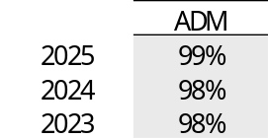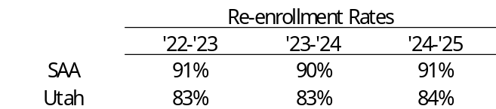

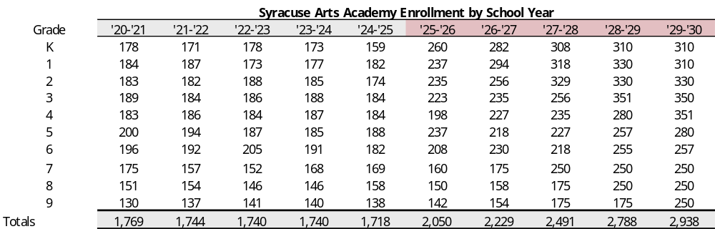

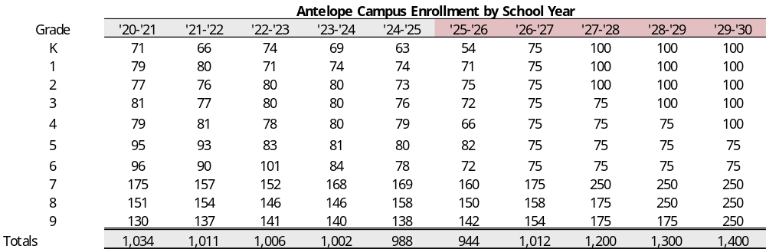

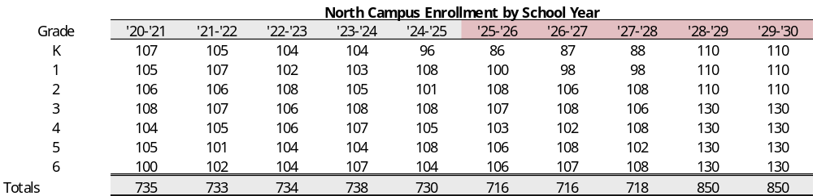

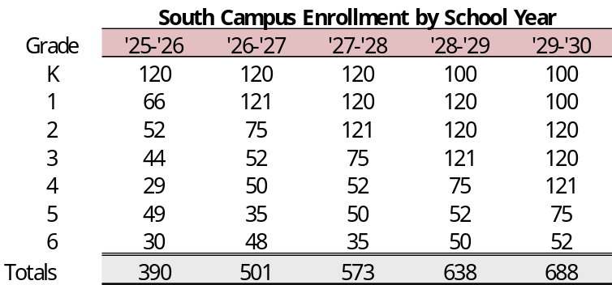

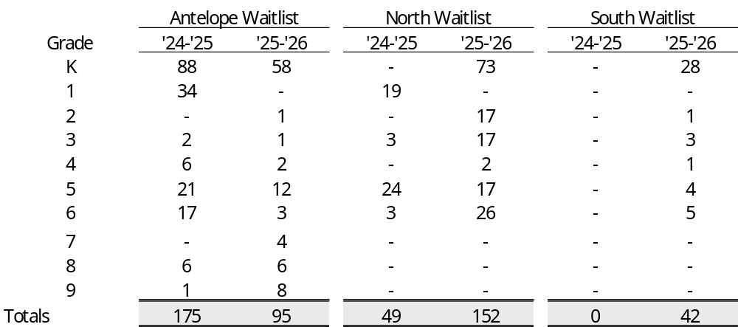

Academic Performance

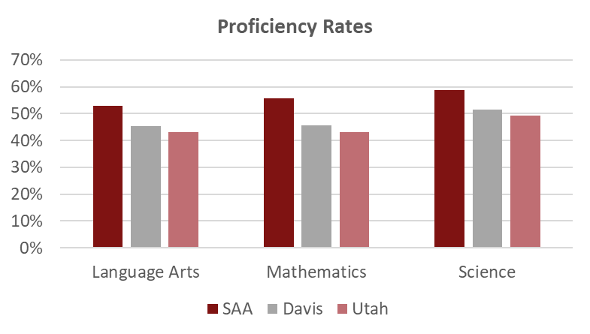

Management

- The School currently has a five-member board. The board members have backgrounds in: education, healthcare, government finance, and business operations.
- The School employs Kellie Mudrow as Lead Director. She has a master’s and bachelor’s degree from the University of Toledo and obtained her administrative license through Utah State University. She previously served as the Professional Learning and Quality Staffing Director for the Davis School District, an elementary teacher and administrator, high school assistant principal, and junior high principal.
- The School employs AW Services (formerly Academica West) for business management services.
- The School has formal policies for budgeting, cash handling, debt, investments, fundraising and donations, and procurement.

Plan of Finance

The School is seeking authorization to sell up to $77,980,000 of BBB- rated bonds via negotiated sale with DA Davidson and Co. serving as the Lead Managing Underwriter and Raymond James and Co serving as Co-Managing Underwriter. The School is seeking credit enhancement through the Utah Charter School Credit Enhancement Program. The bonds will be tax-exempt bonds for the purpose of funding an expansion at the Antelope campus (8 new classrooms, a 45,000 sq ft gymnasium and theater building, and storage space), an expansion at the Junior High facility for Career and Technical Education, a debt service reserve fund, capitalized interest, and costs of issuance. Construction on the School’s addition is expected to be completed by Fall 2027. The bonds will carry a fixed rate of interest and will likely carry an 8 to 10-year call. The bonds are secured by an assignment and secured interest in the revenues of the School and trust accounts and a security interest and pledge of the deed of trust in the land and building located at:

- 2893 W. 1700 S., Syracuse, Utah 84075
- 2211 W. 3060 S., Syracuse, Utah 84075
- 2895 W. 1700 S., Syracuse, Utah 84075
- 357 S. 1550 W., Syracuse, Utah 84075
Ratings

The School is still in the process of receiving its rating. It currently has a rating on the Series 2017 bonds of BBB-. The School has been evaluated below on the basis of both a BBB- and a BB+ rating.

Financial Performance

Summary:
Syracuse Arts Academy last issued debt in FY 2022 and that debt issuance shows up in the School’s financials by creating choppy looking financials. The School has seen an improving operating position over the past several years. Liquidity is a bright spot in the School’s financials and should allow it to smooth over growing pains in the near term. However, even in its best operating year the School did not meet 100% coverage on the expected future debt service. The School is relying on expanded enrollment to meet a significantly increased debt load.

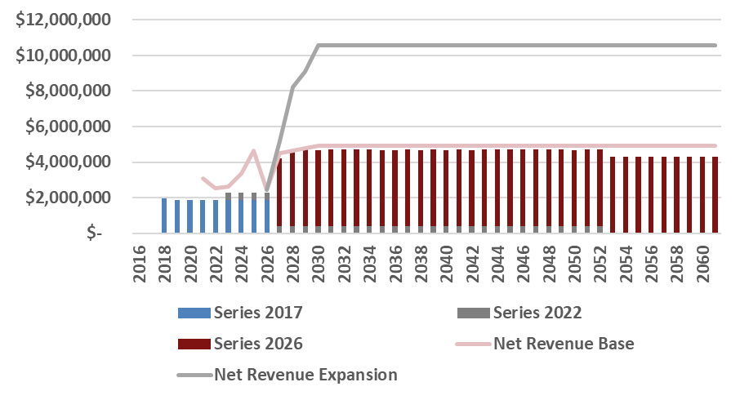

- The School has large differentials between original budgets are actuals in FY 21 and FY 22 driven by large capital outlay expenditures for land purchases in FY 21 and subsequent improvements to that land in FY 22 for sports fields. This also led to audited financials and final fiscal reports that were wildly divergent from the original budgeted amounts.

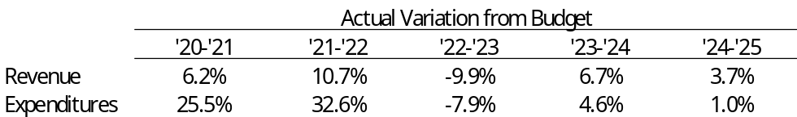

- Cash Position
 | Requirement | Measure at end of FY 2025
 | At least 75 days | 187

The School’s days cash on hand peaked at 212 DCOH in FY 2022. The School has been able to maintain strong cash levels despite utilizing significant amounts of cash over the past 5 years on capital projects.

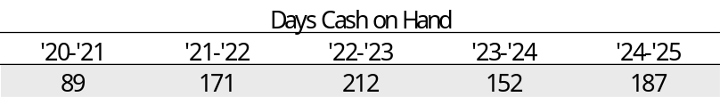

- Fund Balance
 | Requirement | Measure at end of FY 2025
 | At least 15% of following year expenses | 32%

At the end of FY 2025, the School had an unassigned fund balance of 32% of the following year’s operating expenses. Fund balance has moved around as the School utilized existing fund balance for property acquisitions but it remains elevated.

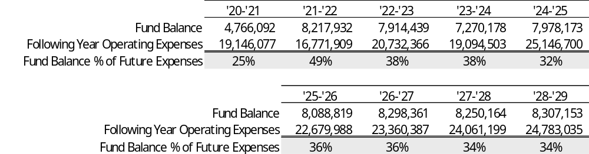

- Debt Coverage Ratio
 | BB+ Requirement | BBB- Requirement | Measure at end of FY 2025
 | At least 115% | At least 110% | 196%

FY 2026 projections show debt coverage dropping to 52%. However, that number would be the lowest net revenue figure the School achieved over the past five years and seems unlikely. The School’s recent addition of the South campus could cause some disruption as schools tend to see fluctuations as new expenditures are brought on. This was evident in the FY 2022 and FY 2023 audits as the School worked through its most recent expansion. If the School is able to return to FY 2025 operating performance, it would be able to roughly cover existing and new debt service.

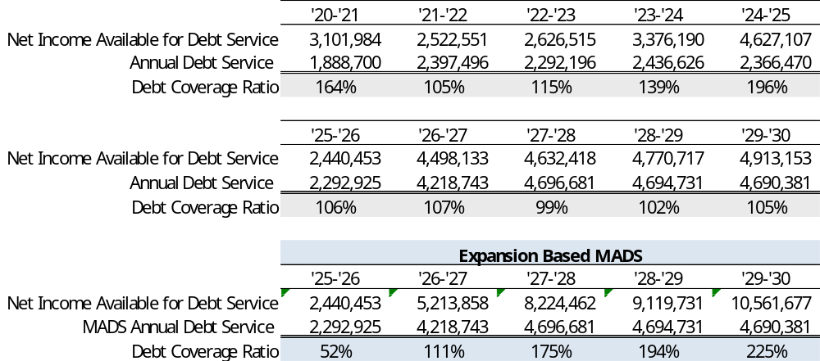

- Debt Burden Ratio
 | BB+ Requirement | BBB- Requirement | Measure at end of FY 2025
 | Less than 18% | Less than 20% | 10.6%

The debt burden ratio gives an idea of operational flexibility. When a School has a low debt burden it means that fixed costs are low and the School has more room to focus on operational costs. As debt burden increases the ability to be flexible in budgeting would decline. This could potentially lead to larger misses on budgets than the School has historically seen. The School will be operating with a heavier debt burden but it should remain within both the BB+ and BBB- requirements.

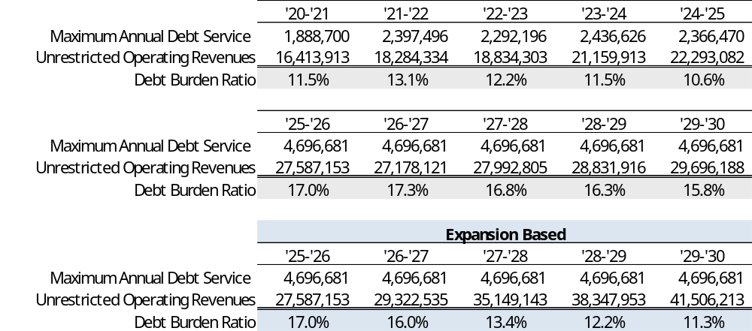

- Operating Margin
 | BB+ Requirement | BBB- Requirement | Measure at end of FY 2025
 | At least 12% | At least 10% | 20.8%

The School met this metric for both rating levels each of the prior five years. The School’s current projections show weak operating margins in the first year of operating the South campus. However, if the School is able to achieve FY 2025 net income levels it would be at nearly 17% operating margins. Even 2024 operating performance would leave the School with roughly 12% operating margins.

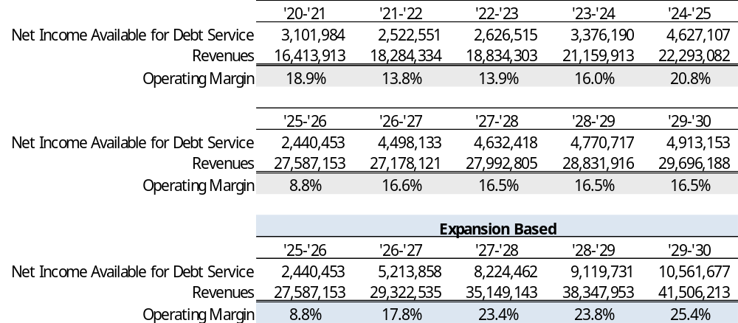

- Current Ratio
 | Requirement | Measure at end of FY 2025
 | At least 150% | 309%

The current ratio is defined as current unrestricted assets divided by current liabilities (including current year debt service). The School’s current ratio has been consistent for the past several years with a slight dip in FY 2024 that was quickly reversed in FY 2025.

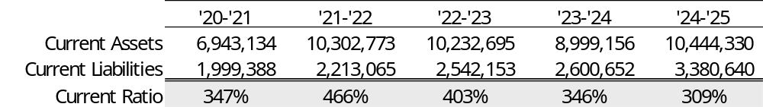

Bond Documents

Legal bond documents are being reviewed by Chapman & Cutler in its capacity as Issuer’s Special Counsel to the Authority, and all requirements are being incorporated. In addition, Gilmore & Bell, as Bond Counsel, has certified that each of the required legal provisions is present in the bond documents.

Continuing Disclosure

The School appears to have properly filed each operating report, budget, and annual financial report since it last issued bonds in FY 2022. The School has an acceptable continuing disclosure policy.

Conclusion

The School is issuing a significant amount of new debt while restructuring an already significant debt profile. Syracuse Academy will be the largest single issuer of debt within the Credit Enhancement Program. The School is reliant on expanded enrollment to meet the increase in debt service. The School has a moderate waitlist it can draw on to meet this new debt and significant liquidity on which it can rely. Recent bond issuances created a murky financial picture that clouds how successful the School might be. The most recent fiscal year did not have expenditures related to bond issues and showed a strong financial position that, when coupled with current liquidity, would allow the School to operate for some time without issues.

