MEMORANDUM

DATE: Friday, March 27, 2026
TO: Marlo Oaks, State Treasurer and Utah Charter School Finance Authority Board
FROM: Japheth McGee, Vice President and Johnathan Ward, Senior Vice President of Zions Public Finance
RE: Lincoln Academy Application to the Utah Charter School Finance Authority and Credit Enhancement Program

Conflicts of Interest

In general, Zions Bancorporation, National Association is made up of many departments and provides various services. Some of those services and departments can be involved on the same transaction. Zions Public Finance Inc. and Zions Corporate Trust are affiliated entities operating under Zions Bancorporation and we all benefit from a strong stock price derived from strong performance by the company and its component members and affiliates across the country. Zions Public Finance does not receive financial or other benefits in association with transactions performed by Zions Corporate Trust who may act as Trustee on charter school transactions. Likewise, Zions Public Finance operates separately from commercial loan divisions of the Bancorporation who may have provided private financing to developers or charter schools to construct the school initially. Zions Public Finance is not aware of the circumstances where this occurs unless told when a charter school applies. Zions Public Finance does not receive financial or other benefits that could result from actions taken by the Charter School Finance Authority outside of the agreed upon fees for services rendered to the Authority.

Zions’ entities engaged with the School:

Zions Public Finance: | Yes. (Advisor to the Authority)
Zions Corporate Trust: | No
Zions Commercial Involvement: | No

Executive Summary

Borrower: | Lincoln Academy
Management Company: | In-house Business Manager: Marie Eads
Municipal Advisor: | LRB Public Finance Advisors, Inc.: David Robertson
Borrower’s Counsel: | Farnsworth Johnson: Brandon Johnson
Underwriter: | Crews and Associates: Marcus Keller
Bond Counsel: | Chapman & Cutler: Eric Hunter
Issuer’s Counsel: | Dorsey & Whitney: Nate Canova
Trustee: | US Bank: Laurel Bailey
Par Amount: | $7,710,000 in tax-exempt bonds.
Enhancement Requested: | Yes
Purpose: | Fund an expansion to the School’s existing facility, capitalized interest, a debt service reserve fund, and pay costs of issuance.
Structure: | Bonds will be repaid with a roughly level amortization of principal and interest over 30 years after an 18-month capitalized interest period. The bonds will carry a fixed rate of interest.
Term: | Final maturity in 2056. Bonds will likely carry an 8 to 10-yr call feature.
Rating: | S&P Global Ratings: BBB-
Costs of Issuance Estimate: | $206,000
Underwriter Fee Estimate: | $6.45/$1,000 (est. $49,697)
Litigation: | None of which we are aware.
Summary: | The School has a strong history of operations and healthy liquidity. The School is expanding its current campus modestly to accommodate new growth. It will be able to draw down its sizable waitlist to accommodate the new growth while still maintaining a healthy waitlist. Current operations are sufficient to meet the new obligation at 100% coverage. Enrollment growth is necessary to fully cover debt service at 110%.

Purpose

The purpose of this memo is to document the adherence of Lincoln Academy (the “School”) to the application requirements of the Utah Charter School Finance Authority (the “Authority”) Credit Enhancement Program Standards and provide credit analysis of the School for the Authority’s consideration. The analysis contained herein is based on the School’s application to the Authority and inquiry for clarification of the Municipal Advisor to the Authority.

Introduction

The School is a non-profit, 501c3 designated, public K-9 charter school with one campus in Pleasant Grove. The School was approved by the Utah State Charter School Board (the “SCSB”) and opened for operation in 2005.

MISSION AND VISION
Mission: Empowering our students to SOAR!

Vision: Lincoln will help students have SOAR by having opportunities to:

Serve
- I can serve others
- I can serve my school
- I can serve my community
- I can serve my country

Overcome
- I can overcome frustrations
- I can overcome fears
- I can overcome poor habits
- I can overcome circumstances

Achieve
- I can achieve individually
- I can achieve collaboratively
- I can achieve academically
- I can achieve technologically

Ready
- Ready to learn
- Ready to contribute
- Ready to create
- Ready to lead with my strengths

Enrollment/Student Demand

October enrollment for the 2025 - 2026 school year was 909 students. The School is using funds from this financing to expand educational space and increase student enrollment to 1,048 by 2030. The School has a strong waitlist and has shown strong retention and resulting enrollment throughout the entire look back period. Average daily membership is above 98%.

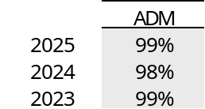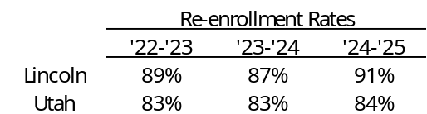

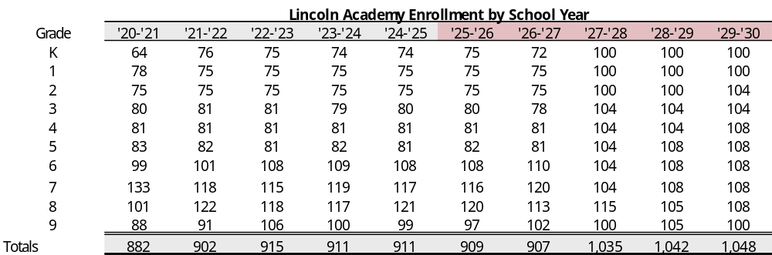

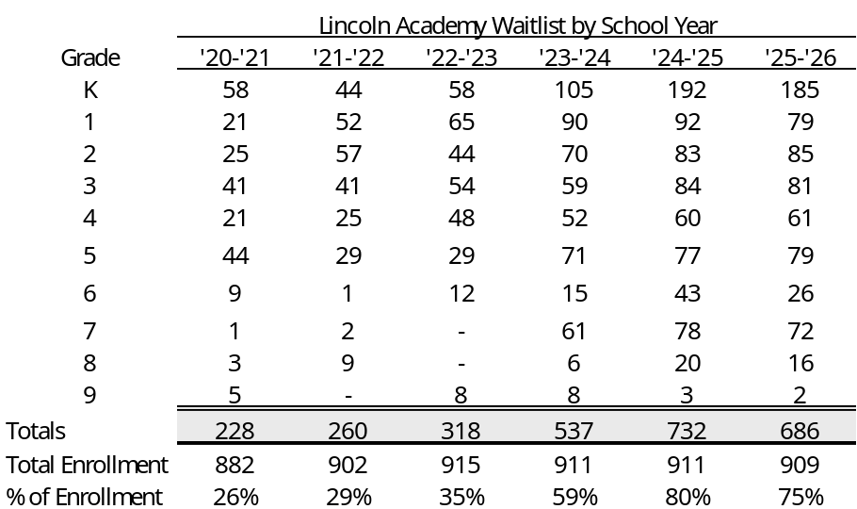

Academic Performance

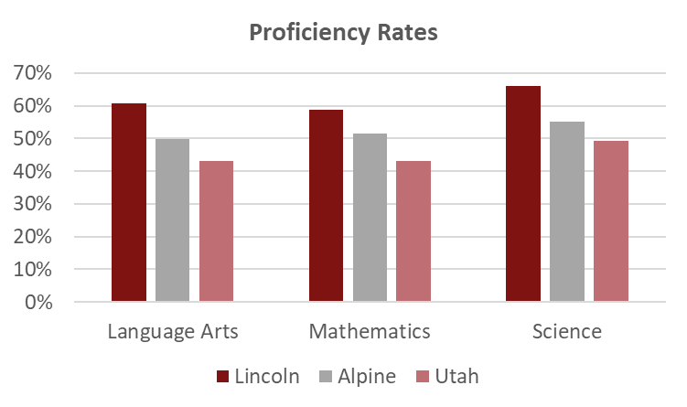

Management

- The School currently has a eight-member board. The board members have backgrounds in: law, sales/accounting, education, business strategy, and construction management
- The School employs Jake Hunt as Executive Director. Mr. Veasey received a Bachelor’s of Education from Utah Tech University and a Master’s in Educational Leadership and Administration from the University of Phoenix. He joined Lincoln Academy in 2006.
- The School employs Marie Eads for business management services. Marie has been with the School since 2005 and has served as business manager for 18 years. She is a graduate of Utah Valley University where she majored in accounting.
- The School has formal policies for budgeting, cash handling, debt, fundraising and donations, and procurement. The School does not have a policy for investments.

Plan of Finance

The School is seeking authorization to sell up to $7,710,000 of BBB- rated bonds via negotiated sale with Crews and Associates serving as the Underwriter. The School is seeking credit enhancement through the Utah Charter School Credit Enhancement Program. The bonds will be tax-exempt bonds for the purpose of funding a 6 to 8 classroom expansion at the current facility, capitalized interest, a debt service reserve fund, and costs of issuance. The bonds will carry a fixed rate of interest and will likely carry an 8 to 10-year call. The bonds are secured by an assignment and secured interest in the revenues of the School and trust accounts and a security interest and pledge of the deed of trust in the land and building located at:

- 1582 W 3300 N, Pleasant Grove, Utah 84062

Ratings

The bonds are rated BBB- by S&P Global Ratings. Noted the following positive factors in its rating report.
- Solid enterprise profile with high academic performance, steady demand, and a healthy waitlist.
- Stable and well-seasoned management team.
- Healthy liquidity above 200 days cash on hand.
- History of positive operations.

The following constraining factors were noted:
- Moderately high debt burden and relatively modest size relative to that of higher rated peers.
- Possibility of additional debt in the near to medium term.
- Typical charter school risks related to charter revocation.

S&P noted that it could downgrade the rating if demand metrics materially weaken impairing MADS coverage or operating performance. If there was a meaningful draw down in reserves it could also lead to a rating downgrade. A rating upgrade could occur if the School demonstrates sustained MADS coverage and liquidity commensurate with higher-rated peers.

Financial Performance

Summary:
Lincoln Academy’s debt plans are fairly modest considering the most recent operating years. Recent margins and coverage ratios are supportive of debt at the current level and should not put significant strain on the School. As S&P noted, cash on hand is strong and the School has a history of solid operating performance.

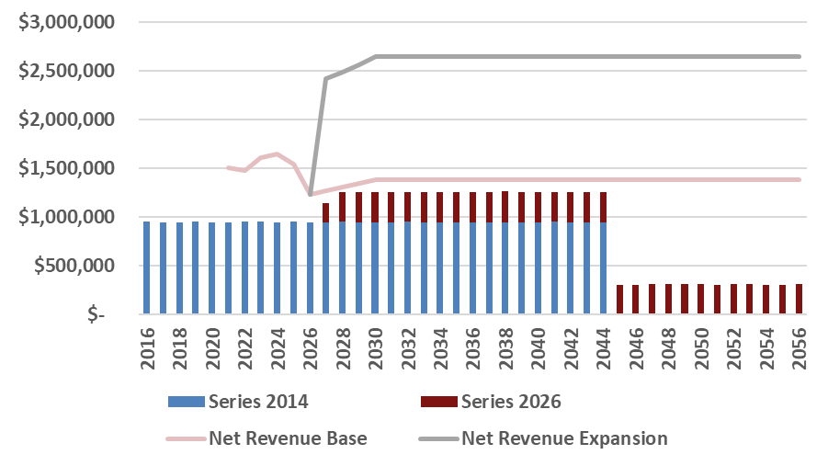

- The School has been conservative in its projections. All budgets have produced actual expenditures within 5% of the budget with most years seeing revenues more than 5% greater than initial budgets.

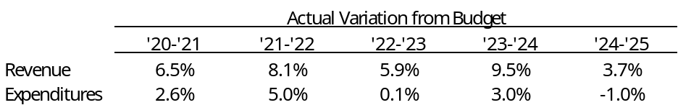

- Cash Position
 | Requirement | Measure at end of FY 2025
 | At least 75 days | 218

The School’s cash on hand of 218 DCOH falls in the lower end of the A rating range for Moody’s Investor Services. The School has held this level of cash for quite some time.

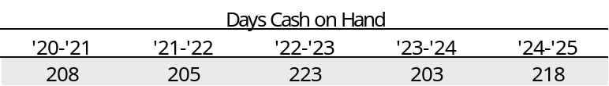

- Fund Balance
 | Requirement | Measure at end of FY 2025
 | At least 15% of following year expenses | 54%

At the end of FY 2024, the School had an unassigned fund balance of 454% of the following year’s operating expenses. Fund balance was strong and stable over the past five years.

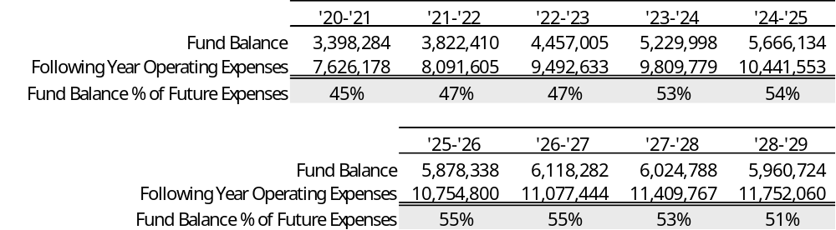

- Debt Coverage Ratio
 | BBB- Requirement | Measure at end of FY 2025
 | At least 110% | 157%

In FY 2025, the School had debt coverage of 157%. Coverage in each of the prior five years was sufficient to meet the expanded debt service obligation, though not at the required 110%. Expanded enrollment should allow the School to meet debt service obligations even with modest enrollment growth. The School’s waitlist is more than sufficient to meet projected enrollment growth and still remain significant.

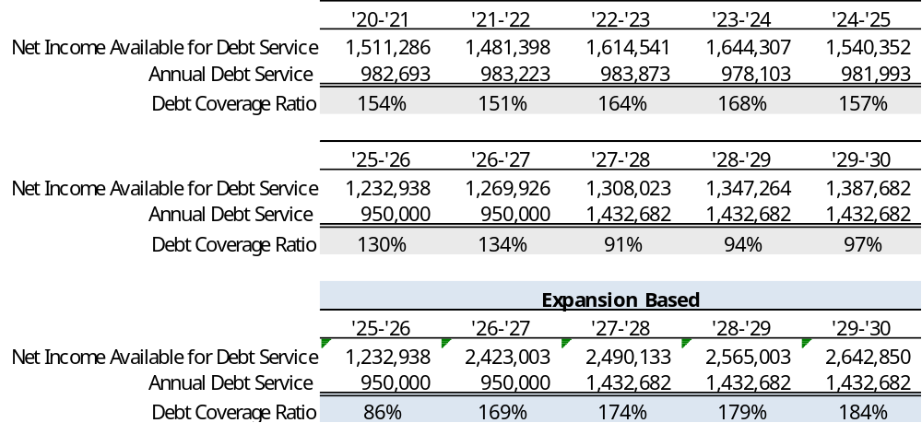

- Debt Burden Ratio
 | BBB- Requirement | Measure at end of FY 2025
 | Less than 20% | 8.7%

The debt burden ratio gives an idea of operational flexibility. When a School has a low debt burden it means that fixed costs are low and the School has more room to focus on operational costs. The Schools debt burden was well below the threshold for BBB- schools and is even expected to remain below the BB benchmark for the Credit Enhancement Program.

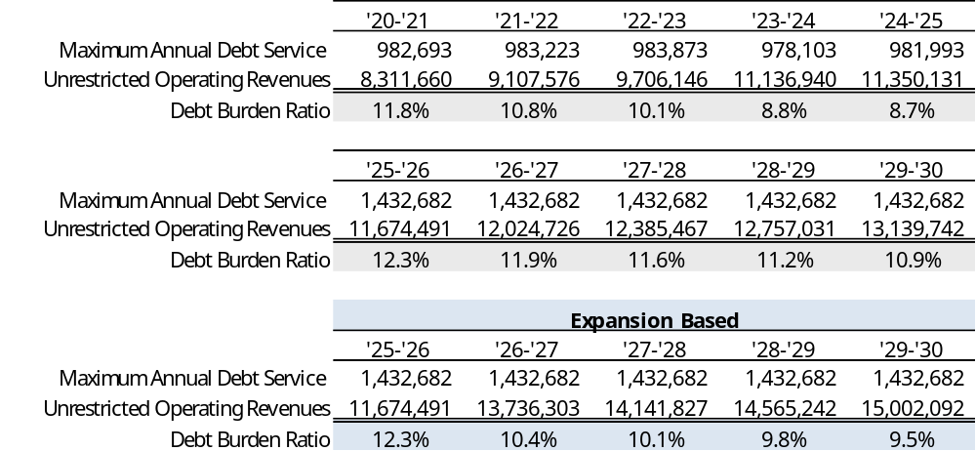

- Operating Margin
 | BBB- Requirement | Measure at end of FY 2025
 | At least 10% | 13.6%

The School has met this metric over each of the prior five years. The conservative projection figures show the operating margin at just above the Authority requirement.

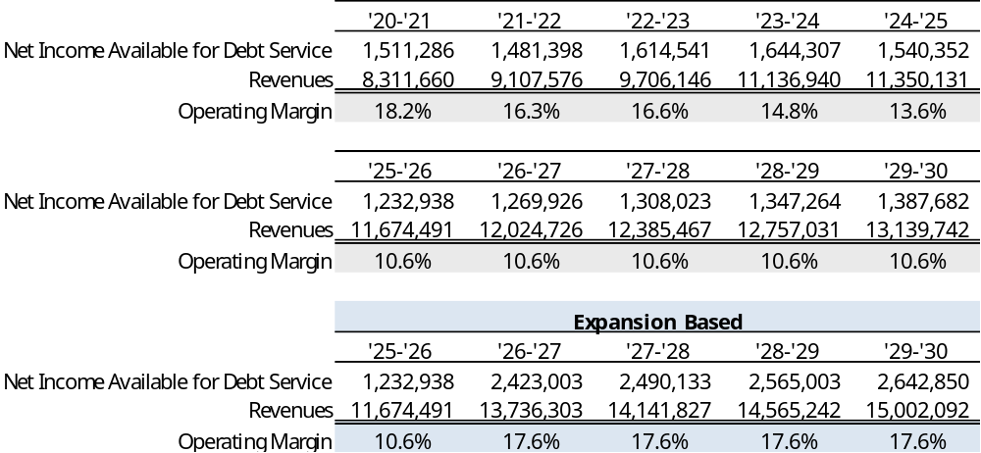

- Current Ratio
 | Requirement | Measure at end of FY 2025
 | At least 150% | 613%

The current ratio is defined as current unrestricted assets divided by current liabilities (including current year debt service). The School’s current ratio has been strong each of the past five years.

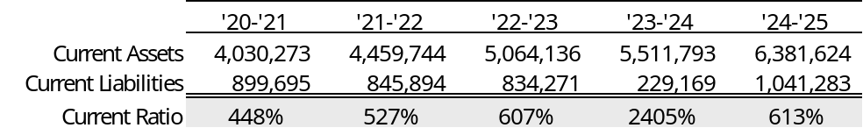

Bond Documents

Legal bond documents are being reviewed by Dorsey & Whitney in its capacity as Issuer’s Special Counsel to the Authority, and all requirements are being incorporated. In addition, Chapman & Cutler, as Bond Counsel, has certified that each of the required legal provisions is present in the bond documents.

Continuing Disclosure

The School has filed all audited financials in a timely fashion. Our review of the other continuing disclosure requirements did not yield any concerns. The School has an acceptable continuing disclosure policy.

Conclusion

The School has a strong history of operations and healthy liquidity. The School is expanding its current campus modestly to accommodate new growth. It will be able to draw down its sizable waitlist to accommodate the new growth while still maintaining a healthy waitlist. Current operations are sufficient to meet the new obligation at 100% coverage. Enrollment growth is necessary to fully cover debt service at 110%.

