MEMORANDUM

DATE: Friday, March 27, 2026
TO: Marlo Oaks, State Treasurer and Utah Charter School Finance Authority Board
FROM: Japheth McGee, Vice President and Johnathan Ward, Senior Vice President of Zions Public Finance
RE: George Washington Academy Application to the Utah Charter School Finance Authority and Credit Enhancement Program

Conflicts of Interest

In general, Zions Bancorporation, National Association is made up of many departments and provides various services. Some of those services and departments can be involved on the same transaction. Zions Public Finance Inc. and Zions Corporate Trust are affiliated entities operating under Zions Bancorporation and we all benefit from a strong stock price derived from strong performance by the company and its component members and affiliates across the country. Zions Public Finance does not receive financial or other benefits in association with transactions performed by Zions Corporate Trust who may act as Trustee on charter school transactions. Likewise, Zions Public Finance operates separately from commercial loan divisions of the Bancorporation who may have provided private financing to developers or charter schools to construct the school initially. Zions Public Finance is not aware of the circumstances where this occurs unless told when a charter school applies. Zions Public Finance does not receive financial or other benefits that could result from actions taken by the Charter School Finance Authority outside of the agreed upon fees for services rendered to the Authority.

Zions’ entities engaged with the School:

Zions Public Finance: | Yes. (Advisor to the Authority)
Zions Corporate Trust: | No
Zions Commercial Involvement: | No

Executive Summary

Borrower: | Lincoln Academy
Management Company: | Business Manager: Red Apple
Municipal Advisor: | LRB Public Finance Advisors, Inc.: David Robertson
Borrower’s Counsel: | Farnsworth Johnson: Brandon Johnson
Underwriter: | Piper Sandler & Co: Nick Hagen
Bond Counsel: | Orrick, Herrington, and Sutcliffe: Eugene Clark-Herrera
Issuer’s Counsel: | Gilmore & Bell: Jacob Carlton
Trustee: | US Bank: Laurel Bailey
Par Amount: | $18,030,000 in tax-exempt bonds.
Enhancement Requested: | Yes
Purpose: | Fund an expansion to the School’s existing facility (classrooms, office space, and an auditorium), 12-18 months of capitalized interest, a debt service reserve fund, and costs of issuance.
Structure: | Bonds will be repaid with a roughly level amortization of principal and interest over 30 years. The bonds will carry a fixed rate of interest.
Term: | Final maturity in 2056. Bonds will likely carry an 8 to 10-yr call feature.
Sale Method: | Negotiated underwriting
Rating: | S&P Global Ratings: BBB-
Costs of Issuance Estimate: | $244,000
Underwriter Fee Estimate: | $4.00/$1,000 (est. $72,120)
Litigation: | None of which we are aware.
Summary: | The School has been a part of the credit enhancement program and is modestly expanding its debt load. The School has a waitlist that is roughly twice the size of the expected enrollment increases it will use to help pay back the new debt. Current operating margins and debt coverage levels, as of FY 2025, would allow the School to meet the expanded debt service obligations even if enrollment were to stay at current levels.

Purpose

The purpose of this memo is to document the adherence of George Washington Academy (the “School”) to the application requirements of the Utah Charter School Finance Authority (the “Authority”) Credit Enhancement Program Standards and provide credit analysis of the School for the Authority’s consideration. The analysis contained herein is based on the School’s application to the Authority and inquiry for clarification of the Municipal Advisor to the Authority.

Introduction

The School is a non-profit, 501c3 designated, public K-7 charter school with one campus in St. George. The School was approved by the Utah State Charter School Board (the “SCSB”) in 2006.

MISSION STATEMENT
George Washington Academy is a free K-7 public charter school. We are a community of learners who empower students to take ownership of their learning through academic excellence and student-led leadership. We are committed to student learning, peer collaboration, and data-driven best practices that support every student's success as a confident learner and leader in their classrooms, families, and communities.

Enrollment/Student Demand

October enrollment for the 2025 - 2026 school year is 1,030 students. The School is using funds from this financing to expand educational space and increase student enrollment to 1,144 by 2030. The School has a moderate waitlist and has shown strong retention and resulting enrollment throughout the entire look back period. Average daily membership is above 98%.

Academic Performance

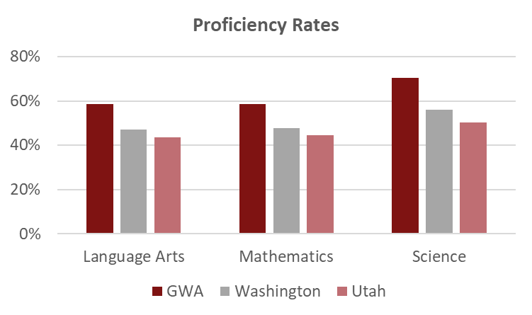

Management

- The School currently has an eight-member board. The board members have backgrounds in: education, business management, finance, law, real estate, and nutrition.
- The School employs Blake Clark as Executive Director. Mr. Clark received a Bachelor’s in Elementary Education and a Master’s in Educational Leadership both from Southern Utah University.
- The School employs Red Apple for business management services.
- The School has formal policies for budgeting, cash handling, debt, fundraising and donations, and procurement. The School does not have a formal policy for investments.

Plan of Finance

The School is seeking authorization to sell to $18,030,000 of BBB- rated bonds via negotiated sale with Piper Sandler and Co. serving as the Underwriter. The School is seeking credit enhancement through the Utah Charter School Credit Enhancement Program. The bonds will be tax-exempt bonds for the purpose of funding an expansion at the current facility (16 new classrooms, additional office space, a 300-person auditorium, meeting rooms, a small library, custodial space, and storage space), a debt service reserve fund, capitalized interest, and costs of issuance. The bonds will carry a fixed rate of interest and will likely carry an 8 to 10-year call. The bonds are secured by an assignment and secured interest in the revenues of the School and trust accounts and a security interest and pledge of the deed of trust in the land and building located at:

- 2277 S. 330 E, St. George, Utah, 84790

Ratings

The bonds are rated BBB- by S&P Global Ratings. S&P noted the following positive factors in its rating report.
- Stable market position including excellent academics.
- Trend of robust operating surpluses.
- Healthy days cash on hand (in spite of recent land purchases)
- Utah’s favorable charter school funding and authorizer environment.

The following factors for concern were noted:
- Moderately high debt burden coupled with additional near-term debt plans (the current expansion).
- Inherent risks related to charter schools being closed for non-performance.

S&P noted that the School could achieve a rating increase (deemed as unlikely) with sustained coverage, cash, and growing enrollment while executing the expansion plans. A rating downgrade could occur if financial metrics materially weakened as a result of the expansion.

Financial Performance

Summary:
The School has a strong history of operations. The School has been a part of the credit enhancement program for several years with no concerns. Debt coverage ratios, as shown in the graph below, have been sufficient to more than cover both the existing debt and the future debt plans at the School. S&P noted the excellent liquidity position of the School with days cash on hand at nearly a full year of operating expenses. The School does have a more conservative approach to budgeting than most charter schools as seen by the consistent near double digit overperformance in revenues from budgets to actuals.

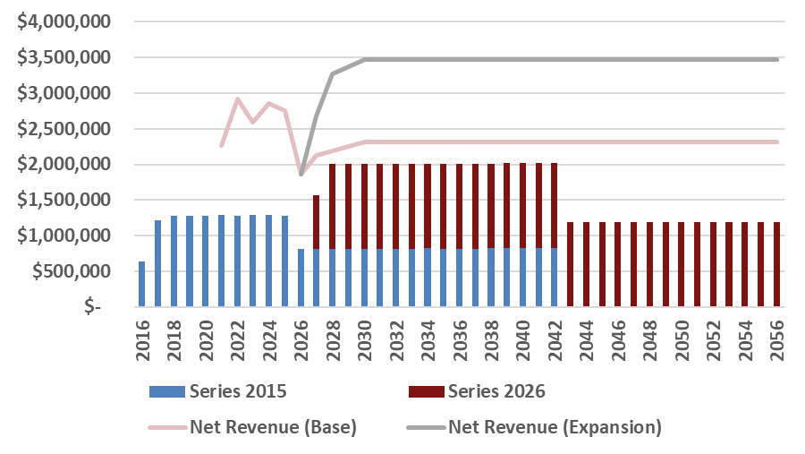

- As noted, the School has been conservative in its projections. No revenue projections were within 5% of the original school year budget. Expenditures also came in well above budgets but, with the exception of FY 2024, revenue actuals more than covered for those disparities. FY 2024 expenditures missed actuals by more than other years in part due to a higher than usual capita outlay for that year as the School purchased new property.

- Cash Position
 | Requirement | Measure at end of FY 2025
 | At least 75 days | 348

The School’s cash on hand of 348 DCOH is incredibly strong and should allow it to operate for some time even if expansion does not provide strong revenue growth as projected.

- Fund Balance
 | Requirement | Measure at end of FY 2025
 | At least 15% of following year expenses | 77%

At the end of FY 2025, the School had an unassigned fund balance of 77% of the following year’s projected operating expenses. Fund balance was strong and generally growing over the past five years.

- Debt Coverage Ratio
 | BBB- Requirement | Measure at end of FY 2025
 | At least 110% | 210%

The School is projecting conservatively that without student enrollment increases it will only have net income that is roughly equal to the expanded debt load. However, the School was able to achieve sufficient net revenues in each of the prior five years to cover the expanded debt load. The additional operating capacity and students will bring new expenditures but those costs are generally scalable. The past performance of the School suggests it should be able to meet the expanded debt service requirements.

- Debt Burden Ratio
 | BBB- Requirement | Measure at end of FY 2025
 | Less than 20% | 11.1%

The School has met this metric in each of the prior 5 years and is expected to continue to meet this metric going forward without much concern. The School qualifies even under the more strict BB metric of less than 16%.

- Operating Margin
 | BBB- Requirement | Measure at end of FY 2025
 | At least 10% | 23.4%

The operating margin for the School is healthy and has been more than double the requirement each of the past five years. The School is conservatively projecting margins to decrease but it seems reasonable that it will continue to operate with strong margins going forward. The School qualifies under the more strict BB metric of at least 14%.

- Current Ratio
 | Requirement | Measure at end of FY 2025
 | At least 150% | 949%

The current ratio is defined as current unrestricted assets divided by current liabilities (including current year debt service). The School’s current ratio has been stable with an increase in the prior fiscal year.

Bond Documents

Legal bond documents are being reviewed by Gilmore & Bell in its capacity as Issuer’s Special Counsel to the Authority, and all requirements are being incorporated. In addition, Orrick, Herrington, and Sutcliffe, as Bond Counsel, has certified that each of the required legal provisions is present in the bond documents.

Continuing Disclosure

The School has an acceptable continuing disclosure policy. The School has a strong track record of providing annual audited financial statements on time.

Conclusion

The School is expecting modest growth in enrollment. It currently has a more than sufficient waitlist to draw down upon to meet the expansion goals. At current operating levels the School should be able to meet the expanded debt service without any trouble.

