LAKE POINT CITY COUNCIL

ORDINANCE NO. __________ DATE: __________

AN ORDINANCE ESTABLISHING THE MULTIPLE-USE ZONING DISTRICT

WHEREAS, pursuant to Utah Code Title 10, Chapter 20, Lake Point is authorized to adopt land use regulations including maps, to create and define the boundaries and locations of zoning districts, and regulate and restrict the erection, construction, reconstruction, alteration, repair, or use of buildings and structures and the use of land within such districts; and

WHEREAS, the Utah Municipal Land Use, Development, and Management Act (“LUDMA”) was renumbered in the 2025 Special Session of the Utah Legislature, resulting in various erroneous cross-references in Lake Point Municipal Code; and

WHEREAS, the City’s General Plan and zoning map identified a multiple use zone “MU Zone” which previously had no applicable land use ordinance; and

WHEREAS, the Lake Point City Zoning Map included outdated references to the MU Zone; and

WHEREAS, the City desires to establish the regulations for the multiple use zone and apply that to the previously-labeled “MU-40” areas within the City and update the zoning ; and

WHEREAS, the City has held the required public hearing and provided proper notice and determined adoption of this ordinance to be in the interests of the City; and

NOW, THEREFORE, BE IT ORDAINED by the Lake Point City Council as follows:

- Enactment of Chapter. Chapter 13.11 of the Lake Point City Code is hereby enacted in the form of the ordinance attached hereto as “Exhibit A.”
- Update of Map. The Lake Point City Zoning Map is hereby replaced in its entirety with the form of the map attached hereto as “Exhibit B” (a full size, downloadable version is available on the City hosting website: https://hosting.civiclinq.com/lakepointut/books/zoning-map/2)
- Application of Zone. The “MU Zone” is hereby applied to those areas designated “MU” on the newly updated Zoning Map.
- Severability: If a court of competent jurisdiction determines that any part of this ordinance is unconstitutional or invalid, then such portion of this ordinance, or specific application of this ordinance, shall be severed from the remainder, which shall continue in full force and effect.
- Direction: The chair and staff, including the city attorney, are authorized and directed to take such steps as may be needed: (a) for this ordinance to become effective under Utah law, including but not limited to compliance with the requirements of Utah Code § 10-3-711; and (b) to finalize and post the ordinance to civiclinQ, including but not limited to making non-substantive edits to correct any scrivener’s, formatting, and numbering errors.
- This Ordinance shall be effective immediately upon its adoption and posting according to law.

PASSED, APPROVED, AND ADOPTED on the day of , 2026

Lake Point

By________________________________
Chair

ATTEST:

__________________________________ SEAL
Jamie Olson, City Recorder

Voting:

Kirk Pearson Yea___ Nay___ Absent ___
Kathleen VonHatten Yea___ Nay___ Absent ___
Kirk Trimble Yea___ Nay___ Absent ___
Ryan Zumwalt Yea___ Nay___ Absent ___
Lori Chigbrow Yea___ Nay___ Absent ___

SUMMARY OF LAKE POINT CITY ORDINANCE NO. ________

On _________, 2025, the Lake Point City Council enacted Ordinance No. ___________ adopting land use regulations for the Multiple-Use Zoning District.

A complete copy of Ordinance No. _________ is available online and in the office of the Lake Point City Recorder and by contacting Jamie Olson at info@lakepoint.gov.

Exhibit A to Ordinance
13.11 Multiple-Use (MU) Zone

- Purpose
  - The purpose of the Multiple-Use zone (“MU ZoneZone") is to implement a coordinated, flexible zoning framework that supports limited, sustainable commercial growth and modest housing opportunities in Lake Point while preserving open space and the community’s rural character.
  - Consistent with the Lake Point General Plan, the MU Zone promotes attractive and practical combinations of residential and small-scale commercial uses, both horizontally and vertically, such as live-work buildings with optional ground-floor businesses, to foster entrepreneurship, walkability, and vibrant community spaces.
  - The MU Zone is intended to facilitate the orderly and intentional expansion of commercial activity from existing centers, ensure access to collector streets, require concurrent development of commercial and residential components, and reduce land-use conflicts by ensuring compatibility between uses, thereby supporting local businesses, community facilities, and a balanced, cohesive development pattern.
  - Consistent with the Lake Point General Plan, development within the MU Zone shall incorporate commercial uses as an integral component of the project and is intended to avoid developments that function primarily as high-density residential.
- Applicability and Relationship to Other Regulations
  - This Chapter applies to all development, redevelopment, and phased development within the MU Zone.
  - The requirements in this Section are minimum requirements. Where other provisions of Chapter 13 (Land Uses) and/or Chapter 14 (Design and Construction Standards) impose additional requirements applicable to a development, those requirements apply in addition to this Section.
- Permitted and Prohibited Uses
  - Allowed and prohibited uses in the MU Zone shall be as provided in Section 13.5.1 (Multiple-Use, Commercial, and Industrial Zoning District Standards), as amended. Uses not expressly permitted are prohibited.
- Rezoning/Annexation into MU Zone
  - Property proposed for rezoning or annexation into the MU Zone shall contain at least fifteen (15) contiguous acres in common ownership at the time of application.
  - A Development Agreement shall accompany any applications for property proposed for rezoning or annexation into the MU Zone. The Development Agreement shall include a Development Master Plan (see 13.11.5).
- Plans Required for Multiple-Use (MU) Developments
  - A Development Agreement is required:
    - for applications subject to Section 13.11.4 (Rezoning/Annexation into MU Zone)
    - for any applications which involve multiple phases; and
    - whenever an applicant requests deviations from development standards or other requirements and is therefore not entitled to administrative approval.
  - Development Agreement
    - A Development Agreement is an enforceable contract between an applicant and the City regulating or controlling the use or development of land, not including an improvement completion assurance that runs with the land and is binding on successors, transferees, and assigns.
    - All Development Agreements for development in the MU Zone shall include a Master Plan. Development Agreements are governed by the Utah Land Use Development and Management Act, and are legislative, discretionary approvals.
    - A Development Agreement shall identify permitted commercial and residential uses, building footprints or development areas, maximum gross floor area, height and massing parameters, access and circulation, parking strategy (including shared or phased parking), open space allocation, buffering and compatibility measures, and phasing and concurrency requirements, including the requirement that commercial components be constructed concurrently with residential components unless otherwise approved.
    - Approval of a Development Agreement shall establish binding development standards for the subject property but may not authorize construction absent approval of a Site Plan.
  - A Master Plan is required for all development in the MU Zone, regardless of whether a Development Agreement is also required.
    - Master Plan: A planning document that establishes the overall vision, framework, and guiding principles for the development of land within the multiple-use (MU) zone or a designated portion thereof. A Master Plan is intended to demonstrate general consistency with the Lake Point General Plan and to guide the preparation of subsequent Site Plan(s). A Master Plan is an Exhibit of the Development Agreement.
    - A Master Plan may include, but is not limited to, conceptual land-use diagrams, general location and relationship of commercial and residential uses, anticipated densities and intensities, circulation and access concepts, open space and community gathering areas, design character themes, and an overall phasing strategy. A Master Plan shall be illustrative in nature and may not authorize construction, confer vested development rights, or substitute for required Development Plan or Site Plan approvals.
  - Site Plan: A detailed, parcel or building-specific plan that illustrates the precise design and physical development of a site in accordance with an approved Development Plan and applicable zoning, engineering, and design standards. A Site Plan shall provide sufficient detail to allow review for compliance and issuance of construction-related permits.
    - Site plans shall comply with Chapter 13.9 and shall include, as applicable, exact building locations and dimensions, architectural elevations, parking layout and counts, landscaping and buffering, pedestrian and vehicular circulation, utilities, grading and drainage, lighting, and other site improvements. Site Plan approval shall authorize construction only for the development shown and may not modify or supersede the approved Development Plan.
- Permit Sequencing
  - Site plan approval is required prior to issuance of building permits. Building permit applications may be submitted concurrently with a site plan; however, no building permit may be issued prior to site plan approval.
  - To ensure timely construction of the commercial component, the applicant shall apply for commercial building permits prior to or concurrently with residential building permits in a manner that is proportional to the approved phasing plan and total project buildout.
  - The City may withhold, suspend, or deny building permits for any building(s) within a development where the applicant fails to comply with this Chapter, an approved site plan, an approved multiple-use master plan, conditions of approval, or a development agreement.
- Use and Space Thresholds
  - This section establishes minimum commercial thresholds for MU developments. Compliance may be achieved through horizontal multiple-use, vertical/integrated multiple-use, or a combination.
  - The City may approve deviations to these thresholds upon written findings that:
    - the commercial component remains sufficient in size and configuration to serve the development and surrounding area;
    - the project maintains a balanced multiple-use character; and
    - the project does not function primarily as a residential subdivision.
  - Horizontal Multiple-Use
    - Where commercial and residential uses are located in separate buildings, commercial uses shall occupy land area at a minimum ratio of one (1) acre of net developable land area designated for commercial uses for every four (4) acres of net developable land area designated for residential purposes within the development.
    - For purposes of this Chapter, “net developable land area” means all land excluding public rights-of-way, perimeter setbacks, and required open space, unless otherwise approved by the City. Required open space is in addition to net developable land area and may not be designated for commercial or residential land uses.
  - Vertical Multiple-Use
    - Where one or more buildings contain both commercial and residential uses, commercial uses may not comprise less than twenty percent (20%) and not more than thirty percent (30%) of the total gross floor area of all buildings within the development.
      - A dedicated multiple-use unit shall contain dedicated space that is solely residential and dedicated space that is solely commercial.
      - These dedicated spaces may be owned or leased by separate entities or by a single entity, but they are fundamentally separate units which must each have their own dedicated access points, bathroom facilities, and utilities.
      - In dedicated vertical multiple-use units, commercial floor area shall be located on the ground floor or in other street-oriented or publicly accessible locations unless the City determines an alternative configuration better meets the intent of the MU Zone.
  - Flexible Vertical Multiple-Use Units
    - A flexible multiple-use unit is and shall be owned as a single unit. A flexible multiple-use unit shall contain a dedicated space that is solely residential and a flexible space which may be used for either commercial or residential purposes
    - The flexible space may be sub-leased to a separate entity but is fundamentally part of the same unit which contains the dedicated residential space.
      - Under no circumstances may a flexible space be sub-leased to a separate entity for use as a dedicated residential space (multi-family residential unit).
    - The flexible space shall count toward the required commercial floor area within a development only when the space has a dedicated access point, dedicated bathroom facilities, and a lockable door separating it from the dedicated residential space.
    - The flexible space shall be designed and constructed to reasonably accommodate conversion among permitted commercial and residential uses without structural modification.
    - The flexible space shall be located on the ground floor unless the City determines an alternative configuration better meets the intent of the MU Zone.
    - The flexible space shall comply with applicable commercial parking, fire, and building code requirements in effect at the time of conversion.
- Phasing Requirement for Commercial Construction
  - Commercial uses shall be constructed concurrently with or prior to residential development unless otherwise approved through a development agreement.
  - A parcel or lot may not rely on commercial uses located on other parcels or lots unless such parcels or lots are part of a unified multi-lot development agreement.
- Residential Transition Areas
  - A development in an MU Zone adjacent to existing single-family residential zones shall be designed to reduce conflicts related to scale, noise, lighting, and service impacts.
    - In the MU Zone, the building(s) nearest the residential zone property line shall be residential in use; or where non-residential buildings are located nearest the residential zone property line, the development shall provide:
      - A ten-foot (10') landscaped buffer;
      - An eight-foot (8') sight-obscuring and noise-dampening masonry fence;
      - A maximum building height of thirty-five (35) feet, measured from finished grade, for the first row of buildings directly adjacent to the residential zone property line;
      - Loading zones, loading docks, and noise/vibration producing utilities shall be set back at least fifty (50) feet from the nearest residential property line;
      - Rooftop mechanical and antenna equipment shall be screened; and
      - Noise, vibration, smoke, dust, odor, glare, and similar impacts may not be discernible beyond the premises except for normal traffic movements.
- Density
  - The average residential density in any development in the MU Zone may not exceed ten (10) dwelling units (DU) per acre across all net developable land area designated for residential use on the Master Plan, unless otherwise approved through a Development Agreement.
  - The guidelines in Table 1 and the example in Figure 1 should be used as a guidance to ensure a density pattern that provides appropriate transitions adjacent to existing residential zoning districts. The City encourages different unit types in the same development. As an example, in a development with 10 acres of net developable land area designated for residential use, there may not be more than 100 dwelling units, but if 5 acres were designated “Mid-Density” with 12 DU/Acre (60 total), the remaining 5 acres could not exceed 8 units per acre (for the 40 remaining maximum units).

Table 1.
 | DU / Acre | Location | Rationale
1. | 1-3 | Low-Density  (e.g. single-family homes) | Appropriate for areas bordering existing dedicated residential zoning in order to maintain open space and rural character of abutting area(s).
2. | 4-6 | Mid-Density  (e.g. townhomes/ condos) | Appropriate for areas in the center of the multiple-use development, providing a buffer between the Low-Density multiple-use and the Higher-Density multiple-use areas. Dense enough to support small-scale retail and local services without introducing urban scale.
3. | 7-12 | Mid-Density  (e.g. mixed-use) | Appropriate for limited areas near major intersections, collector roads, or civic anchors. Located furthest away from residential zones.

Figure 1.

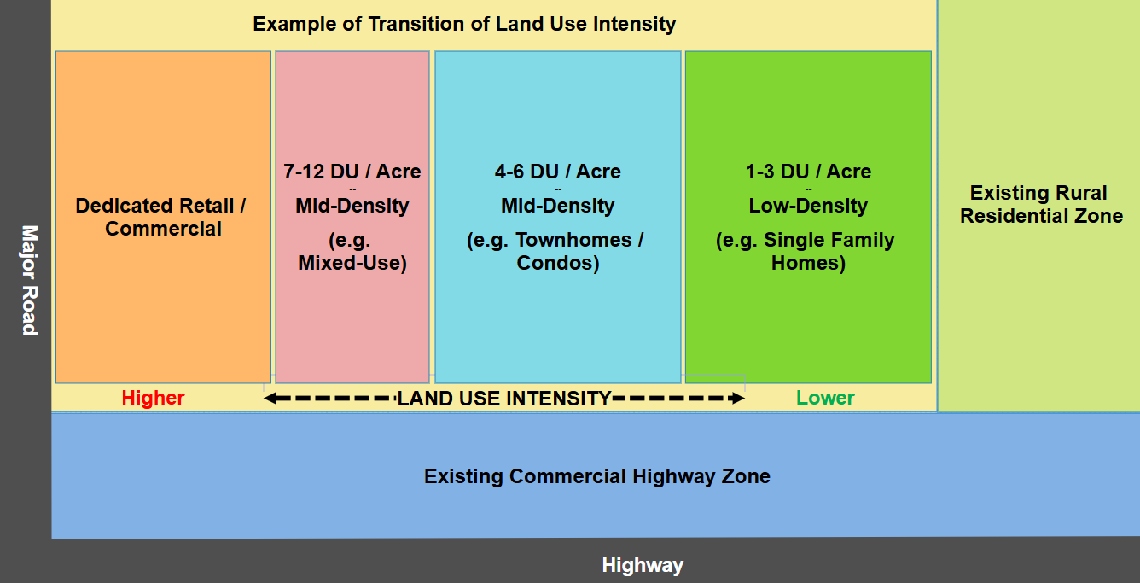
Note: This figure does not depict a separate required open space, which is not counted toward the DU/Acre thresholds and limits.

Figures 2-5 below show conceptual examples of a multiple-use development in a rural town
Figure 2.
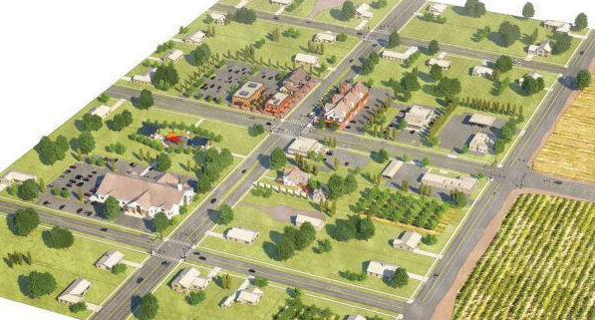

Figure 3.
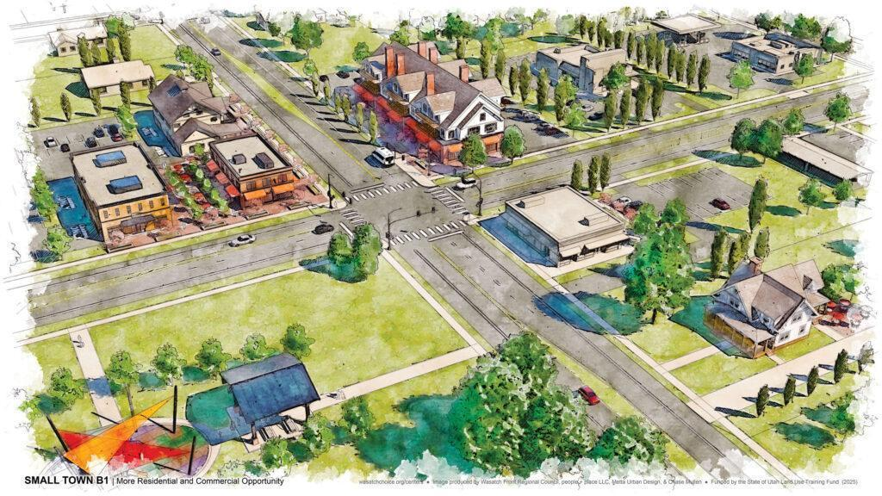

Figure 4.
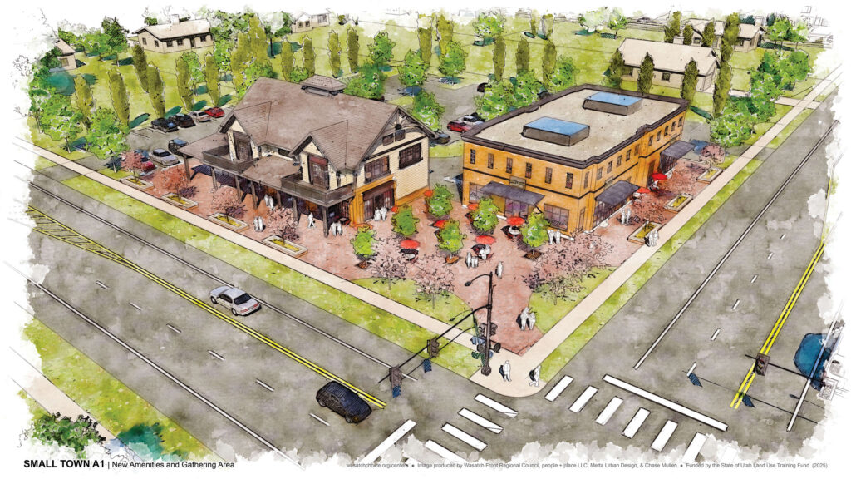

Figure 5.
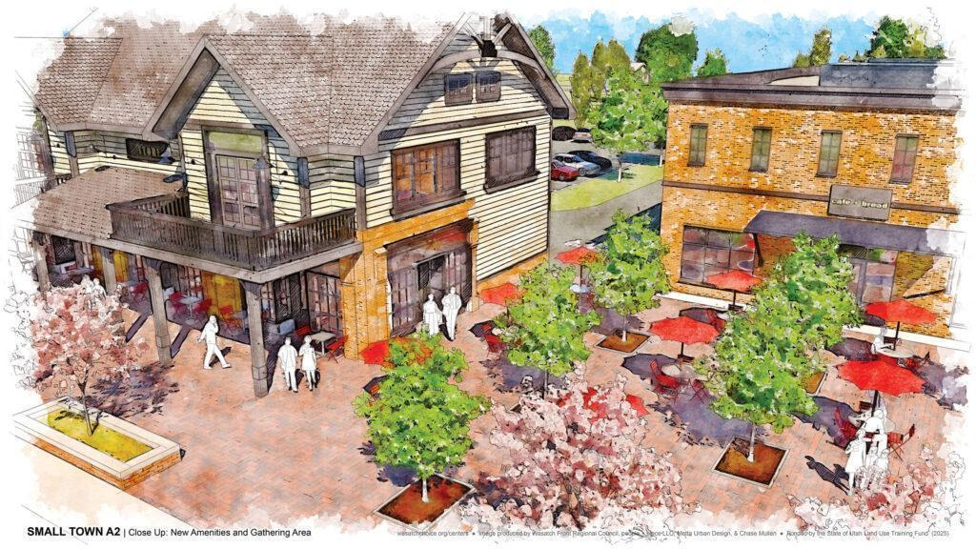

- Site Design and Development Standards
  - Open Space: At least 20% of a multiple-use development shall be open space, including but not limited to landscaped areas and improved amenities (e.g. trails, benches, lighting, recreation features) supporting passive or active use.
  - Maximum Lot Coverage: No more that 50% of a lot may be covered by building(s).
  - Maximum building height in the multiple-use development shall be forty (40) feet, unless a greater height is approved through a development agreement or other process authorized by Lake Point Municipal Code.
  - No uninterrupted wall length may exceed seventy-five (75) feet without façade articulation or architectural features.
  - Building design shall comply with applicable design standards in Chapter 13. Buildings shall demonstrate a unified architectural style. Public street-facing façades shall use durable materials (e.g. stucco, fiber cement board, brick, stone). Vinyl, aluminum, and steel siding are prohibited on street-facing façades except soffits and fascia. Stucco-only façades are prohibited.
- Setbacks
  - Setbacks shall comply with Chapter 13.2 for Residential and Chapter 13.5 for Commercial and Mixed-Use unless otherwise modified through site plan approval.
- Parking Standards
  - Residential Parking
    - Residential parking shall comply with Chapter 13.2 except as modified by this Section.
    - Residential parking shall be designated and reserved for residential use and may not be counted toward non-residential parking requirements.
  - Non-Residential Parking
    - Non-residential parking shall comply with Chapter 13.6 except as modified by this Section.
    - Off-street parking shall be hard surfaced.
    - Parking shall be located and designed to minimize conflicts with residential areas through separation, signage, striping, landscaping, and screening.
    - Shared parking among non-residential uses may not exceed 25% and is permitted only where the applicant demonstrates different peak demand periods and submits an analysis for approval through a development agreement and subsequent site plans.
      - If a use is intensified or modified such that parking demand materially changes, previously approved reductions may be reevaluated for compliance.

Exhibit B Zoning Map

