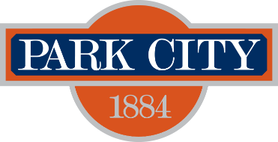

PARK CITY COUNCIL MEETING MINUTES
445 MARSAC AVENUE
PARK CITY, UTAH 84060

February 25, 2026

The Council of Park City, Summit County, Utah, met in open meeting on February 25, 2026, at 10:45 a.m. in the Council Chambers.

SPECIAL MEETING

I. ROLL CALL

Attendee Name | Status
Mayor Ryan Dickey  Council Member Bill Ciraco  Council Member Molly Miller  Council Member Ed Parigian  Council Member Tana Toly  Council Member Diego Zegarra  Heather Sneddon, Acting City Manager  Margaret Plane, City Attorney  Paige Galvin, Deputy City Recorder | Present
None | Excused

Council Member Ciraco moved to close the meeting to discuss personnel at 10:45 a.m. Council Member Miller seconded the motion.
RESULT: APPROVED
AYES: Council Members Ciraco, Miller, Parigian, and Zegarra
EXCUSED: Council Member Toly

Council Member Toly arrived at 10:48 a.m.

Closed Session

Council Member Toly moved to adjourn from Closed Meeting at 5:00 p.m. Council Member Ciraco seconded the motion.
RESULT: APPROVED
AYES: Council Members Ciraco, Miller, Parigian, Toly, and Zegarra

III. ADJOURNMENT

With no further business, the meeting was adjourned.
_________________________
Michelle Kellogg, City Recorder

