MINUTES
Weber School Foundation Board Meeting
9/11/2025 12:00 PM | Meeting held at the Weber School District Office and called to order by Jeremy Dunn

Attendance
Present: Craig Adams, Mark Adams, Dave Andersen, Jenna Andrascik, Matt Bell, Barry Beus, Dave Broadbent, Jan Burrell, Gina Butters, Flora Cassity, Michelle Darrington, Craig Dearden, Scott Dixon, Jeremy Dunn, Jamie Ellison, Kimberli Green, Branden Hansen, Bryan Hurst, Brett Karras, Steve Kier, Karen Leonardi, Ashley Loftus, Austin Mickels, Phil Mickey, Clyde Moore, Emily Oyler, Kathy Saunders, Josh Skidmore, Shekeydrah Smith, Adam Stuart, Jake Talbot, Jennie Taylor & Angie Towns
Excused: Bryan Benard, Lindee Bess, Tony Divino, Jennifer Dunyon, Kori Ann Edwards, Mike Hale, Matt Jensen, Ryan Olsen & Kerry Wahlen

Welcome
Board President Jeremy Dunn welcomed everyone to the meeting.
Introduce new Board Members Karen Leonardi & Austin Mickels-
Karen Leonardi works for the Weber State Dumke College of Health Professions. She lives in Plain City with her husband and has been a great supporter of Christmas Tree Jubilee. She is very excited to serve on our board and give back!
Austin Mickels works at Valley Design & Construction. He lives in the community with his wife and son. He is excited to serve on our board!
“Get to Know You Bingo Game”-The Board Members played a get to know you bingo game and then shared some information that they learned about each other.

Approval of Minutes
Kathy Saunders made a motion to approve the minutes from the April 17, 2025 meeting with a second from Jenna Andrascik. The minutes were unanimously approved.

Share our Story
Class & School Grants-Jennie Taylor informed the board that DonorsChoose is a nonprofit crowdfunding platform that allows the public to donate directly to classroom projects for public school teachers in the United States. The Foundation partnered with them 5 years ago. This allows us to stretch our budget & donate to more classrooms! Since our grant portals opened on August 1st, we have had 74 Class Grants funded already this school year. There was a huge match through DonorsChoose with the Gates Foundation, Project Tiger and Staples. The Weber School Foundation has contributed $19,444.43. It’s exciting how much we can stretch our donor dollars for these grants!
Raptors Night Recap-Phil Mickey reported it was a great night at the ballpark on Friday, September 5, 2025 at the Ogden Raptors sponsored by the Weber School Foundation. It was a way to show our appreciation and to say thank you to the employees and board members for supporting the Foundation. Assistant Superintendent and Foundation board member Clyde Moore threw out the first pitch. The Weber High School Chamber Choir performed the National Anthem and the nominees for last year’s Teacher of the Year were honored between the 3rd & 4th inning.

Committee Reports
Special Needs— Flora Cassity informed the committee since our last meeting we have received 4 requests. These requests include a Cranial Formation Helmet, a pair of SMO Leg Braces and 2 Communication Devices.Total for these requests are $3,448.00. The Special Needs Committee has reviewed and approved these requests. Jeremy Dunn made the motion to approve these requests with a second from Steve Kier. The board unanimously approved.
Finance-Craig Adams reported that the Finance Committee met with Brent Moore, our Investment Advisor from Soltis. Our portfolio is up 7%. The committee is working on a new, simplified version of the IPS (Investment Policy Statement.) Once it is complete it will be brought to the board for final approval.
Projects-Kathy Saunders reported that our grant portals opened on August 1st and we have funded 74 total Class Grants. DonorsChoose had a 1.5 match to celebrate their 25th Anniversary and partnered with the Gates Foundation, Project Tiger and Staples Foundation. This is the largest match we have ever participated in! 67 Class Grants were funded totaling $19,444.43. Grant projects include novel sets, foreign language libraries, flexible seating, manipulatives, art supplies and whiteboards. We had 2 School Grant requests and 1 non DonorsChoose request. For Special Education Class Grants, we received 7 DonorsChoose requests totaling $3,148.62. Grant projects include sensory play items, adaptive seating and communication flashcards and learning manipulatives. Jeremy Dunn made the motion to approve these projects with a second from Steve Kier. The board unanimously approved.
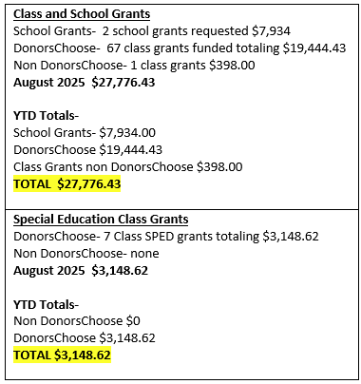
Teen Center-Steve Kier reported that we had our final Teen Center Ribbon Cutting at West Field High School on August 14th. It was a wonderful night with great attendance and support! Emily is going to meet with all of the principals and Teen Center staff to talk about best practices and volunteer help to keep these teen centers open later. Steve thanked the board members for their continued support during this amazing project and the completion of the 6 Teen Centers in each of our High Schools in the Weber School District. Steve reviewed the cost of each teen center and the money that was raised to finish this project.

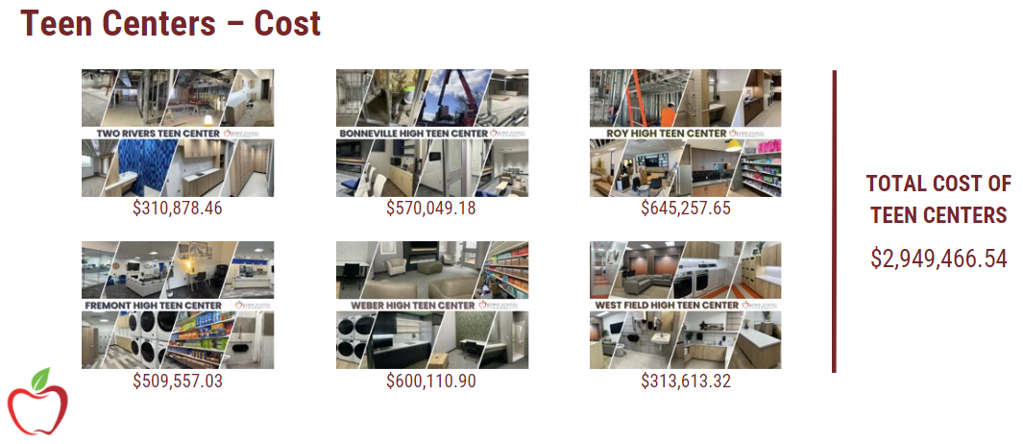
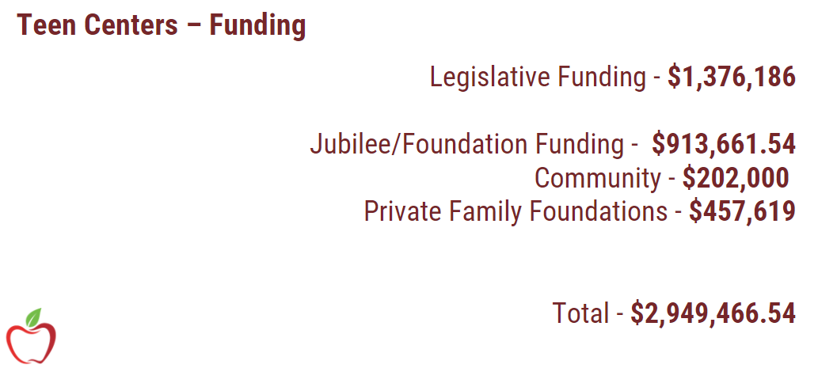

Golf-Craig Dearden informed the board that the Golf Committee met to discuss whether or not to keep our tournament at the Ogden Golf & Country Club because of the rising costs each year. We are looking at other locations including The Barn, Wolf Creek and Mount Ogden Golf Course. The committee will make a final decision and bring that information back to the board.

Director’s Report
Funding Ratification-Emily reported that we received a $20,000.00 request for StoryCon which is a literary conference in Salt Lake City. Students attended this conference last year and it made a huge impact! Last year the Foundation approved $5,000.00 for this conference. The Executive Committee approved a $10,000.00 donation for this year. Kathy Saunders made a motion to approve this funding with a second from Mark Adams. The board unanimously approved.
2025-2026 Budget Approval-Emily reviewed the budget with the board:
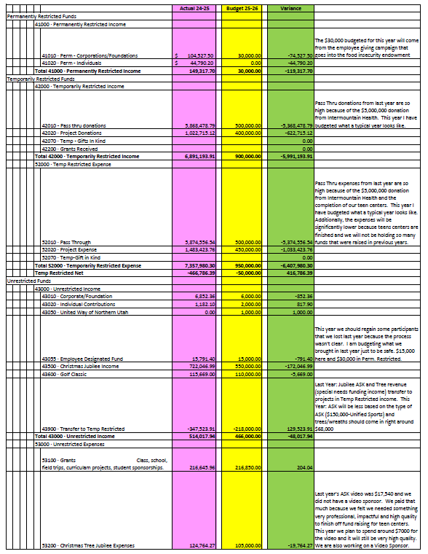
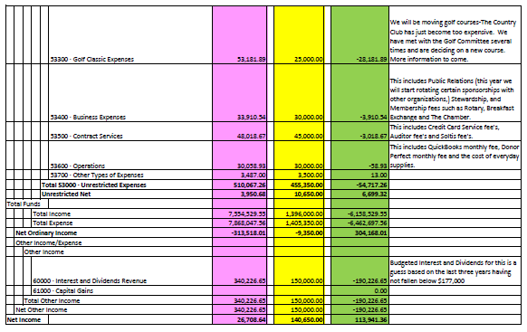
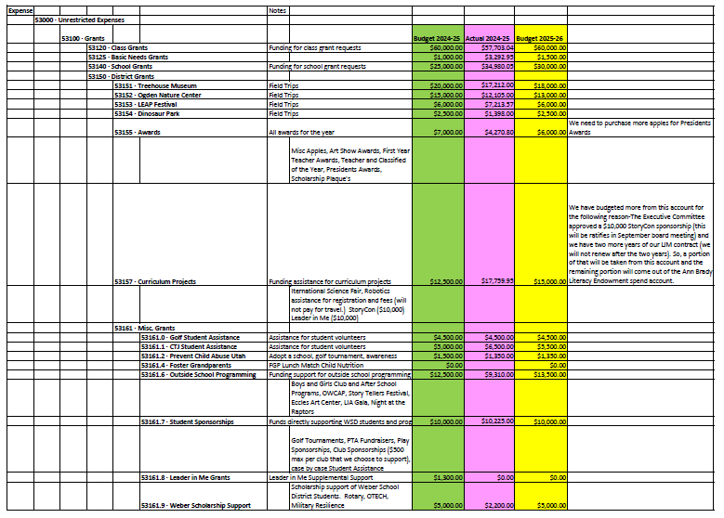

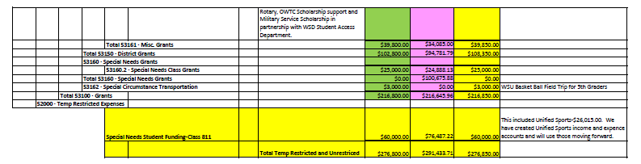
Jeremy Dunn made the motion to approve the 2025-2026 Budget with a second from Phil Mickey. The board unanimously approved.
Elevate 28/Foundation Team Goals-Last year Superintendent Butters gave a presentation on Elevate 28 and asked each department what they were going to do to align with the strategic plan. Emily went over each focal area and how the Foundation aligns with that area.
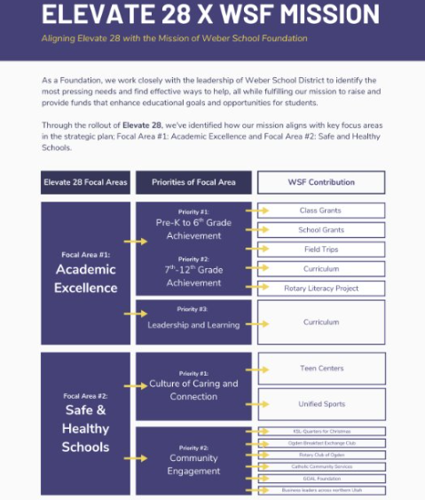
Open Discussion-An open discussion was held regarding foundation support within the community and within our schools regarding academics, teacher support, mental health for students and safety. We are continuing to work on the Legacy Giving Program and will present this to the board after completion.

Christmas Tree Jubilee-Emily reported that America First Credit Union will be our $25,000.00 Presenting Sponsor again this year. Hogan Construction will be our $10,000.00 Entertainment Sponsor and Josh & Kim Skidmore will be our $10,000.00 Tree Room Sponsor again this year. We have added a new $10,000.00 Video Sponsor this year. Board members were asked to speak to Emily if they were interested in this sponsorship.
- Save the Date-Board members received a Save the Date for the 2025 Christmas Tree Jubilee with the Schedule of Events.
- “Ask”-Flora Cassity informed the board that the Special Needs Committee met and decided to do “Unified Sports” as the “Ask” for the 2025 Christmas Tree Jubilee. We are very excited about this!
Other Business-
- Dates to Remember
-Unified Sports Soccer Tournament September 25th 9:45-12:45 @ Bonneville High
-Almond Knot Delivery (October 8th & 9th)
- Emily excitedly informed the board that the Weber School Foundation is going to be the recipient of the Coates Electrical Golf Tournament proceeds! They will be donating $100,000.00 over the next 3 years for our Food Pantry & Food Insecurity Endowment. This donation comes with naming rights to the Roy Jr. High and West Field High Teen Center Food Pantries. Wasatch Peaks Credit Union will be awarded the naming rights to the Fremont High Teen Center Food Pantry with their $50,000.00 donation.
Adjourn

Next Meeting
October 23, 2025

