MINUTES
Weber School Foundation Board Meeting
12/18/2025 12:00 PM | Meeting held at the Weber School District Office and called to order by Jeremy Dunn

Attendance
Present: Craig Adams, Mark Adams, Dave Andersen, Jenna Andrascik, Matt Bell, Dave Broadbent, Barry Beus, Jan Burrell, Gina Butters, Flora Cassity, Heather Christensen, Michelle Darrington, Craig Dearden, Tony Divino, Scott Dixon, Jeremy Dunn, Jennifer Dunyon, Jamie Ellison, Mike Hale, Bryan Hurst, Matt Jensen, Brett Karras, Steve Kier, Karen Leonardi, Ashley Loftus, Phil Mickey, Austin Mickles, Clyde Moore, Ryan Olsen, Emily Oyler, Kathy Saunders, Josh Skidmore, Adam Stuart, Jake Talbot, Jennie Taylor, Angie Towns, Eric Thomas & Kerry Wahlen
Excused: Tyler Buxton, Heather Christensen, Kori Ann Edwards, Kimberli Green, Brandi Hammon & Branden Hansen
Guest: Dave Hales

Welcome
Board President Jeremy Dunn welcomed everyone to the meeting.

Approval of Minutes
Kathy Saunders made a motion to approve the minutes from the October 23, 2025 meeting with a second from Jennie Taylor. The minutes were unanimously approved.

Committee Reports
Special Needs— Flora Cassity informed the committee since our last meeting we have received 8 requests. These requests include iPads, apps & cases and a tomato chair. Total for these requests are $5,926.14. The Special Needs Committee has reviewed and approved these requests. Dave Broadbent made the motion to approve these requests with a second from Tony Divino. The board unanimously approved.

Director’s Report
Sub for Santa-Emily went over the donations that we received from the District Office Sub for Santa Luncheon held on December 5, 2025. These funds go to district employees who are struggling financially during the holidays. Assistant Superintendents Dave Hales and Clyde Moore shared experiences of distributing these funds to employees. Everyone is so appreciative and grateful for the support of the Foundation and district employees during this difficult time. We are grateful for Tony Divino Toyota and the continued Sub for Santa support from his employees each year!
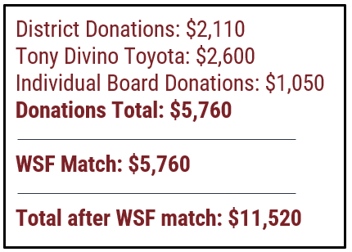
Ratification-Hogan Donation Match-We received a $10,000.00 donation from Hogan & Associates Construction for Teacher Hardship. The Executive Committee approved matching funds of $5,000.00 up to $10,000.00 if necessary. Jennie Taylor made the motion to approve these matching funds with a second from Jeremy Dunn. The committee unanimously approved. Thanks to Hogan & Associates Construction for providing this support!
CTJ Recap & Feedback- Emily reported that WE HAD A GREAT YEAR and went over the comparison numbers.

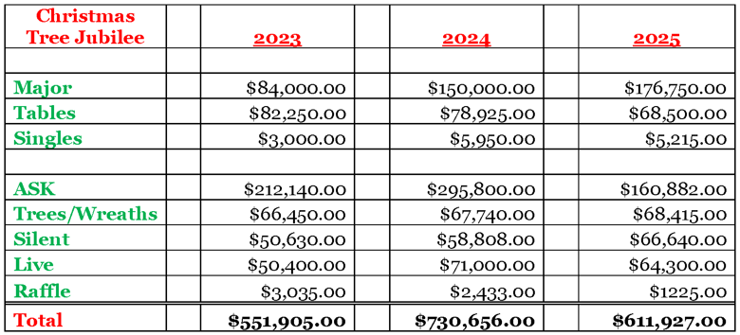
The trees were priced a little higher this year. Everyone loved the BEST OF LIVE ticket opportunity and we will continue to do that again next year. We chose to do 3 stockings this year full of gift cards and treats instead of the raffle. We are very excited with the amount that we earned in the ASK for Unified Sports!
CTJ FEEDBACK-Included at the end of the minutes
Other Business-None

*HYGIENE KIT SERVICE PROJECT-Foundation board members put together Hygiene Kits for the Teen Centers. This funding was from the Light the World Giving Machines.

Next Meeting
January 15, 2026

