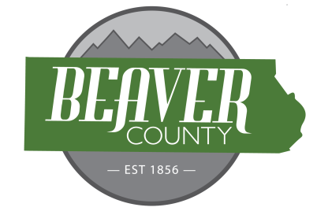
NOTICE AND AGENDA OF A PUBLIC MEETING
MARCH 17, 2026 PUBLIC MEETING OF THE
BOARD OF COUNTY COMMISSIONERS OF
BEAVER COUNTY, UTAH

PUBLIC NOTICE is hereby given that the Beaver County Commissioners of
Beaver County, Utah, will hold a regular Meeting on March 17, 2026 at the place
and time set forth below to consider the agenda item(s) hereinafter set forth.

MEETING PLACE: Beaver County Administration Building 105 East Center Street, Beaver, Utah.
MEETING TIME: 10:00 AM

10:00 AM
Open Meeting
Call to order
- Prayer offered by Matt Sterzer.
- Pledge of Allegiance led by Chloee Anderson
New Business
10:05: Approve Bills
10:10: Vehicle Registration Reimbursement Request
10:15: Economic Development Board Seat Vacancy Resolution No. 2026-04
10:25: Tax Refund Request
10:30: Fervo Energy Update
10:40: Warden and CWS Agreements
11:00: Utah Forge Update
11:15: Ratify Bout Time Construction Demolition Contract
11:30: General Plan Adoption Ordinance No. 2026-03
11:40: Consider Ordinance No.2026-04
11:50: Consider Ordinance No. 2026-05
12:00: Meeting Adjourned

Closed session for the purpose of discussing the character, professional competence, or physical or mental health of an individual; discuss strategy for pending or reasonably imminent litigation, real property negotiation.

(To be discussed when/as time permits)

- Discussion Item
  - Opioid Settlement Agreement
- Old Business
- Commission Updates

BEAVER COUNTY COMMISSION CHAIRMAN
Any other business properly brought before the Board.
Dated the 17 day of March, 2026

