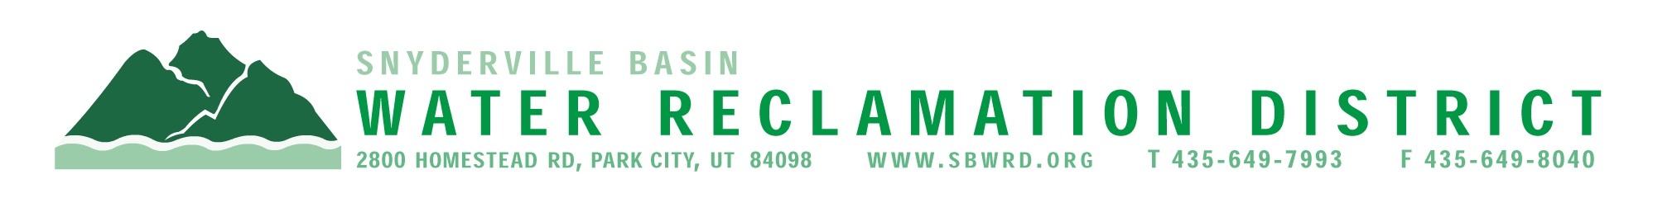
BOARD OF TRUSTEES MEETING

AGENDA

March 16, 2026
** District Office**
5:00 p.m.

** The meeting is open to the public and will also be
conducted electronically using Microsoft Teams**

** For information on how to connect to the meeting, please call 435.649.7993 or email
Dan Olson @ dolson@sbwrd.org by 4:30 p.m. on Monday, March 16, 2026**

I. CALL TO ORDER

II. CONSENT AGENDA – Approval of Board Meeting Minutes for February 23, 2026

III. PUBLIC INPUT

IV. APPROVAL OF EXPENDITURES – Bills in the Amount of $1,043.742.42

V. SUBDIVISION PROJECTS
Estimated LEA REs Year to Date: # Above Splitter 0; # ECWRF 3.33; # SCWRF 12; Total 15.33
Proposed this Meeting: # Above Splitter 0; # ECWRF 0; # SCWRF 0; Total 0

VI. DISTRICT MANAGER
- Discussion Items – Update on EC permit & Associated Study
- Information Items
- Financial Statement
- Impact Fee Report

VII. CLOSED SESSION – Discuss the character, professional competence or physical or mental health of an individual

VIII. FUTURE AGENDA ITEMS
- Projects
- Operations
- Finance
- Governmental Matters

IX. ADJOURN

If you are planning to attend this public meeting and, due to a disability, require reasonable accommodation in understanding, participating in or attending the meeting, please notify the District twenty-four or more hours in advance of the meeting, and we will try to provide whatever assistance may be required. Board members may appear telephonically.

