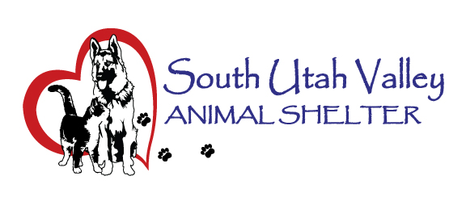
South Utah Valley Animal Special Service District
Board Meeting Minutes Tuesday January 20, 2026
South Utah Valley Animal Shelter Conference Room
582 W 3000 N Spanish Fork UT 84660
Board Member Attendance
Lt. Laursen* Chief Rod Hurst @RandiLyn Warner*
Chief Lance Haight Chief John Jackson @Dr Bott
Officer P. Christensen Scott Hall @Legal-not filled
Kari Malkovich* Kevin Oyler Shawn Carter
(*Absent / @ At large)
Brandy Mortensen (SUVAS Manager) Carrie Ward-Minutes
Members of the public present: Kate Hall with Best Friends, Elizabeth Meltzer and Megan Walker. (Scott Hall sat in for Chief Bishop) (Officer Phil Christensen sat in for Chief James)
The meeting was called to order by Chairman Hurst at 10:36 AM.
Work Session Items:
- There are no Work Session items.
Public Hearing Items:
- There are no public hearing items.
General Meeting Items:
- Public Comment. No public comments.
- Approval of Minutes of Board Meeting held on 11/18/2025. I move to approve the minutes of the Board Meeting held on November 11, 2025. 1st Chief Jackson, 2nd Dr Bott. Motion passed.
- Annual Audit Report from HBME. This report was given to the Board Members by Robb Wood via speaker phone. He reported on some highlights of the report. HBME made some adjustments but has made an Unmodified Opinion (the highest opinion). The summary of a 3-year comparison has shown a 3-5% increase of funds. The 2025 net was $846,914. The vehicle leases (#5 on page 23) were pointed out and Chief Hurst asked about the increasing amounts by $10,000. The discussion was that truck leases do increase over time. URS (#6) is being reported as a liability, but it isn’t actually being paid out. The Separation of Duties (#36) there were no deficiencies or weaknesses. (#38) Audit Compliance, there was no deficit balance; Fraud Risk there were no issues. HBME made some recommendations for Payroll Taxes to Kierstan. Chief Hurst asked if making the payments monthly instead of quarterly would be better. HBME did think that may fix the issue. Chief Hurst asked Brandy if the report could be sent to the Board Members, please. Kevin Oyler noticed that there is a $13,000 decrease in utility fees and asked where those savings were made. Carrie Ward suggested it may have been the access to irrigation water over the summer instead of having to use culinary water.
- Shelter Report by Brandy Mortensen. Our animal numbers this morning: 64 dogs in care and 11 in foster, and 50 cats in care with another 16 in foster. Kierstan wanted clarification for animals coming in from Spring Lake as they have voted to become a city. Utah County will continue covering them for now, as per Shawn Carter. The year-end animal stats were given by Carrie Ward.
- Other Business. Kevin Oyler went over some of the policy being considered about feral or community cats. He wants it clear that if a city adopts a TVNR program, it will be the city's responsibility (along with all costs) to run the program and will not be run through SUVAS. Chief Hurst suggested changing “city” to “member agency” and then defining what agency means. Kevin Oyler will present this to his city attorney for comments or changes. Clay Hall will be representing Mapleton on the SUVAS Board as Chief Jackson is retiring. Kierstan will email him the online link for the Board Member Test and online certification.
- The next Board Meeting will be held on March 10 at 10:30 AM.
- Motion to Adjourn. 1st Chief Jackson, 2nd Kevin Oyler. Motion passed.

