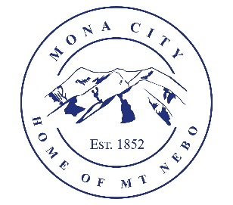
Mona City
435-623-4913
www.monautah.gov
20 West Center Street, Mona, Utah

Mona City Council Meeting Agenda
Tuesday, February 24, 2026
Mona City Building – 20 West Center
7:00 p.m.

- Pledge
- Prayer
- Approval of February 10, 2026, Work Session Minutes
- Approval of February 10, 2026, City Council Meeting Minutes
- Approval of February 12, 2026, City Council Vacancy Work Session
- Approval of February 18, 2026, CUP Water Work Session Minutes
- Action Items
  - Approval of Resolution 2026-4: Cooperative Agreement between Division of Forestry, Fire and State Lands, and Mona City
  - Approval of Ordinance 2026-5: Adoption of International Wildland-Urban Interface Code
- Miscellaneous Items
  - Seasonal Park Employee Position Posting
  - Water & Roads Worker Position Posting
  - Wendy Jo Jensen – CentraCom service project
- Shay Morrison – R6 Community Advisor
- Secretary
- Finance
  - Approval of Finances
- Recorder
- Gas & Water & Roads
- Sewer
- Council Reports
- Public Comment
- Adjournment

CERTIFICATE OF POSTING
This agenda is hereby properly advertised on this 23rd day of February, 2026, by posting copies in the following places: the Mona City Office, on the Mona City website at monautah.gov, at the United States Post Office Mona City Branch, and on the Utah Public Notice Website at www.utah.gov/pmn/index.html.

___________________________________
Alicia Hills, Mona City Recorder

Upon Request, in compliance with the Americans with Disabilities Act, reasonable accommodations for individuals with disabilities will be provided. For assistance, please call 435-623-4913.

