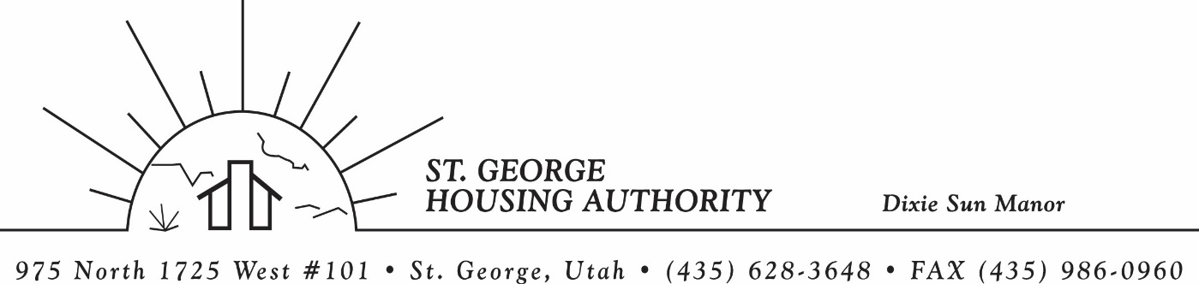
BOARD MEETING
DIXIE SUN MANOR 975 N. 1725 W. # 101
Tuesday February 10, 2026

PRESENT: Mike Barben, Greg Whitehead, Kenny Miller, Jane Fehrenbacher, Tom Cover, Daniel Baldwin, Gloria Shakespeare

EXCUSED: Steve kemp

MINUTES: Minutes of Board Meeting held January 13, 2025 were reviewed. Motion made by Tom Cover to approve minutes as reviewed, motion seconded by Kenny Miller. Motion carried.

Review Housing Assistance Report for February 2025: Mike Barben handed out the HAP reports for February 2026. Board members were able to see the money spent for the months on rental assistance, see the average unit cost, and verify the units leased for the month. The board was also able to ask questions and have a discussion about portability, C of C, VASH, EHV, & Mainstream Vouchers. Each board member present signed off on the HAP payments and month end totals.

Review current 2025-2026 budget: Mike Barben handed the board a copy of the fiscal year 2025-2026 SGHA budget. The board was able to see how the SGHA is doing in the current fiscal year budget. Mike reported that for the most part, SGHA was right on budget, and let the board ask questions on any of the items on the report. The board has asked Mike to provide and present the most recent budget accounts at each board meeting. By providing the current budget monthly, the board can see how the SGHA is keeping up with the current budget throughout the whole year. The board thought it would be great to ask questions and be on top of what the SGHA is doing financially. Greg Whitehead asked Mike if he could break the budget down into separate programs to verify which programs are doing well and which ones are needing help. Mike has now separated the budget into 3 programs so the board can better understand the flow of money in each program.

Report on DSM INSPIRE Inspection Report: Mike Barben informed the board that HUD did an inspection at Dixie Sun Manor and gave each member a report of the inspection. Mike reported that overall, the inspection went very well and DSM scored very high. However, the HUD inspector did find a default of GFI outlets in the kitchen on all 30 units. Mike reported that Don Kruse worked very closely with an electrician to get these GFI outlets installed in each unit. Mike reported that each unit is up to code with the GFI outlets and HUD has approved the fixes. Mike said DSM should not have another inspection for another 2 years.

Report on REAC Certification for SGHA: Mike handed each board member a copy of the REAC (Real Estate Assessment Center) Financial Assessment. Mike explained that this report for all the SGHA financials. Mike said he, Loucks & Schwartz, and FJ & Associates worked very closely with REAC to get this assessment done. Mike said SGHA passed as a high performing agency and is good for another year of financial assessments.

Board Chair Signatures for Financial Certification & Fraud Risk Assessment: Mike asked for board approval to have board chair sign off on 2025 Financial Certification and Fraud Risk Assessment forms. These forms are for HUD and HUD asks for Board approval on these documents. Kenny Miller made a motion for Board Chair Greg Whitehead to sign these documents. Greg Whitehead seconded the motion. Motion carried.

Utah NAHRO Conference April 21-22: Mike reported that Utah NAHRO conference will be held April 21-22. Mike invited all board members to attend if they would like. Board members are checking their schedules to see if they can attend. Mike said it is a great conference, and a great way to network and meet other housing authority board members and employees.

Jane Fehrenbacker report on DSM: Jane reported that the community is doing well, reported that DSM is a great place to live. Jane reported that all units are full. Reported on Dixie Sun Manor Valentines Pot luck.

Report and introduction of Steve Kemp from City of St. George: Unfortunately, Steve Kemp asked to be excused from this meeting. We will have him report next month.

Reports from Board Member & Housing Director: Mike reported that a tenant from DSM had been evicted, but the tenant has asked for a grievance hearing. Mike asked one of the board members to attend the hearing and Kenny Miller said he could do the hearing. The board had a great discussion on this tenant and why she was being evicted. Mike gave the board feed back that the tenant was affecting the peaceful enjoyment of many of the DSM residents. Mike is going to send over the grievance process and DSM admin plan to Daniel Baldwin of the City of St. George and the assistant attorney to Ryan Dooley. The board thought it would be a good idea to make sure we are doing everything according to our admin plan. Once Daniel looks over the plan, a hearing will be scheduled and a decision will be made on whether to keep the tenant at DSM or evict.

Request of a closed meeting to discuss litigation, security, property acquisition or sale, or the character and professional competence or physical or mental health of an individual: None

Motion made by Tom Cover to close the meeting. Gloria Shakespeare seconded the motion. Motion carried. Meeting adjourned at 10:00 a.m. Next board meeting will be Tuesday March 10, 2026 at 8:30 am.

