TO:

FROM:

DATE:

PETITION TO WITHDRAW PROPERTY FROM
WOLF CREEK INFRASTRUCTURE FINANCING DISTRICT No. 1
Withdrawal #I

WOLF CREEK INFRASTRUCTURE FINANCING DISTRICT No. 1, a Utah
infrastructure financing district

Richard H. Webb ("Webb"), an individual residing in Utah; and
Wolf Creek Water & Sewer Improvement District ("WCWSID"), a Utah improvement district (together, "Petitioners")
December ---4::2025

This Petition to Withdraw Property from Wolf Creek Infrastructure Financing District No. 1 (the "District") is submitted in accordance with Title 17B, Chapter 1, Section 504(1)(d), Utah Code Annotated 1953.

Petitioners hereby petition and consent to the withdrawal from the District of approximately 9.139 acres of property in Weber County, Utah, as more particularly described in EXHIBIT A (hereafter the "Property") and referred to separately as Weber Parcel Numbers 200040015 ("Osprey Parcel") and 220150089 ("Eagle Crest Parcel"). Petitioners acknowledge that the District may enact a resolution to withdraw the Property, subject to receipt of all signatures on this Petition.

The undersigned Petitioner WCWSID is designated a sponsor, and the contact sponsor, of this Petition.

In support of this Petition, each Petitioner affirmatively represents, acknowledges, and certifies the following matters for themselves and their respective Property:

- When fully executed, this Petition contains the signatures of 100% of the surface property owners of the Property;
- There are no registered voters residing in the Property;

- The correct mailing address for Petitioners is provided on the signature pages below;

- Webb is the title owner of the Osprey Parcel and WCWSID is the title owner of the Eagle Crest Parcel as of the date of this Petition, and Petitioners will not convey any interest in any part of the Property within sixty (60) days of the date of this Petition (unless following the recording of the withdrawal final local entity plat, in which case the conveyance is permitted);

WCIFD Petition for Withdrawal No. I 120425

- Petitioners petition and consent to the District's withdrawal of the Property that is particularly described in EXHIBIT A and generally shown in the map attached hereto as EXHIBITB;

- The Osprey Parcel so described is located within the approved Annexation Area of the District; and
- The Petitioners authorize the recording of a final local entity plat and notice of impending boundary action on the Property to confirm the withdrawal of the Property from the District.

Each individual who signs on behalf of a trust or entity represents that he or she has authority to do so and to petition for the withdrawal on behalf of the trust or entity, and further represents that there is no legal impediment to the trust or entity's signing this Petition.
This Petition may be signed electronically and executed in counterparts, all of which may be treated for all purposes as an original and shall constitute and be one and the same Petition.

IN WITNESS WHEREOF, Petitioners have executed this Petition effective as of the date indicated above.

(signature pages follow)

Withdrawal #J Petition
Wolf Cree Infrastructure Financing District No.I Page2

Made effective as of the date set forth below.

As to Parcel No. 200040015:
Richard H. Webb 3846 N. River Drive Eden, UT 84310-9707
�<
Date signed: _J_2,-_-_�_.,,._z._s_

Withdrawal #1 Petition
Wolf Creek Infrastructure Financing District

Made effective as of the date set forth below.
As to Parcel No. 220150089:

Wolf Creek Water & Sewer Improvement District

P.O. Box 658
Eden, UT 84310-0658
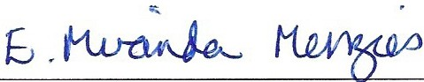
By: f,, ht-AAN-1>A �"t-te.5
Its: Chair, Board of Trustees Date signed: ta..]4 j�5

Attest:

�(�
��µ;✓

Its: Clerk/Secretary

Withdrawal #1 Petition
Wolf Creek Infrastructure Financing District No. l

EXHIBIT A
LEGAL DESCRIPTION OF THE WITHDRAWAL PROPERTY
The following properties located in Weber County, Utah:

PARCEL 200040015 BOUNDARY DESCRIPTION (OSPREY PARCEL)
PART OF THE NORTH HALF OF SECTION 4, TOWNSHIP 6 NORTH, RANGE 1 EAST OF THE SALT LAKE BASE AND MERIDIAN. BEGINNING AT A POINT ON THE SOUTHERLY LINE OF A PROPOSED ROAD BEING LOCATED SOUTH 89°30'26" EAST
314.55 FEET ALONG THE NORTH LINE OF THE NORTHEAST QUARTER OF SAID SECTION 4 AND SOUTH 00°00"00" EAST 681.37 FEET FROM THE NORTH QUARTER CORNER OF SAID SECTION 4; RUNNING THENCE SOUTH 26°54'3811 WEST 250.27 FEET; THENCE SOUTH 00°27'43" WEST 430.42 FEET; THENCE NORTH 89°32'17" WEST 414.34 FEET; THENCE NORTH 00°27'4311 EAST 334.06 FEET; THENCE NORTH 15°23'2011 WEST
410.29 FEET TO SAID SOUTHERLY RIGHT OF WAY LINE; THENCE ALONG SAID RIGHT OF WAY LINE THE FOLLOWING SIX (6) COURSES: (1) ALONG THE ARC OF A
175.00 FOOT RADIUS CURVE TO THE LEFT 173.92 FEET, HAVING A CENTRAL ANGLE OF 56°56'28", CHORD BEARS NORTH 45°21'30" EAST 166.85 FEET; (2) NORTH 16°53'16"
EAST 62.90 FEET; (3) SOUTH 73°06'4411 EAST 231.20 FEET; (4) ALONG THE ARC OF A
547.00 FOOT RADIUS CURVE TO THE RIGHT 295.57 FEET, HAVING A CENTRAL ANGLE OF 30°57'3411, CHORD BEARS SOUTH 57°37'5711 EAST 291.98 FEET; (5) SOUTH 42°09'10" EAST 5.76 FEET; (6) ALONG THE ARC OF A 503.00 FOOT RADIUS CURVE TO THE LEFT 40.76 FEET, HAVING A CENTRAL ANGLE OF04°38'35", CHORD BEARS SOUTH 44°28'28" EAST 40.75 FEET TO THE POINT OF BEGINNING. (CONTAINING 9.074 ACRES)
PARCEL 220150089 BOUNDARY DESCRIPTION (EAGLE CREST PARCEL)
THAT PORTION OF THE NORTHEAST QUARTER OF SECTION 21, TOWNSHIP 7 NORTH, RANGE 1 EAST, SALT LAKE BASE & MERIDIAN, LOCATED IN THE COUNTY OF WEBER, STATE OF UTAH, DESCRIBED AS FOLLOWS: COMMENCING AT THE NORTHEAST CORNER OF SAID SECTION 21, THENCE SOUTH 00°20'4711 WEST 2067.06 FEET ALONG THE EASTERLY LINE OF SAID SECTION 21, THENCE SOUTH 90°00'00" WEST 640.98 FEET TO THE POINT OF BEGINNING, THENCE SOUTH 54°32'0511 WEST
44.00 FEET, THENCE NORTH 35°27'55" WEST 64.00 FEET, THENCE NORTH 54°32'05"
EAST 44.00 FEET, THENCE SOUTH 35°27'55" EAST 64.00 FEET. (CONTAINING 2,816 SQUARE FEET.)
TOTAL: 9.139 ACRES

EXHIBITB
MAP OF WITHDRAWAL PROPERTY

[Insert map/plat or attach on following page]

WITHDRAWAL PROPERTY
WOLF CREEK INFRASTRUCTURE FINANCING DISTRICT NO. 1
OSPREY RANCH
LOCATED IN PARTS OF SECTIONS 33 AND 34,
TOWNSHIP 7 NORTH, RANGE 1 EAST, SALT LAKE BASE AND MERIDIAN, WEBER COUNTY, UTAH
OCTOBER 2024

BOUNDARY DESCRIPTION
A PNlT 0,. SECTION 33, NKJAPAAT Of'THIE«:ll/THWESTOUARTER OF &eCT10N3A.TCMtl$HP1HOll:TH, R!,HQE1 EAST,oP lME
SALTl.>J<lllASEANllMeRJ,W,,N.IIEOltNNQATAPOINTONTMENORTHUME(;#THE"'°"T�OONtrEROFSAIOMCTION U &EINOLOCATEOSOVT}l811·1ur EMT 1107.Nl'W N.ONOTHE:NORTHUt-lEOJISHO NORTl11-'.Et'rOOAATER l'ROMTHE
NORTI-Mt:STCORNEROFS,,06ECTION"3:AUHNOTHCQ!AI.ONO NtiOfl"THUHl!O#$.l>IONORTHWESTQw.RTE.ll:90VfW N'1!'0"EASTaJ1.20FEET;nENCE&OVTI117'W<IO"EA!IT20t.73FEET:rHENCE&OVTHl'"33"3rEMT10.�FEET;TMEHCE NOIITI-tWW�•EAST50l.'3�EET:n!ENCE80VfHC0'01'00"EA8TfOU,rEET:T�NCE80VTHW'2•'C"EMT131t1fFEET:
�50VTHOO"IT'l1"'t'\IEST 1»ueFEET; ™ENCEMOffTHtrlTDll"VEHr ,,1,...0FD!T: THENCESOUTH00-1,e,· Y,E5T
1l2525f1!.ET:TH£NCESOUTHOQ'11Vvot1..e.,,111FEET;TM£NCESOJtH�'l"EASl't?t,O.FEET:THEHCE90UTH OO'IS'$8"v.EST tlt.21FEET:THENCESl)t;t)(*'2T1r""'1s»OOFEET: ntENCE SOUTH00'111'!5"'{\£/ff ,cn.n ,m: ThlENCE
AI..C8lIBE AACOF Am.OCFOOT RADf.JSCUR\fE TOTHERIOHf 1$,02FEET WITH,\N MEA,W.AN0l£0f'02'&723"ANOA Q«)fl:08£AR�SOUfH71'1(1(frEASTte.P2FEET;THENCESOUTHW•l'20"EABf7.MFm:THENCEALONOT)EAR¢0FA 122.00FOOTRilDIUSCVfl.VETOnER!GHf111.11FEEf WfHHt IHTERNill. AHGI.EOf &&'4%11'"�A0-IOROIIEAAINOSOVl"H
- 1'1Ct1r'-"ST 114.00FW;T�ES0..lfk 1$'$0'00"Lf,.IT 122.toFHT; t�E�TIEARCOF A 110.1,FOOT ltA.OIUS cu,r.•&fOfHEWi H.:,$FEET WTHNtll.(TBUtAL AOOlEOF1&WXI'"ANO A CHORD bEMJNO80U'TM21'33"1M�EAST•7.2"'
11U11J1I
I
I
I
l
I

A,::,:�:r...
.2\ �

EDEN£STATE8 6UBOM�

�01'.MMITOOIIHO Htl,U.
���5=
-\�f:;rt-r
FEET;THENCE,ol,lfHl53'MIW�4'1.1.IFEEf:TIENCE80l.l™OOW'11'EAST10154Fffl:THEHCEIIOVTH4''00'WVEt'f 10041FW:nlOUHOATH�17'"\\E:ST'2eoe.4'FEET:THEHCENOR"TMOO"'On.f"EAS'Ttol ...0'1:Ef:THl:NCENOftTH4)'4.-U-WESf.tPHIFEET:TKt«�TH2''.tt,,-EASTn.UFE£T;THENCi90UTH�"�07U1F11:Ef:THENCINORTM OCl"11"40"EA.SUT 24.12FEET:THENCEl'Qfl'HM'41YY&.S"I1225.4' F'EEITOTH&EASTBCXMClAAVUttE Of'IIIQ 5'CY"ESTATI!S i!IUIOIVJaoN� I & NO � RUNNINOTH&HCEM.ONQ SAi)QUe()MSIONllNli TH&FOllO'MNO TEN(10)00Ufl:ISE9:(1) NORTll 13'11'10" EA.91"IKl84f'EET:(:2)SOUTl00'41'WEAST SOOOF£ET: (3)NORTHM'Ol'l!"WEST 1»..111FEEf:(4)NOAn-llM'Y-13" EMT2".12Fl:Ef,�NOfml00'11"23'EAsl2tlO.ll8f'EET:41')NORTH&7'41'1V-v.EST,22.SOf'EET:(7)NOltTH'.a'lno"UBrLWI.OO Fm, (I) NOAlH2,,1••1w� PS).19Fllilil:{Q)NOltlHOJ'11'20"E,\ST 4311.01FEET: {10,NORTH1111"41'31"-.vEST 450,H FEET: THE»O&:HORTM�•«r12'E>,STMU3fUT;TIENCE90VfHW41°4,-EMT33..f.:,SF£lfl:THENCENOftTH19'30'20"Eo\STMa:lO Fl:£fT01lftiPOINTOF8EOINNINO.
LU9N(fJ!XCePflNQTMEFOI.LO'MNQOYc:IIIBiEOPMCB.;
PAATOFTHEHOATMW.V0, sa:TIOM4, TOM,IMPtNORTH.AAMGE1 EASTOF THESN.TLAICE&A91ANOMEIOOWt.

. 0"1:"'2.13'·
""'"""'
-�·-,;: ,,,..,v

l;i·
IIEOlNNINCI AT APOINTOHTHlia0Ul'l-alY UNEOP APROPOSED IIOAQIIElNQ lOCATED IOUTH IO'X1'21"EAST 314.l!olFl B;T Al.ONOTHt:HOIITHLINEOF THENORTHEAST QIJMT(R OI'SAK>SECTION 4 AHO�CIO'OO'OCrEASTOllt.31FEETFROM THE � NOftTI-IOIJARTEltCO�Ol'SAIOSQ;l'IOff4;11\HffNO™EJCE801JTH28'5'1'39"YtUT'::&0.21fEET:ll-!91CE1901JTH00'2TU"
v.ot 430.42FEET,THENCEHOA1Ht8"3,l'I?"\.'.-Efl 414� fttT:flENCf:NORTHOO':ITO"fMT33-1,GefEET; Ttl&ICENORTH
15'23'20"l'IEST•1D.2tF'EET TOSW IIOUfHERI.YfllOHTOFWAYUNE; TI-iEHC£ Al.OHOMIDftlOHT OF WAYl1METHEFOI.LOYW;<)
�X� COOl'tSE8: 11)AI.ONQ TMEAACOI' A 176.0CI"°°T AAOIUl!ICUIVETOTH!:LEFT 1TU2fEET, HAVINO A CENTRAL ANO!.EOI' 5fl'18"21", CHORDBEARSNORTI-145':11'30"EMT111$.15$FUT; (l)NOftTH 1$'5Y1e"EMT 8:1.SOAET, (3,) $0UTM73-W«-fA!T
==�
�1.20fEtT;(4)Al.ONOTIENtCOl'A$4J.OJFOOTAA011)SCUR\fETOTI-IERIGKf205.51FEET,MAVINO.\C8mV,l.-'NOl.l!OF
30�7"34", CHORDBEARSSOUTM'1'lT&rEAST291.�FEET: (GI$0U1'H42W1D'EAST S.7SFE£T; Iii)Al.()HG TIE AACOfA II03.IJO fOOTAAOIU$QJRVETOTl-!EllEFT«).7$FEET.W.VINOACEHTRAL.\NOlEOF0.'3'"36',CHOR08EAASIOVTN44"29'll"EA8T
1H.:w�� Bm!IMNQ,(CCtfTNtllNO 9.014 ACR[.S)
ALSO, BEIDIHl<.ltt3 AT APOINTBBNGLOCATED NO!m400'2Z&rEAST 851,1$F£EfFROMnE SOUTHUBTQO,\RTEACOffNE.11OF SAIOSECllOtf)S;Rl,Nr-lOnENCENORTH00':13'QJ"i,t,$T012.11F"1:nENCe &OIJTHwoe'27"EAST1391.SOFEET: THENC€
I
�fH 3e'02'32'EAST 5flS.17fEl!TTOrl.eVIEST MIOHT-OF-WAV LINEOf'SR,158( JHEHCI! AL.ONO&AlO� RIQHT.QF.WAY UfE �
\I

•
-
«
I

::E
oO
ai
:x:

..i
en

OSPREY RANCH
fflEFQ.I.Cf',1NQTtlfl(Ec,)COORSE8:(1)00t/JH29'1311"YIEST195.e1Fm:(2)80Vl'H1e'CIIJ1S"'l'.Est:,SO.MF£ET:�OOUTH 18'09'1S"YESTIU&FE£1':llENCEMOflllt"'23't:lll"'NEST14USFE&T:THENCEiSOUTH13"n'W�I00.00FEET;THEICE
:::,
:wx:

SUBDIVISION

REMAINING PHASES 211,799ACRES
NORTMIS$'42'21"v.ESTS0.00FE"ET: ™ENCENORTl-4�:n,•�SO.OOFEliT; THENCENOftTM�'2721•� 150.IXIFEET: TMEMCEHORTMW42'21"YSTffl.OOFEET';T�SOVTH00'17'311' YllST70.00FEET; n-lENCEHORTHW◄721"YEST 2SO.II FEET:THEHC&NORTHD0'1t"WEAST5a'I.OOA=ET,TI-EHCE�lHW"27\"\MaST241.00faT;TIE'fCESOUTH01-,1'0rWEar
150.00FEET; Tl4lHCE$01.fl'M)4'45'$2''Mi:Sf 110.0JFEET; lHENCE�1M70"00""3" YEST 108.29 f'EETlO THEPOINT Of
9EOINNINO.COtflAIHIN031&13ACRES.
$ � f-0 w 0 z 0 u..
- <(

HN"V'Oll'W131Ull

I"

NARRATIVE
ftlE PVRFOl!IE� TKS !IUAVEY IS TO CREATC A INffVBTRUCTUf!.E F1NANCIHO OHJTRICT. TIE OOHmOl USE'O TO ESTA&USH THE OOUf.lOARV WA$THE E»STINO v.£8Eft COIMTY SURlr1aV
f2 � �
� ;: z �
s
ttJ �
r
0:: :x: (..) w

- I�
...,.,,.,.�,,. I \,. ---/j
MON\.IWM"ATK:fl AS l9tO.'>ff ANOMOTl!O HEREON. THE IIASISOf"EIEARINQ IS THE WEST UHE OF
SE'Cl'IOH 33, TOM,ISHIP7 NOfllH. AAHOE 1 EAST,Of lite s,,J.T LAKE�ANO ME1t!OI� CM IIEMSNOfl.fMOO'(D"U'EAS�T.8ERCOUHTY, llTHiNORTH NAO83 STATEP\.ANEOROSEAAINQ

SURVEYOR'S CERTIFICATE
I, IWHT H. V.1-fTNEY, 00 HEREB'V CERTIFY lHAfI Nd ALICENSED PROFESSIONAL V,t-,SURVEYOR
(..) (.!) w (.!)
u.. - en �
_J :x: z
� � 0
�-
0:: �
0
z (<.⁽.) 0
- z

Q-INl'TER 22�, ntli"ltOFDSIONM. &!01/CSIS ANOu.H0&ORWVOfl:$ ,r,(;T; I AJlffitER CiRTIFV
ill _J --

  - a:ze"1S'31'W11111UI'
-:,1eu1e-w 360.M"
IN'nESTATtOFIJl"AHJINOTifAT I HOU>C£Rl'IFICAT£NO. 42"272:2811-l AO(X)!U,NCEWTH 11Tl.E5fl
THAT 8Y IIUTMORlfY 0# THE 0',WERS I KAVE OOW'LET£0 A SURVEY OF TI-E PIICf"ERTV OES:CftlllEOON Tl-IS RECORO OF !IUR\/€1Pl.AlINN:;ODROAHCE V."1•1l!ECTION 17-'lS-lO AH:>HAVE VER�IED Al.L�S: TWIT THE R£FEA:ENCE �ME'NTS SHCl',W ONTI-IISRECOROOF 9I.AIIV£Y Pl.AT ARE LOCATED M IHD!CAtED Nl/0 ARE 9Uff!C'81T TO RcfltACE OR REESfASUSH THIS SJ�; AMO TliAT lMe IHf'OAMATIOH SHOWl'l HERBN 18 SUl'RCIENT TO AOCUIATaY ESTA8ll$HTIELATatAl.8ClUiDARl£.SOfTMEHEREIN CIE.3Cfl.t8EOTIV,CTOf� FIIOPel.lY.
i�9

"' 0
i

r
0..

:i:
en
�

8IONEOT�S o,,.,,
.., \'''''t�i;�•,,,,.i:

,,,,,,[� or ,.,......
0 f-

'>�
r
: : : �t J�f==\\
,,�i�
�JJl�,

'WEBER COUNTY SURVEYOR
IHEREBVC&lllFVn-lATTIIEY<El!ERCOUHT"I SURVE'YOA'SOf'FICEHASJI.E\'l�tMSPUT FORMATIIEMATICN.CORAl!CT""88,8SCTION
COfU.ERCATA.ANOFORHAAMOHYWITH I.JH£S AtE WlHUMENTSOH ltECCIROIHC(lUHTY
OFFICE$lHE�AL�THIIP...AT 8YTHE VE9BIODtJNfYSUl'l�OOESNOTRElJEVf': THEllC&ISEO I.ANO8UR"1:YOR W-IOEXEOJTeO
"fllSPLAT,�™EM'&POh'll!Bl.lflOO�
LI,.SIUTIE!IASSOCIATEOTHatEWTM.
IIIGNEOtMS_O.,,VOF m<.
"""���--.-=��- =.,,

'NEBER COUNTY CLERK
t, TlEWEIIERCOI..HTYCl.ERK.MTHE
APPRQWiONJTHOAITVF0FtTHSPUTBASED ONlMl!OE'INITIONSl:"TFO«THlN IJl"�CODE. 17-23-20(1)(,\), GSINOTHE Pli:RSONREOJIREOTO
&IBMITANOTICEOFI��
...cTONTO™ELT.GOVERHOR!JkOER
178--1·2DO(l)(�0V), HAVii:CERTlflEDTHI PETITION
FOi1'1-IISFINALL.OCALEHTITVPI.Al.
$\GNEOTHIS_O...YOF ...

..C.
�

II...
,
LEGEND

-+•\liQDIOOU!ff'l'MONVr-EHTMNO"TEO
0 !:�oJl:�=t<'�OlllfQ

----11n-�n
COUNTY RECORDER a<n,,..,, Fi:EPAID
l'lt.EOFORNlORECO!'!OiO
Al-lie:::>o!l: CForno"-ltECOftOS,PAGE .R�
- - - - �OITPMen

EA!)EM[Nl

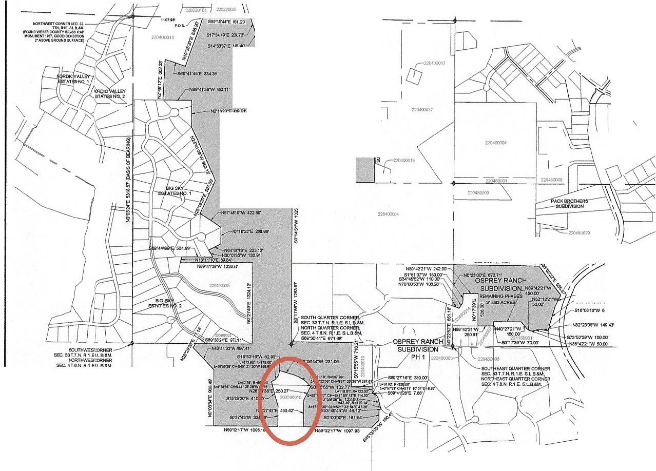

• -· _ \$00' - -•CTIONLM
P: "'"------

WOLF CREEK INFRASTRUCTURE FINANCING DISTRICT NO. 1
EAGLE CREST

PARTlOJUllli..Y OESCRIBEO M FOLLOWS:

BOUNDARY DESCRIPTION
IUJ

WITHDRAWAL PROPERTY
LOCATED IN THE NORTHEAST QUARTER OF SECTION 21, TOWNSHIP 7 NORTH, RANGE 1 EAST, SALT LAKE BASE ANDMERIDIAN,
WEBER COUNTY, UTAH OCTOBER 2024
A PAATOFTl-IENOll:THEAS'T 00AA1VtOFs«:TION 21, T� T NOjltTH, FU.NOE1 E>.Sf,SM.TI.N<:E &ASE&MEFIIOIAN, t.lOR£
IIIEQlhlNINQ AT A PCIHTCHTf/lEIJ()fffl,ISECTIONUNEOf !MIONORTHEASTQUARTER OF SECTION21, SAIDPOINf88NOlOCATEO HOffTH.-:ZT01•Y,£ST◄2◄.� FEET Al.ONG5,1,JONORlliSECTIOH UNIEF�THENORTHEASTCORNEl'IOF SAK)SECTION 21, RIJNHINO THENCE SOUTH2)'1VWEAST leQ,)11FW: TMe<:ESOVTH61'-4f"l7"iAST FE&'T',Tf1£NCE,ol,ITHll8'3210" EAST 0$.otra.T TO THEEl,Sr !IECllONUHEOF Uil0 NORTHEAST QUARTOSECTJOtf;THENCl!!i-'LONCISAIDEASTSEC110N UNESOUTHOO'Xl'◄TY.ur IM.<14FEETT0THliNOATH RlQHT.QF.WAVUNiOF F/>:.FrW,.YS ORIW;THENCli ALOHO SJ\10NORHUllOHT.QF,WAYLINli THlf FOU.O'NINO Sl)(.(l)CO.I.IUiH: (1) ,-,lQ«JTHENICCf'A 7to.COFOOT flAOIU8 CI.MVE TOTHEl8'1U.�FE£fWTH NI INTERNAL ANOI.E 0F�'32'30"
nuo
i
>l«J ,-,CHOfl(l8EARlNO90U1'1'4 w»t,e•v.EST 4.2• l'tET':(21At.ONOTfEAACOFA�.03 FOOT AA00.1$CURVETO Tl!eRlOKT201•3
Flll WTHNIINTEJINN..""'°Ll:OFSl"O:f31•MIOA.C>«)RO&eA.RlhO90IJTli73'•11'23"WEST1111.61 FEFI':C4SOIJTHllll'S1'00"'WESI'
:21M.8' FEET:(") ™ENCE Al.ONO Tl-IEAACOf ,-,�,CO ,o()TRADIOSCURVETO™'ELEFT )12,33FEE"!WT'HAN lh'TetNAI. 1,NOt.EOF WUW I.HOA CHOROBEARINGSOOTH�'21'50"WEST M4,00FW:(5)80UTH 2l"Ol!l'31"WE41'•14.10 FEET: (e) Al.ONOTHE!ARCOf'A 1510,00JrOOTIU,l)IU&CUfl�TOnc�T•z1n,rowTMl'NIHTl!IIIHAI.A.NOll!Ol'•7"23'1M"N«J ... CHOM09'M!l'IOIOUTHII0'48"0T WESf a.eeFEET:TH&fCl!HOlrrH 15"07'31"1'.ESI&3.13FEn: TI◄ENCE NORTM00"22'10"EA8'T1337 74 FEET TOSAIONOm'HaECTION IJNEOFTHE�EASTQUNftER OF SECTION21: TMEHCEM.ONQ $AJONOflTH RCTIONU+IE80UTHW21'01' EMT 1191 it FEETTO TWI!POINT OF 111:GINH�. COHTMi«NO 22.tOGACIIES..
I

/�OUAATUCCAtER
�21T7N=

BRIDGESHOLDINGCOMPANY LLC 220060044
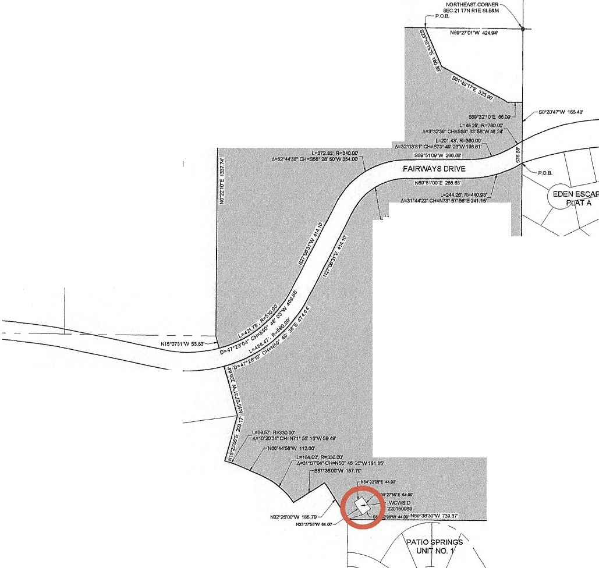
I
1-

BRIDGESHOLDING COMPANY LLC 220060014

BRIDGESHOLDINGCOMPANY LLC 220060045
"'°·
:�==�::SOOTIOH2t, 1�T�TH,RA.NOE1 EASl',&ULAKEIIME&MERlOIN-1,MOII:£
p
IIEOIN!l»KIAT APOINTONT� EAST sa;TIOtlUNEOF lWONOlmEASTOUAATEJIOFSECTION21, SAIOPOINT 8£lNOlOCATEO�H � �
00"20''1"IM:ST178Ill R:n Al.OHO 8'10EA.STeECTl0Nu FeROMTHE NORTHEAe,"CORNEROFSAIC118::TION21: RIJNNINO TWENCE
�

�.51'(BAS!SOfll!AAl-)l(I)

MATTHEW&KATHRYN WATSON 220150109

EAGLE CREST SUBDIVISION

22.325 ACRES

BRIDGES HOLDING COMPANY LLC
220170023
THENCE ,-,LONO $"10EMT SECTIONLINE80UTH00"20•1"� 1t!,I0$2fE!;TT0 TH'6NORTHtiOIIOIVISIONUNEOFP,_TlOSPRING$UNIT
�.1: THENCEN..Cf'IOS,tJONORTHStJ80M9IONlJNENOA'THWY/,U-y,Qf7)8,31 FEETTOTHENOl'IT'HIERLY 8UOCM90NUHE Of U.OLI 11:IOOE$1.JBQVl,oN� 4 &I;T>!BaAL.ONOSM> NOfl'THEll1Y ISV8ClM5'0HUNI!Tttl!,etl�NO $X1'ICOUR$�(1J HORTH 32"215'llO"Y,£ST1111,79 F'Eet;('1)� 157'35"01r'MoSI'1157,19 �EEi": '3) THENCEALONQ 1l4lliAA.COii ,_WCOFOOTRN)IUSCIJRVE TOM.Lm1... �,EETWTHANINTEltNAL. N,!OtE�)1-01'0,r' «>A.CHORO 8EAA\HO NORTH!50',tf'Z"�1eu1eFEET; I">NORTH
•
W4fe.r"Vo/ESI'112.00FEET:�Al.ONGTHEARCOFA:W.OOFOOHtA.OIUSCURVETOTI-ElEFT5ll.61FEETW™AN INTERNAL A.NO!.EOf' 10"20'W'ANO,_CI-IO!'tOBEAAltlO NOATH71"6'18' '.ES'T,41.4FEET: fO)NOflTH1�.,,-()6•EMT2'»,17FUT:�HORll115"07'1'
WEST 220.&IFEETTOTH£SOllTHAJOHT.Qf,WAY lmliOFFAl!MIAYSORIVE;THEHCEALOHQSA,j0SCM.lfHAJ3HTCF.WAY UN6 TlE
FOlLOWNQ flVE(15)OOORSES:Ill ALOH3THE MCCFA 5'0.00 FOOT RADtl)9 CURVE TOT HE LEFf 4M.,r FEST'MTHAHIHTliRNAl
m
.w:IU:01' ,Me"10'ANO... CHORO�MGNORTW SO'�liASl' 66FUT:(2)NORTH27"0n1"EAST ,1uo,m: 13A)\.ONO THE ARCOIA:2eO.OOFOOTRA.01\ISC(JRV&:2115l72FE£1'WlHAHINTERNAI.AHQI.RCf'tl'.._.'3rAAOAafOftOIIEAAltf:J�6&'28'SO"E"5T 210.7I fEET:(4)NORTHWS1'0i" EAST25U&fEET; (5)Al.OHO TH6 AAC OF ,_ •..O-� FOOTANllU$CURVE TO THEl.E1'T244 :.'OFEET WTH Nf INTl:ltNALA.HOLEC,31•44'27' N-10A CHOfU>SEA.RINOHORTH73'\STe,r"IEAST241,UI Fm TO THE POINT 01'IIECINNIHQ.
LU8 A.'IOE)(CEPJINO Tl-IEFOUOV,,NO OE$CRl68) PMCEI.:
THAT POfl'TIOHOf'THENORTHEAST OUAATEROf'IECTION21, TOl',NSHI>7�TM.RANOK I EAST, BAI.Tl.AKE1"511&lll£RIOIA.M, LOCATEO�TMECOVNTYOf'll,QIER,ST,-,TEOFUTNt.OUClt!8EDMFOUO',W;COMMENONOATTH6NORTHEASTCORN£ROf'&\IO l&CTIOH21, THENCE 80Ul'HfXnf/41"Y,ESf 20S7.oe� M.OHOTHI!EASTERt.Y UHE OF SAIOSECTIOH'l1,THEHCll 90UlHto'OO'W'
Vl£Sf IMO.lllfEET lOtkEPDINl OF IIEOltfiMG, THENCE 9DUTH 154'32'0!l"VIE$T '4.00 FE£T.THENCENORTH�'?7'WWE!ST 6'.00 FEET, THEl-aNOftTit54"32'05'EASUT .00 FEET, THENCEIOUl'H!6"17'!15° EAST&I.COFm. (CONTAININO 2,115SCVAAEFEET.) CONTAINIMG",831)1,,CRU,

NARRATIVE
THE PVf!POSE Of nD SUl'IVEY IS TD CREATE,_ INFAASTRur;nJRE FIHNCNO Cl.STRICT. THE

Cl
!!:
"

� 1111i1

,::; :a'.
0 z ,o0 :i
.=:: _j
frl
(/) ewn
� �u.
cw:: 0
i:::, �t5

,.->2M.72';R"280.00'
CONTROi. U$EO TO EiSlAIIUSH THE OOUICARY WM THE EXISTWO l',£8eR COIMrY &JR\IE'I' MOHLIMENTATIOH11B !IHOY,toN-10NOTEOHEAEOtlTHEBASISOF &EARING!S THe:NORTH UNE OF SECTION 21, T�PtNOR'll4, Al.NOE 1 EAST,Of'THESALT LAl<Ea.t.GI!! At«>MEIIIOIAN\l'MICM BEARSNOATH8''27'01"V.CST,WEBER COYHT'I', Ul'AHNORTHNAO13 ST,_TePlANEGRIDBEMING.
w0 �
I- w
w
!
c::
( ) (.!)
it!5: .

�-el'U'3,$"CH-NWne.o-e21'0.?1'

SURVEYOR'S CERTIFICATE
!, Kl.Jiff H. VMTNE'Y, 00 HEA:U'I'CERTIFY TW>f I AM A UCENSEO PMOFESSK>NAI.l.>H>SOl'IVEYOA IN THESTATE OF UT.oJ-l�TWIT I HOLOCERTIFICATENO. tl22'7:rnltNACCOftDNICIWTHTTTLEN, CHAPTER 22.Of '01& �E$$10NAI.ENOlNEER$ AN) UNO 8l/A\IEYORS ACT: I FUftTHER CERTIFY
(.)

�

c:: :i::

0z ^{I}c⁻::
w 0
z
:i::

Tl4.T 8'I' ALITHOll:ffY OF THE ov.NEl'IS I HAVE COMPL&TED A� Cf THIEi PROPEATY OUCR!BEOOH TWIS AEO:),q00F SUltVE'YPl.ATIN ACCOl!OANCI!WTH SECTION17-23-XIH«J MAW;
\16'.�Al.I. MEASI.M:MENTS; THAT THE REKRENCE IIIONUMEHl'S 5ttOWN ON THISRB:X)!IQ OF SVR\IEY Pl.AT ARE LOCA.TEO M INQIC,ATEO ANO ARE SUFFIQENT TO RE'TRI.CE OR 11£ESTA8U$H THIS !IURVE'I': >HJ THAT TIE IHFCRMATION SHO'M-1 He:RElN IS 91.JFACIOO" TO ACCURATB.Y
ESTAalSHT'MElATERAl80UND,IJIIE$0F TH&HERElN OE.9Cltl8E0 TNCT OfREAi,.PROPEATV.

&IOHEOTHIS om,e ...
I- ,._
� 9:
Cl :I:
� (/)
<( �
(.) 0

EAGLERIDGE EDENLLC 220150104
EAGLE CREST SUBDIVISION
3M30ACRES
I
.�t.::,§ ;
��
/g

�

WEBER COUNTY SURVEYOR
t HERESYCERTIFY THA.7Tl£¥<ESER COt.tm'
$1JRVEYOll'SOf'JICE�RE\11:'t'.EOTHSFV,T FOIiMAntEW.TlCAI. CORMCTHESS, SECTION OOA;NOI:0,1,T'A,N'IOFORHARMOH'VWTHUNCS AAOMONLM:NTSOHRECORD fl C0UNrY OFFICES.THEN>PAOVA.1.0l'THiSPlAJIYTIE
\l,£8ERCOUNTY�ROOESNOTl'll!J.IEVE
TJ4E LICCNSEOI.ANO� WHOEXEclJTED TI-ISf\ATFROM THERESPONSIOUTICIANOl'OR i.lA8HJ1'1E$ ASSOQATEO TI-ERFi'WT>I.
SIGHEOTHIB PAYO#' >O><

Vo/EBER COUNTY CLERK
I, THE VE BER �Ya.ER!(,MTHE olPMO'IINCAU1'�FOAT'Ml$Pl.AT&t.$EO ONTI-£DEANITIOHSET �lH INl/fAHCODE 17-2S-20!.I)(�, 8EIHQTME�90t,IRECUIEOTO
9JBMn'A.NOTICEOf'IMPENOINO 800ttlM'Y
ACTIONTO THE LT. 00\11:RNOR Ll"UA:
17B-1•ZJ11(3)(1!){1\I), HAW:CERTIREDTHEl'ETIT!ON FOR MS FlNALI.OCAL 8fflTV Pl.AT,

SIQIEOTfllS_OAYOI ''"
0 I-
-'

EAGLERIDGE
PHASES 4&5

�
,wCIJ..,

LEGEND
+ -��TASl«)Jf.0 WTl<'ll.�A»IOCNI 1,1,AA!(ll)GA.11.0HOOIGINilllMl
0

- - - - INTstlOlll"IJICn
----Jr0.l,l,C£NJ"AII.CS.
-SECTIONUIIE

COUNTY RECORDER
em,v,., FEEPAIO Fll.mFORANORE(X)R()Et)
I
"1 �w.lllOOK OFOfflCIAI. REOORO:!PI, AGe_. Rl!COII.OEO


---------� IP➔

