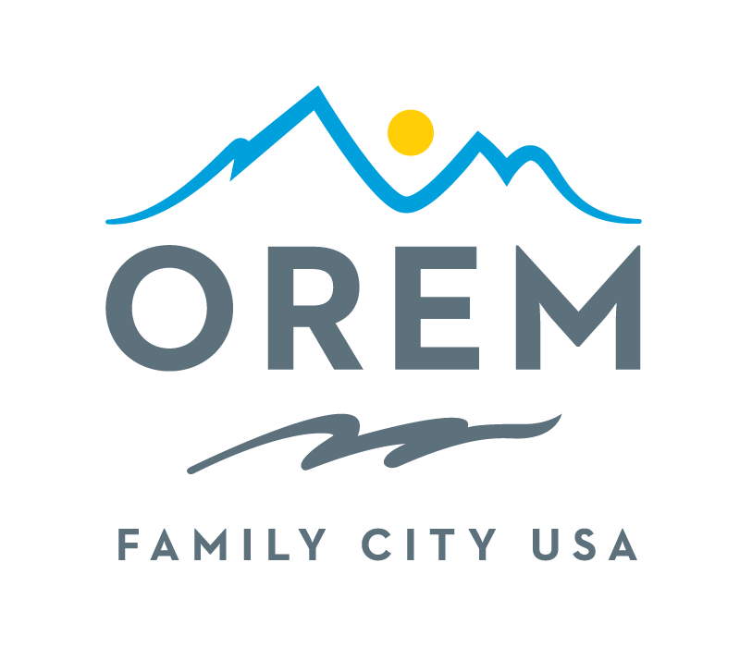
CITY OF OREM
ADVISORY BOARD/COMMISSION
MEETING AGENDA
meeting may be held electronically to allow a board/commission member to participate.
PUBLIC BODY: Events Advisory Commission
DATE: Thursday, March 12, 2026 ROOM: City Council Conference Room #1002
(Right next to the City Council Chambers)
TIME: 4:00 p.m. - 5:30 p.m. ADDRESS: 56 North State Street, Orem, Utah

AGENDA ITEMS:

Welcome Ashley Shumway
- Introduction of the new Events Commission Member
Review and Approve Minutes from February 12, 2026 Ashley Shumway

City Updates
- Grand Marshal Acceptance Kenice Whitaker
- Oremfest Applications Update Sydney Bailey

Commission Updates Ashley Shumway
- Boutiques Kami Burgess
- Car Show Rodney Gardner

Discussion Items
- Spirit of Orem Nominations and Selection Ashley Shumway

Review Action Commitments Ashley Shumway

Next Meetings – Thursday, April 16, 2026 (moved due to Spring Break) Ashley Shumway

Adjournment Ashley Shumway

Directly after this meeting, the sub-committees will meet.

Subcommittee Meetings
- Children’s Crafts
- Orchard Jam

THE PUBLIC IS INVITED TO PARTICIPATE IN ALL CITY MEETINGS.

If you need special accommodation to participate in Advisory Commission meetings
Please contact us on the City's website at orem.org or call (801) 229-7000 at least three working days.
prior to the meeting. This agenda is available on the Utah Public Notice website at utah.gov/pmn.

