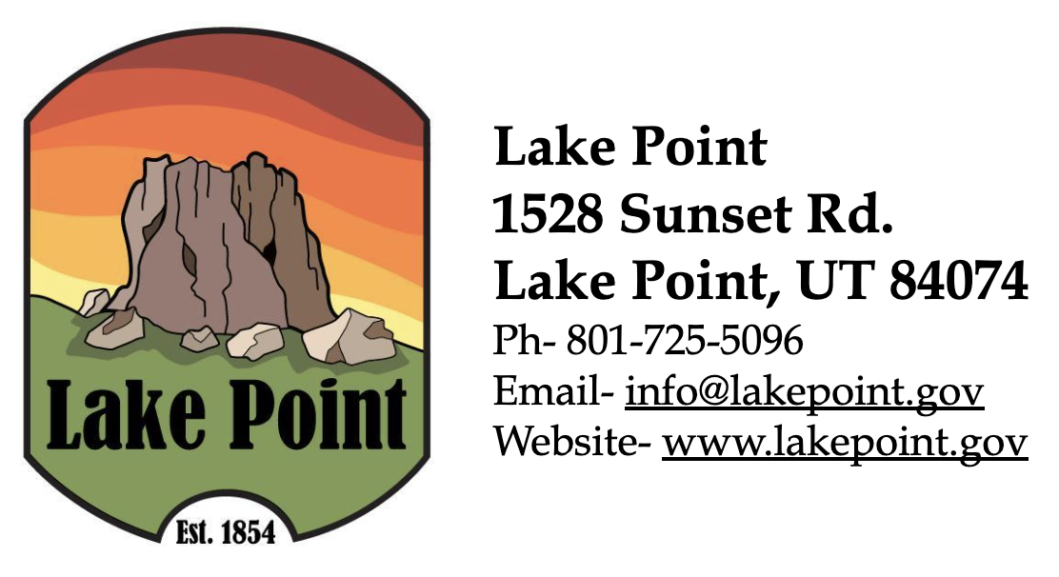

PUBLIC NOTICE
FY25 AUDIT REPORT

The public is hereby given notice that the annual audit of the city of Lake Point's financial statements for the fiscal year ending June 30, 2025, has been completed and is available for inspection at the office of the City Recorder by appointment (Jamie Olson, Lake Point City Recorder) 801-725-5096, 1528 Sunset Road, Lake Point, Utah 84074. The audit report can also be viewed by visiting the Utah Public Notice Website or visiting the city website at https://lakepoint.gov/city-recorder/

March 2, 2026

Jamie Olson
Lake Point City Recorder
info@lakepoint.gov
jamie.olson@lakepoint.gov
801-725-5096

