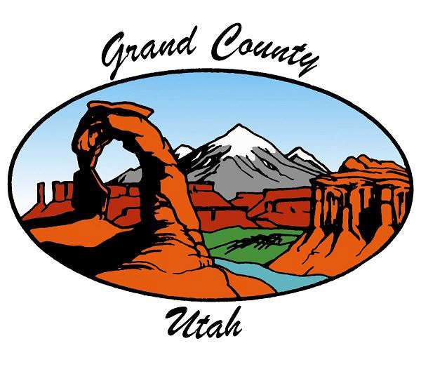
PUBLIC NOTICE IS HEREBY GIVEN THAT THE Grand County Commission WILL
MEET FOR A Regular Meeting IN THE
Grand County Commission Chambers 125 East Center Street, Moab, Utah
March 3, 2026 - 4:00 PM
Times in this agenda are approximate. Commission meetings allow for both in-person and virtual attendance. Remote participation is through Zoom, and meetings can be viewed live on YouTube. To call into the meeting dial: (669) 900 – 6833 Use Meeting ID: 851 7082 0571 #Password (if needed): 214317. To unmute press *6.
Zoom Meeting
YouTube (please note that we do not take public comments on YouTube, due to the delay in the video feed.)
To make a public comment, please do so in person or go through the Zoom link.

Zoom And Youtube Meeting Information

Times in this agenda are approximate. Commission meetings allow for both in-person or virtual attendance. Remote participation is through Zoom and meetings can be viewed live on YouTube. To call the meeting dial: (669) 900 – 6833 Use Meeting ID: 851 7082 0571 #Password (if needed): 214317. To unmute press *6. Zoom Meeting YouTube (please note that we do not take public comments on YouTube, due to the delay in the video feed.) To make a public comment please do so in person or go through the Zoom link.

Remote Participation Is Through Zoom And Meetings Can Be Viewed Live On Youtube. To Call In To The Meeting Dial: (669) 900 – 6833 Use Meeting ID: 851 7082 0571 # Password (If Needed):
214317. To Unmute Press *6.
Grand County Utah Government Live On Youtube
Join The Zoom Meeting

Board Of Equalization - Special Meeting 3:45 PM - See Separate Agenda

Call To Order - At Approximately 4:00 PM

Pledge Of Allegiance

Citizens To Be Heard At Approximately 4:00 PM And 6:00 PM

Times are approximate. The 6:00 PM Citizens to be Heard may not occur if the regular business of the commission is completed before 6:00 PM. Written comments can always be submitted through the county website or by emailing commission@grandcountyutah.gov We are receiving public comments by phone and online through Zoom. Dial: (669) 900 - 6833 Meeting ID: 851 7082 0571 Password: 214317
Link: https://us02web.zoom.us/j/85170820571?pwd=M24yQjRIdElCejUxTUlFeXFoZHNQQT09 When joining the meeting, you will be placed in a waiting room and be added to the meeting by the moderator. Your comments will be recorded and on YouTube. (Unmute for public comment: *6)

Workshop

1. | Colorado River Updates

Marc Stilson, P.E. Utah's Colorado River Authority

Presentations (15 Min)

2. | Nuclear Energy Education And Community Outreach Campaign

Patrick Lee, Envoy Public Labs

General Business - Action Items - Discussion And Consideration Of Approval

3. | ​Commission Member Disclosures And Future Considerations

4. | Approval Of Consent Agenda Items

a. | Approval Of Meeting Minutes For February 17, 2026

b. | Ratification Of Payment Of Bills

c. | Ratification Of 24/7 Sobriety Agreement Between Grand County Sheriff And Utah Dept. Of Publc Safety

d. | Ratification Of Letter Of Support For BLM Grant Application OHVR

e. | Ratification Of Statement Of Responsibility UORG Grant For Archery Range At OSTA

f. | Ratification Of A Funding Commitment Letter For The Holyoak Lane TAP Project

g. | Letter Of Support For The Museum Of Moab And The Museums Of America Grant Application

h. | Letter Of Intent To Convert Legacy Sovereign Lands Easements To General Permits For The Colorado River Bike Path

i. | Non- Motorized Recreational Trail Program Grant Application And Commission Letter Of Support

j. | Motorized Recreational Trail Program Grant Application And Commission Letter Of Support - POSTPONED

k. | ​Moab Office Of Tourism Local Creators Video Program

Alison Harford, Moab Office of Tourism

5. | Resolution Extending The Deadline To File A Final Plat For Kane Creek Preservation & Development

Andrew Jackson, Planning and Zoning Director

6. | Position Backfill Requests - GCSO (SAR) And Library

Tess Barger, Personnel Services Director

7. | Resolution Amending Employee Handbook - POSTPONED

Tess Barger, Personnel Services Director, Stephen Stocks, Grand County Attorney

8. | Resolution South Valley Subdivision Final Plat 4747 South Spanish Valley Drive (Bates)

Andrew Jackson, Planning and Zoning Director

9. | Resolution Edge Of Sage Minor Subdivision Final Plat, 2666 Desert Road.

Andrew Jackson, Planning and Zoning Director

10. | Resolution For Lot 30 - A Minor Subdivision Final Plat, Located At 2191 Roberts Lane.

Andrew Jackson, Planning and Zoning Director

11. | Ordinance Consolidated Fee Schedule Amendments

Mark Tyner, Commission Coordinator

12. | Community Information And Outreach Program

Commissioner Martinez

13. | Archery Range UROG Grant Match - Old Spanish Trail Arena

Commissioner Hedin, Angela Book, Old Spanish Trail Arena

Discussion Items

General Reports - Time Permitting - Available Online

• | General Commission Reports And Future Considerations

• | Elected Official Reports

• | Commission Administrator Report

Closed Session(S) (If Necessary)

Adjourn

NOTICE OF SPECIAL ACCOMMODATION DURING PUBLIC MEETINGS. In compliance with the Americans with Disabilities Act, individuals with special needs requests wishing to attend Grand County Commission meetings/hearings and other Grand County Boards, Commissions, or Committees are encouraged to contact the County two (2) business days in advance of these events. Specific accommodations necessary to allow participation of disabled persons will be provided to the maximum extent possible. T.D.D. (Telecommunication Device for the Deaf) calls can be answered at:(435) 259-1346. Individuals with speech and/or hearing impairments may also call the Relay Utah by dialing 711. Spanish Relay Utah: 1 (888) 346-3162
It is hereby the policy of Grand County that elected and appointed representatives, staff and members of the Grand County Commission meetings/hearings and other Grand County Boards, Commissions, or Committees may participate in meetings through electronic means. Any form of telecommunication may be used, as long as it allows for real time interaction in the way of discussions,questions and answers, and voting.
At the Grand County Commission meetings/hearings and other Grand County Boards, Commissions, or Committees any citizen, property owner, or public official may be heard on any agenda subject. The number of persons heard and the time allowed for each individual maybe limited at the sole discretion of the Chair. On matters set for public hearings there is a three-minute time limit per person to allow maximum public participation. Upon being recognized by the Chair, please advance to the microphone, state your full name and address, whom you represent, and the subject matter. No person shall interrupt legislative proceedings.
Requests for inclusion on an agenda and supporting documentation must be received by 5:00 PM on the Tuesday prior to a regular Commission Meeting and forty-eight (48) hours prior to any Special Commission Meeting. Information relative to these meetings/hearings may be obtained at the GrandCounty Commission’s Office,125 East Center Street, Moab, Utah; (435)259-1346.

