13.11 | Multiple-Use (MU) Zone
13.11.1 | Purpose
1 | The purpose of the Multi-Use zone (MU zone) is to implement a coordinated, flexible zoning framework that supports limited, sustainable commercial growth and modest housing opportunities in Lake Point while preserving open space and the community’s rural character.
2 | Consistent with the Lake Point General Plan, the MU zone promotes attractive and practical combinations of residential and small-scale commercial uses—both horizontally and vertically—such as live-work buildings with optional ground-floor businesses, to foster entrepreneurship, walkability, and vibrant community spaces.
3 | The MU zone is intended to facilitate the orderly and intentional expansion of commercial activity from existing centers, ensure access to collector streets, require concurrent development of commercial and residential components, and reduce land-use conflicts by ensuring compatibility between uses, thereby supporting local businesses, community facilities, and a balanced, cohesive development pattern.
4 | Consistent with the Lake Point General Plan, development within the MU Zone shall incorporate commercial uses as an integral component of the project and is intended to avoid developments that function primarily as high-density residential.
13.11.2 | Applicability; Relationship to Other Regulations
1 | This Chapter applies to all development, redevelopment, and phased development within the MU zone.
2 | The requirements in this Section are minimum requirements. Where other provisions of Chapter 13 (Land Uses) and/or Chapter 14 (Design and Construction Standards) impose additional requirements applicable to a development, those requirements apply in addition to this Section.
13.11.3 | Permitted and Prohibited Uses
1 | Permitted and prohibited uses in the MU zone shall be as provided in Section 13.5.1 (Commercial and Industrial Zoning District Standards), as amended. Uses not expressly permitted are prohibited.
13.11.4 | Rezoning/Annexation into MU Zone
1 | Property proposed for rezoning or annexation into the MU zone shall contain at least fifteen (15) contiguous acres in common ownership at the time of application.
2 | A Development Agreement shall accompany any applications for property proposed for rezoning or annexation into the MU zone. The Development Agreement shall include a Development Master Plan (reference 13.11.5).
13.11.5 | Plans Required for Multiple-Use (MU) Developments
1 | Development Agreement: A detailed, regulatory plan submitted for approval that establishes the specific layout, density, mix of uses, and development standards for a multiple-use (MU) development or a defined phase thereof. The Development Agreement shall include a Development Master Plan.  Per Chapter 12.2.2, “A written agreement or amendment to a written agreement between the City and one (1) or more parties that regulates or controls the use or development of a specific area of land. The development agreement does not include an improvement completion assurance.”
1.1 | A Development Agreement shall identify permitted commercial and residential uses, building footprints or development areas, maximum gross floor area, height and massing parameters, access and circulation, parking strategy (including shared or phased parking), open space allocation, buffering and compatibility measures, and phasing and concurrency requirements, including the requirement that commercial components be constructed concurrently with residential components unless otherwise approved. Approval of a Development Agreement shall establish binding development standards for the subject property but shall not authorize construction absent approval of a Site Plan.
2 | Master Plan: A planning document that establishes the overall vision, framework, and guiding principles for the development of land within the multiple-use (MU) zone or a designated portion thereof. A Master Plan is intended to demonstrate general consistency with the Lake Point General Plan and to guide the preparation of subsequent Site Plan(s). A Master Plan is an Exhibit of the Development Agreement.
2.1 | A Master Plan may include, but is not limited to, conceptual land-use diagrams, general location and relationship of commercial and residential uses, anticipated densities and intensities, circulation and access concepts, open space and community gathering areas, design character themes, and an overall phasing strategy. A Master Plan shall be illustrative in nature and shall not authorize construction, confer vested development rights, or substitute for required Development Plan or Site Plan approvals.
3 | Site Plan: A detailed, parcel- or building-specific plan that illustrates the precise design and physical development of a site in accordance with an approved Development Plan and applicable zoning, engineering, and design standards. A Site Plan shall provide sufficient detail to allow review for compliance and issuance of construction-related permits.
3.1 | Site plans shall comply with Chapter 13.9 and shall include, as applicable, exact building locations and dimensions, architectural elevations, parking layout and counts, landscaping and buffering, pedestrian and vehicular circulation, utilities, grading and drainage, lighting, and other site improvements. Site Plan approval shall authorize construction only for the development shown and shall not modify or supersede the approved Development Plan.
13.11.6 | Permit Sequencing
1 | Site plan approval is required prior to issuance of building permits. Building permit applications may be submitted concurrently with a site plan; however, no building permit shall be issued prior to site plan approval.
2 | To ensure timely construction of the commercial component, the applicant shall apply for commercial building permits prior to or concurrently with residential building permits in a manner that is proportional to the approved phasing plan and total project buildout.
3 | The City may withhold, suspend, or deny building permits for any building(s) within a development where the applicant fails to comply with this Chapter, an approved site plan, an approved multiple-use master plan, conditions of approval, or a development agreement.
13.11.7 | Use and Space Thresholds
1 | This Section establishes minimum commercial thresholds for MU developments. Compliance may be achieved through horizontal multiple-use, vertical/integrated multiple-use, or a combination.
2 | The City may approve deviations to these thresholds upon written findings that: the commercial component remains sufficient in size and configuration to serve the development and surrounding area; the project maintains a balanced multiple-use character; and the project does not function primarily as a residential subdivision.
13.11.7.1 | Horizontal Multiple-Use
1 | Where commercial and residential uses are located in separate buildings, commercial uses shall occupy land area at a minimum ratio of one (1) acre of commercial land area for every four (4) acres of residential land area within the development.
2 | Land area shall be based on net developable area and shall exclude public rights-of-way, perimeter setbacks, and required open space, unless otherwise approved by the City.
13.11.7.2 | Vertical Multiple-Use
1 | Where one or more buildings contain both commercial and residential uses, commercial uses shall comprise not less than twenty percent (20%) and not more than thirty percent (30%) of the total gross floor area of all buildings within the development.
13.11.7.2.1 | Dedicated Vertical Multiple-Use Units
1 | A dedicated multiple-use unit shall contain dedicated space that is solely residential and dedicated space that is solely commercial.
2 | These dedicated spaces may be owned or leased by separate entities or by a single entity, but they are fundamentally separate units which must each have their own dedicated access points, bathroom facilities, and utilities.
3 | In dedicated vertical multiple-use units, commercial floor area shall be located on the ground floor or in other street-oriented or publicly accessible locations unless the City determines an alternative configuration better meets the intent of the MU zone.
13.11.7.2.2 | Flexible Vertical Multiple-Use Units
1 | A flexible multiple-use unit shall contain a dedicated space that is solely residential and a flexible space which may be used for either commercial or residential purposes
2 | The flexible space may be sub-leased to a separate entity but is fundamentally part of the same unit which contains the dedicated residential space.
2.1 | Under no circumstances shall a flexible space be sub-leased to a separate entity for use as a dedicated residential space (multi-family residential unit).
3 | The flexible space shall count toward the required commercial floor area within a development only when the space has a dedicated access point, dedicated bathroom facilities, and a lockable door separating it from the dedicated residential space.
4 | The flexible space shall be designed and constructed to reasonably accommodate conversion among permitted commercial and residential uses without structural modification.
5 | The flexible space shall be located on the ground floor unless the City determines an alternative configuration better meets the intent of the MU zone.
6 | The flexible space shall comply with applicable commercial parking, fire, and building code requirements in effect at the time of conversion.
13.11.8 | Phasing; Requirement for Commercial Construction
1 | Commercial uses shall be constructed concurrently with or prior to residential development unless otherwise approved through a development agreement.
2 | A parcel or lot may not rely on commercial uses located on other parcels or lots unless such parcels or lots are part of a unified multi-lot development agreement.
13.11.9 | Residential Transition Areas
1 | A development in an MU zone adjacent to existing single-family residential zones shall be designed to reduce conflicts related to scale, noise, lighting, and service impacts.
1.1 | In the MU zone, the building(s) nearest the residential zone property line shall be residential in use; or where non-residential buildings are located nearest the residential zone property line, the development shall provide:
1.1.1 | A ten-foot (10') landscaped buffer;
1.1.2 | An eight-foot (8') sight-obscuring and noise-dampening masonry fence;
1.1.3 | A maximum building height of thirty-five (35) feet, measured from finished grade, for the first row of buildings directly adjacent to the residential zone property line;
1.1.4 | Loading zones, loading docks, and noise/vibration producing utilities shall be set back at least fifty (50) feet from the nearest residential property line;
1.1.5 | Rooftop mechanical and antenna equipment shall be screened; and
1.1.6 | Noise, vibration, smoke, dust, odor, glare, and similar impacts shall not be discernible beyond the premises except for normal traffic movements.
13.11.10 | Density
1 | Residential density in the MU zone shall not exceed ten (10) dwelling units (DU) per acre within areas designated for residential use on the master plan, unless otherwise approved through a development agreement.
2 | The guidelines in Table 1 and the example in Figure 1 should be used as a guidance to ensure a density pattern that provides appropriate transitions adjacent to existing residential zoning districts.
 | Table 1:
 | DU / Acre | Location | Rationale
1 | 1-3 | Low-Density (e.g. single-family homes) | Appropriate for areas bordering existing dedicated residential zoning in order to maintain open space and rural character of abutting area(s).
2 | 4-6 | Mid-Density (e.g. townhomes / condos) | Appropriate for areas in the center of the multiple-use development, providing a buffer between the Low-Density multiple-use and the Higher-Density multiple-use areas. Dense enough to support small-scale retail and local services without introducing urban scale.
3 | 7-12 | Mid-Density (e.g. mixed-use) | Appropriate for limited areas near major intersections, collector roads, or civic anchors. Located furthest away from residential zones.

Figure 1:
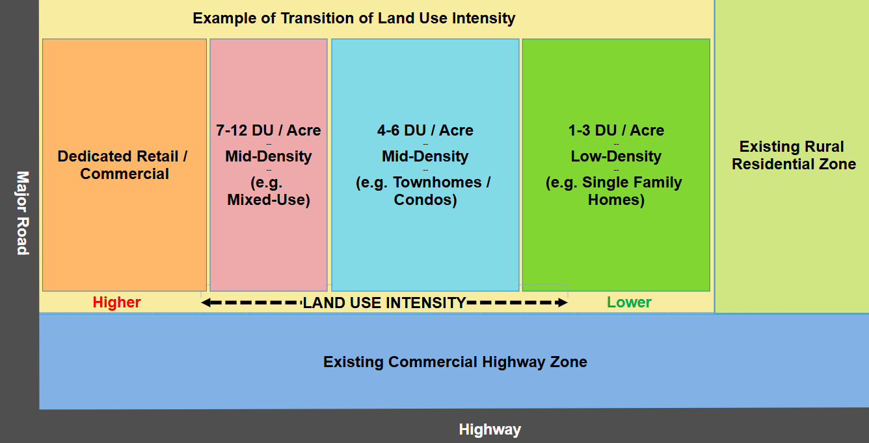
The figures below show conceptual examples of a multiple-use development in a rural town:
Figure 2:
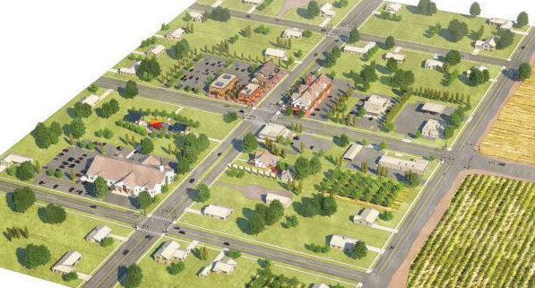
Figure 3:
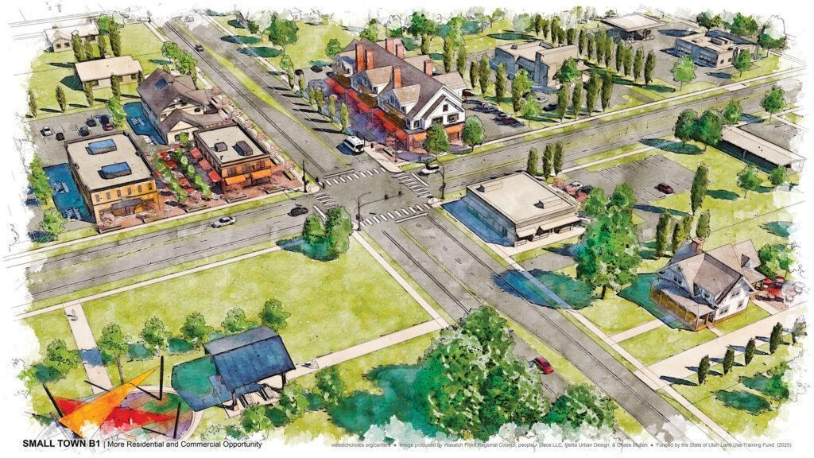
Figure 4:
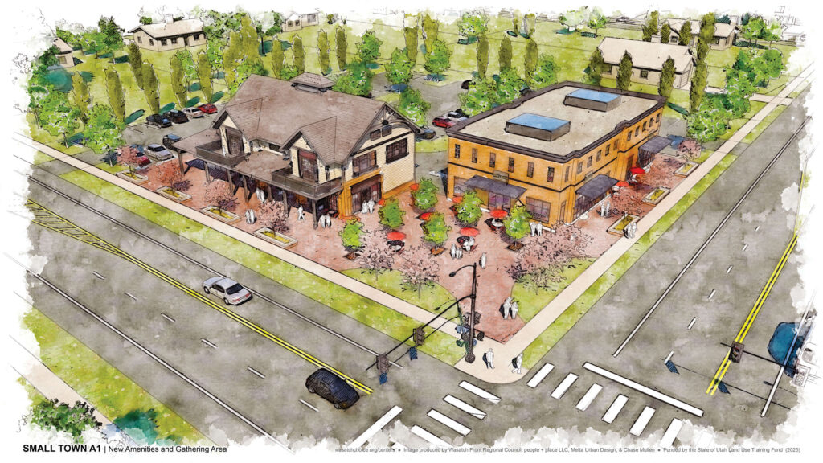
Figure 5:
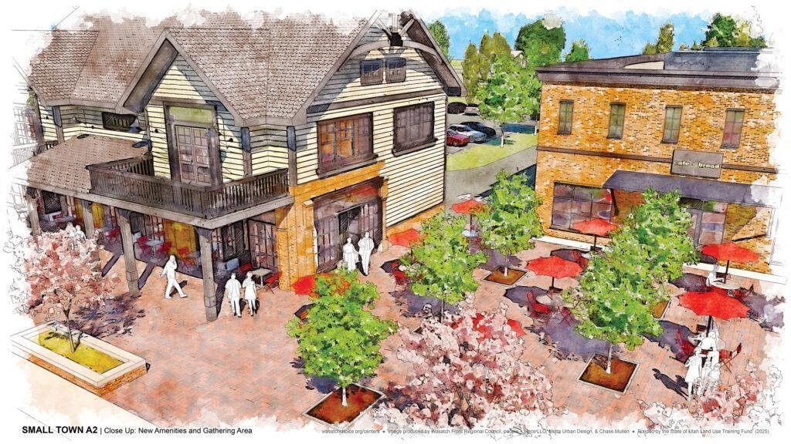
13.11.11 | Site Design and Development Standards
1 | Open Space: At least 20% of a multiple-use development shall be open space, including but not limited to landscaped areas and improved amenities (e.g. trails, benches, lighting, recreation features) supporting passive or active use.
2 | Maximum Lot Coverage: No more that 50% of a lot may be covered by building(s).
3 | Maximum building height in the multiple-use development shall be forty (40) feet, unless a greater height is approved through a development agreement or other process authorized by Lake Point Municipal Code.
4 | No uninterrupted wall length may exceed seventy-five (75) feet without façade articulation or architectural features.
5 | Building design shall comply with applicable design standards in Chapter 13. Buildings shall demonstrate a unified architectural style. Public street-facing façades shall use durable materials (e.g. stucco, fiber cement board, brick, stone). Vinyl, aluminum, and steel siding are prohibited on street-facing façades except soffits and fascia. Stucco-only façades are prohibited.
13.11.12 | Setbacks
1 | Setbacks shall comply with Chapter 13.2 for Residential and Chapter 13.5 for Commercial and Mixed-Use unless otherwise modified through site plan approval.
13.11.13 | Parking Standards
13.11.13.1 | Residential Parking
1 | Residential parking shall comply with Chapter 13.2 except as modified by this Section.
2 | Residential parking shall be designated and reserved for residential use and shall not be counted toward non-residential parking requirements.
13.11.13.2 | Non-Residential Parking
1 | Non-residential parking shall comply with Chapter 13.6 except as modified by this Section.
2 | Off-street parking shall be hard surfaced.
3 | Parking shall be located and designed to minimize conflicts with residential areas through separation, signage, striping, landscaping, and screening.
4 | Shared parking among non-residential uses shall not exceed 25% and is permitted only where the applicant demonstrates different peak demand periods and submits an analysis for approval through a development agreement and subsequent site plans.
4.1 | If a use is intensified or modified such that parking demand materially changes, previously approved reductions may be reevaluated for compliance.

