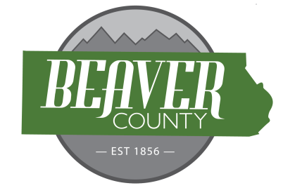
NOTICE AND AGENDA OF A PUBLIC MEETING
MARCH 3, 2026 PUBLIC MEETING OF THE
BOARD OF COUNTY COMMISSIONERS OF
BEAVER COUNTY, UTAH

PUBLIC NOTICE is hereby given that the Beaver County Commissioners of
Beaver County, Utah, will hold a regular Meeting on March 3, 2026, at the place
and time set forth below to consider the agenda item(s) hereinafter set forth.

MEETING PLACE: Beaver County Administration Building 105 East Center Street, Beaver, Utah.
MEETING TIME: 10:00 AM

10:00 AM
Open Meeting Commissioner Hollingshead
Call to order Commissioner Hollingshead
- Prayer offered by Von Christiansen
- Pledge of Allegiance led by Ginger McMullin
New Business
10:05: Approve Bills
10:10: Approve February Minutes
10:15: DWR PILT Payment
10:25: Victim Advocate Update
10:35: DMA Request for Refund
10:45: BHS FFA Donation Request
10:55: Adopting Privacy Policy Resolution No 2026-02

(To be discussed when/as time permits)

- Discussion Items
  - Legislative Updates
- Old Business
- Commission Updates

Closed session for the purpose of discussing the character, professional competence, or physical or mental health of an individual; discuss strategy for pending or reasonably imminent litigation, real property negotiation

BEAVER COUNTY COMMISSION CHAIRMAN
Any other business properly brought before the Board.
Dated the 3rd day of March, 2026

