

PUBLIC NOTICE
City Council Budget Planning Meeting

Notice is hereby given that the Santaquin City Council will conduct two Budget Planning Sessions on February 27, 2026, at 5:00 p.m. and February 28, 2026, at 8:00 a.m. at the Santaquin City Hall located at 110 S. Center Street, Santaquin.

The City Council will be discussing budgetary items with members of staff.

This public meeting will not be shown live on the Santaquin City YouTube Channel.

The undersigned duly appointed City Recorder for the municipality of Santaquin City hereby certifies that a copy of the foregoing Public Notice was posted on www.santaquin.gov, Santaquin City social media sites, posted in three physical locations within the city, and posted on the State of Utah’s Public Notice website.

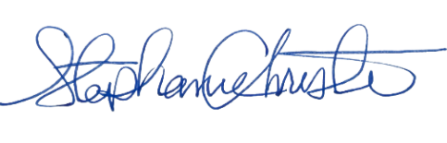

City Recorder, Stephanie Christensen

