CITY OF HYDE PARK ORDINANCE 2026-03RZ
An ordinance approving a zoning map amendment for property located at approximately 455 s wolfpack way, Hyde Park, Ut 84318, parcel 04-037-0013, amending 5.48 acres from C- (Commercial) to MXD-(Mixed use) zone.
WHEREAS, TOM HILL (“Owner Representative”) is the owner of record of 5.45 acres of real property known as parcel No. 04-037-0013, more specifically described as follows:
BEG AT S/4 COR SEC 11 T 12N R 1E & TH N89*40'42"W 5271.23 FT TO S/4 COR SEC 10 T 12N R 1E TH N65*22'33"W 2845.85 FT TO E LN OF HWY 91 & TRUE POB TH N89*24'13"E 1054.95 FT TO MID-BLOCK LINE BLK 2 PLT A HYDE PARK FARM SVY TH S1*11'10"W 237.51 FT ALG SD LN TH S89*24'13"W 1054.70 FT TO E LN OF HWY 91 TH N1*07'34"E 237.10 FT ALG HWY TO TRUE POB CONT 5.75 AC M/B

WHEREAS, the applicant submitted an application in compliance with HPC code 12-10-050, requesting to change the zoning on the subject property from COMMERCIAL zone to INDUSTRIAL zone.
WHEREAS, in a public hearing on FEBRUARY 18, 2026, the Hyde Park Planning Commission considered all evidence and testimony presented with respect to the subject application and unanimously approved a motion to send a recommendation of APPROVAL to the Hyde Park City Council.
WHEREAS, due notice was given that the Hyde Park City Council would meet to consider the Rezone application in a public meeting on February 25, 2026;
Considerations:
  - Whether the proposed amendment would be harmonious with the overall character of existing development in the vicinity of the subject property, or in cases of text amendments, in areas governed by the amended text.
  - Whether the proposed amendment would be consistent with the standards of any applicable overlay zone(s) and, in cases of text amendments, harmonious with areas governed by the amended text.
  - The extent to which the proposed amendment may adversely affect adjacent property; and
  - The adequacy of facilities and services intended to serve the subject property, including but not limited to roadways, parks and recreation facilities, police and fire protection, schools, storm water drainage systems, water supplies, waste water and refuse collection.
  - The application conforms to the provisions of the Hyde Park General Plan including the future land use map.

WHEREAS, the City Council has heard and considered all evidence and testimony presented with respect to the application subject and has determined that the adoption of this ordinance is in accordance with city code and the General Plan.

NOW, THEREFORE, BE IT ORDAINED by the Hyde Park City Council that it does hereby rezone real property located at 455 South Wolf Pack Way, Hyde Park, Utah, known as Cache County Parcel No. 04-037-0013, from COMMERCIAL to MIXED USE.

PASSED, ADOPTED, AND APPROVED by the Hyde Park City Council in open session this_____ day of __________________, 2026 by the following vote:
Those voting aye:
Those voting nay:
Those absent:
ATTEST:

Bryan Cox, Mayor:
Donja Wright, Recorder:
Map of Parcel
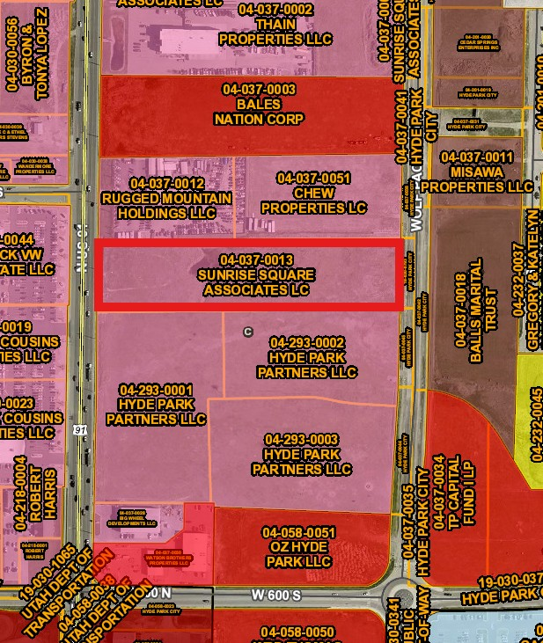

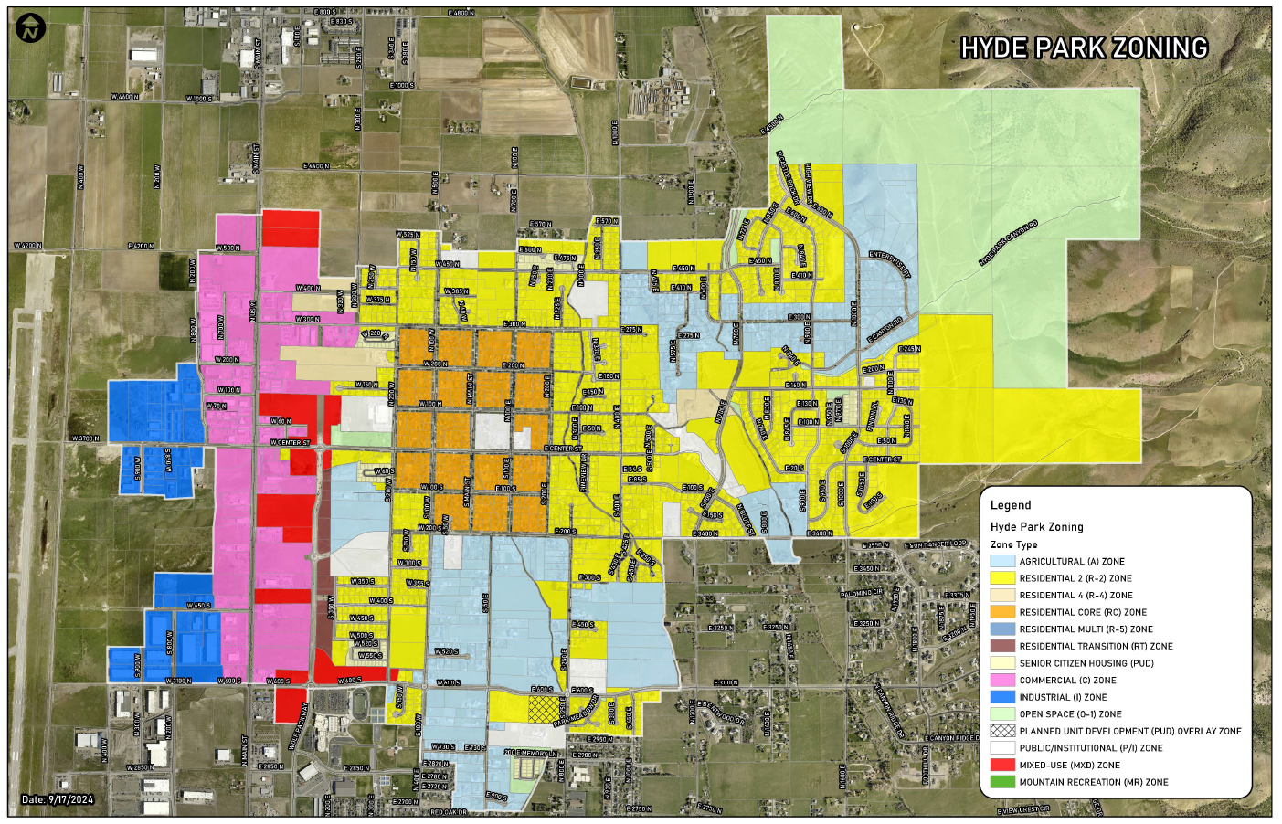
Hyde Park Zoning Map

Future Land Use Map
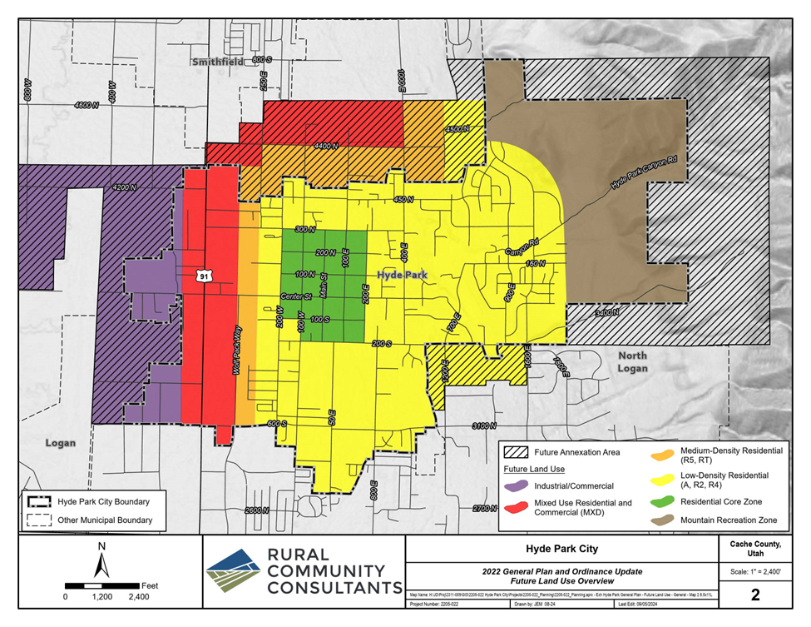
General Plan

