Methodology to estimate South Arm dissolved salt mass and volume-weighted salinity values

A Cooperator Publication Prepared for:
Utah Division of Forestry, Fire and State Lands,
Utah Department of Environmental Quality, and
the Great Salt Lake Salinity Advisory Committee

Attention:
Ben Stireman and James Harris

Prepared by:
U.S. Geological Survey – Utah Water Science Center
Christine Rumsey – crumsey@usgs.gov
Scott Hynek – shynek@usgs.gov
2329 W. Orton Circle
Salt Lake City, Utah 84119-2047

Methodology to estimate South Arm dissolved salt mass and volume-weighted salinity values

Christine Rumsey and Scott Hynek

U.S. Geological Survey, Utah Water Science Center

Purpose
This document outlines the approaches used for calculating various salinity and dissolved salt mass estimates for the South Arm (also known as Gilbert Bay and includes Ogden Bay and Carrington Bay) of Great Salt Lake (GSL). Water-quality profiles and associated salinity measurements from point samples taken at discrete depths are paired with South Arm lake surface elevations and a topobathymetric model to understand the evolving relationship between lake elevation, dissolved salt mass, and salinity. Uses of the salt mass and salinity estimates include:
- An estimate of the total dissolved salt mass (full depth) in the South Arm to track salt mass trajectories for the GSL Salinity Advisory Committee (SAC)
- Volume-weighted salinity vs. lake surface elevation plotted in the context of total dissolved salt mass (isomass plot) to evaluate current and anticipated South Arm conditions for the GSL SAC
- An estimate of the volume-weighted salinity for the upper brine layer (UBL) in the South Arm for the Utah Division of Water Quality to aid in application of Utah State Rule 317-17

Input data
South Arm estimates of dissolved salt mass and volume-weighted salinity are computed by combining discrete salinity values with mean daily lake surface elevation data. Discrete measurements of salinity from four South Arm sampling locations are made using lake samples collected monthly by the Great Salt Lake Ecosystem Program (GSLEP; Figure 1; Table 1); salinity data are made publicly available via the Water Quality Portal (Water Quality Portal, 2021; https://www.waterqualitydata.us/). For each sampling event, lake samples are collected at multiple depths at each of the four sites. At deep sites 3510 and 2565, lake samples are collected 0.5 meters (m) below the lake surface, 3.0 m below the lake surface, and 0.5 m above the lake bottom (total water depths were 5.9 to 9.1 m and 5.4 to 8.6 m deep for 3510 and 2565, respectively, between 2010 and 2024). At shallow site 2267, lake samples are collected 0.5 m below the lake surface and 0.5 m above the lake bottom (1.4 to 4.6 m deep between 2010 and 2024). At shallow site 2767 (0.3 to 3.5 m deep, 2010 to 2024), one lake sample is collected 0.5 m below the lake surface. In total, nine lake samples are collected from the four-site monitoring network on the same sampling day for measurement of salinity. Note, sample collection at 3.0 m below the lake surface began in April 2023; prior to that time, UBL salinity was represented by samples collected 0.5 m below the lake surface and the 2267 sample taken 0.5 m above bottom (~3 m below the surface). Salinity is computed from measured densities using the Great Salt Lake equation of state (EOS; Naftz et al., 2011) following established protocols (Great Salt Lake Salinity Advisory Committee, 2020); herein referred to as an EOS-measured salinity. South Arm water-quality profile data used to determine chemocline depths are compiled in-house by USGS and GSLEP and are available upon request; future data releases to make water quality profile data publicly available (e.g., McIlwain et al., 2023) may be possible based on available resources and cooperator interest. South Arm lake surface elevations are monitored at 15-minute intervals at the Saltair Boat Harbor (USGS site 10010000) and are used to derive mean daily lake surface elevations (reported on NWIS/National Water Dashboard; U.S. Geological Survey, 2025). Mean daily lake surface elevations are then used to estimate daily volumes for the entire South Arm as well as for Gilbert Bay and Carrington Bay separately by converting lake surface elevation to volume using topobathymetry (Root, 2023).
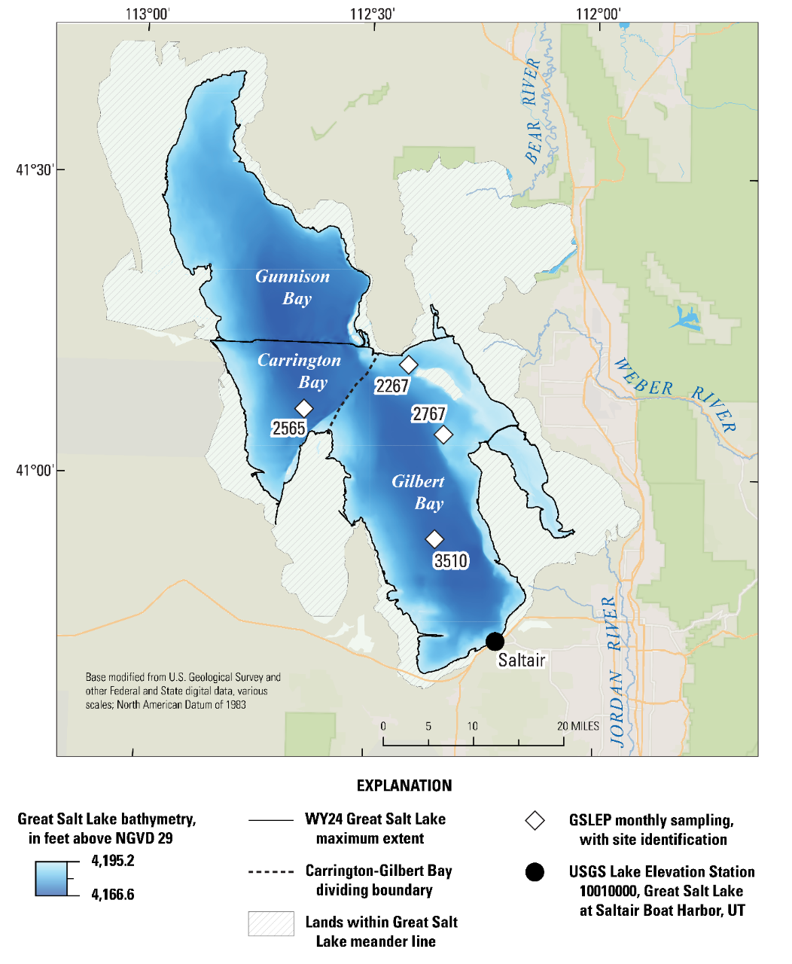
Figure 1. South Arm monitoring locations (diamonds) sampled monthly by the Great Salt Lake Ecosystem Program for measurement of salinity at multiple depths. Displayed topobathymetry (Root, 2023) represents lake extent at maximum mean daily lake level during the 2024 water year (October 1, 2023–September 30, 2024). Site numbers correspond to map IDs in Table 1. Political boundaries and locations modified from U.S. Geological Survey (USGS) and other federal and state geospatial data. Horizontal coordinates referenced to the North American Datum of 1983 with the National Adjustment of 2011. [GSLEP, Great Salt Lake Ecosystem Program; WY24, Water Year 2024; USGS, U.S. Geological Survey]
Table 1. Locations of Great Salt Lake (GSL) monitoring sites used for salinity and dissolved salt mass estimates (U.S. Geological Survey, 2025). Water-quality profiles and samples collected at sites 2565, 3510, 2267, and 2767 are used to obtain measurements of salinity and to define horizontal layers in the water column; the lake surface elevation record at the Saltair Boat Harbor permits South Arm volume estimates. [GSL, Great Salt Lake; ID, identification; mi, mile; N, north; NGVD29, National Geodetic Vertical Datum of 1929; NW, northwest; USGS, U.S. Geological Survey; UT, Utah; W, west]
Map ID | USGS Site  ID | USGS Site  Name | Latitude | Longitude | Lake-bed elevation (NGVD29),  in feet
2565 | 410644112382601 | GSL 2565, NW of Hat Island | 41.11214 | -112.6414 | 4170.8
3510 | 405356112205601 | GSL 3510, 6 mi West of Antelope Island | 40.89881 | -112.3497 | 4169.1
2267 | 411116112244401 | GSL 2267, 1 mi NW of Fremont Island | 41.18771 | -112.413 | 4183.9
2767 | 410422112200001 | GSL 2767, 4 mi W of N tip of Antelope Island | 41.07272 | -112.3341 | 4187.6
Saltair | 10010000 | Great Salt Lake at Saltair Boat Harbor, UT | 40.73133 | -112.2136 | -------

South Arm dissolved salt mass estimation
To compute dissolved South Arm salt mass, the water column is divided into three horizontal layers to pair salinity measurements at different depths with corresponding layer volumes (Figure 2), following the approach in Mohammed and Tarboton (2012). Layer 1 (l₁) is defined as the horizontal layer from the lake surface to 1.0 m below the lake surface to evenly bracket the 0.5 m depth sample, encapsulating the fresher surface lens present at certain times of the year. The depth of the interface between Layers 2 and 3 is adjusted based upon the specific conductance data from water-quality profiles taken concurrently with monthly sampling at the four-site monitoring network (profiles provided by GSLEP upon request). As an example, in water year 2025 delineations, Layer 2 (l₂) is the horizontal layer from 1.0 m below the lake surface to 5.0 m below the lake surface and Layer 3 (l₃) is the horizontal layer from 5.0 m below the lake surface to the lake bottom. Horizontal layers are defined separately for Carrington and Gilbert Bays based on water-quality profile data at sites 2565 and 3510, respectively. Dissolved salt masses are computed layer by layer separately for Carrington and Gilbert Bays, and subsequently summed to estimate the South Arm dissolved salt mass as:
$M_{SA}=M_{CB}+M_{GB}$ (1)
where,
$M_{SA}$ is South Arm dissolved salt mass for the date of GSLEP sample collection, in millions of tonnes (Megatonne; Mt),
$M_{CB}$ is Carrington Bay dissolved salt mass, in Mt, and
$M_{GB}$ is Gilbert Bay dissolved salt mass, in Mt.
Carrington Bay dissolved salt mass ($M_{CB}$) is estimated as:
$M_{CB}=\frac{\left(C_{CB,0.5}V_{CB,l_{1}}+C_{CB,3}V_{CB,l_{2}}+C_{CB,0.5AB}V_{CB,l_{3}}\right)}{{10}^{9}}$ (2)
where,
$C_{CB}$ is an EOS-measured salinity concentration, in grams per liter (g/L), at each sample depth; numbers in subscript denote sample depth in meters below the lake surface, except for 0.5AB which denotes 0.5 m above the lake bottom. Salinity measurements for Carrington Bay layers are taken from site 2565, and$C_{CB}$ represents salinity at a discrete point in time and space (i.e., salinity at a specified depth on the day of GSLEP sample collection).
$V_{CB}$ is water volume on the day of GSLEP sample collection, in cubic meters (m³), calculated for each layer in Carrington Bay, where l₁, l₂, and l₃ denote Layers 1, 2, and 3, respectively, and
${10}^{9}$ is a conversion factor to obtain $M_{CB}$ in Mt from salinities measured in g/L and volume measured in m³.
Gilbert Bay dissolved salt mass estimates ($M_{GB})$ are calculated following Equation 2, where the subscript GB refers to Gilbert Bay concentrations and volumes:
$M_{GB}=\frac{\left(C_{GB,0.5}V_{GB,l_{1}}+C_{GB,3}V_{GB,l_{2}}+C_{GB,0.5AB}V_{GB,l_{3}}\right)}{{10}^{9}}$ (3)
where,
$C_{GB}$ is an EOS-measured salinity concentration, in grams per liter (g/L), at each sample depth; numbers in subscript denote sample depth in meters below the lake surface, except for 0.5AB which denotes 0.5 m above the lake bottom. Salinity measurements for Gilbert Bay layers are taken from sites 2267, 2767, and 3510. For Layer 1 (l₁), mean salinity ($C_{GB,0.5}$) is calculated from individual salinity measurements from 0.5 m below the lake surface at sites 2267, 2767, and 3510. For Layer 2 (l₂), mean salinity ($C_{GB,3}$) is calculated from the salinity measurements of samples 3 m below the lake surface at sites 2267 and 3510. For Layer 3 (l3), salinity ($C_{GB,0.5AB}$) is from the sample taken 0.5 m above the lake bottom at site 3510. $C_{GB}$ represents salinity at a discrete point in time and space (i.e. salinity at a specified depth on the day of GSLEP sample collection).
$V_{GB}$ is water volume on the day of GSLEP sample collection, in cubic meters (m³), calculated for each layer in Gilbert Bay, where l₁, l₂, and l₃ denote Layers 1, 2, and 3, respectively, and
${10}^{9}$ is a conversion factor to obtain $M_{GB}$ in Mt from salinities measured in g/L and volume measured in m³.
Dissolved salt masses are estimated for the date of GSLEP sample collection and used to track South Arm salt mass trends, evaluate current conditions, and inform lake management.

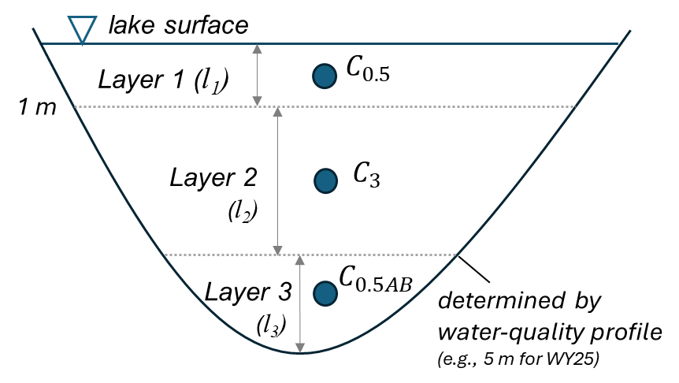
Figure 2. Layers ($l_{1}$, $l_{2}$, and $l_{3}$) used to pair layer volumes with discrete salinity measurements from three depths (blue circles; $C_{0.5}$ is salinity from 0.5 m below the lake surface, $C_{3}$ is salinity from ~3 m below the lake surface, and $C_{0.5AB}$ is salinity from 0.5 m above the lake bottom). Layers are defined separately for Carrington and Gilbert Bays based on water-quality profile data at sites 2565 and 3510, respectively. [m, meters; WY25, Water Year 2025]

South Arm full depth volume-weighted salinity estimation
To estimate South Arm full depth volume-weighted salinity (VWS_{SA,FD}) values, South Arm dissolved salt mass ($M_{SA})$ is divided by South Arm volume for each date of GSLEP sample collection as:
${VWS}_{SA,FD}=\left(\frac{M_{SA}}{V_{SA}}\right)*{10}^{9}$ (4)
where,
$V_{SA}$ is the water volume of the South Arm, in m³, on the day of salt mass estimation.
The resultant salinity value in g/L is an estimate for mixing a horizontally and vertically heterogenous lake based upon two water-quality profiles and nine individual salinity measurements. Note that this salinity value is an estimated concentration and is not measured. South Arm full depth volume-weighted salinity values account for the total salt mass throughout the water column and are helpful for medium- to long-term planning and management of South Arm salinity. Note, another approach used for estimating South Arm full depth volume-weighted salinities does not divide measured salinity by bays but rather takes the average of shallow and deep salinities and applies them over South Arm upper brine layer and deep brine layer volumes, respectively. This approach apportions salinity to volume differently, and the resultant volume-weighting yields slightly higher monthly salinity estimates on the order of 1.2 g/L ± 0.3 g/L (p ≤ 0.05; comparing estimates from 2010 to 2022).
To inform salinity management action, a framework was developed to aid in the interpretation of changing salinity and salt mass estimates. Full depth volume-weighted salinity estimates and corresponding lake-surface elevations for each date of GSLEP sample collection are plotted with computed, theoretical South Arm total dissolved salt masses. This isomass plot (Figure 3) is used to evaluate current and anticipated South Arm conditions in the context of target salinity ranges identified by the Great Salt Lake Salinity Advisory Committee and target lake surface elevation ranges identified by the Great Salt Lake Commissioner’s Office. Theoretical South Arm total dissolved salt masses are plotted as isomass lines (grey lines in Figure 3) underlying salinity estimates to illustrate the evolving connections between dissolved salt mass, salinity, and lake surface elevation. These full-depth, volume-weighted salinity estimates aid in evaluating the current condition of the South Arm, inform management considerations, and indicate possible future trajectories for South Arm salt mass and salinity (Figure 3).
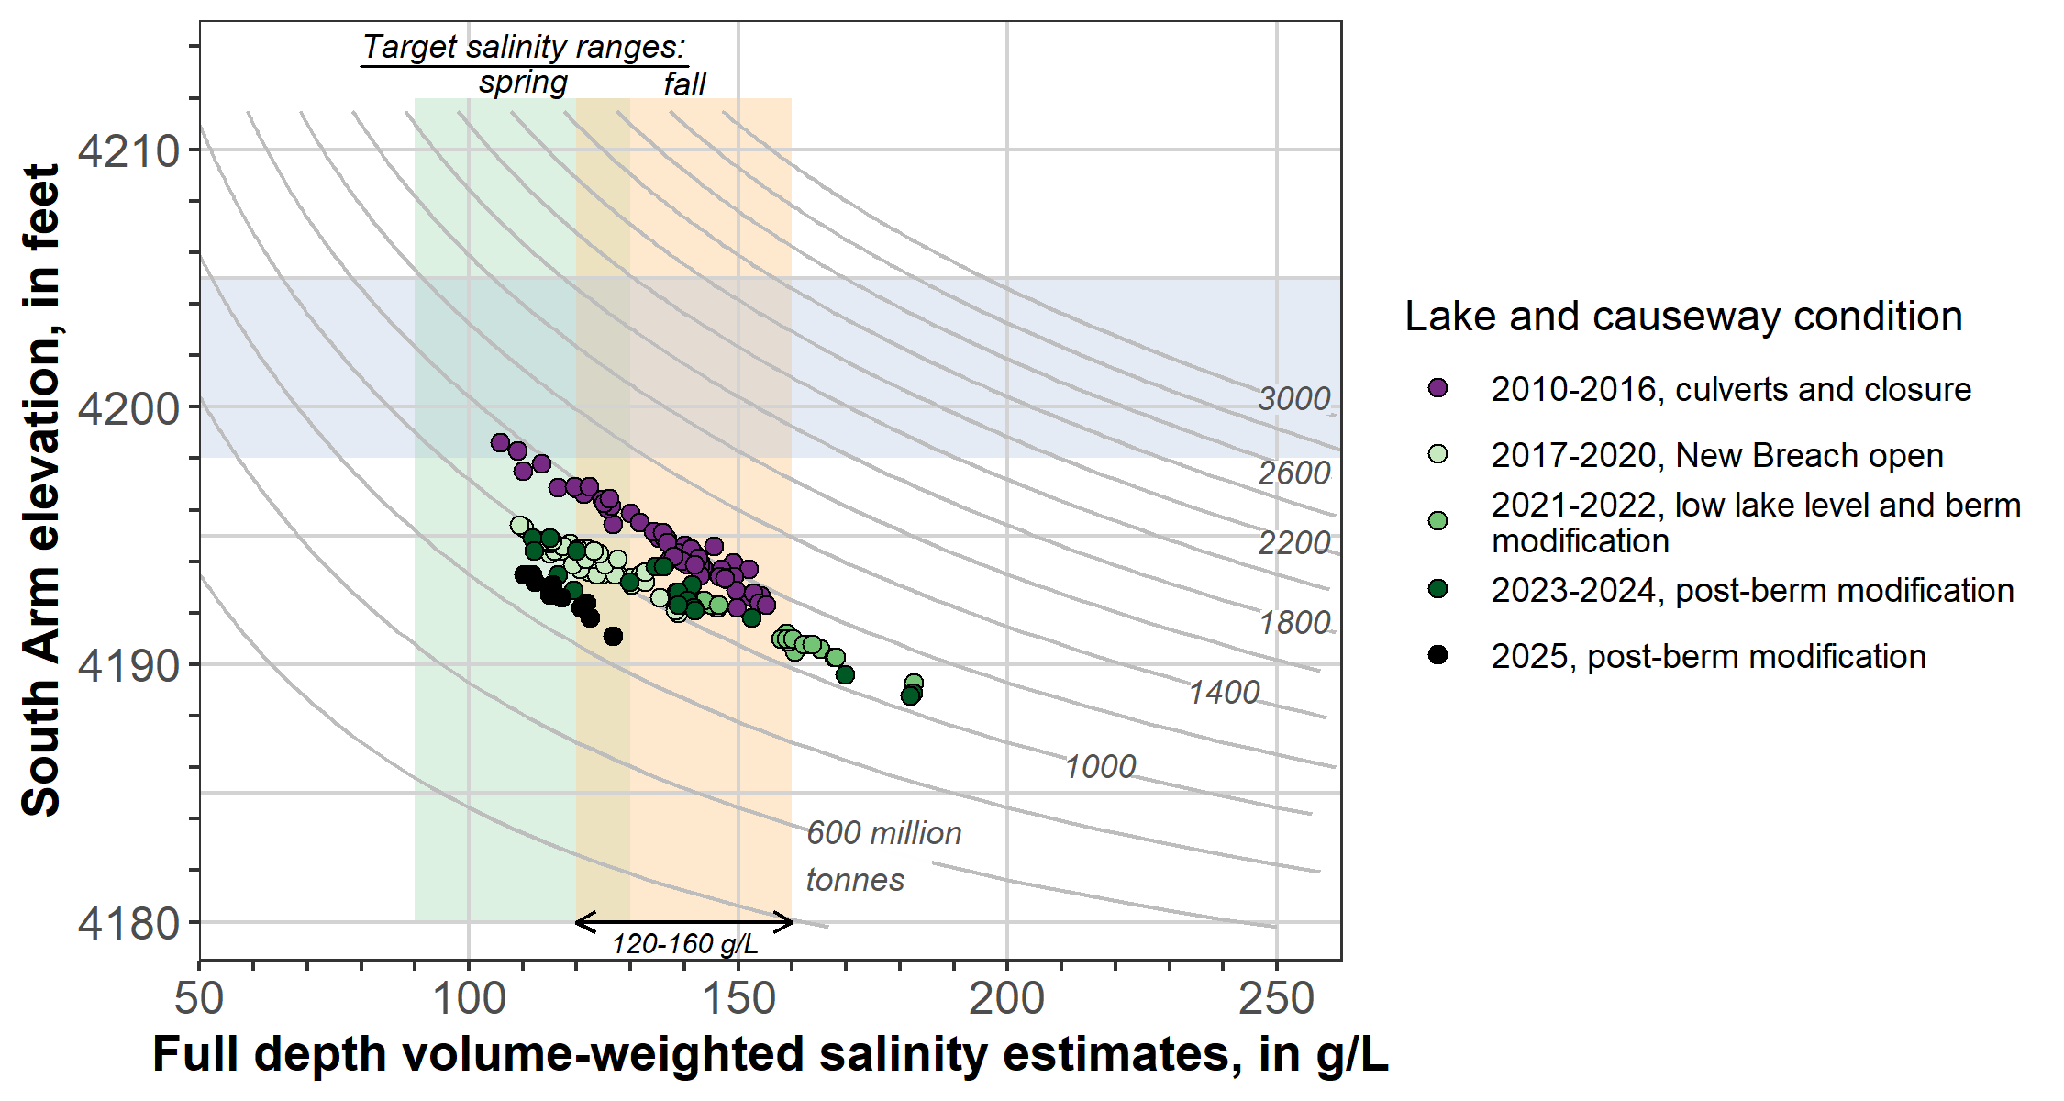
Figure 3. South Arm full depth volume-weighted salinity estimates and corresponding lake surface elevations for each date of Great Salt Lake Ecosystem Program sample collection. These paired elevation-salinity values are plotted in the context of theoretical South Arm dissolved salt masses (grey lines define possible combinations of salinity and lake surface elevation for a given dissolved salt mass and are commonly referred to as isomass lines, or collectively as an isomass plot). Vertical shaded bands depict target salinity ranges for fall (120 to 160 g/L; GSL SAC, 2021, 2023) and spring (90 to 130 g/L; GSL SAC, 2023); the horizontal band marks the target elevation range set forth by the GSL Commissioner’s Office (Steed, 2024) [g/L, grams per liter; GSL, Great Salt Lake; SAC, Salinity Advisory Committee].

South Arm upper brine layer volume-weighted salinity estimation
Computation of an upper brine layer (UBL) volume-weighted salinity for the South Arm will be used by the Utah Division of Water Quality to aid in application of Utah State Rule 317-17. As such, this methodology is distinct from the South Arm full depth volume-weighted salinity estimates in that it uses fixed water column layers to ensure consistency in calculations through time and for variable lake conditions. To compute South Arm UBL volume-weighted salinity, the water column is divided into two horizontal layers to pair salinity measurements at different depths with corresponding shallow layer volumes. Analysis of South Arm water-quality profiles during 2011–2025 indicates the chemocline depth varies from 4.8 to 7.0 m below the surface in Carrington Bay and from 5.8 to 8.0 m below surface in Gilbert Bay. Based on these observations, the upper brine layer is defined here as the top 4 m of the water column for both Carrington and Gilbert Bays to ensure exclusion of the deep brine layer for all lake conditions. Layer 1 (l₁) occupies the volume from the lake surface to 1.0 m below the lake surface; Layer 2 (l_{2,UBL}) occupies the volume from 1.0 m below the lake surface to 4.0 m below the lake surface (Figure 4). To estimate South Arm UBL volume-weighted salinity values (VWS_{SA,UBL}), South Arm UBL salt mass is divided by South Arm UBL volume on the day of GSLEP sample collection as:
${VWS}_{SA,UBL}=\left(\frac{M_{UBL}}{V_{UBL}}\right)*{10}^{9}$ (5)
where,
$V_{UBL}$ is the volume of the South Arm UBL, in m³, on the day of GSLEP sample collection.
UBL dissolved salt masses are computed layer by layer separately for Carrington and Gilbert Bays, and subsequently summed to estimate the South Arm UBL dissolved salt mass as:
$M_{SA,UBL}=M_{CB,UBL}+M_{GB,UBL}$ (6)
where,
$M_{SA,UBL}$ is South Arm UBL dissolved salt mass on the day of GSLEP sample collection, in Mt,
$M_{CB,UBL}$ is Carrington Bay UBL dissolved salt mass, in Mt, and
$M_{GB,UBL}$ is Gilbert Bay UBL dissolved salt mass, in Mt.
This is similar to the full depth, volume-weighted dissolved salt mass method described above (Equations 1 and 4); however, this method applies only for Layers 1 and 2 (Figure 4). Carrington Bay UBL dissolved salt masses are estimated as:
$M_{CB,UBL}=\frac{\left(C_{CB,0.5}V_{CB{,l}_{1}}+C_{CB,3}V_{CB,l_{2,UBL}}\right)}{{10}^{9}}$ (7)
where,
$C_{CB}$ is an EOS-measured salinity concentration, in g/L, at each sample depth; numbers in subscript denote sample depth in meters below surface. Salinity measurements for Carrington Bay layers are taken from site 2565$. C_{CB}$ represents salinity at a discrete point in time and space (i.e., salinity at a specified depth at a specified site on the day of GSLEP sample collection).
$V_{CB}$ is water volume on the day of GSLEP sample collection, in m³, calculated for each layer in Carrington Bay, where l₁ and l_{2,UBL} denote Layers 1 and 2 (see Figure 4), respectively, and
${10}^{9}$ is a conversion factor to obtain $M_{CB,UBL}$ in Mt from salinities measured in g/L and volume measured in m³.
Gilbert Bay UBL dissolved salt masses ($M_{GB,UBL})$ are calculated as for Carrington Bay (Equation 7):
$M_{GB,UBL}=\frac{\left(C_{GB,0.5}V_{GB{,l}_{1}}+C_{GB,3}V_{GB,l_{2,UBL}}\right)}{{10}^{9}}$ (8)
where,
$C_{GB}$ is an EOS-measured salinity concentration, in g/L, at each sample depth; numbers in subscript denote sample depth in meters below surface. Salinity measurements for Gilbert Bay layers are taken from sites 2267, 2767, and 3510. For Layer 1, mean salinity ($C_{GB,0.5}$) is calculated from salinity measurements from 0.5 m below the lake surface at sites 2267, 2767, and 3510. For Layer 2, mean salinity ($C_{GB,3}$) is calculated from salinity measurements taken 3 m below the lake surface at sites 2267 and 3510. $C_{GB}$ represents spatially averaged salinity at a discrete point in time (i.e., average salinity for Gilbert Bay at a specified depth on the day of GSLEP sample collection).
$V_{GB}$ is water volume on the day of GSLEP sample collection, in m³, calculated for each layer in Gilbert Bay, where l₁ and l_{2,UBL} denote Layers 1 and 2 (refer to Figure 4), respectively, and
${10}^{9}$ is a conversion factor to obtain $M_{GB,UBL}$ in Mt from salinities measured in g/L and volume measured in m³.
UBL dissolved salt masses are estimated for the day of GSLEP sample collection. Note, collection and measurement of salinity from samples taken 3 m below the surface ($C_{CB,3}$ and $C_{GB,3}$) began in April of 2023. Prior to this date, UBL volume-weighted salinity estimates used the 0.5-m deep and the 2267 0.5 m above bottom EOS-salinity measurements to estimate UBL salinities for each bay ($C_{CB,0.5}$, $C_{GB,0.5}$, and $C_{GB,3}$; note, prior to April 2023, $C_{GB,3}$ is the salinity at 2267 at 0.5 m above bottom) and subsequently applied those concentrations across a single layer of UBL from the water surface (0 m) to 4.0 m below the water surface.
The resultant volume-weighted UBL salinity value (in g/L) is an estimate for mixing a horizontally and vertically heterogenous UBL over a 4-m depth using seven individual salinity measurements. In contrast to full depth volume-weighted salinity estimates for the entire volume of the South Arm, the UBL volume-weighted salinity values are weighted more heavily toward Layer 1 by reduction of Layer 2 volume and exclusion of Layer 3. These values account for dynamic UBL dissolved salt mass in the photic zone, capturing conditions relevant to South Arm benthic and pelagic ecosystems, and aid in near-term management and regulation of salinity. Note, this salinity value is an estimated, not measured, concentration.

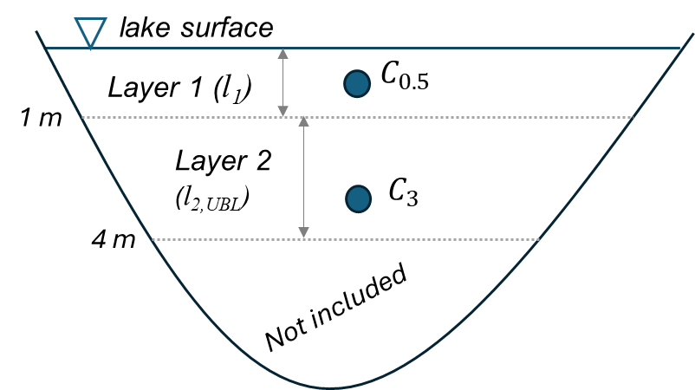
Figure 4. Horizontal layers (l₁ and l_{2,UBL}) used to pair layer volumes with discrete salinity measurements from two depths to estimate UBL volume-weighted salinity (blue circles; $C_{0.5}$ is salinity from 0.5 m below surface and $C_{3}$ is salinity from 3 m below the lake surface; bottom samples are not included). Horizontal layers are defined separately for Carrington and Gilbert Bays.

References Cited
Great Salt Lake Salinity Advisory Committee, 2020, Standard operating procedure—Great Salt Lake water density measurement and salinity calculation: Utah Geological Survey Open-File Report 728, 6 p., https://doi.org/10.34191/OFR-728.
Great Salt Lake Salinity Advisory Committee (GSL SAC), 2021, Influence of salinity on the resources and uses of Great Salt Lake. Memorandum by the GSL SAC, July 27, 2021. Accessed 12 May 2023 at https://ffsl.utah.gov/wp-content/uploads/GSLSAC_SalinityInfluencesRangesTM_Final_July2021.pdf.
Great Salt Lake Salinity Advisory Committee (GSL SAC), 2023, Recommendations pertaining to interim protocol for berm modifications. Memorandum by the GSL SAC, April 6, 2023.
Mohammed, I., N. Tarboton, D.G., 2012, An examination of the sensitivity of the Great Salt Lake to changes in inputs. Water Resources Research (48), W11511. doi: 10.1029/2012WR011908
Mcilwain, H.E., Arias, M.C., McDonnell, M.C., Seawolf, S.M., Rumsey, C.A., 2023, Vertical water-quality profiles collected at Great Salt Lake monitoring sites, Utah, 1995–2022: U.S. Geological Survey data release, https://doi.org/10.5066/P9J6A07X.
Naftz, D.L., Millero, F.J., Jones, B.F., Green, W.G., 2011, An equation of state for hypersaline water in Great Salt Lake, Utah, USA. Aquatic Geochemistry, 17: 809-820. https://doi.org/10.1007/s10498-011-9138-z
Root, J.C., 2023, Half-meter topobathymetric elevation model and elevation-area-volume tables for Great Salt Lake, Utah, 2002-2016: U.S. Geological Survey data release, https://doi.org/10.5066/P9DGG75W.
Steed, B., 2024, The Great Salt Lake Strategic Plan. Submitted by the Great Salt Lake Commissioner’s Office. https://greatsaltlake.utah.gov/great-salt-lake-strategic-plan-2
U.S. Geological Survey, 2025, USGS water data for the Nation: U.S. Geological Survey National Water Information System database, accessed March 6, 2025, at https://doi.org/10.5066/F7P55KJN.
Water Quality Portal, 2021, Washington (DC): National Water Quality Monitoring Council, United States Geological Survey (USGS), Environmental Protection Agency (EPA). http://doi.org/10.5066/P9QRKUVJ.

