Long-Term Salinity Management Plan: South Arm of Great Salt Lake
Document no: 250702193718_2f56aeaf
Version: Draft
Utah Division of Forestry, Fire and State Lands
Utah Division of Water Quality
Prepared by the Great Salt Lake Salinity Advisory Committee
July 30, 2025
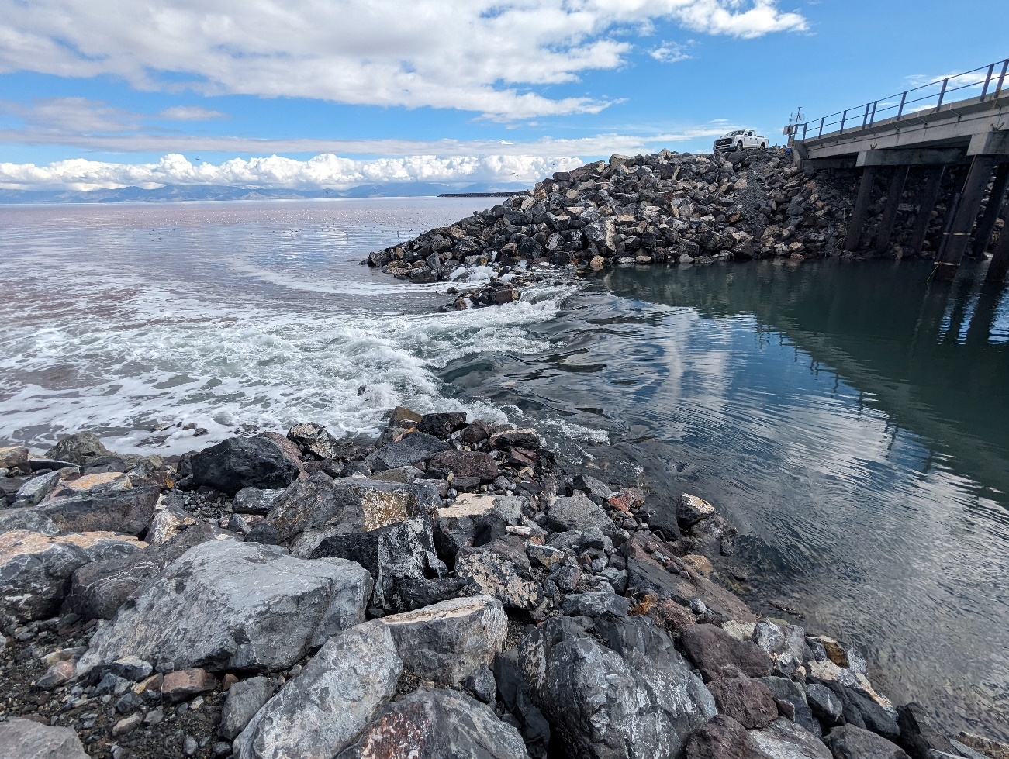

Executive Summary
The salinity of Great Salt Lake (GSL or the lake) plays an influential role in shaping the lake’s unique ecological, recreational, and economic resources and uses. GSL’s salinity is complex, dynamic and responds to changes in lake water levels and in-lake hydrology and hydraulics. Recent historically low lake water elevations, corresponding increases in the South Arm’s salinity, and resulting impacts on the South Arm’s ecology accentuated the need to better monitor and manage South Arm salinity to protect the resources and uses of the lake. A review of the literature and datasets determined that a rising trend in lake water level will require a higher dissolved salt mass in the South Arm and a declining trend in lake water level will require a lower dissolved salt mass in the South Arm to maintain the salinity within desired thresholds. Extensive tracking and modeling of the dissolved salt mass and salinity of the South Arm by the United States Geological Survey and GSL Salinity Advisory Committee identified an important relationship between lake water level, dissolved salt mass and salinity in the South Arm. The recommended means of managing the dissolved salt mass and salinity in response to changing lake water levels in the South Arm is by controlling the transfer of water and dissolved salt to and from the North Arm through the Northern Railroad Causeway. Salinity management is a long-term endeavor; months, if not years, will be needed to influence the direction of South Arm salinity. Active salinity management will require carefully monitoring water levels and water density in the South and North Arms and improved monitoring, modeling, and management of inflows to GSL to facilitate forecasting of changes in lake water level and salinity. This Long-Term Salinity Management Plan for the South Arm of Great Salt Lake recommends several actions to respond to trending lake water levels, dissolved salt mass, and salinity.

Contents
Executive Summary i
Acronyms and Abbreviations iii
1. Introduction and Goals 1-1
2. Background and Context 2-3
2.1 Salinity Changes and Responses 2-3
2.1.1 Pre-1959 (Pre-Northern Railroad Causeway) 2-3
2.1.2 1960 through 1980 2-3
2.1.3 1980 through 2000 2-5
2.1.4 2000 through 2020 2-6
2.1.5 2020s 2-7
2.2 South Arm Deep Brine Layer 2-7
2.3 Great Salt Lake Salinity Advisory Committee 2-8
3. South Arm Salinity Thresholds 3-1
4. South Arm Salinity Management 4-1
4.1 Recommended Approach 4-2
4.2 Long-Term Salinity Management Plan 4-3
4.2.1 Objectives 4-3
4.2.2 Approach 4-3
4.2.3 Recommendations 4-5
5. Conclusions 5-1
6. References 6-1

Figures
Figure 1-1. Hydrographic Features of Great Salt Lake 1-2
Figure 2-1. North and South Arm Salt Mass Calculations for the Period of Record from Utah Geological Society and the U.S. Geological Survey Measurements 2-4
Figure 3-1. Great Salt Lake South Arm Recommended Salinity 3-2
Figure 4-1. South Arm Volume-Weighted Salinity estimates and Corresponding Great Salt Lake Surface Elevations for Each Sample Collection Date 4-1
Figure 4-2. Relationship between Salinity Management and Trending Water Levels in Great Salt Lake 4-2
Figure 4-3. Recommended Approach for South Arm Salinity Management 4-4
Figure 4-4. Recommended Minimum Monitoring and Sampling to Track Changes in Temperature, Density, and Salinity in South and North Arms and Estimate Monthly Volume-Weighted Dissolved Salt Mass and Upper Brine Layer Salinity in South Arm 4-5
Figure 4-5. Recommended Minimum Monitoring and Sampling to Track Water Flow and Salt Flux through the Northern Railroad Causeway 4-5
Figure 4-6. Target Dissolved Salt Mass in the South Arm for Various South Arm Water Levels and Salinity Targets 4-7

Acronyms and Abbreviations
DBL deep brine layer
DWQ Utah Division of Water Quality
DWR Utah Division of Wildlife Resources
DWRe Utah Division of Water Resources
DWRi Utah Division of Water Rights
El elevation
FFSL Utah Division of Forestry, Fire and State Lands
g/L gram(s) per liter
GSL Great Salt Lake
lake, the Great Salt Lake
Mg metric ton
Mt/yr million tonnes per year
Plan Long-Term Salinity Management Plan for the South Arm of Great Salt Lake
SAC Salinity Advisory Committee
UBL upper brine layer
UGS Utah Geological Survey
UPRR Union Pacific Railroad
USGS United States Geological Survey

Introduction and Goals
The salinity of Great Salt Lake (GSL or the lake) plays an influential role in shaping the lake’s unique ecological, recreational, and economic uses (Woolley and Marsell 1946; Belovsky et al. 2011; Baxter 2024). Recent historically low lake water elevations, corresponding increases in the South Arm’s salinity, and resulting impacts on the South Arm’s ecology accentuated the need to better monitor and manage South Arm salinity to protect the resources and uses of the lake. The purpose of this Long-Term Salinity Management Plan for the South Arm of Great Salt Lake (the Plan) is to summarize the recommendations of the GSL Salinity Advisory Committee (SAC) to the Utah Division of Forestry, Fire and State Lands (FFSL) and the Utah Division of Water Quality (DWQ) for long-term salinity management of the South Arm of GSL (Figure 1-1).
This Plan is organized to accomplish the following:
Define goals for salinity management
Provide background and context
Summarize the history of the GSL SAC and its activities
Review the development of salinity thresholds for the South Arm
Provide salinity management recommendations
This Plan would not have been possible without the foresight and invaluable contributions of countless researchers, managers, and partners over the years.
Consistent with the charter of the GSL SAC (GSL SAC 2024), the goals for GSL long-term salinity management are to maximize the benefits of GSL in accordance with the public trust doctrine (Utah Administrative Code R652-2-200) and protect the designated uses of GSL in accordance with the Utah Water Quality Act (Utah Administrative Code Title 19, Chapter 5).
Figure 1-1. Hydrographic Features of Great Salt Lake
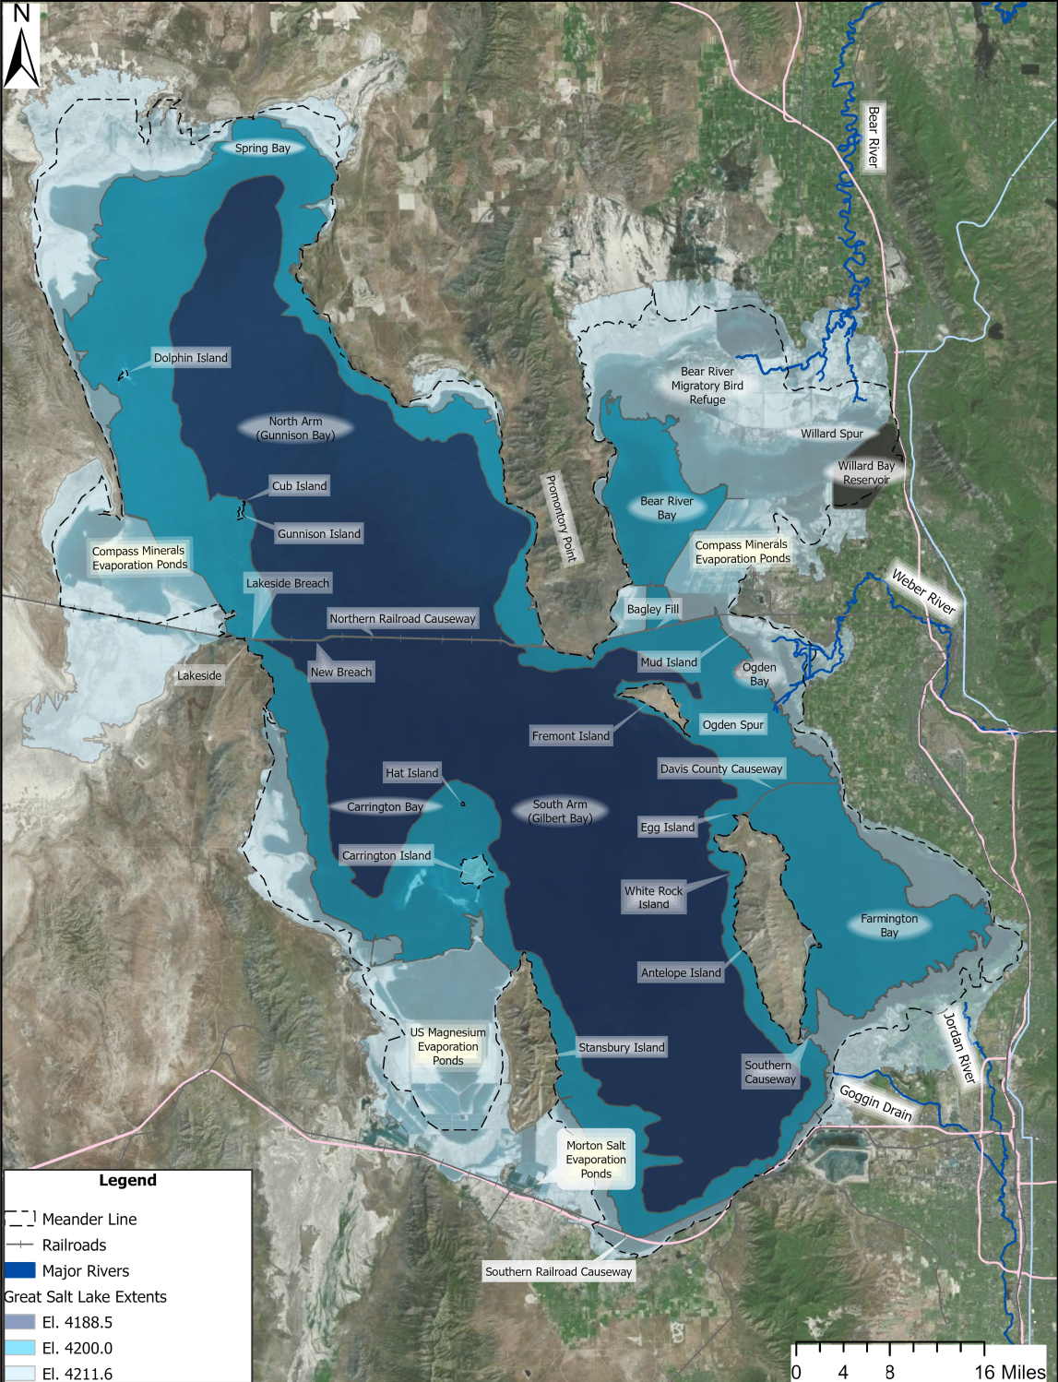

Background and Context
This section provides important background and context as a foundation for GSL long-term salinity management.

Salinity Changes and Responses
An understanding of changes in and responses to the South Arm’s salinity over time provides an important perspective in how salinity dynamics could be managed into the future.

Pre-1959 (Pre-Northern Railroad Causeway)
Before the Northern Railroad Causeway was constructed (1957 through 1959), GSL salinity was relatively homogeneous throughout the lake, with some seasonal and spatial variations correlated to the timing of and distance from freshwater inflows to the lake. Salinity was observed to be strongly correlated to both seasonal and long-term water level fluctuations (Adams 1964; Butts 1980). A relatively constant salt mass in the lake allowed for rising water levels to dilute the dissolved salt mass and lower the salinity (that is, the dissolved salt concentration) and declining water levels to concentrate the salt mass and increase the salinity. As a result, GSL salinity for low water levels of less than 4,195.0 feet was often at saturation with salt precipitating on the lakebed before the causeway was completed in 1959 (Madison 1970; Whelan 1973). Historical data going back to 1850 (Hahl and Langford 1964) indicate that GSL salinity was previously less than 20 percent by weight only when lake water levels were above 4,202 feet (Madison 1970; Whelan 1971).

1960 through 1980
Construction of the Northern Railroad Causeway was completed to replace a wooden trestle, part of the Lucin Cutoff, that had been built between Promontory Point and Lakeside in the early 1900s (Figure 1-1). The wooden trestle had previously allowed for circulation between the North and South Arms of the lake and for salinity to be relatively homogeneous (Adams 1964; Gwynn 2002). The new rock-fill causeway finished in 1959, including the original Rambo and Saline fills that were part of the trestle structure, however, created a new separation between the North and South Arms of the lake; “a lake with two essentially differing bodies of water” (Butts 1980). Even with the engineered permeability of the causeway and two 15-foot-wide by 20-foot-deep box culverts through the causeway west of Promontory Point, the causeway had a marked impact upon GSL hydrology and salinity (Adams 1964; Handy and Hahl 1966; Madison 1970; Whelan 1973; Waddell and Fields 1977; Sturm 1980; Loving et al. 2000). Some key changes included the following:
- Stratified or bidirectional flow through the causeway. An estimated 90 percent of the inflow to GSL occurred in the South Arm (Madison 1970; Whelan 1973). Higher inflows to the South Arm and a limited capacity for water to flow through the causeway’s rock-fill and culverts restricted the ability for water levels to equalize on each side of the causeway; this resulted in the water level of the South Arm to often rise higher than the North Arm (Adams 1964; Hahl and Handy 1969). The higher water level in the South Arm drove shallow, less dense South Arm water through the causeway (both the rock-fill and culverts) to the North Arm near the surface. Most water that flowed into the North Arm stayed in the North Arm, evaporated, and left the salt behind; this made North Arm water more saline and its density higher than South Arm water and drove the deep, more dense North Arm water to flow in the opposite direction (north-to-south) to the South Arm below the south-to-north flow (Adams 1964; Hahl and Handy 1969; Gwynn 1977; Waddell and Fields 1977). This bidirectional flow through the causeway continues today (Yang et al. 2019; Dutta et al. 2021; Rasmussen et al. 2021; Rowland 2025).
- Salt imbalance between the South and North Arms. The causeway’s disruption of the water and salt circulation within the lake caused a salt imbalance between the South and North Arms. Larger south-to-north flows than north-to-south flows had the effect of exporting more salt from the South Arm to the North Arm in the shallow flow layer than what was imported from the North Arm to the South Arm in the deep flow layer. That salt was, over time, sequestered in the North Arm and caused the South Arm salinity to gradually decline and the salinity of the North Arm to increase and stay near saturation as salt precipitated in the North Arm (Adams 1964; Hahl and Langford 1964; Hahl and Handy 1969; Whelan 1971; Loving et al. 2000; Gwynn 2002). Loving et al. (2000) noted that the lake water level generally rose and salinity declined in the South Arm during 1964 through 1971, but total salt mass in the South and North Arms (including precipitated salt) did not change from 1972 through 1980, as illustrated on Figure 2-1 (Merck and Tarboton 2023).
Figure 2-1. North and South Arm Salt Mass Calculations for the Period of Record from Utah Geological Survey and U.S. Geological Survey Measurements
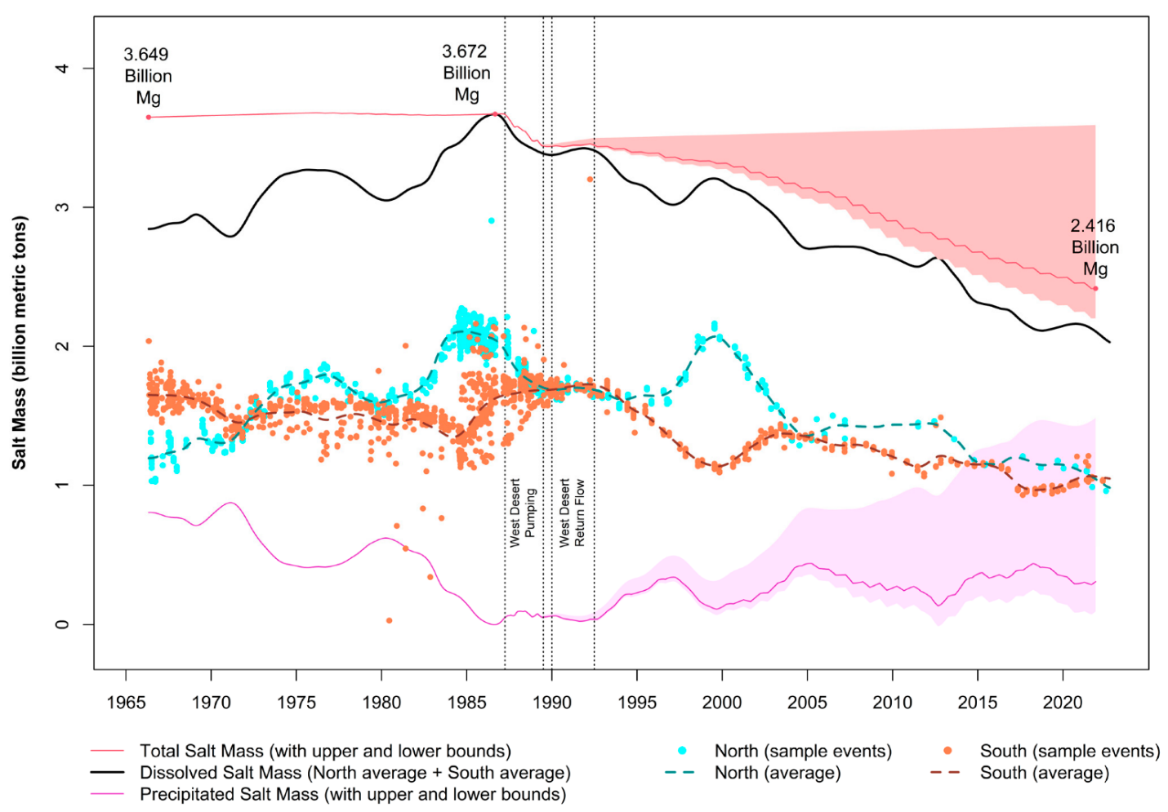
Source: Merck and Tarboton 2023.
Note: 1 Mg = 1 metric ton
- Stratification of the South Arm. An added disruption to GSL salinity, thought to be due to the causeway, was South Arm stratification (Madison 1970). South Arm salinity is thought to have been vertically homogeneous before the causeway was constructed (Wold et al. 1997). The South Arm was first observed to have two horizontal layers of water with different salinity in the 1960s. The upper brine layer (UBL) was observed to be “clean” and had a lower salinity than the deep brine layer (DBL). In addition to a higher salinity, the DBL was also observed to be “dirty” and have an offensive smell. The DBL was initially thought to be a relic of precipitated salts in the South Arm, but growing consensus supported a theory that it was a result of the migration of dense North Arm water that had passed through the causeway (Gwynn 1977). Consensus still maintains that the DBL in the South Arm, when present, is largely maintained by the migration of dense North Arm water into the South Arm (Loving et al. 2000; Naftz et al. 2014; Yang et al. 2019; Merck and Tarboton 2023).
Declining salinity in the South Arm in the 1960s motivated new studies and proposals for mitigating the salinity changes (Hahl and Mitchell 1963; Adams 1964; Hahl and Langford 1964; CRS 1965; Hahl and Handy 1969; Madison 1970). Adams (1964) first proposed diverting fresh water into the North Arm or pumping North Arm water back to the South Arm to restore the salt balance of GSL. The GSL 1965 Preliminary Master Plan (CRS 1965) affirmed Adams’ proposal (1964) to bring Bear River water to the North Arm and echoed recommendations from the 1930s (also a period of low lake water levels) to partition GSL to manage salinity and reduce evaporative loss.
Monitoring and consideration of options to manage salinity continued into the 1970s (Whelan and Stauffer 1972; Whelan 1973; Waddell and Bolke 1973; Whelan and Peterson 1975; Whelan and Peterson 1977). Concerns were centered on South Arm salinity becoming too low and North Arm salinity becoming too high. Some options considered for managing GSL salinity and salt mass included the following (Whelan and Stauffer 1972):
- Doing nothing. The South Arm was projected to freshen to approximately 55 grams per liter (g/L) with lake water levels at 4,205.0 feet if bidirectional flows through the causeway continued.
- Remove fill from approximately 1,500 feet of the causeway. This would restore normal circulation and equalize lake water levels and salinity between the South and North Arms.
- Pump 1,000 cubic feet per second of flow from the Bear River into the North Arm and remove fill from approximately 65 feet of the causeway. First proposed by Adams (1964), this option was intended to equalize lake water levels and salinity.
- Pump North Arm brines to South Arm mineral extraction industries (Adams 1964). This option would allow for South Arm industries to continue production even with a less saline South Arm.
- Pump South Arm brines to the North Arm. This option would equalize water levels, reduce North Arm salinity, reduce mass of salt precipitated in the North Arm, and make more salt available to industry.
Concerns over rapidly rising water levels in the 1970s and early 1980s, flooding along the GSL shoreline, and the integrity of the Northern Railroad Causeway in the 1970s (Gwynn 1977; Waddell and Fields 1977) temporarily diverted attention away from salinity concerns to focus upon strategies to control the lake’s water level. Gwynn (1977) summarized three early options for controlling the water level: expanding evaporation areas on the west side of the lake, pumping from the lake to the West Desert, and opening the causeway.

1980 through 2000
A rapid rise of almost 14 feet in lake water level from 1981 to 1986 (the South Arm rose to a historical peak of 4,211.85 feet in 1986 and 1987; DWRe 1999) established flood control as the new, highest priority in lake management. Interventions, while focused largely upon reducing lake water levels, did influence GSL’s salt balance. Key interventions included the following:
- High inflows to GSL created a 3.5-foot head differential across the Northern Railroad Causeway in 1983 (that is, much higher water levels in the South Arm than in the North Arm), contributing to flooding around the South Arm shoreline and placing the causeway itself at risk. A new breach in the causeway, the Lakeside Breach, was built in 1984 on the west end of the Northern Railroad Causeway to increase the capacity to convey water through and alleviate the head differential across the Northern Railroad Causeway (Figure 1-1). The Lakeside Breach was completed on August 1, 1984, and successfully reduced the head differential to less than 1 foot within just a few months (DWRe 1999; Loving et al. 2000). The resulting increase in bidirectional flow through the causeway significantly changed the balance of flow through the causeway. This change in flow resulted in North Arm stratification, precipitated salts in the North Arm coming back into solution, and a net transfer of salt mass to the South Arm of 500 million tons of salt from the North Arm from August 1, 1984, to May 1989 (Loving et al. 2000).
Key Takeaways from the 1980s and 1990s
Higher inflows to the South Arm in the 1980s resulted in rising lake water levels, a larger head differential between the South Arm (higher) and North Arm, and a net export of dissolved salt from the South Arm to the North Arm.
Declining lake water levels in the late 1980s and 1990s combined with seasonal reductions of inflow to the South Arm resulted in a lower head differential between the South Arm (higher) and North Arm, which then resulted in a net import of dissolved salt from the North Arm to the South Arm.
The Lakeside Breach and culverts worked in concert to respond to changing lake water levels and transport salt between the South and North Arms.
- Moving water from GSL to the West Desert was seen as a potential means of reducing risks from lake flooding as early as the 1880s. The State of Utah and its partners began feasibility studies in the 1970s to pump water from GSL to the West Desert as a means of enhancing evaporative losses and reducing or mitigating the rise of GSL lake water levels. The West Desert Pump Station and associated facilities were constructed, and the pump station became operational in April 1987. The pump station operated until August 1988 and pumped an estimated 1,768,000 acre-feet of water to the West Desert. An estimated 1,350,000 acre-feet of water evaporated (DWRe 1999) and approximately 300 to 600 million tons of salt was removed from GSL during the pump station operation (Wold and Waddell 1994; Loving et al. 2000; Mohammed and Tarboton 2012).
- Significant fill was added to the Northern Railroad Causeway during the 1980s to maintain its elevation above the rapidly rising lake water levels. The weight of added fill may have reduced the permeability of the causeway fill, reducing the amount of north-to-south flow returning salt back to the South Arm (Gwynn 2002).
The combined salt mass of the North and South Arms was largely stable as water levels declined and some salt returned from the West Desert from 1989 through 1993 as shown on Figure 2-1 (Loving et al. 2000; Merck and Tarboton 2023). The dissolved salt mass of GSL and South Arm salinity, however, began a slow decline in 1994 as lake water levels began to increase again in the late 1990s, salt began to move from the South Arm to the North Arm, stratification of the North Arm diminished, and more salt began to precipitate in the North Arm (Loving et al. 2000; Mohammed and Tarboton 2012; Merck and Tarboton 2023; Figure 2-1).
The steady decline in the salinity and in the South Arm’s brine shrimp population raised concerns over the potential for a significant shift in the ecosystem. In 1996, the State of Utah deepened the Lakeside Breach from an invert elevation of 4,200.0 feet to 4,198.0 feet and cleaned the two culverts to increase the amount of north-to-south flow and mitigate the decline in salinity. Even so, South Arm salinity declined from approximately 14 percent by weight in 1994 to 7 percent by weight in 1999 (Gwynn 2002).

2000 through 2020
The State of Utah deepened the Lakeside Breach again in 2000 to a new invert elevation of 4,193.0 feet (Gwynn 2002) to mitigate the continued decline in South Arm salinity by attempting to increase north-to-south flow through the causeway. The effort was successful and did temporarily raise South Arm salinity from 2000 to 2003; however, South Arm salinity reverted to a continued steady decline until approximately 2018 (Merck and Tarboton 2023; Figure 2-1).
Inspection of the two culverts in the Northern Railroad Causeway in the late 2000s raised concerns about their structural integrity. The Union Pacific Railroad (UPRR) applied for permits to close both culverts in 2011 and proposed constructing a new breach in the causeway. The west culvert was closed in 2012, and the east culvert was closed in 2013 by UPRR (HDR 2015). UPRR built a new bridge in 2016 and opened the New Breach to replace the capacity of the two original culverts to convey both water and salt between the South and North Arms (Figure 1-1). A low adaptive management berm across the flow channel was included as part of bridge construction to help regulate flow through the New Breach. The New Breach, with an invert elevation of approximately 4,178.0 feet, provided the State of Utah with a new tool, in addition to the Lakeside Breach (invert elevation of 4,193.0 feet), to better manage the salt flux between the South and North Arms even when lake water levels were below 4,195.0 feet. The New Breach was intended to preserve the historical salt balance; it did so until GSL water surface elevations continued to decline and South Arm salinity continued to rise in the early 2020s.

2020s
Record low lake water levels in 2021 and 2022 brought an intense focus upon South Arm rising salinities. The UBL salt mass had been steadily increasing since 2017 (when the New Breach opened), however, the source of the salt load was unknown. A new evaluation was completed of potential impacts from various levels of salinity upon the resources and uses of GSL (GSL SAC 2021b). A new, concerning salinity and lake water level relationship had been established as reflected by salinities more than 160 g/L in November 2021 (Brown 2021; Rumsey 2021). Emergency actions by the State of Utah to modify the adaptive management berm at the New Breach did mitigate the rise of salinity in 2022 and 2023 by preventing north-to-south flow through the New Breach, allowing for south-to-north flow to export salt to the North Arm and allowing inflows to the South Arm to dilute the salt mass of the South Arm. Continued monitoring, investigations, and discussions led to the development of this Plan.

South Arm Deep Brine Layer
South Arm stratification was first observed in the 1960s and is thought to have been formed as a result of Northern Railroad Causeway construction (Madison 1970; Gwynn 1977). The DBL has been maintained by higher salinity and density water from the North Arm flowing through the causeway rock-fill and openings and settling under the less saline South Arm water (Naftz et al. 2014; Yang et al. 2019). The DBL spreads throughout the South Arm with an interface with the UBL at a fairly consistent depth throughout the South Arm. The DBL is thought to slowly dissipate into the UBL but can also be mixed into the UBL during episodic wind events (Naftz et al. 2014; Yang et al. 2019). UBL salinity can potentially increase by 2 g/L to 8 g/L when the DBL is fully mixed into the UBL (Brown 2021; Rumsey 2021) but the DBL reforms after these mixing events.
Salinity Dynamics of the South Arm
South Arm salinity varies seasonally and spatially depending upon the timing of and proximity to freshwater inflows to it. Direct precipitation and spring runoff are less saline than the South Arm and will generally stay near the surface until they are mixed into the water column. Spring runoff generally lowers South Arm salinity by 5-78 g/L in the spring (average of 24 g/L); with salinity rebounding by 3-44 g/L after the summer evaporative season (average of 22 g/L). Locations near surface water inflow points or flow paths will typically be less saline than more remote or secluded areas. Wind events generally accelerate the mixing process.
A DBL forms in the South Arm if inflow of more saline and higher density water from the North Arm adequately flow through the Northern Railroad Causeway. The DBL is more saline than the UBL and is often anoxic. Water in the DBL generally flows toward the south side of the South Arm and slowly dissipates into the UBL. The South Arm can create a similar stratified intrusion into the fresher Bear River and Farmington Bays when conditions are favorable.
Freshwater inflow to GSL typically serves to dilute the salt mass and lower South Arm salinity but is an important means that drives flow and salt exchanges with the North Arm; these exchanges with the North Arm are central to South Arm salinity dynamics.
The DBL was observed from 1966 through 1991 but then dissipated from 1992 through 1997 due to a combination of low lake water levels, a reduction in the permeability of the causeway’s rock-fill and plugging of the culverts by debris (Jewell 2021; Merck and Tarboton 2023). Deepening of the Lakeside Breach in 1996 and again in 2000 likely reestablished the DBL in the South Arm (Jewell 2021), but it was not as pronounced after 1997 (Merck and Tarboton 2023). This weaker DBL may have been a result of reduced north-to-south flow through the causeway due to low lake water levels and a reduction in the permeability of the causeway’s rock-fill. Merck and Tarboton (2023) indicated 2009 through 2011 and 2014 through 2016 were additional periods when the DBL dissipated. Yang et al. (2019) noted that the 2014 through 2016 event was a result of UPRR plugging the two culverts with the DBL forming again in 2017 and 2018 after the New Breach was opened. The DBL disappeared 6 months after the culverts were closed, representing a lag between the act of terminating north-to-south flow and the disappearance of the DBL (Yang et al. 2019).
The DBL dissipated again in 2022 when the State of Utah first raised the adaptive management berm in the New Breach to actively “turn off” the north-to-south flow through the New Breach (Rowland 2022). The DBL appears to be reforming in Carrington Bay of the South Arm even as a low north-to-south flow has begun again at the New Breach (Rumsey 2025).

Great Salt Lake Salinity Advisory Committee
The GSL SAC was chartered in 2018 (GSL SAC 2018; GSL SAC 2024) to monitor changes in salinity and provide recommendations to the State of Utah regarding New Breach management and GSL salinity. The GSL SAC has accomplished the following:
- Developed and implemented a salinity research plan (GSL SAC 2020a)
- Standardized a protocol for measuring density and reporting the salinity of GSL (GSL SAC 2020b)
- Studied salinity dynamics and impacts in the South Arm (GSL SAC 2021b)
- Recommended salinity thresholds for the South Arm (GSL SAC 2021b)
- Initiated new modeling of the New Breach (Dutta et al. 2021; Rasmussen et al. 2021; Jacobs 2025) and GSL salt balance (Rumsey 2025; Rumsey and Hynek 2026)
- Recommended constructing a berm within the New Breach to mitigate rising salinity in the South Arm (GSL SAC 2021a; GSL SAC 2023a; GSL SAC 2023b)
South Arm salinity rose to a concerningly high level in 2021 and 2022 due to drought and changing trends in the lake water level; this resulted in the State of Utah actively managing GSL salinity through construction (2022) and modification (2023) of a new adaptive management berm at the New Breach. The new berm has successfully mitigated rising salinity in the South Arm at low water surface elevations (less than 4,192.0 feet), but more active flow control may be required to maintain South Arm salinity within the desired range of 120 g/L to 160 g/L. This has resulted in the following parallel and ongoing efforts to better understand and control GSL salinity:
- The State of Utah has been working with the United States Geological Survey (USGS) through the GSL SAC to develop an improved salt balance model for GSL.
- Several agencies and entities are monitoring GSL salinity on an ongoing basis. These include Utah Geological Survey, Utah Division of Wildlife Resources (DWR), DWQ, USGS, Utah State University, University of Utah, and brine shrimp harvesting and mineral extraction companies among others.
- USGS is currently working with FFSL, GSL Advisory Council, GSL SAC, and the mineral extraction industry on a mineral extraction study to better understand the flux of salt to and from mineral extraction ponds and to and from the North Arm.
- The Utah Division of Water Resources (DWRe) is updating its GSL model to better represent the salt and water mass balance of GSL over time.
- DWRe is also developing a GSL basin integrated plan to better understand inflows to GSL and provide a resilient water supply for GSL and all water uses, including people and the environment, throughout the watershed.
- FFSL, USGS, and Utah State University have been developing and implementing improved monitoring protocol, updated hydraulic models, and reporting of salinity, water surface elevations, and flow velocities and discharge through the New Breach (Dutta et al. 2021; Rasmussen et al. 2021; Jacobs 2025; Dunn et al. 2025; Dutta 2025).
- FFSL is currently updating its comprehensive management plan and mineral leasing plan for GSL that will incorporate salinity management goals and strategies.
- FFSL and DWQ have initiated new rules to regulate the mineral extraction industry and manage GSL salinity (House Bill 453); this includes a new salinity threshold of 150 g/L for the South Arm.
- FFSL evaluated several conceptual designs for a new flow control structure for the New Breach to provide additional flexibility in actively managing GSL salinity (Jacobs 2025). Options included construction of a slide gate or culvert and concrete block structure within the New Breach and using a pump station to pump North Arm water to the South Arm.
- The Utah Division of Water Rights (DWRi) developed a water distribution management plan for GSL to better manage diversion from and return of brines to GSL from mineral extraction operations (DWRi 2025).
- DWRi is also working with numerous partners, including the USGS, DWRe and DWR, to better characterize and monitor surface water inflows to GSL (Turney et al 2025, Luken et al 2024).
- The USGS is monitoring salt loading from surface water inflows to GSL.
- The Utah Geological Survey is working with its partners, including the USGS and University of Utah, to better understand groundwater inflows to GSL and salt loading to GSL from groundwater.
- GSL SAC is working to develop this Plan.

South Arm Salinity Thresholds
The South and North Arms are distinct waterbodies within GSL, each with unique water chemistries and ecosystems (Butts 1980; FFSL 2013; Baxter 2024). Utah Administrative Code (R317-2-6) reflects these differences in terms of how the different beneficial uses that Gilbert Bay (South Arm) and Gunnison Bay (North Arm) are protected. A high priority the GSL SAC identified was to develop a means to interpret salinity data and evaluate their significance (for example, how might a given salinity impact the different uses of GSL (GSL SAC 2020a)?) As such, the GSL SAC reviewed literature and GSL databases to describe critical salinity ranges that influence the lake’s resources and uses (GSL SAC 2021b). While Bear River Bay, Farmington Bay, and the North Arm were not disregarded, the GSL SAC chose to focus primarily on the South Arm, because the South Arm has the more sensitive management endpoints, and it and the North Arm are most directly impacted by management of the Lakeside and New Breaches. Figure 3-1 illustrates the range of salinities observed in the North Arm, South Arm, Bear River Bay and Farmington Bay for the period of 1966-2020 (GSL SAC 2021b).
FFSL and DWQ implemented recommended thresholds for South Arm salinity in 2021 based on the GSL SAC’s recommendations (GSL SAC 2021b). Figure 3-1 illustrates the historical range of salinity in the different GSL water bodies and the sensitivity of various users within GSL to changes in salinity. The ideal salinity range for South Arm UBL was identified as between 120 g/L to 160g/L (Figure 3-1). Salinities that are higher than this range result in marked responses by ecological resources, such as the failure of microbialite habitats and negative impacts on the brine fly and brine shrimp populations in the South Arm. A lower salinity of 90 g/L to 130 g/L is desired during spring months to enable brine shrimp to hatch (GSL SAC 2023b). These lower spring salinities have historically occurred by virtue of freshwater inflows and or precipitation on the lake. Salinities of less than 90 g/L can result in the propagation of corixids, a predator of brine shrimp, and significant shifts in the South Arm’s food web (GSL SAC 2021b).
Figure 3-1. Great Salt Lake South Arm Recommended Salinity
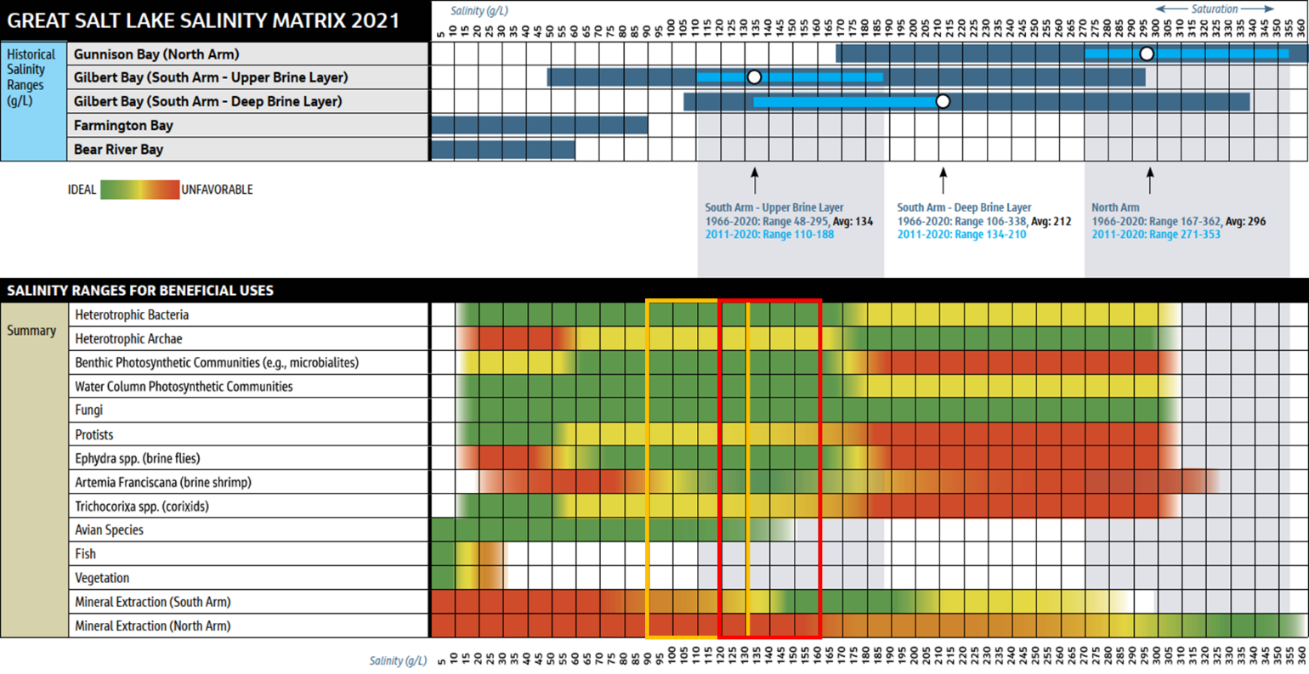
Sources: GSL SAC 2021b; GSL SAC 2023b.
Note: The recommended range is 120 g/L to 160 g/L, with a desired range of 90 g/L to 130 g/L during spring months.

South Arm Salinity Management
Extensive tracking and modeling of South Arm dissolved salt mass and salinity by the USGS, GSL Brine Shrimp Cooperative and GSL SAC confirmed that the dissolved salt mass of the post-causeway South Arm has been dynamic (Figure 2-1) and salinity, especially since implementation of the adaptive management berm in 2022, is not directly correlated to lake water level. An isomass plot (Rumsey and Hynek 2026, Figure 4-1), however, integrates volume-weighted South Arm salinity estimates and corresponding lake water levels with theoretical South Arm dissolved salt masses to describe the changing relationship between South Arm lake water level, dissolved salt mass, and salinity. Together, these provide a means to forecast how salinity could change as a function of lake elevation and salt mass and, thus, enable the State of Utah to determine if salinity management actions are warranted.
Figure 4-1. South Arm Volume-Weighted Salinity estimates and Corresponding South Arm Surface Elevations for Each Sample Collection Date
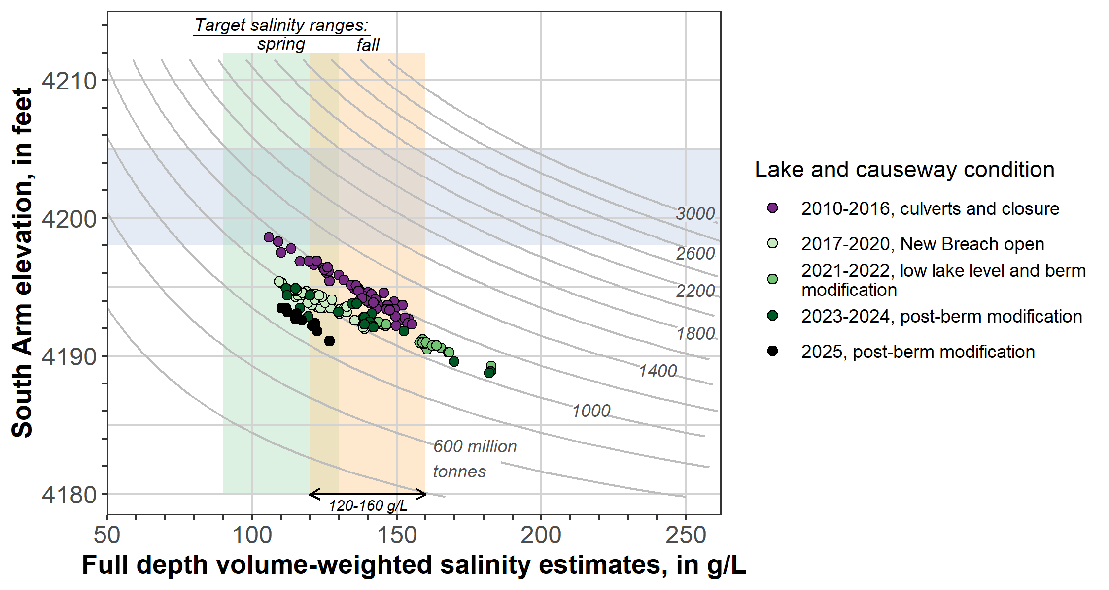
Note: These paired elevation-salinity values are plotted in the context of theoretical South Arm dissolved salt masses (grey lines define possible combinations of salinity and lake surface elevation for a given dissolved salt mass and are commonly referred to as isomass lines, or collectively as an isomass plot). Vertical bands depict target salinity ranges for fall (120 g/L to 160 g/L) (GSL SAC 2021; GSL SAC 2023b) and spring (90 g/L to 130 g/L) (GSL SAC 2023b); the horizontal band marks the target elevation range set forth by the GSL Commissioner’s Office (Steed 2024). Source: Rumsey and Hynek 2026
The following key elements are represented in the isomass plot:
- The South Arm water level is currently monitored by the USGS at its station at Saltair (USGS Station 1001000).
- The volume-weighted salinity provides a means to monitor conditions in the South Arm and potential impacts on South Arm resources and uses (GSL SAC 2021b). The GSL SAC recently approved and recommended a protocol for estimating this value (Rumsey and Hynek 2026).
- The South Arm dissolved salt mass provides a means to monitor how the South Arm is responding to changes in GSL inflow and lake water level and changes in flow and salt flux through the Northern Railroad Causeway (that is, through the causeway fill and Lakeside and New Breaches). The GSL SAC recently approved and recommended a protocol for estimating this value (Rumsey and Hynek 2026).

Recommended Approach
GSL salinity naturally rises as the standing dissolved salt mass is concentrated by declining water levels and declining water volume. Conversely, the salinity naturally declines as the dissolved salt mass is diluted by rising water levels and increasing water volume. Thus, a rising trend in lake water level will require a higher dissolved salt mass in the South Arm, and a declining trend in lake water level will require a lower dissolved salt mass in the South Arm to maintain South Arm salinity within desired thresholds (Figure 4-2). Figure 3-1 illustrates the desired thresholds for salinity in the South Arm.
Figure 4-2. Relationship between Salinity Management and Trending Water Levels in Great Salt Lake
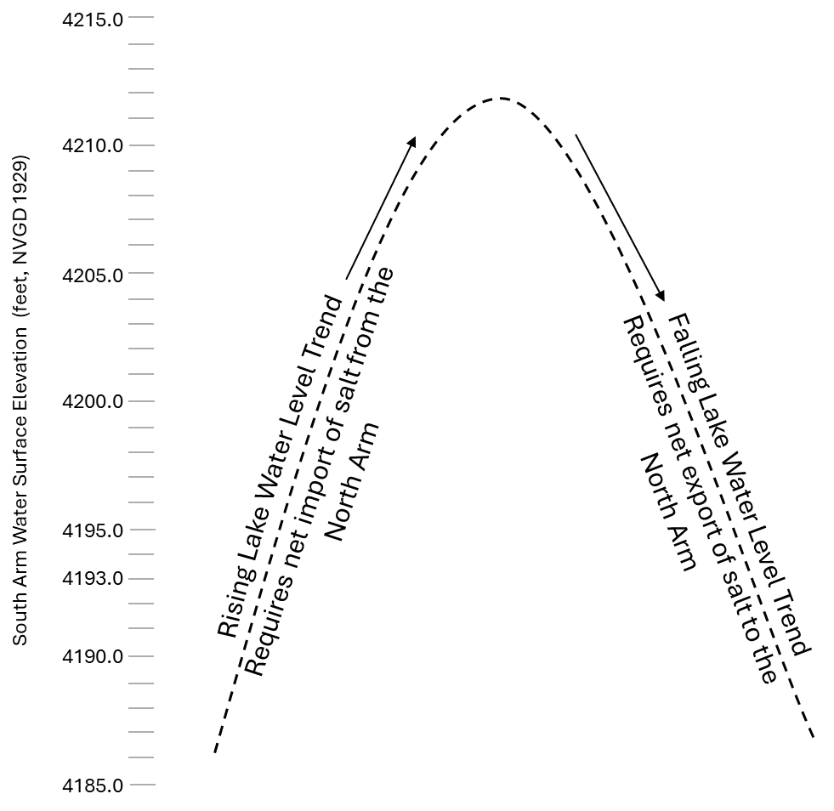
The North Arm can be both a source of salt for the South Arm when needed and a location to export to and sequester salt if less salt is needed in the South Arm. The recommended approach to managing the dissolved salt mass and salinity in response to changing lake water levels in the South Arm is by controlling the transfer of water and dissolved salt to and from the North Arm through the Northern Railroad Causeway. This approach has significant challenges, including the following:
- Forecasting year-to-year changes of inflow to GSL and resulting year-to-year trends in lake water level is extremely difficult.
- The lake water level can fluctuate up to 3 feet within a given year.
- The response of observed salinity lags with changes in lake water level.
- Controlling the flow of water and salt through the causeway can be complex.
- This approach does not address other sources of salt loading to GSL such as from groundwater.
Salinity management is a long-term endeavor; months, if not years, will be needed to influence the direction of South Arm salinity. Active salinity management will require carefully monitoring water levels and water density in the South and North Arms and improved monitoring, modeling, and management of inflows to GSL to facilitate forecasting of changes in lake water level and salinity. The recommended approach for salinity management centers on key activities that can be implemented within GSL when lake water level trends are declining or rising, regardless of actions taken to manage inflow to GSL.
Utah Administrative Code R317-17-3
This new rule was promulgated in 2025 as an additional strategy to limit the discharge of brine to GSL, that is, new salt load to the South Arm, if the salinity of the South Arm exceeds 150 g/L.

Long-Term Salinity Management Plan
The following section defines objectives, an approach, and recommended actions for long-term South Arm salinity management.

Objectives
South Arm salinity management should accomplish the following:
- Maintain a dissolved salt mass in the South Arm commensurate to the lake water level and water volume required for the target salinity range (Figures 3-1 and 4-1). This is consistent with the State of Utah’s goal for South Arm long-term salinity management.
- Maintain the South Arm’s UBL volume-weighted salinity within the target salinity range of 120 g/L to 160 g/L in the fall and 90 g/L to 130 g/L in the spring.
A recommended target UBL salinity of approximately 120 g/L in the fall (such as on October 1) will best position the South Arm for desired spring salinities and optimize opportunities to adjust for rising or falling lake water levels. This value is only provided for guidance in decision-making and is not a requirement.

Approach
The State of Utah should complete the following tasks aligned with the recommended approach for South Arm salinity management as illustrated in Figure 4-3:
- Monitor fluctuations and trends in lake water level, dissolved salt mass, and salinity in the South and North Arms. The differentials in water level and water density between the South and North Arms are what drives the flow of water and salt through the Northern Railroad Causeway (Loving et al. 2000; Dutta et al. 2021; Jacobs 2025). Ongoing monitoring of the South Arm dissolved salt mass and salinity provides a snapshot of the South Arm’s existing conditions and trends. Figure 4-4 summarizes parameters that should be part of an ongoing monitoring program.
- Monitor discharge and salt flux through the Northern Railroad Causeway. These activities should include both the New and Lakeside Breaches and improved estimates of flow through the rock-fill of the causeway (Figure 4-5). This information is used to evaluate trends in salt flux through the causeway and inform potential interventions.
- Compute the South Arm UBL volume-weighted salinity using methods described by Rumsey and Hynek (2025) and assess if the UBL salinity is within desired thresholds. The UBL volume-weighted salinity represents the salinity experienced by the majority of biota in the South Arm. Figure 3-1 shows salinity thresholds (GSL SAC 2021b).
- Compute the South Arm full-depth volume-weighted salinity and dissolved salt mass using methods described by Rumsey and Hynek (2025).
- Assess whether the full-depth volume-weighted salinity is within desired thresholds. The full-depth volume-weighted salinity represents the salinity that could occur if the UBL and DBL fully mixed, thus representing a worst-case value for the present condition. Figure 3-1 shows salinity thresholds (GSL SAC 2021b).
Figure 4-3. Recommended Approach for South Arm Salinity Management
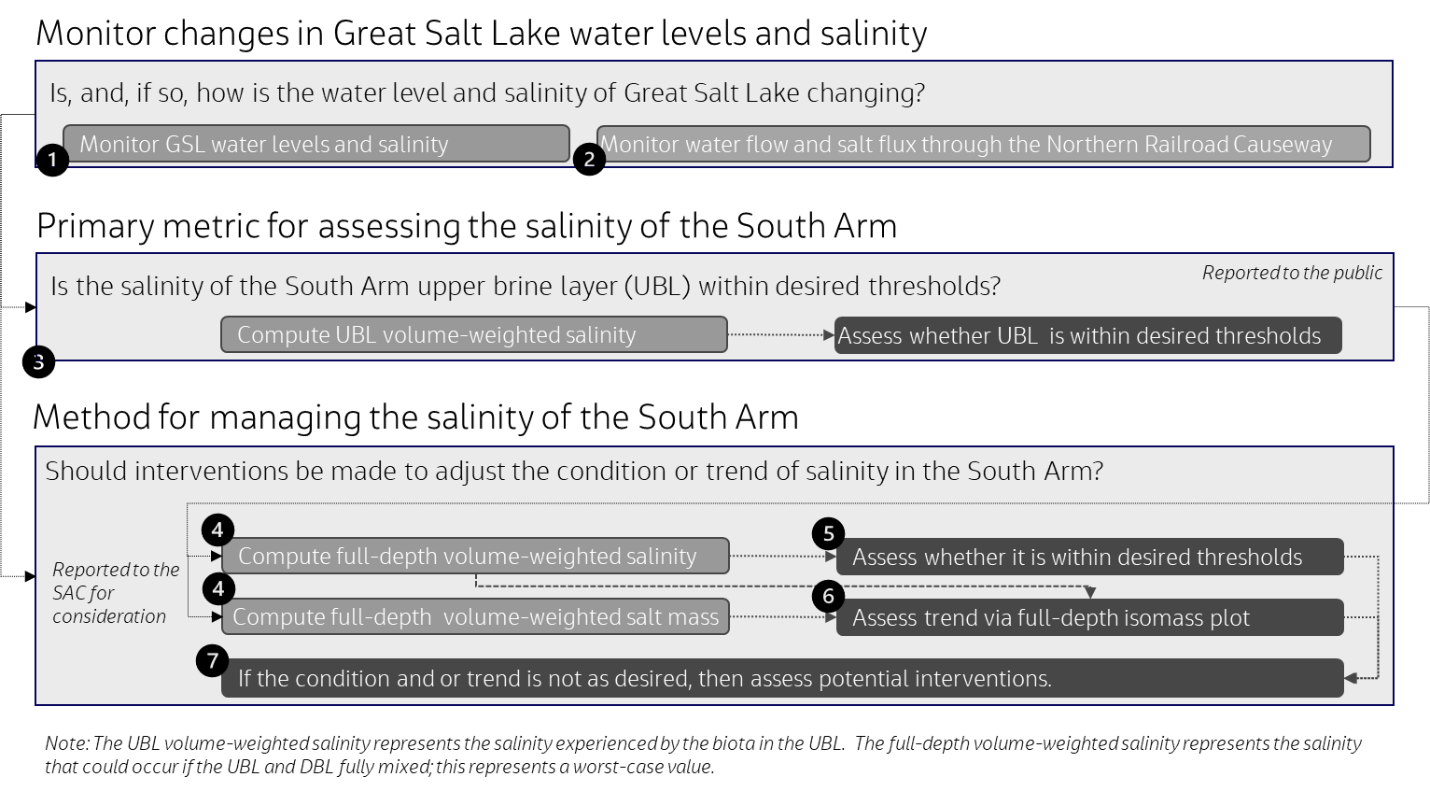
- Assess whether the trend of the South Arm full-depth volume-weighted dissolved salinity and salt mass is as desired.
Figure 4-4. Recommended Minimum Monitoring and Sampling to Track Changes in Temperature, Density, and Salinity in South and North Arms and Estimate Monthly Volume-Weighted Dissolved Salt Mass and Upper Brine Layer Salinity in South Arm
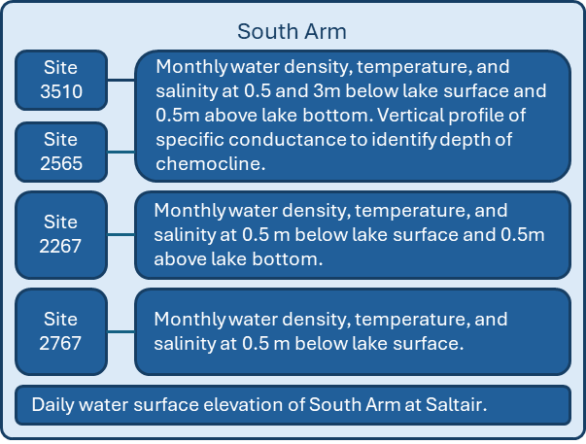
  - Plot South Arm existing conditions as represented by the measured water level, estimated dissolved salt mass, and the estimated full-depth volume-weighted South Arm salinity, on the isomass plot for the South Arm (Figure 4-1).
  - Evaluate recent and long-term trends in observed changes in lake water level, dissolved salt mass, and salinity to understand the trajectory of salinity change.
  - Estimate future lake water level and dissolved salt mass based upon seasonal and year-to-year trends in changing water level, dissolved salt mass, and salt loading to or export from the South Arm.
- Determine whether forecasted changes in salinity are acceptable and or action is warranted. Figure 4-6 may be used in addition to Figure 3-1 to identify the desired range of dissolved salt mass for a given lake water level, assess the current condition, and evaluate whether action is warranted. Target salinities of 90 g/L, 120 g/L, and 160 g/L are those on Figure 4-1; these targets may be updated by FFSL as new information arises.
Figure 4-5. Recommended Minimum Monitoring and Sampling to Track Water Flow and Salt Flux through the Northern Railroad Causeway
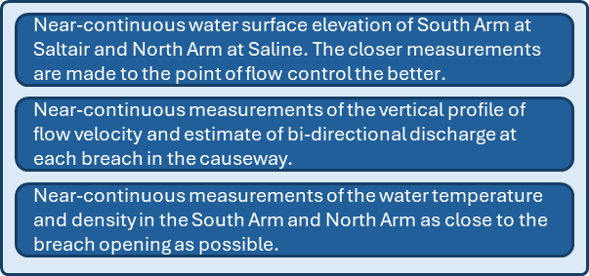
- Control flow exchanges and salt flux between the North and South Arms through the Northern Railroad Causeway if action is warranted.

Recommendations
This section summarizes salinity management and operational recommendations for the South Arm of Great Salt Lake.

Management Recommendations
The following recommendations for salinity management will be validated and updated per recommendations from the GSL SAC as conditions warrant. Recommendations are grouped for three different lake water level paradigms: stable, declining and rising water levels. New tools may be required if lake water levels begin to increase again.
- Maintain desired salinity for stable lake water levels: South Arm salinity and the salt flux through the causeway will fluctuate seasonally due to changing hydrologic conditions. However, if South Arm salinity is generally within the desired range, then the annual net salt flux through the causeway should be maintained as close to zero as possible (that is, the annual south-to-north salt flux is similar to annual north-to-south salt flux). This may be accomplished by establishing full-depth bi-directional flow through the breaches in the causeway (Jacobs 2025). Careful monitoring of seasonal salt flux dynamics will be required. South-to-north fluxes will dominate during spring runoff when South Arm water levels rise; north-to-south fluxes will dominate in the fall after spring runoff ends and South Arm water levels start to decline. Careful flow control through the breach may also be required.
- Maintain desired salinity for declining lake water levels: Declining lake water levels in the South Arm concentrate the standing salt mass and increase the salinity and may indicate a need to reduce the salinity and dissolved salt mass of the South Arm. If a decrease in South Arm salinity is needed, then salt export to the North Arm must be increased and salt import from the North Arm must be decreased to achieve a net positive salt flux to the North Arm. The adaptive management berm was effectively used in this manner at the New Breach in 2022 through 2025. The response time is likely 6 to 12 months for these strategies.
The actual salt flux through the causeway depends upon the actual water level and water density differential between the South and North Arms. A lower water density differential between the South and North Arms will generally decrease deep north-to-south flows through the causeway, and a higher water level differential between the South and North Arms will generally increase surface south-to-north flows through the causeway (Loving et al. 2000; Dutta et al. 2021; Jacobs 2025). A combination of the following strategies may be used to maintain a desired salinity when lake water levels are declining:
Successful Case Study
Modifying the adaptive management berm in the New Breach in July 2022 (from 4,183.0 feet to 4,187 feet) and February 2023 (from 4,187.0 feet to 4,192.0 feet) illustrated the effectiveness of the recommended strategy for maintaining South Arm salinity within desired thresholds with declining lake water levels and high salinity conditions (>180 g/L). Raising the adaptive management berm to progressively higher elevations reduced the import of dissolved salt from the North Arm to the South Arm, facilitated an increase in water levels and water volume and, thus, dilution of dissolved salt mass in the South Arm, and allowed for the export of dissolved salt to the North Arm. The result was a lower standing dissolved salt mass and salinity within desired thresholds in the South Arm for historically low lake water levels (Figure 6-1).
  - Reduce salt import from the North Arm. Deep north-to-south flows through the New and Lakeside Breaches may be controlled using a berm (or gate) that extends from the channel bottom to a height commensurate to the north-to-south flow rate that is desired. A higher berm will limit more north-to-south flow, and an adequately high berm can completely block north-to-south flow if desired (Dutta et al. 2021).

Figure 4-6. Target Dissolved Salt Mass in the South Arm for Various South Arm Water Levels and Salinity Targets
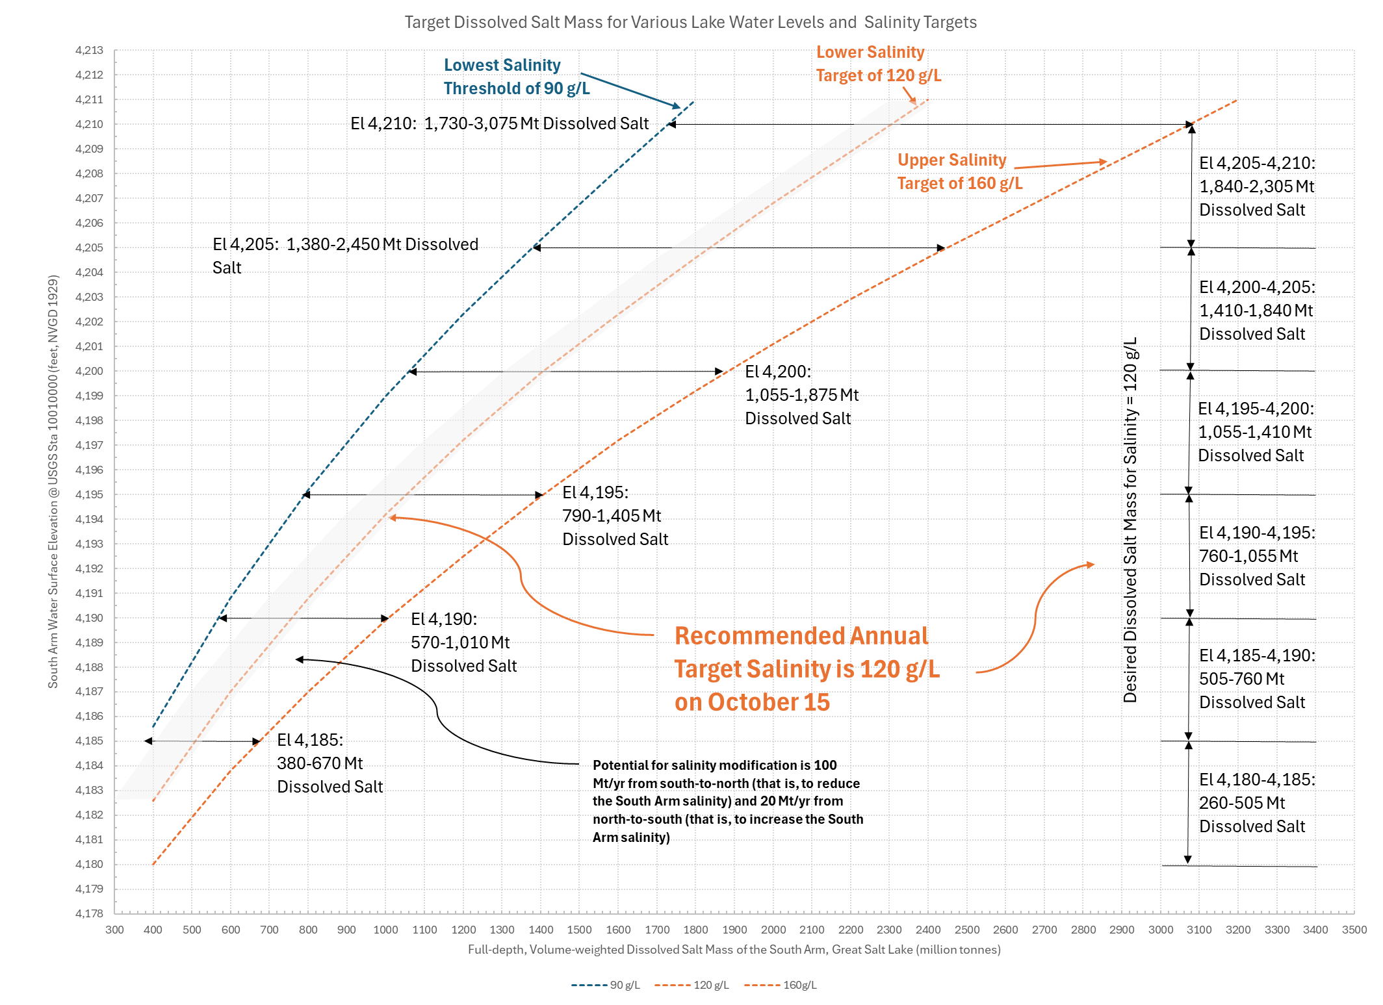
Source: Derived from isomass plot (Rumsey and Hynek 2026) and salinity matrix (GSL SAC 2021b; GSL SAC 2023b).
El = elevation

  - Increase salt export to the North Arm. Surface south-to-north flows through the New and Lakeside Breaches may be controlled using a gate that extends from the water surface to a depth commensurate to the south-to-north flow rate that is desired. A gate that extends to a shallower depth (that is, the opening is greater) will increase south-to-north flow, and the lack of any gate at the surface will maximize south-to-north flow for the available channel width (Jacobs 2025). Note that Bear River inflows have been observed to flow more directly through the South Arm toward the New Breach without fully mixing with the South Arm. The salinity of south-to-north flows may thus be slightly lower than observed in the South Arm
  - Dilute the dissolved salt mass in the South Arm. To accomplish this, inflows to the South Arm should be temporarily detained to raise the South Arm water level, dilute the standing dissolved salt mass, and reduce the South Arm salinity; to do this, openings to the New and Lakeside Breaches should be temporarily constricted or blocked. This strategy will likely increase the water level differential between the South and North Arms and result in the export of water and salt to the North Arm when the blockage is removed. Care must be taken to protect the resources and uses of the North Arm when this strategy is implemented.
- Maintain a desired salinity for rising lake water levels: Rising lake water levels in the South Arm dilute the standing salt mass, lower the salinity, and may indicate a need to increase South Arm salinity and dissolved salt mass. If an increase in South Arm salinity is needed, then the export of salt to the North Arm must be reduced, and the import of salt from the North Arm must be increased to achieve a net positive salt flux to the South Arm. Initial analyses indicate that increasing South Arm salinity could occur only with careful flow control at the New and Lakeside Breaches and over a period of years (Jacobs 2025). Natural inflow to the South Arm has generally resulted in a net long-term export of salt through the causeway to the North Arm (Merck and Tarboton 2023).
The actual salt flux through the causeway depends upon the actual water level and water density differential between the South and North Arms. A higher water density differential between the South and North Arms will generally increase deep north-to-south flows through the causeway, and a lower water level differential between the South and North Arms will generally decrease surface south-to-north flows through the causeway (Loving et al. 2000, Dutta et al. 2021, Jacobs 2025). A combination of the following strategies may be used to maintain a desired salinity when lake water levels are rising:
  - Increase salt import from the North Arm. Deep north-to-south flows through the New and Lakeside Breaches may be increased by lowering or removing a berm (or gate) to a height commensurate to the north-to-south flow rate that is desired. A lower berm will increase north-to-south flow. Completely removing the berm will maximize north-to-south flow through the breach. Lakeside Breach construction in 1984 and then its deepening in 1986 and 2000 enabled a net positive flux of salt to the South Arm at that time (Merck and Tarboton 2023). Recent low lake water levels, however, have prevented North Arm water from reaching the Lakeside Breach. An additional option considered by the GSL SAC was to pump North Arm water directly to the South Arm (Jacobs 2025).
Target North Arm and South Arm Salt Flux for Rising Great Salt Lake
The approximate net annual north-to-south salt flux required to maintain South Arm salinity for every 0.5 foot of annual lake water level rise is as follows (note: actual mass required depends on target salinity):
- 4,185 feet to 4,190 feet: 20 Mt/yr to 35 Mt/yr
- 4,190 feet to 4,195 feet: 20 Mt/yr to 45 Mt/yr
- 4,195 feet to 4,200 feet: 25 Mt/yr to 50 Mt/yr
- 4,200 feet to 4,205 feet: 30 Mt/yr to 60 Mt/yr
- 4,205 feet to 4,210 feet: 35 Mt/yr to 60 Mt/yr
  - Import salt to the South Arm from other sources. Two additional options considered by the GSL SAC to import salt to the South Arm are to divert natural runoff from the West Desert to the South Arm via the Lakeside Breach and to flush sequestered salts in evaporation basins along the shoreline to the South Arm.
  - Reduce salt export to the North Arm. Surface south-to-north flows through the New and Lakeside Breaches may be controlled using a gate that extends from the water surface to a depth commensurate to the south-to-north flow rate that is desired. A gate (or other structure within the flow stream) that extends to a deeper depth (that is, the opening is smaller) will limit more south-to-north flow. Most surface south-to-north flow could be blocked with a gate but will require that the water level differential is very low. This could likely only be accomplished under carefully timed and controlled conditions during natural, seasonal lake water level dynamics (Jacobs 2025).

Operational Recommendations
The following recommendations are offered to assist in guiding operational decisions:
- For active salinity management, carefully monitor water levels and water density in the South and North Arms and improve monitoring, modeling, and management of inflows to GSL to facilitate forecasting of changes in lake water level and salinity (refer to Figures 4-4 and 4-5 for monitoring recommendations).
- Target a recommended target salinity of approximately 120 g/L on October 15 to best position the South Arm for desired spring salinities and optimize opportunities to adjust for rising or falling lake water levels; Figure 4-6 illustrates assessing the required dissolved salt mass for a given lake water level and salinity. This target salinity is provided only as guidance and is not a requirement.
- Understand salinity management is a long-term endeavor; months, if not years, will be needed to influence the direction of South Arm salinity. Based upon the GSL SAC’s experience, an intervention at the New Breach with currently available tools could elicit a response of up to a net annual flux of 100 million tonnes per year (Mt/yr) south-to-north and a net annual flux of 20 Mt/yr north-to-south (Figure 4-6). For example, for a given lake water level and a desired salinity of 120 g/L (or other value as desired), the South Arm dissolved salt mass would ideally not be more than 100 Mt above or 20 Mt below the required salt mass for a salinity of 120 g/L at that water level (Figure 4-6). This would allow for operational changes to have the highest likelihood of achieving the desired target within the year. These rates are solely based upon professional judgement and must be investigated and confirmed, however, they do provide some guidance as to what may be possible within 12 months with readily available tools.

Conclusions
Intensive work by FFSL, DWQ and all its partners on the GSL SAC has resulted in a strategy and a plan for South Arm salinity management. Work, however, is not complete.
The GSL SAC, FFSL, and DWQ are continuing to monitor and work toward better understanding the dynamics and influence of GSL’s salinity to better manage and minimize impacts from changing salinity on GSL resources and uses. FFSL has been working closely with mineral extraction companies to evaluate options and develop agreements that better protect the lake and is updating GSL’s comprehensive management plan. DWQ recently developed new rules to limit discharges from mineral extraction evaporative ponds when South Arm salinity exceeds 150 g/L. This Plan will be incorporated into FFSL’s updated comprehensive management plan, which is expected to be finalized in 2026.
Achieving Healthy Great Salt Lake Water Levels
The GSL Commissioner’s Office references a healthy range of water levels in GSL of 4,198 feet to 4,205 feet. Contemporary (2025) water levels in the South Arm are 4,193.0 feet, requiring a substantial volume increase to achieve healthy water levels. The South Arm will require a commensurate increase in dissolved salt mass to stay within desired salinity ranges at these healthy water levels; this increase can be achieved by controlling flow exchanges between the North and South Arms to facilitate the net import of dissolved salt mass into the South Arm. This control may represent the best opportunity to manage South Arm salinity at high lake water levels.
Further study of the South Arm salt and water balance is needed to better refine operational requirements for these exchanges. Further study of sources of salt loading to and salt dynamics within the South Arm will help identify additional opportunities to better manage salinity. Improved forecasting of GSL inflows will enable the State of Utah to anticipate changes in GSL’s water level and better shape GSL’s trajectory of salinity. These are all steps that will enable the State of Utah to better manage South Arm salinity for the benefit of GSL’s unique resources and uses.

References
Adams, T.C. 1964. “Salt Migration to the Northwest Boyd of Great Salt Lake, Utah.” Sci. Vol. 143, pp. 1027-1029.
Baxter, B.K. (2024). The Great Salt Lake Food Chains: Fragility and Resiliency. University of Utah Press. https://dx.doi.org/10.1353/book.135731.
Belovsky, G.E., D. Stephens, C. Perschon, P. Birdsey, D. Paul, D. Naftz, R. Baskin, C. Larson, C. Mellison, J. Luft, R. Mosley, H. Mahon, J. Van Leeuwen, and D. V. Allen. 2011. “The Great Salt Lake Ecosystem (Utah, USA): long term data and a structural equation approach.” Ecosphere 2(3), pp. 1-40. https://doi.org/10.1890/ES10-00091.1.
Brown, P. 2021. Gilbert Bay Salinity Trends, 2010-2021. Presentation to the Great Salt Lake Salinity Advisory Committee, Utah Department of Natural Resources, Salt Lake City, Utah. September 14.
Butts, D.S. 1980. “Factors Affecting the Concentration of Great Salt Lake Brines.” In: Great Salt Lake—a scientific, historical, and economic overview. J.W. Gwynn, editor. Utah Geological and Mineral Survey Bulletin 116, pp. 163-167, https://doi.org/10.34191/B-116.
Caldwell, Richards & Sorensen, Inc. (CRS). 1965. A Preliminary Master Plan for the Development of the Great Salt Lake – Over a Period of the Next 75 Years. Prepared for Great Salt Lake Authority. January 15.
Dunn, D, S. Dutta, S. Izadifar, and Y. Chen. 2025. Increasing the Fidelity of Water and Salt Balance Prediction in the Great Salt Lake. Presentation to the Great Salt Lake Salinity Technical Team, Utah Department of Natural Resources, Salt Lake City, Utah. May 13.
Dutta, S. 2025. Fiscal Year 2025 Updates: 3D Hydrodynamic Model of the GSL. Presentation to the Great Salt Lake Technical Team, Utah Department of Natural Resources, Salt Lake City, Utah. May 13.
Dutta, S., B.M. Crookston, M. Rasmussen, and R. Larsen. 2021. Predicting Flow through the Causeway of the Great Salt Lake Using Hydrodynamic Simulations and Artificial Neural Networks. Final Report. Prepared for Utah Department of Natural Resources. July 31.
Great Salt Lake Salinity Advisory Committee (GSL SAC). 2018. Where does the GSL Salinity Advisory Committee fit in? https://ffsl.utah.gov/wp-content/uploads/OrgChart_v3.pdf.
Great Salt Lake Salinity Advisory Committee (GSL SAC). 2020a. Salinity Research and Monitoring Framework for Great Salt Lake. Draft Memorandum. Prepared for Utah Divisions of Forestry, Fire and State Lands and Water Quality. October 2.
Great Salt Lake Salinity Advisory Committee (GSL SAC). 2020b. Standard Operating Procedure - Great Salt Lake Water Density Measurement and Salinity Calculation. Utah Geological Survey Open File Report 728. https://doi.org/10.34191/OFR-728.
Great Salt Lake Salinity Advisory Committee (GSL SAC). 2021a. Recommendations Pertaining to Rising Salinities in the South Arm of Great Salt Lake. Letter to Directors Jamie Barnes and Erica Gaddis. December 2.
Great Salt Lake Salinity Advisory Committee (GSL SAC). 2021b. Influence of Salinity on the Resources and Uses of Great Salt Lake. Utah Geological Survey Open File Report 736. https://doi.org/10.34191/OFR-736.
Great Salt Lake Salinity Advisory Committee (GSL SAC). 2023a. Recommendations Pertaining to Rising Salinities in the South Arm. Letter to Directors Jamie Barnes and John Mackey. January 23.
Great Salt Lake Salinity Advisory Committee (GSL SAC). 2023b. Recommendations Pertaining to Interim Protocol for Berm Modifications. Letter to Utah Divisions of Forestry, Fire and State Lands and Water Quality. April 6.
Great Salt Lake Salinity Advisory Committee (GSL SAC). 2024. Great Salt Lake Salinity Advisory Committee Charter. October. https://ffsl.utah.gov/wp-content/uploads/SACCharter_final_October-2024.pdf
Gwynn, J.W. 1977. “An evaluation of the effect of proposed lake level and salinity controls on the brines of the Great Salt Lake, Utah.” Utah Geology Vol. 4, No.2, pp. 85-93.
Gwynn, W. 2002. A Lake Divided - A History of the Southern Pacific Railroad Causeway and its Effect on Great Salt Lake, Utah. Survey notes. Vol. 34, No. 1. https://geology.utah.gov/map-pub/survey-notes/a-lake-divided-a-history-of-the-sprr-causeway-and-its-effects/.
Hahl, D.C. and A.H. Handy. 1969. Great Salt Lake, Utah: Chemical and physical variations of the brine, 1963-1966. Utah Geological and Mineral Survey Water Resources Bulletin 12.
Hahl, D.C. and C.G. Mitchell. 1963. Dissolved-mineral inflow to Great Salt Lake and chemical characteristics of the salt lake brine. Part I: Selected hydrologic data. Utah Geological and Mineral Survey Water Resources Bulletin 3.
Hahl, D.C. and R.H. Langford. 1964. Dissolved-mineral inflow to Great Salt Lake and chemical characteristics of the salt lake brine. Part II: Technical report. Utah Geological and Mineral Survey Water Resources Bulletin 3.
Handy, A.H. and D.C. Hahl. 1966. “Great Salt Lake, Chemistry of the water.” In: The Great Salt Lake: Utah Geological Survey Guidebook to the Geology of Utah. No. 20, pp. 135-151.
HDR Engineering, Inc. (HDR). 2015. Union Pacific Railroad Great Salt Lake causeway culvert closure and bridge construction project, final compensatory mitigation and monitoring plan. Utah Department of Environmental Quality. January 7. https://documents.deq.utah.gov/water-quality/standards-technical-services/gsl-website-docs/uprr-causeway/DWQ-2017-006447.pdf.
Jacobs Engineering Group Inc (Jacobs). 2025. Basis of Design: Great Salt Lake Breach Flow Control Structure. Final Report. Prepared for Utah Department of Natural Resources, Division of Forestry Fire and State Lands. March 11.
Jewell, P.W. 2021. “Historic low stand of Great Salt Lake, Utah: I.” SN Appl. Sci. 3, 757. https://doi.org/10.1007/s42452-021-04691-5.
Loving, B.L., K.M. Waddell, and C.W. Miller. 2000. Water and salt balance of Great Salt Lake, Utah, and simulation of water and salt movement through the causeway, 1987–98. U.S. Geological Survey Water Resources Investigations Report 00-4221.
Lukens, E., E. K. Turney, S. Null, B. Neilson (2024). Measurement and Infrastructure Gap Analysis in Utah's Great Salt Lake Basin, HydroShare, https://doi.org/10.4211/hs.8bf055dbe78b46d184cc7a4bb53931c7
Madison, R.J. 1970. Effects of a causeway on the chemistry of the brine in Great Salt Lake, Utah. Utah Geological and Mineral Survey Water Resources Bulletin 14.
Merck, Madeline F. and David G. Tarboton. 2023. The Salinity of the Great Salt Lake and Its Deep Brine Layer. Publications. Paper 175. https://digitalcommons.usu.edu/water_pubs/175 https://doi.org/10.3390/w15081488.
Mohammed, I.N. and D.G. Tarboton. 2012. “An examination of the sensitivity of the Great Salt Lake to changes in inputs.” Water Resour. Res. 48, W11511. https://doi.org/10.1029/2012/WR011908.
Naftz, D.L., G.T. Carling, C. Angeroth, M. Freeman, R. Rowland, and E. Pazmino, 2014. “Density-stratified flow events in Great Salt Lake, Utah, USA: implications for mercury and salinity cycling.” Aquat. Geochem. 20 (6), pp. 547–571. https://doi.org/10.1007/s10498-014-9237-8.
Rasmussen, M., S. Dutta, B.T. Neilson, and B.M. Crookston. 2021. “CFD Model of the Density-Driven Bidirectional Flows through the West Crack Breach in the Great Salt Lake Causeway.” Water 2021, 13 2423. https://doi.org/10.3390/w13172423.
Rowland, R. 2022. Update on Great Salt Lake Conditions. Presentation to the Great Salt Lake Salinity Advisory Committee, Utah Department of Natural Resources, Salt Lake City, Utah. April 6.
Rowland, R. 2025. Update on Great Salt Lake Conditions. Presentation to the Great Salt Lake Salinity Advisory Committee, Utah Department of Natural Resources, Salt Lake City, Utah. March 25.
Rumsey, C. 2021. Update on Great Salt Lake Conditions. Presentation to the Great Salt Lake Salinity Advisory Committee, Utah Department of Natural Resources, Salt Lake City, Utah. November 9.
Rumsey, C. 2025. Update on Great Salt Lake Conditions. Presentation to the Great Salt Lake Salinity Advisory Committee, Utah Department of Natural Resources, Salt Lake City, Utah. March 20.
Rumsey, C. and Hynek, S. 2026. Methodology to estimate South Arm dissolved salt mass and volume-weighted salinity values. Prepared by U.S. Geological Survey for Utah Division of Forestry, Fire and State Lands, Utah Department of Environmental Quality, and the Great Salt Lake Salinity Advisory Committee. January.
Steed, B. 2024. The Great Salt Lake Strategic Plan. Submitted by Great Salt Lake Commissioner’s Office. https://greatsaltlake.utah.gov/great-salt-lake-strategic-plan-2.
Sturm, P.A. 1980. “The Great Salt Lake brine system.” In: Great Salt Lake—a scientific, historical, and economic overview. J.W. Gwynn, editor. Utah Geological and Mineral Survey Bulletin 116, pp. 147-162, https://doi.org/10.34191/B-116.
Turney, E., E. Lukens, S. Null, B. Neilson (2025). Evaluating Surface Water Movement and Measurement near Great Salt Lake, HydroShare, https://doi.org/10.4211/hs.4dff7b44bc574fb29beaa6ee56adbddd
Utah Division of Water Resources (DWRe). 1999. The Great Salt Lake West Desert Pumping Project; its Design, Development and Operation. Utah Department of Natural Resources. June..
Utah Division of Water Rights (DWRi). 2025. Great Salt Lake Distribution Management Plan. Adopted October 1, 2025. https://waterrights.utah.gov/GSLDMP/final_GSL_distribution_management_plan_2025101.pdf
Utah Division of Forestry, Fire and State Lands (FFSL). 2013. Final Great Salt Lake Comprehensive Management Plan and Record of Decision. Prepared by SWCA Environmental Consultants for the Utah Division of Forestry, Fire and State Lands. March. https://ffsl.utah.gov/wp-content/uploads/OnlineGSL-CMPandROD-March2013.pdf.
Waddell, K.M. and E.L. Bolke. 1973. The effects of restricted circulation on the salt balance of Great Salt Lake, Utah. Utah Geological and Mineral Survey Bulletin 18.
Waddell, K.M. and F.K. Fields. 1977. Model for Evaluating the Effects of Dikes on the Water and Salt Balance of Great Salt Lake, Utah. Prepared by U.S. Geological Survey for Utah Geological and Mineral Survey. Water Resources Bulletin 21.
Whelan, J.A. 1971. Freshening of South Arm Great Salt Lake, Utah: 1959 - 1971+. Report of Investigation No. 60. Utah Geological and Mineralogical Survey.
Whelan, J.A. 1973. Great Salt Lake, Utah: Chemical and Physical Variations of the Brine, 1966-1972. Utah Geological and Mineralogical Survey Water Resources Bulletin 17.
Whelan, J.A. and C.A. Peterson, 1975. Chemical and physical variations of the brine, water year 1973, Great Salt Lake, Utah. Water Resources Bulletin 20.
Whelan, J.A. and C.A. Peterson, 1977. Chemical and physical variations of the brine, water years 1974 and 9175, Great Salt Lake, Utah. Water Resources Bulletin 22.
Whelan, J.A. and N. Stauffer. 1972. Preliminary report on possible solution to "fill effect" causing dilution of South Arm brines and concentration of North Arm brines, Great Salt Lake, Utah. Utah Geological and Mineral Survey Special Studies No. 40.
Wold, S.R. and K.M. Waddell. 1994. Salt Budget for West Pond, Utah, April 1987 to June 1989. U.S. Geological Survey Water Resources Investigations Report 93-4028.
Wold, S.R., Thomas, B.E., and Waddell, K.M., 1997, Water and salt balance of Great Salt Lake, Utah, and simulation of water and salt movement through the causeway: U.S. Geological Survey Water-Supply Paper 2450, 64 p.
Woolley, R. R., and R. E. Marsell (1946), Great Salt Lake: A selected bibliography with annotations, Eos Trans. AGU, 27(1), 103–107, doi:10.1029/TR027i001p00103.
Yang, S., W.P. Johnson, F.J. Black, R. Rowland, C. Rumsey, and A. Piskadlo. 2019. “Response of density stratiﬁcation, aquatic chemistry, and methylmercury to engineered and hydrologic forcings in an endorheic lake (Great Salt Lake, U.S.A.).” Limnol. Oceanogr. 65, pp. 915–926.

