



Site Plan Review
Meeting Date 2026 Feb 23, 7 pm 1528 Sunset Road, Lake Point, UT 84074
Applicant Todd Barrett
Request Commercial Site Plan Review
Property Address 8235 Commerce Drive, Lake Point Utah 84074
Parcel 21-016-0-0105 Lot 105
Acreage 2.55
Zone Commercial General
Prepared by Jamie Olson
Presented by Jamie Olson

Scope of Decision- This is a legislative matter to be decided by the land use authority Lake Point City Council upon receiving a recommendation from the Planning and Zoning Commission and a review from the DRT Committee.
Request Summary
- The applicant requests a Site Plan Review for a Commercial building
- The Zoning is CG- Commercial General and is an allowed use under Lake Point code chapter 13.5
- Building Size is a warehouse 80’ x 200’
- 16,000 sq ft total, 4,800 sq ft office, 11,800 sq ft shop storage.
- EXAMPLE Building Height at the highest point is 33’. Wall height is 28’
- The site plans for plenty of parking (35 stalls) for the current 10-12 employees and deliveries.
- ProIndustrial is an industrial general construction contractor. We offer a broad range of services including procurement, project and construction planning, management, in plant mechanical and civil structural construction and maintenance that encompass excavation, concrete, structural, equipment setting and piping, Our Core business is on site services in the Oil and Gas, midstream/downstream, and mining sectors. We have been in business for over 26 years.

General Plan Considerations
After review, staff finds that this application aligns with the goals, policies, or land-use directives contained in the Lake Point General Plan adopted on April 10, 2024

DRT Committee Review and Comments
- Building Official approved and any comments or corrections made
  - none
- Engineering approved and any comments or corrections made
  - Coversheet requirements
  - Refuse collection location
  - Parking stall requirements
  - Asphalt slope and drainage slope
- Fire Marshal approved and any comments or corrections made
  - Fire access road surface
  - Gate access width increase and gate emergency access
  - A few notes were made that will be deferred until the building permit process
- Zoning
  - Needed sign, light, and landscape plan
  - Ensuring “will serve” approvals were submitted
- Staff approved and any comments or corrections
- Any public feedback
  - No public feedback to report
- Geotechnical Study independently provided by GSH Geotechnical Inc.
- Land Survey Provided
- Complies with proposed use under current zoning -state ordinance and use

Development Review Team (DRT) Approvals

The following departments have reviewed the site plan application which provides the subject for this staff report, and it has been found to be appropriate for review by the Lake Point City Planning Commission and/or City Council.

Fire Marshal (Buck Peck)
Recorder (Jamie Olson)
Engineering (Dan Fechner)
Building Official (Kelly Brown)
Rocky Mountain Power (Foster Greenwood)
Enbridge (Candice Miller)
Lake Point Improvement District (Brendan Thorpe)
Oquirrh Mountain Water Company (Levi Mele)

Recommendation

Based on the findings and conclusion listed in this report, and recommendation from Planning and Zoning, staff recommends the City Council review the request and approve the Site Plan Review Application for applicant Todd Barrett.

Supporting Document

Parcel Location and CG Zone Boundary
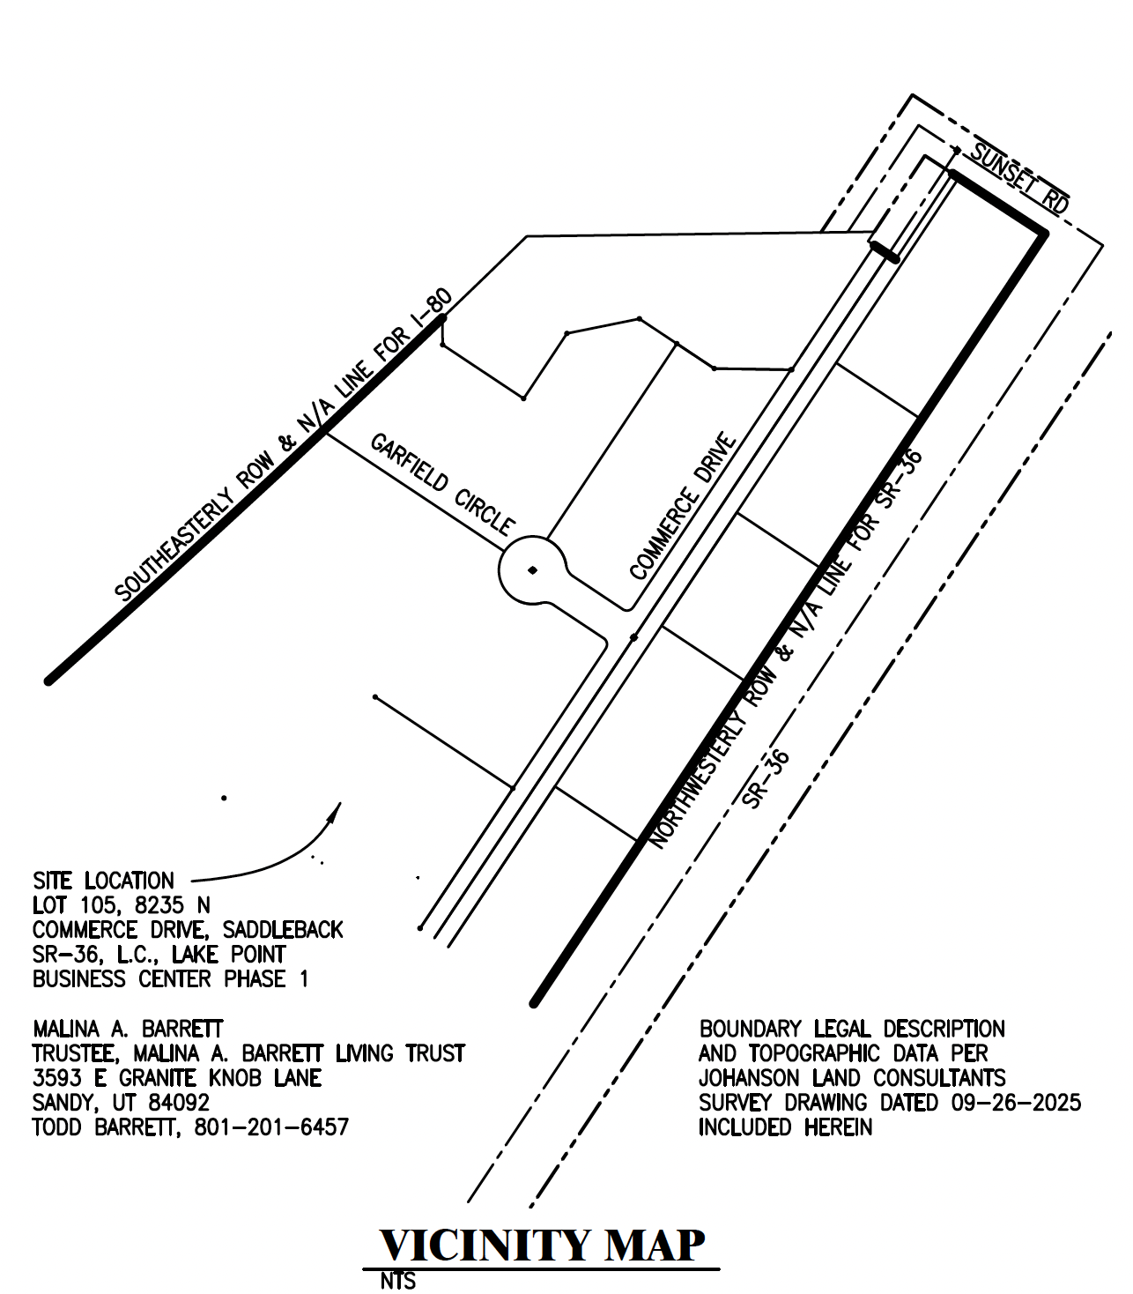

Site Plan of Building
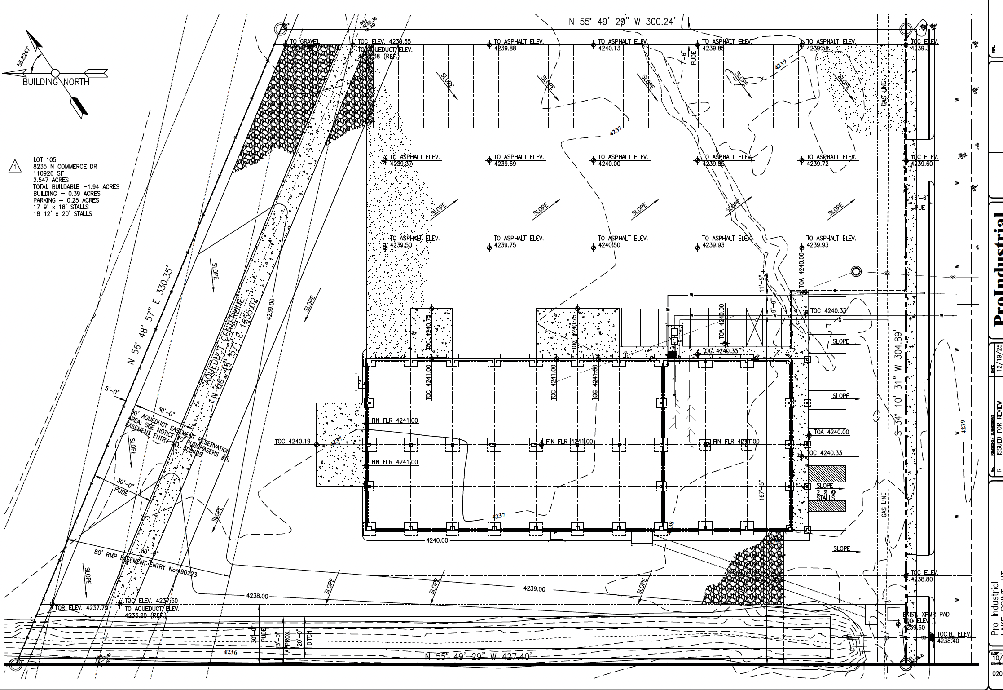

Warehouse and Office Space Layout
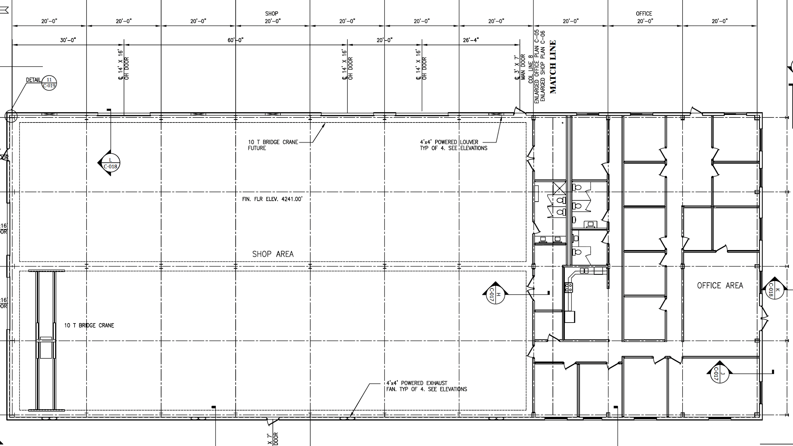
Outside View
