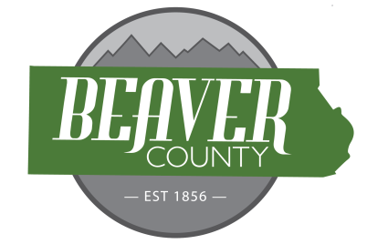
NOTICE AND AGENDA OF A PUBLIC MEETING
FEBRUARY 17, 2026 PUBLIC MEETING OF THE
BOARD OF COUNTY COMMISSIONERS OF
BEAVER COUNTY, UTAH

PUBLIC NOTICE is hereby given that the Beaver County Commissioners of
Beaver County, Utah, will hold a regular Meeting on February 17, 2026, at the place
and time set forth below to consider the agenda item(s) hereinafter set forth.

MEETING PLACE: Beaver County Administration Building 105 East Center Street, Beaver, Utah.
MEETING TIME: 10:00 AM

10:00 AM
Open Meeting
Call to order
- Prayer offered by Klellin Bradshaw.
- Pledge of Allegiance led by Matt Sterzer.
New Business
10:05: Approve Bills
10:10: Rockin 4B Youth Buckle Series (Kade & Hailey Blackner)
10:20: Election Equipment to Public Surplus – Scanner, Laptop, 2 Touchscreens (Clerk & Commission)
10:30: URS Service Agreement (Heidi Eyre)
10:36: Ratify New Hires (Heidi Eyre)
10:40: Ratify Signature on Federal Aid Agreement (Brandon Yardley)
10:45: Consider Oil Contract with NuRock for Oil(Commission)
10:50: Consider County Fair Contracts (Alison Webb)

(To be discussed when/as time permits)

- Old Business
- Commission Updates

BEAVER COUNTY COMMISSION CHAIRMAN
Any other business properly brought before the Board.
Dated the 17th day of February, 2026

