Monthly Fire District Report EMS

Transports for the Year
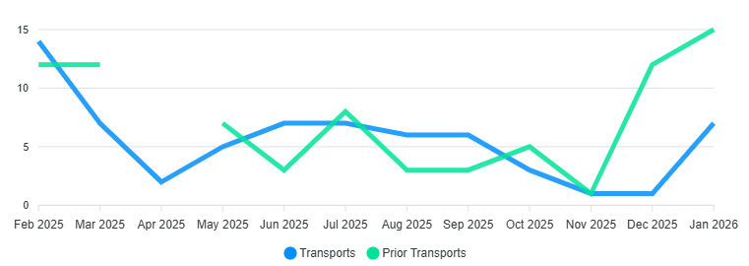

Billing
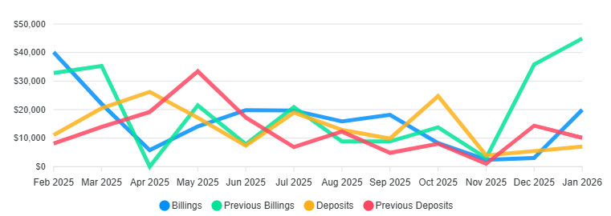
2026 Totals
Transports 7 / Billed $19,954.08 / Collected $7,052.17 /2026 YTD
2025 Totals
Transports 75 / Billed $214,109.74 / Collected $168,296.14

Monthly Calls for Service

YEAR | 15 | 16 | 17 | 18 | 19 | 20 | 21 | 22 | 23 | 24 | 25 | 26 | Tot.
JAN |  | 18 | 28 | 23 | 24 | 44 | 28 | 46 | 50 | 37 | 40 | 26 | 338
FEB |  | 18 | 17 | 26 | 27 | 23 | 25 | 29 | 46 | 42 | 35 |  | 288
MAR |  | 12 | 14 | 15 | 25 | 11 | 19 | 33 | 44 | 26 | 27 |  | 226
APR |  | 13 | 10 | 14 | 4 | 9 | 5 | 11 | 14 | 7 | 9 |  | 96
MAY |  | 15 | 13 | 13 | 11 | 12 | 12 | 15 | 12 | 28 | 22 |  | 153
JUN |  | 21 | 21 | 30 | 29 | 20 | 26 | 17 | 16 | 25 | 28 |  | 233
JUL |  | 30 | 32 | 44 | 25 | 30 | 28 | 28 | 25 | 34 | 34 |  | 310
AUG |  | 22 | 28 | 17 | 29 | 32 | 26 | 17 | 15 | 18 | 41 |  | 245
SEP |  | 16 | 12 | 28 | 19 | 28 | 26 | 25 | 18 | 23 | 26 |  | 221
OCT |  | 11 | 10 | 14 | 19 | 16 | 15 | 15 | 18 | 20 | 26 |  | 164
NOV |  | 7 | 1 | 19 | 12 | 11 | 9 | 10 | 11 | 7 | 21 |  | 108
DEC |  | 21 | 18 | 19 | 26 | 19 | 26 | 50 | 33 | 36 | 16 |  | 264
TOTALS | 163 | 204 | 204 | 262 | 250 | 255 | 245 | 302 | 302 | 303 | 325 | 26 | 2244

Red is a Monthly or Yearly Record
NFFD Trends

3 Year Monthly Call Average /42.3 26 Calls , Calls year to date 26

Notes of Interest

EMT Class February 2026
Hiring for the 2026 Fire Season / Completed
Wildland Gross Revinue $1,673,051.22 Million (Completed)
Foresty, Fire State Lands Grant $10,000.00 Equpiment/PPE (26)
Utah DNR Grant $180,000.00 Mitigation (26-27)
Utah Water Conservancy Grant $45,000.00 Mitigation (26)
Capital Item Pickup Truck For Chipping and Wildalnd $56,166.00

