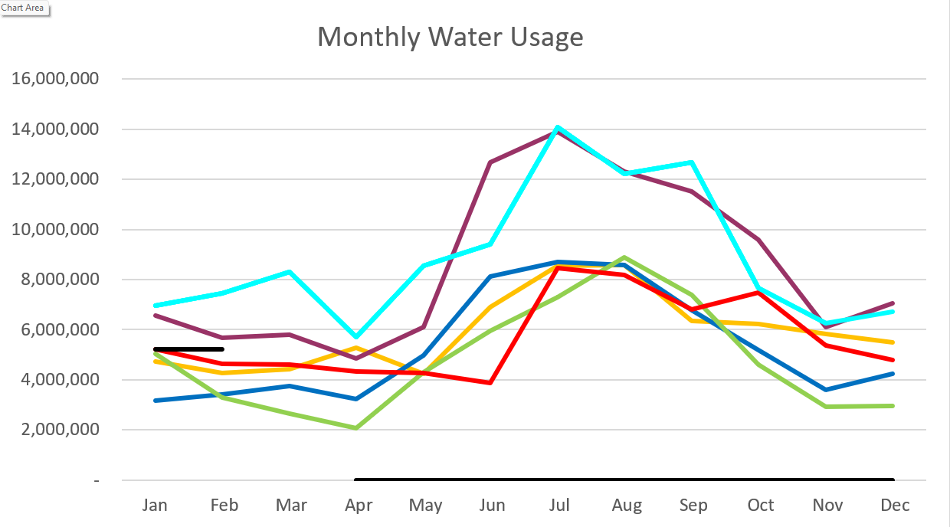2026 - Black
2025 – Light Blue 2024 – Purple
2023 – Red 2022 – Yellow
2021 – Blue 2020 – Green

January 2026

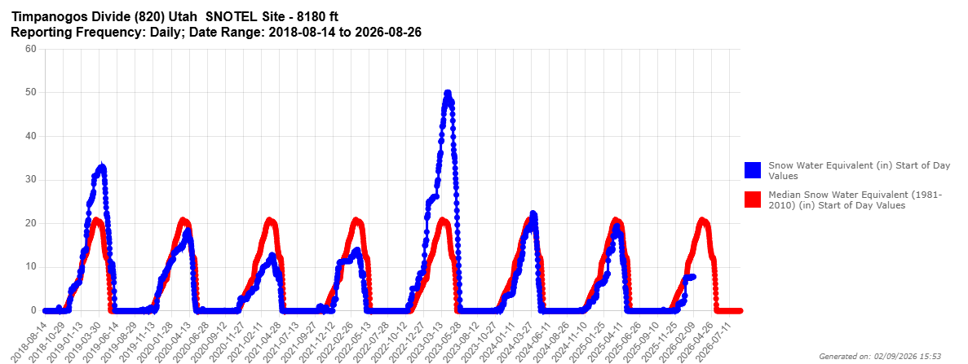
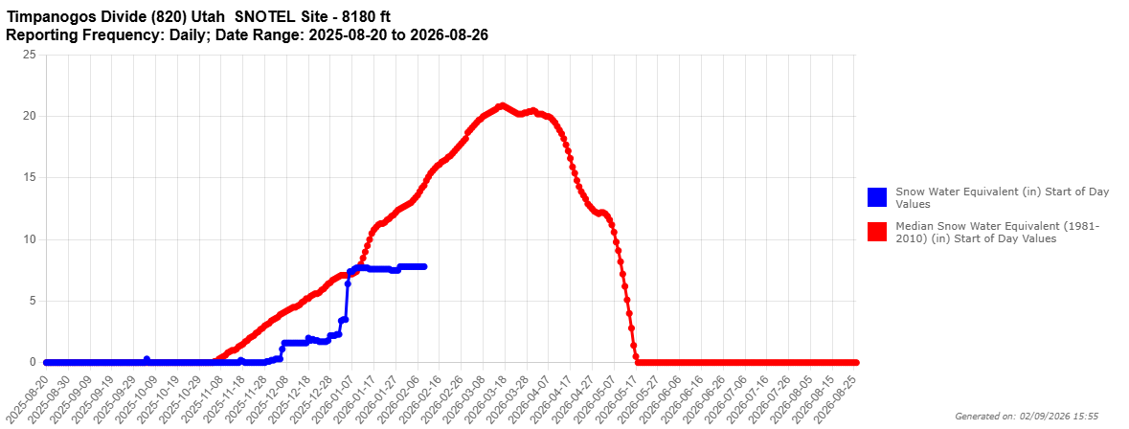

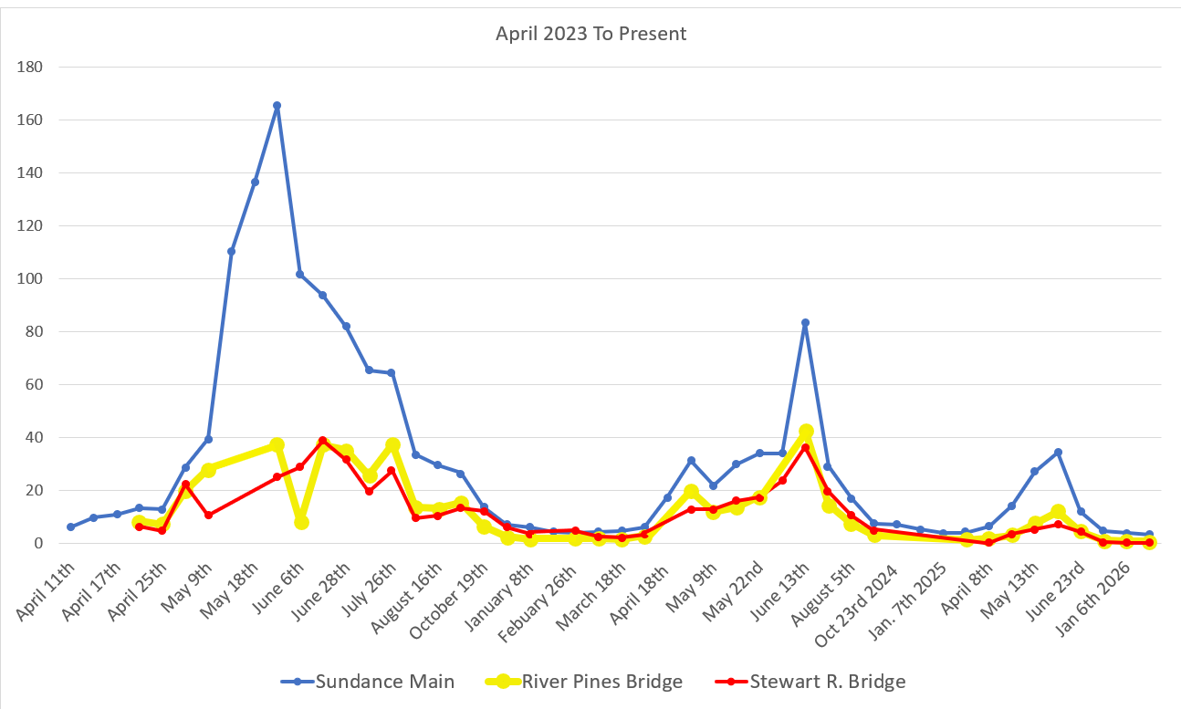
C
F
S

Water Department Information for January
- Our overall water consumption is similar to last year.
- Aspen Grove wet-well levels are averaging 5.25 feet for January 2026 which is slightly down from last month. This time last year, in January 2025, our average was 5.5 feet.
- Stewart Spring is averaging 41 gpm for January 2026, which is down from as last month. This time last year it was averaging 74 gpm for January 2025. This is down because of altering water valves in searching for leaks.
- Stewart spring overflow is running 16 gpm for the month of January which is down from last month. Total Stewart Spring produced an average of 57 gpm for January 2026.
- Unaccounted water
  - Lower Pressure Zone and Stewart Zone
- COP has started on the building siding. They have one side to finish but we are waiting on electrical to install their equipment.
- Aqua is working on master meters and updating the master plan.
- We are now doing multiple water samples every other week. We are completing the PFAS sampling as well. One more PFAS sample in April.
- The master mag meters for the springs arrived. We will get the other parts needed to install and schedule APCO to integrate into the SCADA system. Looking like the second week of March.
- PRV was installed on the Hydrant line at the Redford property.
- Unaccounted water elimination processes:
  - We have replaced almost all the service meters including the 6-inch meters.
  - Corrected meters with wrong calculations, and mismatched register sizes.
  - We have had the spring meters heartbeat checked multiple times
  - We have had 2 leak detection companies conduct leak surveys
  - We have fixed multiple leaks
  - We have replaced 2 leaking hydrants.
  - We have inspected about 50 percent of the hydrants with a camera device.
  - We have had all the PRV’s inspected and replaced one 6 inch one 4 inch and two 2 inch PRV’s
  - We eliminated a section of old pipe on coming from the old Stewart Tank
  - We isolated Stewart tank to check for tank leaks.
  - We have two new zero meters ordered to replace the spring meters.
  - We started isolating zones in the system by transferring usage from Stewart to Aspen grove sides.

Wastewater Department Information for January
- We have one lab for January; BOD was out of limits.
- The plant construction is moving forward. We did a dry test on the blowers and Mixers. One mixer was bad, we submitted for a replacement.
- We received some stainless-steel pipe and they are starting to install the blower piping.
- We are working through the process of keeping the plant operational and bringing new equipment online by the end of the month.
- We have seen a change in the wastewater coming in and have been making changes to accommodate the paper clogging the fine screen.

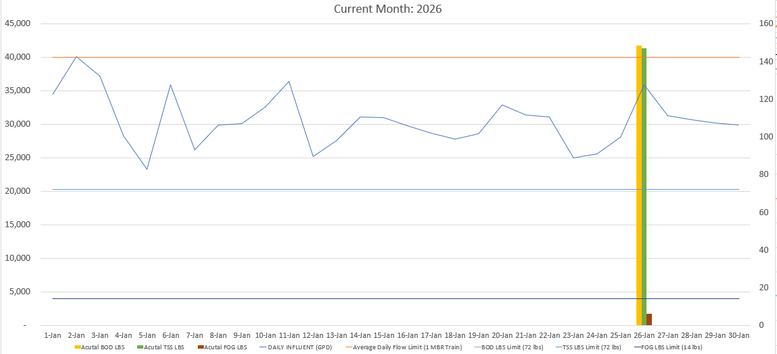

AVERAGE DAILY FLOW (GPD) | 30,661
HIGHEST DAILY FLOW (GPD) | 40,063

