Kanosh Town held its regular council meeting at 7:00 p.m. on Wednesday, January 14, 2026, 2025, in the Kanosh Town Hall, located at 55 North Main, Kanosh, Utah.
Members present: Council members present: Mayor Wenda Crabb, Councilmembers Josh Whitaker and Dan DeGraffenried, Brian Batt, and Tim White. Kanosh Town Clerk Cindy Turner, Kanosh Town Deputy Clerk Kacie Whatcott and Kanosh Town Treasurer DeniAnn Whitaker.
Others in attendance: CERT Captain Geri Minton, Tim York, Jim Kooy, Stephen Adams, Star Cummings, Liz Whitaker, Steve O’camb, Jim Weaver, Stan Koyle, R6 representative Jess Peterson, Perry Watts, Lily Whitaker, Kanosh Town Attorney Justin Wayment, Kody Stott, Hayden George, Ben Coray
Attending online: Ryan Black, Travis Taylor, Tylynn Taylor, Brandon Stephenson
Councilmember Brian Batt offered the opening ceremonies through an invocation.
Councilmember Dan DeGraffenreid led everyone in attendance in the Pledge of Allegiance.
Under new administration Mayor Wenda Crabb presented the following appointments:
Departmental:
Cemetery and Parks: Councilmember Tim White
Electrical Department: Councilmember Josh Whitaker
Water Department: Councilmember Brian Batt
Road Department: Councilmember Dan DeGraffenreid
Kanosh Town Treasurer: DeniAnn Whitaker
Kanosh Town Clerk: Cindy Turner
Kanosh Town Deputy Clerk: Kacie Whatcott
Kanosh Town Sexton: Mary Elizabeth Whitaker
Kanosh Town Fire Chief: Lorin Shumway
Each of the appointments mentioned has graciously accepted the assigned appointment.

Minutes of the December 2025 meeting were read and approved by motion Councilmember Josh Whitaker; Councilmember Dan DeGraffenried provided a second to the motion, and all Council members voted in favor, as noted below:
Mayor Wenda Crabb Aye
Council members
Josh Whitaker Aye
Dan DeGraffenried Aye
Brian Batt Aye
Tim White Aye

Warrants for January 2026 were read, discussed, and approved to be paid through a motion by Councilmember Josh Whitaker. Councilmember Brian Batt provided a second to the motion, and all Council members voted in favor as noted below:
Mayor Wenda Crabb Aye
Council members
Josh Whitaker Aye
Dan DeGraffenried Aye
Brian Batt Aye
Tim White Aye

CERT
CERT Commander Geri Minton reported nothing new to report from CERT at this time.

Fire Department:
*Kanosh Town Fire Chief Lorin Shumway reported the tires were pumped up on the military truck. Kody picked up batteries for it and then it was taken to Fillmore to hopefully get permanently repaired!
*New tires were purchased and installed on the E71 truck. This truck may be going out of state if the opportunity arises! Hopefully, it can start bringing in some money. When the truck is called out it can make about $300.00/hour.

Planning and Zoning:
*Planning and Zoning spokesman Tim York addressed the council, reporting that no new permits have been approved by the planning commission; therefore, nothing new to report at this time.
*Mr. York extended an invitation to the Council members to attend the next Planning and Zoning meeting; this meeting is scheduled for the 1st Tuesday in February.

Sexual Harassment/Open and Closed Meeting training (OMPA):
Kanosh Town Attorney Justin Wayment first provided the annual *Sexual Harassment Training: JUST DON’T DO IT! What is Sexual Harassment Training?
Sexual harassment is the most common type of workplace harassment. Recent statistics show that more than half of all workers (54%) have experienced some form of sexual harassment in the workplace. Because of its prevalence and damaging affects to an organization's productivity, morale, and culture, employers must try and actively prevent and eliminate sexual harassment in their organization.

The first step in preventing and eliminating sexual harassment involves educating all members of the workforce on sexual harassment and acceptable behaviors. Managers and supervisors must be given additional specialized training on how to properly handle cases of sexual harassment. The final step is setting up a process for when sexual harassment occurs handling complaints, investigations, and corrective measures. Workplace harassment, which includes sexual harassment, is prohibited by Title VII of the Civil Rights Act of 1964 which prohibits employers with 15 or more employees from discriminating on the basis of race, color, sex, religion, or national origin. The law applies to federal, state, and local employers and governs all employment actions. Laws regarding workplace harassment are enforced by the US Equal Employment Opportunity Commission.

The following includes the Primary Types of harassment (By Action)
- Verbal/Written:
Offensive jokes, slurs, insults, threats, repeated requests for dates, or derogatory comments sent via text, email, or in person.
- Physical:
Unwanted physical contact, such as touching, pushing, blocking someone's path, or assault, creating an unsafe environment.
- Visual:
Displaying offensive pictures, objects, or graphics, often online or in shared spaces.

The objectives of harassment prevention training are multifaceted. Primarily, the goal is to educate employees and supervisors about what constitutes harassment and discrimination, including the various forms it can take. Additionally, the training is intended to empower individuals to recognize and address inappropriate behavior, whether they are victims, bystanders, or perpetrators. Ultimately, it's about building a workplace where people feel safe, respected, and able to do their best work without fear of being treated unfairly.

Kanosh Town Attorney Justin Wayment then provided the annual *Open and Closed Meeting training (OMPA)
UTAH OPEN & PUBLIC MEETINGS ACT Utah Code §§ 52-4-101 et seq
OPMA requires that the public’s business be done in public. It provides requirements for conducting meetings of public officials, who have the authority to make policy and budget decisions in the public’s interest. It requires
that there be notice and an open deliberative process before a public body votes on matters under its jurisdiction. ALL votes are taken in public

OPMA defines a Public body as: Any administrative, advisory, executive, or legislative body of the state or its political subdivisions that:
1. Is created by the Utah Constitution, statute, rule, ordinance, or resolution;
2. Consists of two or more persons;
3. Expends, disburses, or is supported in whole or in part by tax revenue; and
4. Is vested with the authority to make decisions regarding the public’s business.

What is a Meeting? OPMA defines a Meeting as: “The convening of a public body or specified body, with a quorum present, including a workshop or an executive session, whether in person or by means of electronic communications, for the purpose of discussing, receiving comments from the public about, or acting upon a matter over which the public body or specific body has jurisdiction or advisory power. OPMA says a meeting does
not mean a chance gatheringor social gathering.

*NOTICE and AGENDA

NOTICE
• At least 24 hrs. in advance of meeting;
• Posted at public body’s office; and
• Posted on Utah Public Notice Website; and
• Newspaper of general circulation.

AGENDA
• Posted with notice.
• Must be “reasonably specific” (an average person would be on notice as to all topics of discussion and action planned for the meeting).
*A public body may discuss a topic raised by the public that is not listed on the agenda but may not take final action on the topic at the meeting.

Notice Requirements
In addition, a public body that holds regular meetings that are scheduled in advance over the course of a year shall give public notice at least once a year of its annual meeting schedule.

Records of Open Meetings
Do we have to keep minutes and/or recordings? • YES, TO BOTH!
• Even though there is an audio recording, the approved written minutes will be the official record.
• Include both written minutes and recording of open meetings as public records.
• Public body shall establish and implement procedures for the public body’s approval of the written minutes of each meeting.

Written Minutes
• Date, time, and place of meeting.
• Names of members present and absent.
• Substance of all matters proposed, discussed, or decided by the public body which may include a summary of comments.
• Record, by individual member, of each vote taken by the public body
• Name of each person who makes a public comment and the substance of the comment; and
• Any other information that is a record of the proceedings of the
meeting that any member requests be entered in the meetings or
recording.

Recordings to Public Notice Website
Pending Minutes:
Available to public within 30 days after the meeting (State Public Body and Specified Local Public Body). All other public bodies are required to make pending minutes available to public in a reasonable amount of time.
Approved Minutes:
Posted to the PNW within 3 business days of public body’s approval (State Public Body and Specified Local Public Body). Or a website link on the PNW where approved minutes are posted for public bodies that are not State or Specified Local Public Body.
Audio Recordings:
Posted to the PNW within 3 business days after the meeting (State Public Body and Specified Local Public Body). Public body that isn’t a State Public Body or Specified Local Public Body is required to make audio recording available to public but no requirement to post.

Electronic Meetings
Do I have to attend meetings in person? May a meeting be held without people in the same room?
Public bodies may meet by phone or other electronic means that allows participants to hear or observe communications.
• The public body must adopt by resolution, rules, or ordinance governing the use of electronic meetings.
• Notice requirements still apply.
• The public must have a means to attend or participate.
• May be held without an anchor location if it presents a substantial risk to health or safety, but requires written
determination by the chair of the public body.

Emergency Meetings
Due to unforeseen circumstances that must be articulable.
• An example might be a broken water line that cannot wait for the next scheduled meeting.
• Emergency! Failure to comply with OPMA requirements isn’t an unforeseen circumstance. Requires best notice practicable.
Cannot be held unless an attempt has been made to notify all members of the public body and a majority of the members approve the meeting.

Closed Meetings
A public body can go from an open meeting into a closed meeting under certain circumstances.
• 52-4-205 lists all the reasons for closing an open meeting.
• A quorum must be present. A motion to close the meeting must be made, naming the specific statutory reason for closure. Then, a roll call vote must be taken. Two-thirds of the body must approve the closed meeting.
• If the closed meeting is held to discuss 52-4-205(1)(a), (1)(f), or
(2), the presiding member of the public body is to execute a sworn statement that the sole purpose of the closed meeting was to discuss these issues. No recording is required.
• If the meeting is closed for any other statutory reason, a recording shall be made, and written minutes can also be made.
These are protected records under GRAMA.
• NO VOTES ARE TAKEN IN CLOSED MEETINGS
(Except allowed to end a closed meeting)

Reasons a Meeting May be Closed
1. To discuss character, professional competence, or physical or mental health of an individual (doesn’t require recording if the chair signs an affidavit after).
2. To discuss collective bargaining.
3. To discuss pending or reasonably imminent litigation.
4. To discuss the purchase, exchange, or lease of real property, if public discussion would disclose the appraisal value or prevent the transaction on the best possible terms.
5. To discuss the sale of property, if public discussion would disclose the appraisal value or prevent transaction on best possible terms if there’s public notice of sale and terms are disclosed before the sale.
6.To discuss security personnel, devices, or systems (doesn’t require recording if the chair signs an affidavit after).
7. To discuss investigative proceedings regarding allegations of criminal misconduct; and
8. A few other exceptions relating to the Legislature, Higher Education and the Utah Procurement Code.

What is Forbidden During a Closed Meeting?
You may not:
• Approve an ordinance, resolution, rule, regulation, contract, or appointment.
• Interview a person to fill an elected position.
• Take final action: Final votes must be open and on the record.

What Happens if Someone Violates OPMA?
A court can void any action in violation of the law:
• Sometimes a violation can be cured by discussing and taking a public vote in a subsequent meeting.
• May have to pay court costs and attorney fees.
• “In addition to any other penalty under this chapter, a member of a public body who intentionally violates or intentionally abets or advises in violation of the closed meeting provisions of this chapter is guilty of a class B misdemeanor.” (6 months in jail and/or $1,000 fine)

Disruption of Meetings
OPMA does not prohibit the removal of any person from a meeting if the person willfully disrupts the meeting to the extent that orderly conduct is seriously compromised.

TRAINING
The presiding officer of a public body shall ensure that the body receives OPMA training on an annual basis.

Common Violations of OPMA
• Closing meeting without members of the public body voting first in an open meeting to close the meeting.
• Conducting a closed meeting for reasons other than those allowed by OPMA.
• Taking official or final action in a closed meeting.
• Failing to properly provide notice of a public meeting.

Rule of thumb:
• 24-hour notice
• Be specific with agenda items
• No “old business, new business.”
• “Action taken on items discussed in closed meeting” is not enough
• Close meetings only for allowed statutory purposes and follow the process
• Provide minutes in a timely manner
• Don’t text during meetings
• Receive training once a year
• Err on the side of transparency
• When in doubt, consult your legal counsel.

Water bill error:
Upon receipt of a letter from Mr. Gale George, Mayor Wenda Crabb noted a significant error in one of our water billings, $1599.27. As outlined below the error began in November 2018 at the RV park.
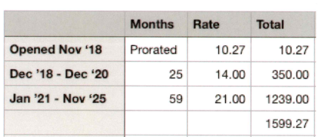

Councilmember Dan DeGraffenried motioned to rectify this error through an issuance of a refund to the Ruvalcaba’s in the amount of 1,599.27, Councilmember Tim White provided a second to the motion, and all Council members voted in favor as noted below:
Mayor Wenda Crabb Aye
Council members
Josh Whitaker Aye
Dan DeGraffenried Aye
Brian Batt Aye
Tim White Aye

Possible sale of power line to Dixie Power:
Councilmember Josh Whitaker provided an update on the sale of the power line from the Hatton Road to our substation and the pending contract with Dixie Power. The contract price of the sale is $100,000.00, the money from this sale will be used on the powerline for the Well. Councilmember Josh Whitaker motioned in approval of the contract for the sale of the powerline, Councilmember Brian Batt provided a second to the motion, and all Council members voted in favor as noted below:
Mayor Wenda Crabb Aye
Council members
Josh Whitaker Aye
Dan DeGraffenried Aye
Brian Batt Aye
Tim White Aye

CCI:
Mr. Stan Koyle spokesman for Corn Creek Irrigation provided a brief update of the Irrigation company. Currently CCI is installing a pipeline and have a grant, however the grant does not cover 100%. CCI has been able to meet a portion of their remaining responsibility through in-kind donations, cash, or time. Kanosh Town owns the property at the dam and allows CCI to use in-kind donation for silt at the dam to bed the pipe. The pipe must be bedded so it is somewhat “puncture proof”. CCI has kept track of the loads and assessed the cost base on what it would have cost if it had been purchased from Carlings. Someone up the line has now decided they need additional confirmation, from the Town of Kanosh stating the numbers are in fact true and accurate. The below letter of confirmation was written and will be submitted as required.
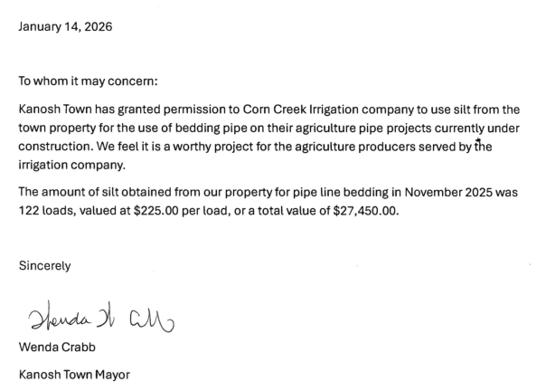
There will be a letter prepared, signed and sent in each month that the CCI uses the silt.

Conex container
Mr. Stan Koyle mentioned that the Irrigation Company has not got anywhere to store materials and are considering the purchase of a Conex container, the problem is that the irrigation company does not own any ground. Mr. Koyle stated the Irrigation company is wondering about the possibility of placing their Conex next to the Conex owned by the Fire Department, at the old Olive Service Station. They would like to put is somewhere less likely to be vandalized. There would need to be some kind of written agreement in place. Kanosh Town and the Irrigation Company have a good working relationship and would like to continue as such.

Mr. Hayden George addressed the Council on behalf of Corn Creek Irrigation. Below the spillway there is a berm of dirt, the irrigation company would like permission to use it as backfill. Councilmembers agreed to this request. Mr. George states that the irrigation company has a grant of 2 million dollars for the pipe and installation, to date 20,000 feet of pipe has been laid, and they have a couple hundred thousand dollars left, however, they are running out of company funds at a 50% match. The Irrigation company would really like to pipe 200 West 200 North. As was mentioned they are running low on the company funding and questioned if there is any way Kanosh Town could help them, if possible. Mr. George stated it would be for flood control as well as getting rid of a tremendous hazard when there is a lot of water. There are a couple ways we could go about it, in kind by labor, dump truck, backhoe, or through a cash donation. Everything must be complete by the 30th of June.

Communication tools
Mayor Wenda Crabb addressed the topic of implementing the communication tools presented in last moths meeting. Mayor Crabb provided a demonstration of how effectively the tools can be used. Mayor Crabb proposed first the implementation of Gmail email accounts, which will add consistency throughout current and future administrations. All the contracts, communication etc. would continue to be available to future administrations. The next part of Mayor Crabb’s proposal is the implementation of project management software, Basecamp. It is free to the Town. This software allows tracking of each project. Everyone can work and collaborate in real-time, making it easy to understand project progress and better contribute to the project’s overall success. Basecamp keeps both sides organized, everyone’s feedback on the record, and all decisions, approvals, files, tasks, deadlines, and communications safe and centralized. Basecamp provides visual tools that help you clearly see where projects really stand. The home screen organizes your projects, assignments, and upcoming events together on one screen. Councilmember Josh Whitaker motioned to adopt the specific gmails as described and the basecamp project management as presented, Councilmember Brian Batt provided a second to the motion, and all Council members voted in favor as noted below:
Mayor Wenda Crabb Aye
Council members
Josh Whitaker Aye
Dan DeGraffenried Aye
Brian Batt Aye
Tim White Aye

Review electrical rates and potentially reset the surcharge based on the review
In looking at the six-month average, there is no need for a change or adjustment: we are right where we have been.

Utility Delinquency Review:
Council members reviewed the monthly delinquency list. It was determined, again, to handle those accounts in arrears according to the established Town policy. It should be noted that a very kind townsperson has now paid off all the utility delinquencies.

Department Report:
*Roads: Councilmember Dan DeGraffenried reported on the constant fight to overcome the ever-growing goat head population. Councilmember DeGraffenried and Mr. Stan Koyle have worked together two separate days and have planted about 50 pounds of high crest grass and 5 pounds of Bluegrass along the narrow strip between the road and the existing vegetation, the east side of Town has been completed. After the west side has been prepared, Councilmember DeGraffenried and Mr. Koyle will get it planted.

After the last meeting, Councilmember DeGraffenried followed up on a concern brought up by Mr. Rod Cox, the old fence has been moved, It appears to be a problem between two private citizens. To straighten out the bend in the road, when we get a bid from hales sand and gravel on the chip seal project for the east side of town, we will get that in a separate bid to straighten out that road and put in a ditch or a pipe on the east side.

*Water: Councilmember Batt will meet with the past Councilmember over the water. Councilmember Batt will also make a point to learn as much as he can about the well project. Councilmember Batt has met with individuals at the dam, who provided an educational update on the Well house.

*Electrical Department: Councilmember Josh Whitaker will find out what he needs to know about the UAMPS contract and report accordingly.

*Parks and cemetery: Councilmember Tim White expressed some ideas to compost the park and cemetery to help with water retention. Councilmember Josh Whitaker suggested advertising the bid for park and cemetery care as soon as possible, Usually the individual who is awarded the bid begins on April 15.

Public comments:
*Steve Ocamb: Addressed the council and everyone in attendance, for the purpose of making everyone aware that he is running for Sherriff. Steve has 28+ years of law enforcement experience. He began his career in 1995 at the Millard County Sheriff's Office as a dispatcher, corrections officer, and patrol deputy. He also acted as the public information officer, an inmate hearing officer in the jail, and was a certified EMT. He then spent nearly 15 years with the West Valley City Police Department. He worked patrol, was a youth detective (school resource officer), sex crimes and special victim's unit (SVU) detective and supervisor. He worked the 2002 Winter Olympics, and was heavily involved in the preemployment process as a background investigator and CVSA examiner, before retiring in 2015 as the SVU Sergeant. Steve went on to earn a bachelor's degree in Criminal Justice and Law Enforcement from Utah Valley University in 2017 where he graduated Summa Cum Laude. Three days later he became a cold case investigator for the Utah Department of Public Safety (DPS) at the State Bureau of Investigation (SBI).
He eventually wrote and coordinated millions of dollars of grant funding for police agencies statewide to do Advanced DNA Testing via the Sexual Assault Kit Initiative (SAKI), and Byrnes JAG Community Project Funding (CPF) programs. These initiatives continue to solve some of the most high-profile cold cases in Utah, including homicides, violent felonies, missing persons and unidentified human remains cases. Steve has been instructing at the Utah Peace Officer Standards and Training (POST) Adult Sexual Assault Investigations course since 2018, and remains an inaugural member of the state's Cold Case Review Board since 2020. He co-created the DPS/SBI Monthly "Tuesteenth" Trainings on Zoom, which are attended by every discipline of responder in Utah - thousands per year since 2020. Topics include forensic DNA, trauma-informed response, medical examiner and annual legal & legislative update.
Steve is a certified trauma advocate and was appointed by the governor to the Utah Crime Victim Reparations and Assistance Board of Directors where he served from 2021-2024. Steve resides in Delta, but grew up in Fillmore, and graduated from Millard High School in 1988. He was a member of the Future Farmers of America (FFA) and co-MVP of the baseball team. He was a football team captain of the 1987 state runner-up, and 1st Team All-State on offense and defense. Despite a mediocre grade point average, he was also a silver medalist in the state Academic Decathlon competition. He is currently attending the Utah Rural Leadership Academy through the Utah Association of Counties and is also a student in the Master of Public Administration program at SUU.
*Jess Peterson: just wanted to take a minute to introduce himself to the new council. Mr. Petersson is a great resource for the Town Council, he works with R6 Regional Council formerly Six County Local Government. Mr. Peterson wanted to make sure the new council is aware of what R6 has to offer through the various programs. If we have people delinquent in their utilities send them to R6, surely there would be a program to help them in some way. Below are only some of the programs R6 has available:
Economic & Community Planning
- CIB Application
Aging and Volunteer Services
- In home services – Medicaid Waiver, Alternatives, Caregiver
- Senior Nutrition
- Senior Health Information
- Senior Medicare
- Patrol Ombudsman Services
- Senior Volunteer opportunities
- VITA Volunteers
Community Assistance
- HEAT Assistance
- HEAT Crisis
- CSBG
- TANF
- Critical Needs
- SSBG
- FEMA
Housing Services
- Weatherization
- Mutual Self Help
- CROWN Homes
- Home Rehabilitation

*Jim Kooy: addressed the council stressing the need for an additional full time town employee, if we cannot financially hire a full-time employee at least, we need a part time employee, we are to that point.
Old Business:
*Corn Creek Irrigation; Mr. Layne Jensen with Fransen Engineering plans to attend the February Council meeting and will update the Council at that time.

*Well Project: Mr. Ben Coray stated the loan closing for the well project is coming up. The well was mostly grant, but a portion of it is a loan. We need to close the loan, the paperwork has all been signed, we have been working with Chamberlain and Associates on the loan closing. The only question outstanding is does the Town want to apply for any more loan funds to help cover the powerline. If Kanosh is going to do it, we should do it now, there is an opportunity if needed to ask for a little more loan to help offset some of the power cost.
The parameters resolution is not to exceed $900,000. It looks like the loan is for $524,000 which leaves a $376,000 cushion, so we would not need to do any public hearings or additional paperwork as long as we stay under the $900,000.00 total cap.
Ben will contact Karl Larson to see if there is a penalty for early payoff of the loan. He will also find out the difference in payments if Kanosh opts for additional loan money.
The other item of business Ben Coray brought to the attention of the council, the contingency balance is 100,000.00, meaning the current funding is $100,000.00 high than our know expenses. The well drilling took longer than anticipated, there was the problem with the well water,
This will serve as an agenda item for the February meeting.
Mr. Coray noted that with the surplus grant money and the additional funding, he would ask for an amendment of the additional funding for Sunrise Engineering, stating that some of their services have been donated this far. See the below contract amendment
Councilmember Brian Batt motioned in favor of the Amendment to Owner-Engineer Agreement Amendment No. 1 agreeing to the increase of $26,200.00 to Sunrise Engineering Company, Councilmember Dan DeGraffenried seconded the motion, and all Council members voted in favor as noted below:
Mayor Wenda Crabb Aye
Council members
Josh Whitaker Aye
Dan DeGraffenried Aye
Brian Batt Aye
Tim White Aye

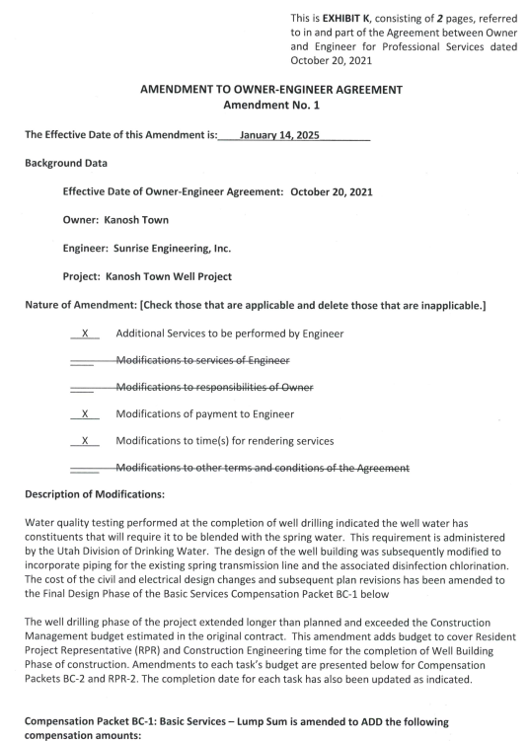

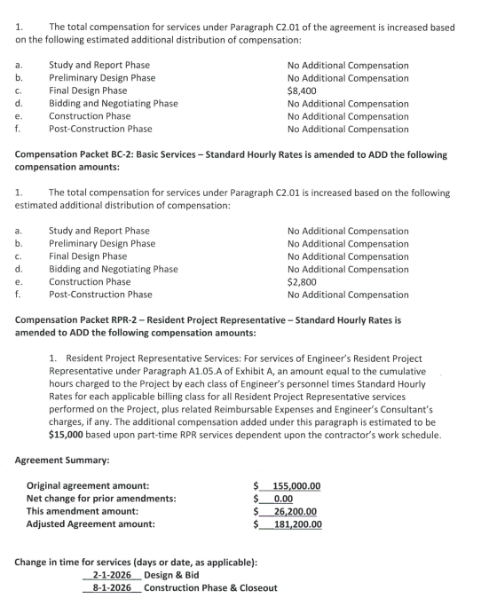

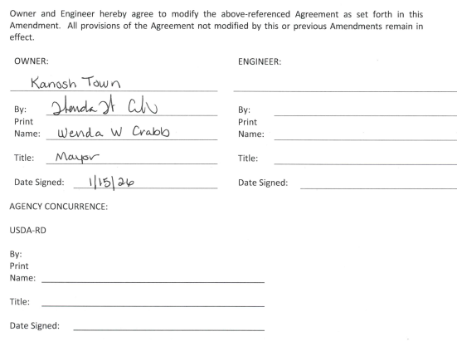
Mr. Coray addressed the “pay requests” discussed in last month’s meeting; the way the projects typically run is the last week of the month the contractor will put together his pay request, he will send it to Sunrise Engineering (which is his invoice for his work done that month) so this month the pay request should be received from the contractor on or about the 30th. It is then reviewed and then processed by Sunrise Engineering (who would authorize a percentage of payment to the contractor) then the next step would be to send it to the Town for their approval after that it is sent to the funding agency (Rural Development) and then they release the funds back into the Town’s account. If they had to wait until Council meeting to do it simply prolongs the repayment cycle. Most communities will just approve the pay request as they come through. It is money that has been already authorized for the project. The money has already been earmarked for the project.
The Clerk Cindy Turner had been in correspondence with the Kanosh Town attorney via email and reported to Mayor Wenda Crabb. Mayor Crabb emailed Mr. Coray and copied the clerk on the correspondence. See Below:

Hi Cindy and Ben,

Before our meeting on Wednesday, Cindy had already asked Justin about what is required by the town to protect us when spending the money on the well chlorinator building. Her voice was spent, so she told me to meet with her before sending Justin an email about it. I met with Cindy yesterday.

While it is possible to handle the spending as you suggested, it’s not very practical and opens the town up for potential misunderstandings and litigation. This is different than spending grant money. A loan that must be paid back by the citizens, will be under heavier scrutiny. At the meeting Ben suggested that he might be able to change the contractor spending requests to a fiscal month instead. That will work best.

Please correct me if I'm wrong, but here’s what I understand the steps for payment to be.

Contractor provides documentation for work completed in a month’s period to Sunrise.
Sunrise approves the work as stated by the contractor and requests the funds from the town for approval.
Once approved, (the town or sunrise - please advise) then forwards the money request to the bank.
The Bank releases the funds to the town.
The town delivers a check for the funds to the contractor.

Did I miss a step? If not the bank, then where?

Here are the town council dates for the next 5 months
Feb 11, Mar 11, Apr 8, May 13 and Jun 10.

Would it be workable to have a contractor work cycle of Sun - Sat before town council as follows:
Current - Sat Feb 7. Council Wed Feb 11
Sun Feb 8 - Sat Mar 7. Council Wed Mar 11
Sun Mar 8 - Sat Apr 4. Council Wed Apr 8
Sun Apr 5 - Sat May 9. Council Wed May 13
Sun May 10 - Sat Jun 6. Council Wed Jun 10

Or anything similar.

If you could make that happen, that would be amazing. Right now, we have a brand-new clerk in training, new mayor and two new council members. The treasurer is still new, and the most senior members have been in 2 years. That’s a lot of new. It would be awesome if we could make it as easy as possible for us, so we don’t mess it all up.

Thank you for your support. You both do so much for our town, and I really appreciate it.
*Mr. Lorin Shumway noted that he has been taking care of GoDaddy our website host. Lorin also has a website, and he also uses GoDaddy for it as well. Somehow the Town Credit card got used to pay for both. Mr. Shumway has tried and tried again to rectify this action however, it happened again recently. Mr. Shumway presented the Kanosh Town Treasurer with a reimbursement check for this most recent charge in the amount of $286.37. Mr. Shumway would like someone else to take over management of the account so this will not happen again.

There being no further business to come before the board, the meeting was adjourned.

Wenda Crabb Cindy Turner,
Kanosh Town Mayor Kanosh Town Clerk

