Millcreek
1330 East Chambers Avenue
Millcreek, UT 84106

Request for Qualifications
City Hall Public Market Café Restaurant Provider due
Thursday, February 19, 2026, at 12:00 p.m. local time

- Introduction. Millcreek (the “City”) is requesting proposals/qualifications (“Proposals” or “Responses”) from qualified proposers (“Proposers”) in becoming an anchor tenant on the Millcreek Public Market (ground floor) in our new city hall (as described below).

  - Intent. It is the intent of this Request for Qualifications (this “Request”) to set forth the minimum acceptable requirements for Responses to this request.

- Background and Detailed Description of Apparatus. The City was incorporated in December of 2016 and currently has an approximate population of 63,000 residents. City Hall is a six-story concrete and glass structure that features a basement, ground-floor market and exposition space, four floors for city and police operations, and a sixth-floor community center reception hall. The 10,250 square feet ground-floor marketplace houses a restaurant and a 380-sf café space. Dining will be provided in the common indoor dining area and an outdoor patio dining area. This Request for Qualifications is focused on the Café kitchen space.

  - Public Market Café Features. This 380-sf kitchen will come equipped with a type 1 exhaust hood, a three-compartment sink, hand sinks; interior wall, ceiling and floor finishes; and with exterior finishes to match the public market décor. Other features include basement storage and walk-in cooler and freezer space in basement walk-ins. Restaurateur will be responsible for food preservation and preparation equipment, reach-in cooler, cooking and baking equipment, soda fountains, coffee preparation equipment, etc. There is no range hood.

  - Proposed Menu. Will include, but not limited to coffee, tea, hot chocolate, espresso, Coca Cola fountain sodas, breakfast pastries, etc. No beer or wine will be offered from this Café.

  - Public Market Features. This 10,250-sf market and event space includes the following features and more: the two restaurant kitchens, common area indoor seating and outdoor seating; free parking in 400-plus public parking structure west of city hall, access to deliveries and storage from Chambers Avenue and at ground floor in parking structure; public restrooms; access to a common back-of-house commercial prep kitchen; ground floor exposition center that will accommodate several market stalls and kiosk spaces; access to our two-acre Millcreek Common located east of city hall with all its features (ice skating - winter, roller skating – spring and summer, splash pad, outdoor stage, pizza and ice cream, etc.); access to conference rooms, and access to the sixth floor 2,500-sf community room where catered events and conferences will be held. The operator of the Public Market Café could also be available to serve scheduled events at City Hall, in the sixth-floor Community Room, at the ground floor Public Market, or even events schedule on adjacent Millcreek Common.

  - Location. Millcreek City Hall is the crown jewel of the Millcreek City Center. The new City Hall will be located at 1330 E Chambers Avenue (3205 South). The Millcreek City Center is the area approximately bounded by 1300 East on the west, Highland Drive on the east, with Elgin Avenue at the north end and Luck Lane at the south end. Within this city center zone, more than 1,600 apartment units are being planned, with several leasable spaces available for retail, restaurant, and other commercial ventures (See Exhibit A).

  - Millcreek Current Demographics.

Distance from the New City Hall
 | 1 Mile | 3 Miles | 5 Miles
Population | 19,888 | 159,938 | 324,039
Median Age | 37 | 36.1 | 34.9
Households | 8,416 | 65,830 | 131,969
Average HH Size | 2.34 | 2.4 | 2.4
Median HH Income | $78,057 | $73,608 | $67,754
Median HH Disposable Income | $59,597 | $57,878 | $55,028

  - Leasing Options. The City is proposing at five (5) year lease term, and to cover anticipated operating expenses for the market center, the lease rate is set at $1,000 per month in vouchers (redeemable at this location, produced and distributed monthly by the City, each voucher good for $2 off any menu item, no change given) plus 5% of gross sales revenue. All utilities shall be included in the lease. The City is also requiring this food establishment be open for business at a minimum from Sunday to Thursday 8:00 a.m. to 9:00 p.m. and Friday and Saturday 8:00 a.m. to 10:00 p.m.

  - Additional Information. Proposer will also provide a list of suggested menu items, food prep appliances, and other ideas the City should consider as part of this RFQ process.

- Proposal Requirements. An electronic copy in PDF (Portable Document Format) of the Proposal is required to be submitted to Elise Summers, Economic Development Assistant at esummers@millcreekut.gov, no later than 12:00 p.m. local time on Thursday, February 19, 2026. Any response, modification, or amendment received after the due date and time is considered late. No late response, modification, or amendment will be accepted. Proposals must include the following elements and be signed by an authorized representative of the Proposer:

  - Introductory Letter. An introductory letter expressing an interest in providing the Service should be included, which shall include the primary contact’s name, cell phone, and email address.

  - Qualifications. Describe, in detail the Proposer’s experience operating a food establishment in or near the Utah region.

  - Timeline. Describe, in detail, the timeline for preparing the Café space, training personnel, and being ready to serve the public.

  - References. Include the name, address, and contact person of government or private agencies with which the Proposer has provided a similar service. The City may contact such references.

- Evaluation Criteria and Scoring Process. All Proposals received will be reviewed by the Evaluation Committee. Each evaluation criterion has been given a percentage based on its relative value. The criteria and each associated percentage are as follows:

    - Qualifications (track record, realistic plan, ability to do this successfully) (30%)
    - Ability to attract customers (marketing plans, branding, creativity) (30%)
    - Customer experience (menu, good customer service, consistent product and hours) (30%)
    - Passion for this project (10%)

- Selection. One or more Proposers may be invited to participate in an interview; however, Proposals may be accepted without discussion or interview. The Mayor or her designee will make the award.

- General Information. City reserves the right to reject any and all Responses. The City reserves the right to amend, modify or waive any requirement set forth in this Request. Response to this Request is at the Proposer’s sole risk and expense. All Proposers must comply with applicable federal, state, and local laws and regulations. Except for written responses provided by the contact person described below, the City has not authorized anyone to make any representations regarding the subject matter of this Request. The City anticipates selecting one or more of the responding Proposers, but there is no guarantee that any responding Proposer will be selected. Responses will be placed in the public domain and become public records subject to examination and review by any interested parties in accordance with the Government Record Access Management Act (Utah Code Ann. § 63G-2-101, et seq.). All materials submitted in response to this Request will become the property of the City and will be managed in accordance with the Government Record Access Management Act.

- Terms of Contract. The successful Proposer will be required to enter into a contract with the City to provide the services described herein. If the selected Proposer and the City Attorney are unable to negotiate an acceptable agreement, then another Proposer(s) will be selected by the Mayor, or her designee, and negotiation will continue with such other Proposer(s) until an acceptable agreement is completed.

- Contact Person. For more information on the Proposal or for American with Disabilities Act (ADA) accommodation, contact Elise Summers, Economic Development Assistant, esummers@millcreekut.gov 1330 East Chambers Avenue, Millcreek, UT 84106.

Exhibit “A” City Hall
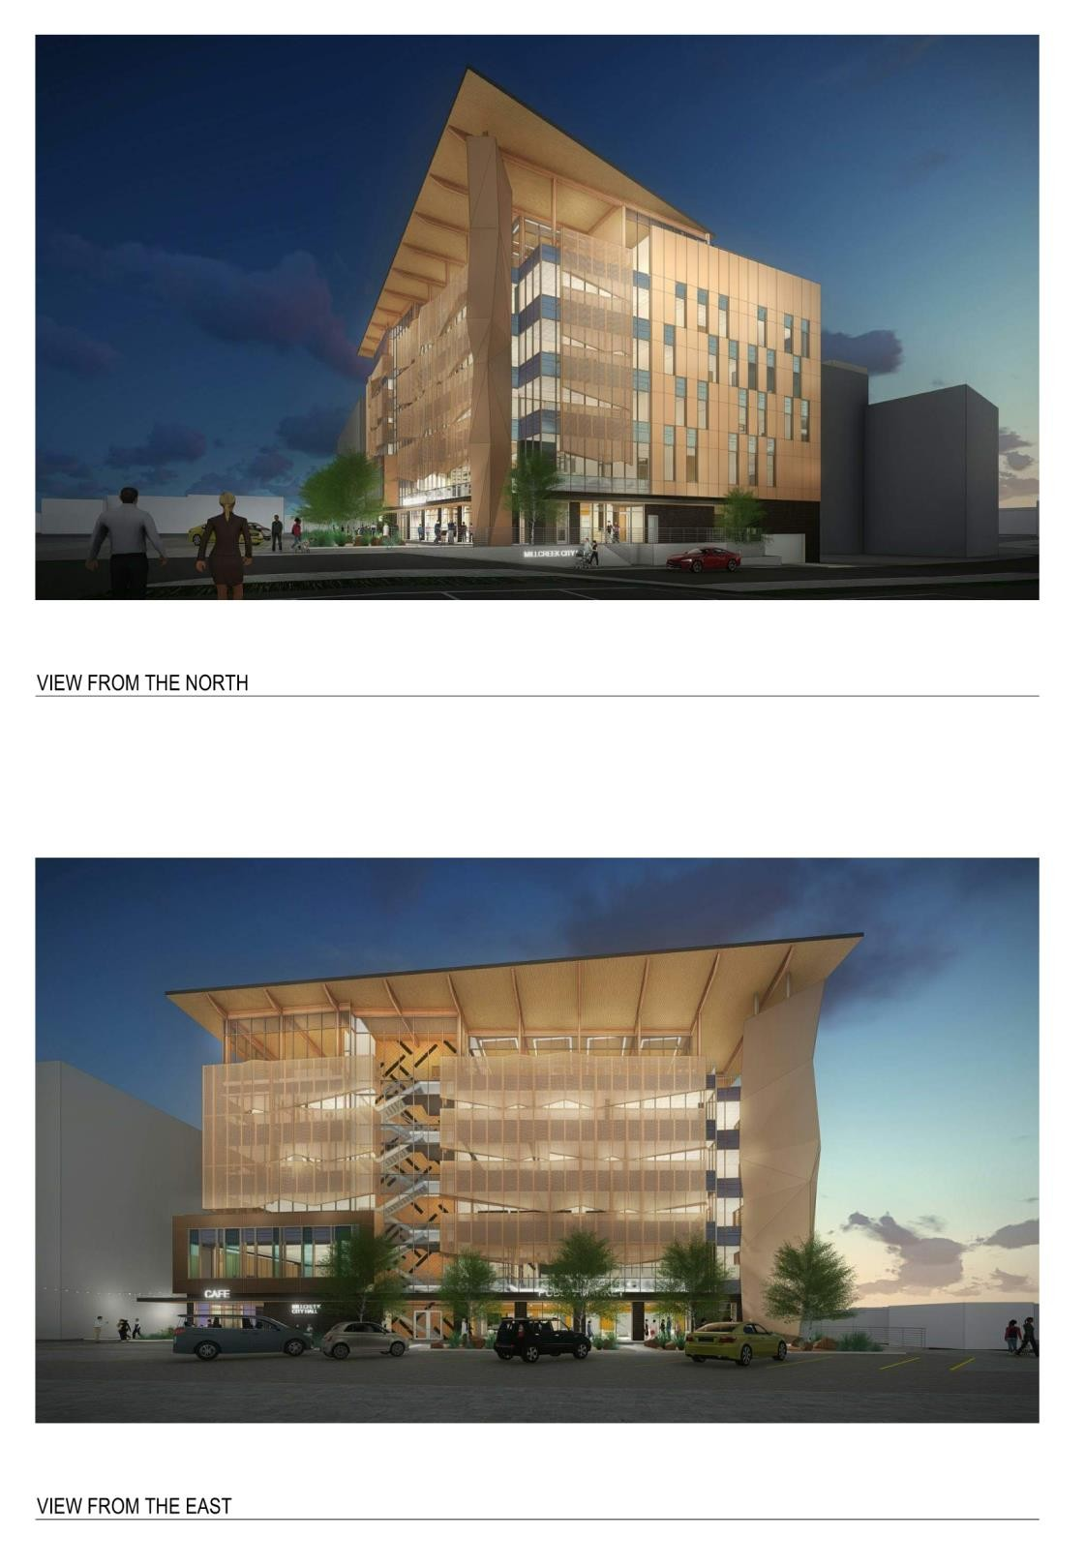
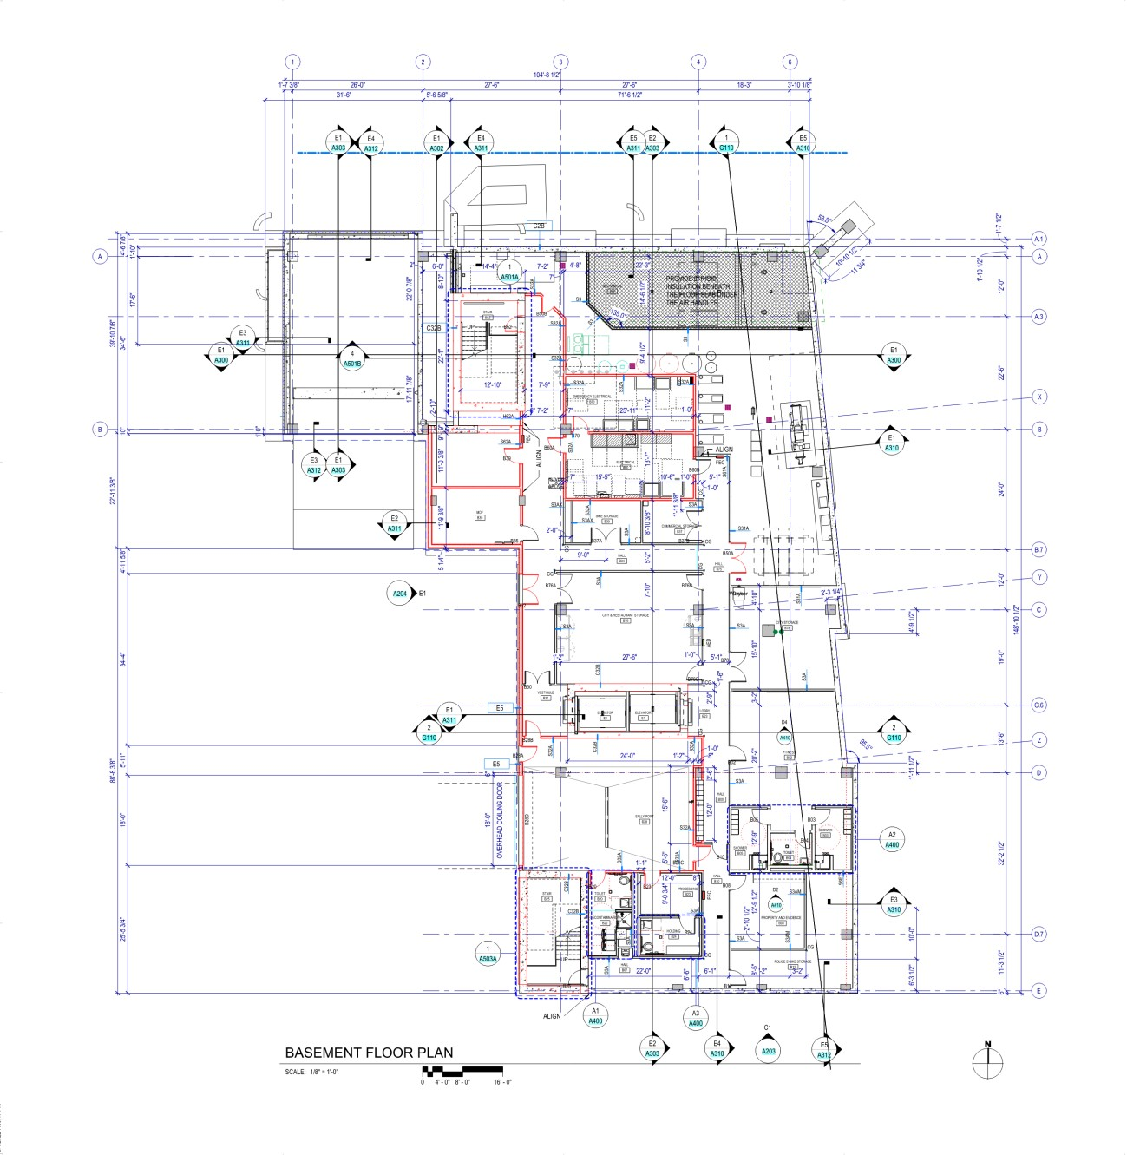
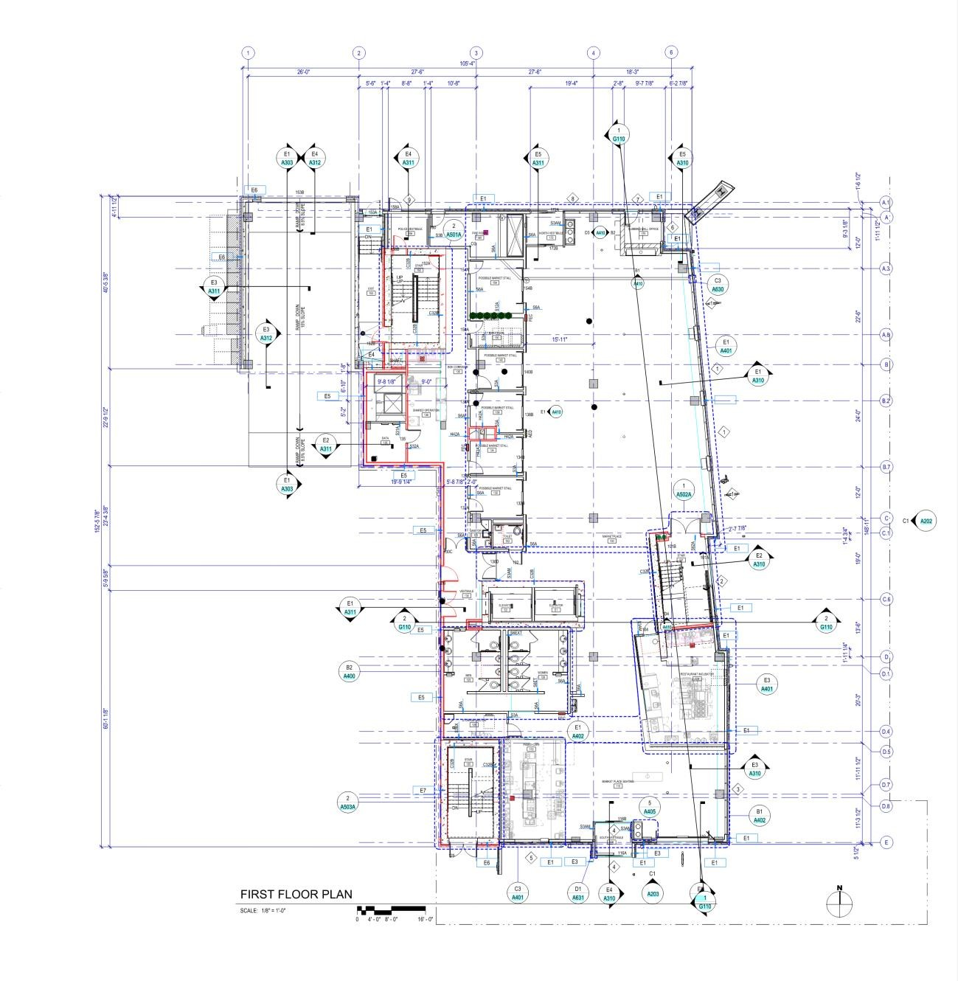

Exhibit “B” Millcreek City Center Development Summary

