Unapproved Minutes

Newborn Hearing Screening Advisory Committee

Meeting information:
November 18, 2025

Join Zoom Meeting

https://utah-gov.zoom.us/j/7998499427?omn=85740269038

Meeting ID: 799 849 9427
Join instructions

https://utah-gov.zoom.us/meetings/85740269038/invitations?signature=09fHZvxdNpyrU71V5JofVzpm3cJqvIW5VemlgqpDiA4

Adrienne Johnson | Alisha Reece | Annette Stewart | Ashleigh Sorenson
Aubri Ogden | Brittany Chandler | Chris Furner | Erin Zinkan
Fara Bitter | Karl White | Kevin Baird | Nicole Pilling
Sally Ormsby | Stephanie Morgan | Taunya Paxton | Taylor Enochson
Todd Huffman
Committee Members Present:

Excused/Absent:
Charlene Frail-McGeever | Eliza Hintze | Eric Christensen | Jeff Jackson
Jenny Pedersen | Jordan Schramm | Lara Waite | Lauri Nelson
Max Sidesinger | Stephanie McVicar

Staff:
Holley Ezzell | Jacinda Merrill | Krysta Badger | Shannon Wnek

Guests:
Eli Lyon | Esperanza Reyes | Mack Tempero | Sarah Cordingley
Jenny - ASL Interpreter | Sonya - ASL Interpreter

Minutes: Alexis Weight, Secretary

Topic | Discussion
Welcome | Stephanie Morgan opened the meeting at 9:01 am and welcomed the Committee.  Krysta Badger assisted in taking attendance.
Approval of Minutes | The minutes from the August 12th, 2025, meeting were reviewed.  Sally Ormsby made the motion to approve the minutes as written.  Karl White seconded the motion. The motion passed unanimously.
Public Comment | No public comments
Membership | Introductions  - Alisha Reece, Early Head Start Representative, replacing DeeDee Zaelit  Voting on seats  - Lara Waite’s term renewal  Ms. Morgan made the motion to open a vote to renew Ms. Waite’s term.  The motion passed unanimously.  - Sarah Cordingley, Community Audiologist seat  Ms. Morgan made the motion to open a vote to add Ms. Cordingley to the committee.  The motion passed unanimously.  - Kendra Torgerson, Public Health Nurse  Ms. Torgerson was not in attendance. Therefore, the committee was unable to vote her in during this meeting and will need to vote in a future meeting.  Open Seats  - Family Physician  - Public Health Nurse  Stephanie Morgan’s term as professional co-chair is coming to an end. Nominations for the new co-chair will take place in the next meeting, so Ms. Morgan suggested that the committee consider who to nominate in the interim.
Special Education Updates | Esperanza Reyes from the Utah Parent Center presented special education updates. Presentation slides are available on the Public Notice Website.  Topics included:  - Parent Training and Information Centers  - Funded through the Office of Special Education Programs at the U.S. Department of Education  - Part of the Individuals with Disabilities Education Act (IDEA) (Part D)  - Services support families of children and youth, birth to 26  - Impact of Shutdown  - Reductions in Force (RIF) Notices Issued  - 60 Day Warning  - Eliminated by December 9th  - PTIs Remained Operational and Funded  - Concern with  - Oversight  - Technical Assistance  - Guidance  - What We Know  - Reinstated all Reductions in Force (RIFs)  - Continuing Resolution through January 30, 2026  - Congress working on 9 appropriations bills through end of year  - Potential shift of OSEP programs to HHS  - What Remains Constant  - The Individuals with Disabilities Education Act (IDEA) is still the law  - The Utah Parent Center has great relationships with both the Utah State Board of Education and many Local Education Agencies  Ms. Reyes opened the meeting up for questions about her presentation.  Ms. Morgan asked what happens to funds for these programs that were paid through taxpayer money if the programs end.  Ms. Reyes responded that if a move were to happen and if the functions of the Department of Education were to move to a different agency, it would have to happen via notice in support of the Senate. It is written into Senate rules that a major move like that would have to have their input and support.  Dr. White added that, historically, Congress has authorized funding and appropriated funding, and then the executive branch has distributed that funding according to what Congress has mandated.  Dr. White also stated that, over the last year, there appeared to be exceptions to that, where cuts were made in federal funds which had been appropriated by Congress. And there have been many lawsuits filed and people who say that can't happen, but it continues to happen. So, the answer is, we really don't know right now. Dr. White suggested that anyone who is concerned ought to reach out to the members of their local house of representatives.
Parent Consultants’ Updates | Ms. Sorenson and Ms. Ogden went over parent updates:  - Family contact calls (initial contacts & birthday check-ins):  - September: 61 calls  - October: 64 calls  - November: 43 calls  - Primary Children’s Hospital Cochlear Implant Picnic  - September 20th, 2025  - Opportunity for families to meet consultants, sign up for newsletters, and learn about free family activities  - Hands and Voices Conference  - October 5th-7th, 2025, in Panama City Beach, FL  - Sessions of Interest:  - Language Development through play  - Involving D/HH Youth  - Family Relationship with a D/HH Child  - Resources for D/HH Children  - Single Sided Hearing Loss  - Education Stages for D/HH Children  - Family Fall Festival Event  - Hosted with the Parent Infant Program (PIP) on October 17th, 2025  - 87 Attendees  - Green Acres Dairy in Ogden, UT  - Craft provided by SLCC ASL Interpreter Program  - 3 D/HH Youth Ambassadors  - Prize Drawings  - EHDI Family Newsletter  - October Issue:  - English – sent to 892 email addresses  - Spanish – sent to 46 email addresses  - Newsletters go out at the beginning of every other month  - Next Newsletter in December  - If you would like to be added to the newsletter mailing list, email: ehdiparents@utah.gov  - Looking For:  - Parents to join our Parent Volunteer Network  - D/HH Teens and Young Adults for our Youth Ambassador Program (High School / College Age)  - Active on social media pages where various information on topics like ASL, listening and spoken language, general D/HH hearing tips, spotlights to young adults and families in the D/HH community, and other resources can be found.  - FB and IG: @UtahEHDI  - Ashleigh Sorenson  385-275-4916, ashleigh@utahparentcenter.org  - Aubri Ogden  385-419-2156, aubri@utahparentcenter.org
cCMV Diagnosis and Evaluation Update | Mack Tempero from the University of Utah presented an update on Congenital Cytomegalovirus (cCMV) Diagnosis and Evaluation. Presentation slides are available on the Public Notice Website.  Topics included, but were not limited to:  - What cCMV is and why it’s important  - Most common congenital infection worldwide (0.5% prevalence)  - In utero infection  - Important cause of neurodevelopmental delay  - Most common cause of pediatric nonhereditary SNHL (25%)  - Early intervention is important for improving speech & language  - Diagnosis  - Child less than 2-3 weeks of age  - Postnatal infection not associated with hearing loss  - Urine culture of PCR  - Saliva – breastmilk contamination (26-41% false positive), confirm with urine PCR  - Dried blood spot (DBS) samples  - Hearing Targeted Testing in 2013  - July 1, 20103 – June 30, 2015: 103,868 births  - 509 never passed NBHS and were eligible for cCMV testing  - 243/509 infants tested for cCMV before 3 weeks of life  - 14 cCMV positive  - 6 cCMV disease with SNHL  - 8 cCMV infection  - 0.013% prevalence  - Expanded Targeted Testing in 2019  - Improvement on existing program  - Infants with cCMV disease  - Most at risk for long term sequelae and most likely to benefit from antiviral therapy  - 2024: 69% born at hospitals with expanded testing  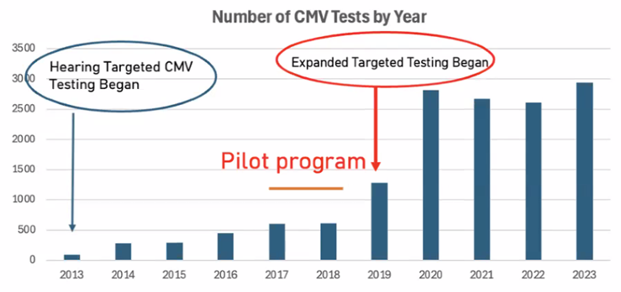  - Comparison to Universal Screening  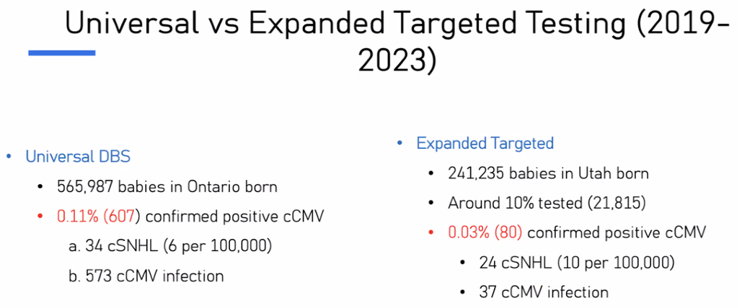  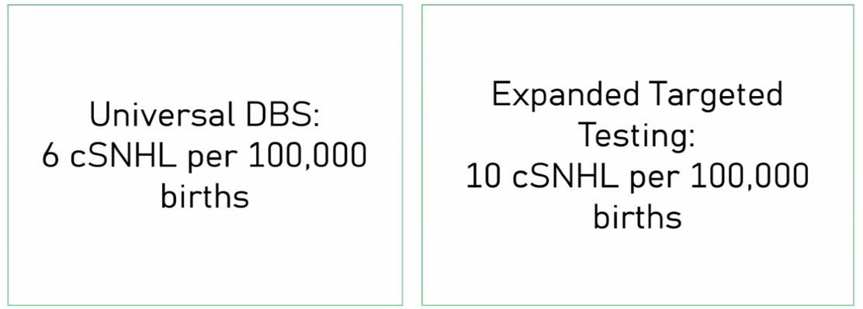  - University of Utah recommendations  - Optimal Approach: Expanded targeted early CMV testing in all Utah hospitals and DBS testing for older patients  - Identify more treatable cases than hearing targeted alone in an economically feasible manner  - Other considerations  - Ensure families are opting in for DBS retention
EHDI* Updates | Krysta Badger reviewed EHDI updates  - Completing deliverables  - Submitted 2024 data to the CDC this month as per the NOFO  - HRSA grant project to receive language outcomes for deaf and hard of hearing children at the age of 3 is still moving forward. Expect to start receiving that data by the end of the year.
Early Intervention Meeting Recap | Dr. Shannon Wnek went over the Early Intervention (EI) Director’s Consortium  - Early Intervention (EI) data dating back to 2016  - Bouncing around 60%, with a high of 71% and a drop down to 56% in 2024  - How can we make this process better?  - Increase resources for families  - Beginnings book for every family  - 8 Reasons to say yes to EI services  - FAQ documents for families  - Importance of EI  - Cost  - Service locations  - FAQ document for audiologists as well  - Created a letter with pediatric audiology working group and a few primary care providers  - To be sent at time of diagnosis from the diagnosing audiologist  - Notifies doctor of patient diagnosis  - Asks doctor to encourage patient’s parents to enroll in EI  - Changed process in recommending that all audiologists refer newly diagnosed families directly to PIP in the hopes that they would have an opportunity to be able to talk to families about EI services.  - Enrollment data findings  - > 95% of children were receiving that referral from their diagnosing audiologist.  - Maternal ethnicity was not significant.  - Maternal education was statistically significant. College graduates were more likely to enroll.  - Patients with severe to profound hearing loss were more likely to enroll in PIP services.  - Undetermined hearing loss were less likely to enroll.  - Salt Lake County was least likely to enroll in EI services.  - Sent out two surveys, one to EI providers and one to USDB PIP providers.  - Learned that a clear system of how to work together is needed to address and work on  - communication issues  - timing of appointments and assessments  - staff education  - Meeting in December, planning next steps for better education, etc. Possibly creating an optional Canva training course for EI providers.
Utah Midwives Organization (UMO) Conference Recap | Holley Ezzell provided a recap of the Utah Midwives Organization Conference  - November 6th - 8th, 2025, at Thanksgiving Point in Lehi, UT  - Holley did a 45-minute presentation with epidemiologist, Max Sidesinger  - 35 people attended in-person and 4 online. It was also recorded.  - Started with a live survey and, from that, saw what information midwives had about hearing screening, CMV, and the processes.  - Gathered info and did education based off the survey.  - Covered the following topics:  - CMV testing and House Bill 363  - The importance of talking with their clients about opting in to keep the blood spot  - Genetic hearing loss, Microtia, Atresia & hearing loss, cleft palate, cleft lip, Downs Syndrome, and ear pits & tags. These topics served to inform attendees a bit of what to look for when they have babies that may have these anomalies, and the importance of hearing screening follow-up.  - There were midwives from Wyoming and Idaho who were very interested in learning how Utah EHDI works with midwives in our state, and how they can return to their states and try to work more closely with their EHDI programs.
NCHAM Updates | Dr. Karl White provided NCHAM updates:  - National EHDI conference coming up  - March 15th – 17th, 2026 in Jacksonville, FL  - 25th Anniversary of holding EHDI conferences  - New issue of the Journal of Early Hearing  - www.jehdi.org  - EHDI-PALS program  - An online portal to help families and professionals find pediatric audiologists  - A recent update provides some additional functionality  - A great place for families whose children have not passed their newborn hearing screening. If they're looking for a pediatric audiologist, the site provides information on:  - Location  - The kinds of procedures they have experience with and equipment they use.  - The kinds of ancillary services they provide (i.e. translation, interpretation for Spanish-speaking people, what kind of insurances they take, etc.)  - www.ehdi-pals.org  Ms. Morgan asked if there would be a virtual option for the upcoming EHDI conference. Dr. White responded that there will not be a virtual option, due to the costs associated with making it virtual as well.
Future Agenda Items | No future agenda items
Next Meeting | February 10, 2026
Adjourn | Karl White made a motion to adjourn the meeting. Adrienne Johnson seconded the motion. The meeting adjourned at 10:07 am.
Minutes Approved | February 10, 2026

Note: These minutes are not intended to be a verbatim transcript but are to record the significant features of the business
conducted in this meeting. Discussed items are not necessarily shown in the chronological order they occurred.

