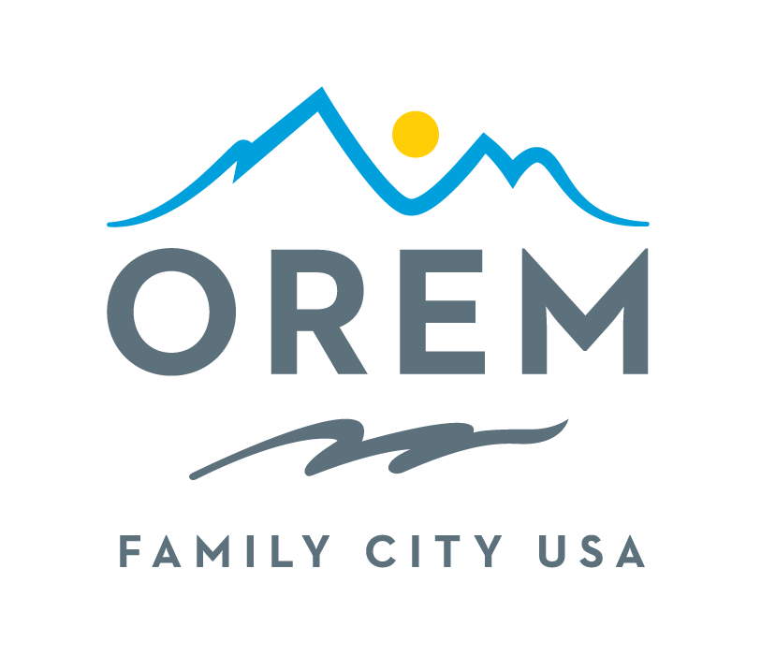
CITY OF OREM
ADVISORY BOARD/COMMISSION
MEETING AGENDA
meeting may be held electronically to allow a board/commission member to participate.
PUBLIC BODY: Events Advisory Commission
DATE: Thursday, February 12, 2026 ROOM: City Council Conference Room #1002
Right next to the City Council Chambers
TIME: 4:00 p.m. - 5:30 p.m. ADDRESS: 56 North State Street, Orem, Utah

AGENDA ITEMS:
Welcome Ashley Shumway
- Introduction of the new City Council Member Representatives
- Introduction of the new Events Commission Members
Review and Approve Minutes from January 8, 2026 Ashley Shumway

City Updates
- Commission Advisor Assignments Crystal Muhlstein/Kenice Whitaker
  - Appointments
  - Schedule a time to meet with your committee.
- Application Status Sydney Bailey
- Training Makeup Kenice Whitaker

Commission Updates Ashley Shumway

Training Kenice Whitaker
- Volunteer Recruitment Kenice Whitaker
  - Needs Assessment
  - Volunteer Duty Descriptions
  - How to Sign Up to Volunteer
  - Volunteer Waivers
- Discussion Items Ashley Shumway
  - Oremfest Theme (Discuss and Vote)
  - Parade Float (Discuss and Vote)
  - Grand Marshal
    - Final call for nominations (Discuss and Vote)
  - Oremfest Entertainment – Free passive and scheduled activities
    - Scales and Tales – Discussion
    - Other Activity Ideas – Discussion
  - Vendor Selection Committee Formation
- Review Action Items Kenice Whitaker

- Next Meeting – Thursday, March 12, 2026 Ashley Shumway
    - April 9th meeting is scheduled for the same time as spring break, discuss other meeting time options.

- Adjournment Ashley Shumway

THE PUBLIC IS INVITED TO PARTICIPATE IN ALL CITY MEETINGS.

If you need special accommodation to participate in Advisory Commission meetings
Please contact us on the City's website at orem.org or call (801) 229-7000 at least three working days.
prior to the meeting. This agenda is available on the Utah Public Notice website at utah.gov/pmn.

