Posted on February 5, 2026, on the Utah Public Notice Website www.utah.gov/pmn/ Draper City Website www.draperutah.gov/news/ and at Draper City Hall, 1020 E. Pioneer Road, Draper, UT

NOTICE OF PUBLIC HEARING: City Initiated Residential Parking Requirements Zoning Text Amendment Request
Notice is hereby given that Draper City will hold a public hearing before the City Council to consider the above listed request. The purpose of the request is to amend the text of portions of Draper City Municipal Code (DCMC) Title 9 to address recent changes to Utah State Code related to residential parking requirements.
The hearing will be held at Draper City Hall in the City Council Chambers, on February 17, 2026 at 7:00 p.m. The complete notice is posted on the Utah Public Notice Website; www.utah.gov/pmn/, Draper City Website; www.draperutah.gov/news/, and at Draper City Hall.
To request a copy of the public notice or for additional inquiries contact Todd Taylor at (801) 576-6510 or todd.taylor@draperutah.gov.

Dated this 5th day of February, 2026.
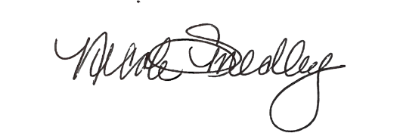
Attest:
_______________________________
Nicole Smedley, City Recorder

