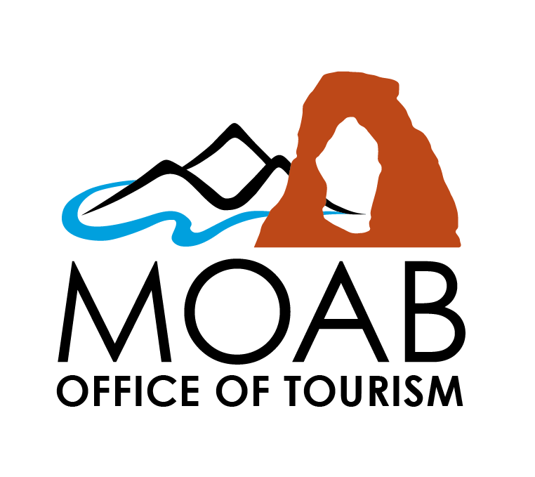 | Regular Meeting  Moab Tourism Advisory Board  Grand County Commission Chambers 125 East Center Street, Moab, Utah

3:00 PM

AGENDA
February 10, 2026

Zoom And Youtube Meeting Information

Join Zoom Meeting:
Https://Us02web.Zoom.Us/J/84013922560?Pwd=Qbxjbarkaa0wjttygndb9won3nd7j4.1
Meeting ID: 840 1392 2560
Passcode: 135246

Call To Order

Citizens To Be Heard

Opening Items

- Welcome
- Introductions
- Conflicts Of Interest, Disclosures, Ex-Parte Communication

1. | Board Member Reports

Discussion And Action Items

2. | Approval Of Minutes

3. | Elect Chair / Vice Chair For MTAB

4. | Update On Board Applicants

5. | Outdoor Mitigation Grant Discussion

6. | Canyon Spirit 2026 Update

7. | Archery Range At OSTA Grant Discussion / Endorsement Letter

8. | Update From Marketing Subcommittee

9. | ​"Who Is Moab" Project Update

10. | Consideration Of Future Agenda Items

Adjourn

NOTICE OF SPECIAL ACCOMMODATION DURING PUBLIC MEETINGS. In compliance with the Americans with Disabilities Act, individuals with special needs requests wishing to attend Grand County Commission meetings/hearings and other Grand County Boards, Commissions, or Committees are encouraged to contact the County two (2) business days in advance of these events. Specific accommodations necessary to allow participation of disabled persons will be provided to the maximum extent possible. T.D.D. (Telecommunication Device for the Deaf) calls can be answered at:(435) 259-1346. Individuals with speech and/or hearing impairments may also call the Relay Utah by dialing 711. Spanish Relay Utah: 1 (888) 346-3162
It is hereby the policy of Grand County that elected and appointed representatives, staff and members of the Grand County Commission meetings/hearings and other Grand County Boards, Commissions, or Committees may participate in meetings through electronic means. Any form of telecommunication may be used, as long as it allows for real time interaction in the way of discussions,questions and answers, and voting.
At the Grand County Commission meetings/hearings and other Grand County Boards, Commissions, or Committees any citizen, property owner, or public official may be heard on any agenda subject. The number of persons heard and the time allowed for each individual maybe limited at the sole discretion of the Chair. On matters set for public hearings there is a three-minute time limit per person to allow maximum public participation. Upon being recognized by the Chair, please advance to the microphone, state your full name and address, whom you represent, and the subject matter. No person shall interrupt legislative proceedings.
Requests for inclusion on an agenda and supporting documentation must be received by 5:00 PM on the Tuesday prior to a regular Commission Meeting and forty-eight (48) hours prior to any Special Commission Meeting. Information relative to these meetings/hearings may be obtained at the GrandCounty Commission’s Office,125 East Center Street, Moab, Utah; (435)259-1346.

