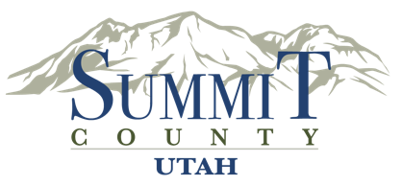
Summit County Health Department
650 Round Valley Drive
Park City, Utah 84060
summitcounty.org
30 Day Comment Period:
Revisions to the Summit County Code of Health Chapter 15

February 11, 2026 - March 13, 2026
The Summit County Health Department is issuing a 30-day formal notice and comment period during which the public can review the proposed revisions to the Summit County Code of Health. Please submit comments to the Health Department in writing either by email or mail, or telephone by calling Summit County Health Department at 435-333-1500.
The Summit County Health Department proposes revisions to Code of Health Chapter 15: Body Art and Permanent Makeup Establishments. Proposed revisions can be viewed online at https://summitcounty.info/boh, or by scanning this QR code.
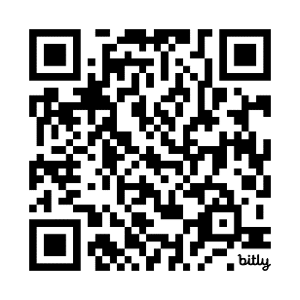
All public comment on the proposed changes must be postmarked or received no later than 11:59 pm on March 13, 2026. Please contact Nathan Brooks (nbrooks@summitcountyutah.gov) with any comments on proposed changes for Chapter 15: Body Art and Permanent Makeup Establishments. Please call the Health Department at 435-333-1500 and ask for Nathan Brooks to provide comment over the phone. Please mail public comments to the address listed below.
Attention: Nathan Brooks
Summit County Health Department
650 Round Valley Drive, Park City, Utah 84060
Public comments will also be taken at the Board of Health meeting held on Monday, April 6, 2026 at 4:00 p.m.

