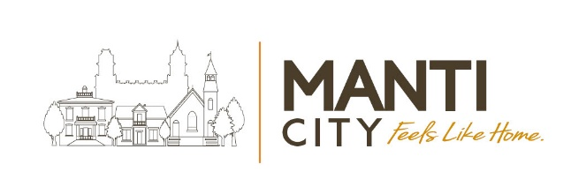
Council Meeting Agenda
Manti City Building • 50 South Main Street
February 4, 2026 – 6:30 p.m.

Call to order & Welcoming: ☐Mayor Mary Wintch
Roll Call of City Council Members (Attendance):
☐Meagan Johnson ☐Mary Pipes ☐AJ Mower ☐Jen Christiansen ☐Brian Francois

Council Meeting Agenda Items:

- Declaration of conflicts of personal interest with any agenda items:

- Approval of recent Council Meeting Minutes: January 21, 2026

- Capital Improvement Projects Discussion

- City Sponsored Events Discussion

- South Sanpete School District Appreciation & Support

- Payment Approval Report (Bills): 2/1/2026 – 2/15/2026

- Continuing Business:

  - Short Term Rentals Moratorium
  - Annexation/Subdivision Moratorium
  - Cemetery Ordinance
  - Proposed Veterans’ Memorial.
  - Quarry Hills Trail Development
  - America250 Utah
  - Accessory Dwelling Unit (ADU) recommendations from the Planning Commission. A public hearing is scheduled for February’s Planning Meeting.
  - Economic Development: Inland Port project

- Councilmember Reports:
Brian Francois
Jen Christiansen
AJ Mower
Mary Pipes
Meagan Johnson

- Administration Reports (City Manager): Jason Brown

- Public Comment (two minutes per each comment):

- Mayor Comments: Mayor Wintch

- Motion to convene to a Closed Session (if needed): The Manti City Council may close a portion of their meeting to discuss the character, professional competence, conduct, or other factors of an individual per Utah Code 52-4-205(1)(a); or to discuss the purchase, exchange, or lease of real property, or water rights/shares per Utah Code 52-4-205(1)(d) and (e); to hold a strategy session to discuss pending or reasonably imminent litigation per Utah Code 52-4-205(1)(c); discussions regarding security of City devices or systems. ACTION: Any necessary action to be taken as a result of discussions had in the closed session.

- Adjourn:

In Accordance with the Americans with Disabilities Act (ADA) individuals needing special accommodations or interpretive services during this meeting should contact the city office at
435-835-2401 at least (3) working days prior to the meeting.

Certificate of Posting: The undersigned, duly appointed Recorder, does hereby certify that the above notice & agenda was posted and provided to the local media and the posted on the Utah State website.

Matt Gray, City Recorder

