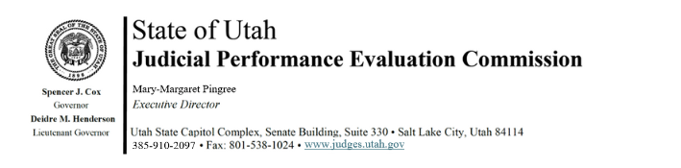
Tuesday, February 3, 2026
8:30 am-12:00
CCJJ Board Room, 3rd Floor Senate Building (anchor location)
Hybrid Meeting

Members: Lisa Watts Baskin, Mallory Bateman, Terry Buckner, Christine Durham, Becky Edwards, Christian Hansen, Blair Hodson, Curtis M. Jensen, Gil A. Miller, Mary Noonan, Bridget Romano, Tom Ross, Mike Smith

Staff: Madison Klein, Julie Spilker, Chris Russell, Mary-Margaret Pingree, Paul Tonks

8:30 am Welcome Bridget Romano
Approval of Minutes – January 20, 2026

8:35 am Announcements Mary-Margaret Pingree

8:45 am Commission Updates Bridget Romano

9:00 am New Judge Portal Madison Klein

9:15 am 2026 Retention Evaluations Chris Russell
Closed Session Madison Klein

9:45 am Break (if needed)

10:00 am 2026 Retention Evaluations Chris Russell
Closed Session

11:30 am Adjourn

Next Meeting: Tuesday, February 17, 2026
8:30 a.m. – noon
CCJJ Board Room, 3rd Floor Senate Building

