
S ANDY CITY COMMUNITY DEVELOPMENT
JAMES SORENSEN COMMUNITY DEVELOPMENT DIRECTOR

MONICA ZOLTANSKI
MAYOR

SHANE E. PACE
CHIEF ADMINISTRATIVE
OFFICER

Notice of Public Meeting

NOTICE IS HEREBY GIVEN that on February 12, 2026, at approximately 6:30 p.m., the Sandy City Board of Adjustment will hold a public meeting regarding an appeal submitted by Garrett and Samantha Lisi, who are represented by Clyde Snow & Sessions, Attorneys at Law. The appeal is regarding an alleged error of the Planning Commission’s decision on the Falls Creek Estates Subdivision located at 2873 E Wasatch Blvd. All application materials and a full staff report for this item can be found at https://sandyutah.legistar.com when the agenda is published (typically the Friday preceding the meeting date).
This Board of Adjustment meeting will be conducted both in-person (in the Sandy City Council Chambers at City Hall, 10000 S. Centennial Pkwy.), and via Zoom Webinar (see details below). Interested parties may attend the meeting either in-person or by accessing the meeting using the Zoom webinar link below; however, proceedings for appeals are not open to public comment. A listen-only option is also available using the phone numbers provided below.
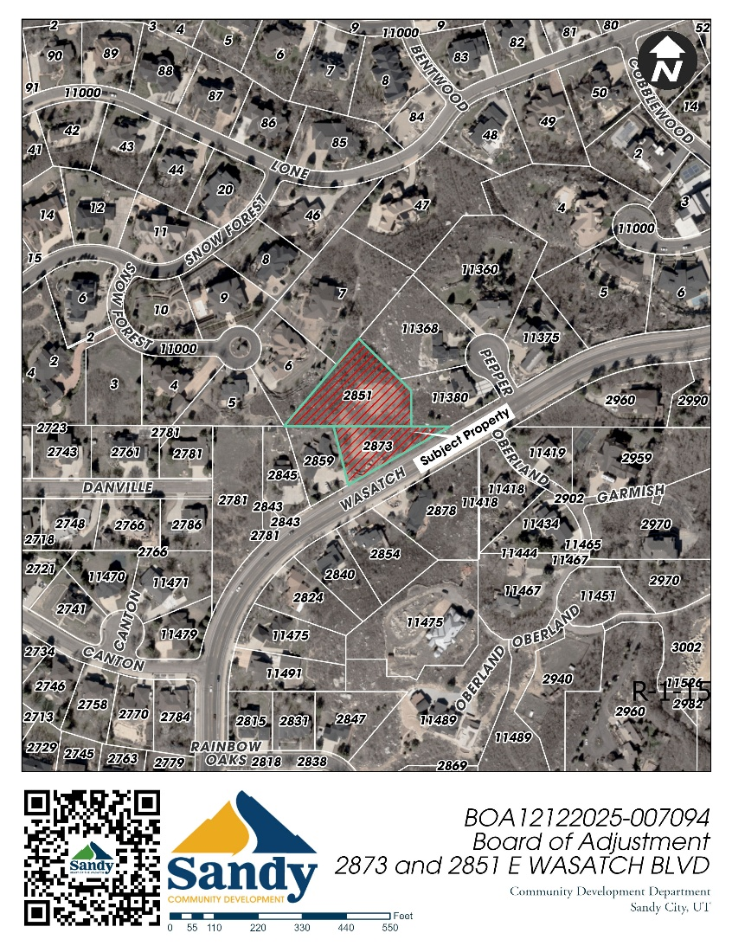
This notice is being sent to known property owners within 500 feet of this proposal. Please forward this information on to others who may be interested. Interested parties may inquire about the proceedings prior to the meeting by contacting the Zoning Administrator Melissa Anderson,
at 801-568-7275 or by email at: manderson@sandy.utah.gov.

How to join Zoom Webinar General Instructions:
• Join on via laptop, desktop or mobile device
• Go to www.zoom.us
• Click ‘join a meeting’, in the top right-hand corner
• Enter Meeting ID: 854 4840 9997 and click “Join.”
• Enter Meeting Password: 990658
• A download should start automatically in a few seconds. If not, click “download here.”
• Open download, meeting should begin at 6:30 p.m.

You can also join directly through this URL:
https://us02web.zoom.us/s/854 4840 9997

Or join by phone (choose based on your current location):
US: 1 253 215 8782 or 1 346 248 7799 or 1 669 444 9171
Webinar ID: 854 4840 9997
Or find your local number: https://us02web.zoom.us/u/kBxWREqL8

