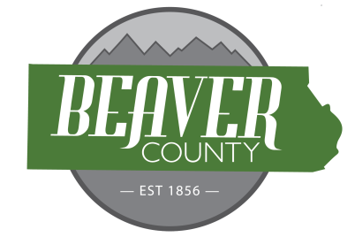
NOTICE AND AGENDA OF A PUBLIC MEETING
FEBRUARY 3, 2026 PUBLIC MEETING OF THE
BOARD OF COUNTY COMMISSIONERS OF
BEAVER COUNTY, UTAH

PUBLIC NOTICE is hereby given that the Beaver County Commissioners of
Beaver County, Utah, will hold a regular Meeting on February 3, 2026, at the place
and time set forth below to consider the agenda item(s) hereinafter set forth.

MEETING PLACE: Beaver County Administration Building 105 East Center Street, Beaver, Utah.
MEETING TIME: 10:00 AM

10:00 AM
Open Meeting Commissioner Wade Hollingshead
Call to order Commissioner Wade Hollingshead
- Prayer offered by Klell Bradshaw
- Pledge of Allegiance led by Wade Hollingshead
New Business
10:05: Approve Bills
10:10: Approve January Minutes
10:20: Western Rock Conditional Use Permit
10:30: Lincoln-Hill Consulting Agreement
10:35: PDCF Contract Fiscal Year 2025/2026
10:40: DNR Conservation Easement
10:50: Adjourn Meeting

(To be discussed when/as time permits)

- Old Business
- Commission Updates

Closed session for the purpose of discussing the character, professional competence, or
physical or mental health of an individual; discuss strategy for pending or reasonably imminent litigation, real property negotiation.

BEAVER COUNTY COMMISSION CHAIRMAN
Any other business properly brought before the Board.
Dated the 3rd day of February, 2026

