Posted on January 29, 2026, on the Utah Public Notice Website www.utah.gov/pmn/ Draper City Website www.draperutah.gov/news/ and at Draper City Hall, 1020 E. Pioneer Road, Draper, UT

NOTICE OF PUBLIC HEARING: Highpointe Office Building II Site Plan and Parking Deviation

Notice is hereby given that Draper City will hold a public hearing before the Planning Commission to consider the above listed request. The property is located at approximately 193 E. Highland Drive. The purpose of the request is to construct a new office building, with a deviation from strict compliance for required parking.

The hearing will be held at Draper City Hall in the City Council Chambers, on February 12, 2026, at 6:30 p.m. The complete notice is posted on the Utah Public Notice Website; www.utah.gov/pmn/, Draper City Website; www.draperutah.gov/news/, and at Draper City Hall.

To request a copy of the public notice or for additional inquiries contact Maryann Pickering at (801) 576-6391 or maryann.pickering@draperutah.gov.

Dated this 29th day of January, 2026.

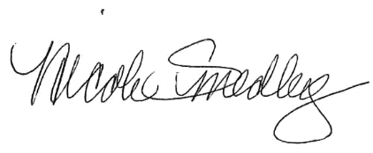
Attest:

_______________________________
Nicole Smedley, City Recorder

