Posted on January 29, 2026, on the Utah Public Notice Website www.utah.gov/pmn/ Draper City Website www.draperutah.gov/news/ and at Draper City Hall, 1020 E. Pioneer Road, Draper, UT

NOTICE OF PUBLIC HEARING: Highland Boundary Adjustment Land Use Map and Zoning Map Amendment Requests.

Notice is hereby given that Draper City will hold a public hearing before the Planning Commission to consider the above listed request. The property is located at approximately 16199 S. 3300 E. The purpose of the request is to remove the current land use and zoning designations from the Draper City Land Use and Zoning maps for property that is part of a separate boundary adjustment between Highland City and Draper City.

The hearing will be held at Draper City Hall in the City Council Chambers, on February 12, 2026 at 6:30 p.m. The complete notice is posted on the Utah Public Notice Website; www.utah.gov/pmn/, Draper City Website; www.draperutah.gov/news/, and at Draper City Hall.

To request a copy of the public notice or for additional inquiries contact Todd Draper at (801) 576-6335 or todd.draper@draperutah.gov.

Dated this 29th day of January, 2026.


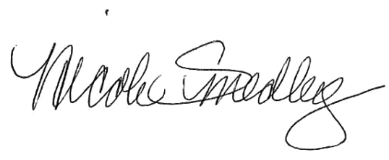
Attest:

_______________________________
Nicole Smedley, City Recorder

