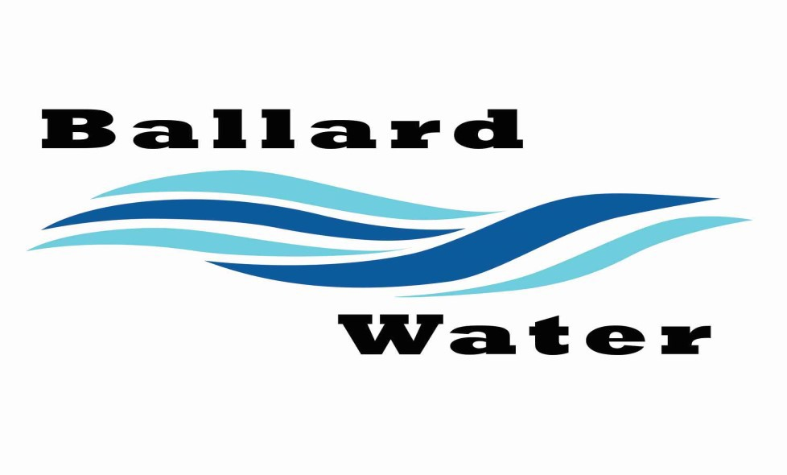

Ballard Water & Sewer Improvement District Fee Schedule
2381 E. 1000 S., Ballard, UT 84066
Phone: 722-3393
(updated January 2022)

Monthly Water Rates
Residential Water basic rate | $65.00 for first 5,000 gallon  $2.10 per 1,000 gallon over 5001 – 20,000 gallons  $3.00 per 1,000 gallon over 20,001 and over
Commercial Water basic rate | $102.00 for first 5,000 gallon  $2.20 per 5001 - 30000 gallons  $3.50 per 30,001 and over
Industrial Water basic rate | Basic Rate of $81.00 with a $4.00 per 1000 gallons overage
Monthly Sewer Rates
Sewer Single Family Dwelling Units — $30.50  Sewer Residential Dormant — $13.00  Sewer Commercial 1 — $30.00 Sewer Commercial 3— $36.50 Sewer Commercial 5— $36.50 | Sewer Residential 1/2 — $18.00  Sewer Multiple Dwell Unit & Trailer Ct — $20.00 x 80% Sewer Commercial 2 — $98.00  Sewer Commercial 4—$98.50
Monthly
Water / Sewer Hook-up and Impact Fees
Water Hook-up Fee $ 1800.00  Water Impact Fee $ 4200.00  Sewer Hook-up Fee $ 500.00  Sewer Impact Fee $ 2500.00 Total $ 9000.00 | Security Deposits  Water Hook-up $250.00  Sewer / Water 300.00


Ballard City Fee Schedule

2381 E. 1000 S.
Ballard, UT 84066
Phone: 722-3393
re-approved June 6, 2023

Planning & Zoning Fees
Subdivision:  Pre-Application Meeting $ 0.00  Concept Plan Review $ 0.00*  Preliminary Plan Review $ 200.00 (plus  $25.00 per lot)*  Final Plat Review $ 40.00 per lot  (Maximum  $400.00)*  Minor Subdivision Application $ 400.00*  Simple Boundary Adjustment $ 0.00*  Full Boundary Adjustment $ 0.00*  Subdivision Plat Amendment $ 0.00*  Out-Of-Pocket Account $ 0.00**  (Minimum Balance) | Land Use:  Annexation $100.00*  General Plan Amendment $ 500.00* (Plus  Acreage Fee)  Rezone Request $ 300.00*  (Plus Acreage Fee)  Planned Development Zone Change $ 400.00* (Plus  Acreage Fee  Conditional Use Permit $ 300.00*  Site Plan Review $ 200.00*  Other Requests $ 50.00*  Out-Of-Pocket Account $ 0.00**  (Minimum Balance)
Notes:
* Plus Additional Fees which shall include expenses incurred by the City which are to be paid for by the applicant as outlined in 14.08.100.
** If deemed necessary by the City, an applicant may be required to establish an “Out-Of-Pocket Account” as outlined in 14.08.100 to ensure the prompt payment of additional fees.
Encroachment / Road Cut Fees
Road Cuts (across paved city roads) $ 750.00 | Right-of-way access $ 75.00
Road Bores (under paved city roads) $ 250.00  Road Cuts (across gravel or native roads) $100.00 | Right-of-way encroachment $ 500.00 Within asphalt surface (plus .50 per ft)
Temporary Pipelines $250.00 (plus .10 per lineal foot of pipe) | Right-of-way encroachment $ 250.00 Within 4ft of shoulder (plus .25 per ft)  Exigent encroachment on a moratorium road $5,000.00
Office / Park Rental Fees
Copies $ .10 page  Zoning Book Copy $25.00  Zoning Map $ 1.00 | Business License Fee $100.00 start up fee  $ 50.00 yearly renewal Exempt License Only $ 25.00
 | Building Permit Fees figured from square footage and valuation amount.
Park Pavilion Rental  Minor Event NonPft Profit Deposit  Small Groups 35.00 35.00  Groups of 75—100 75.00 90.00 100.00  Groups of 101—250 150.00 180.00 150.00  (waiver form and application available | Major Event Park Rental NonPft Profit Deposit Groups of 251—500 250.00 300.00 250.00  Groups of 501—1000 400.00 450.00 500.00  Groups of 1001—1500 500.00 550.00 750.00  (Special Events Permit Application available)

