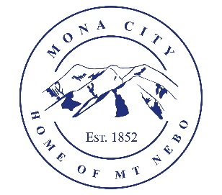
Mona City
435-623-4913
www.monautah.gov
20 West Center Street, Mona, Utah

Mona City Council Meeting Agenda
Tuesday, January 27, 2026
Mona City Building – 20 West Center
7:00 p.m.
- Pledge
- Prayer
- Approval of January 13, 2026, Closed Executive Session Minutes
- Approval of January 13, 2026, Work Session Minutes
- Approval of January 13, 2026, City Council Meeting Minutes
- Miscellaneous Items:
  - Jay Mecham – Garbage Services
- Action Items
  - Resolution 2026-3: Contract for municipal garbage pickup services
  - Approval of up to $9,800 for sewer service audit from Veolia Corporation
- Regional Planner Shay Morrison
  - OPMA/Newly Elected Training
- Planning and Zoning
- Finance
  - Approval of Finances
- Recorder
  - Conflict of Interest & Ethical Behavior Forms
  - City Council Vacancy Meeting for Council Candidates
  - Water work session on Tuesday February 10th at 6:00 pm
- Gas & Water & Roads
- Sewer
- Council Reports
- Public Comment
- Adjournment

CERTIFICATE OF POSTING
This agenda is hereby properly advertised on this 26th day of January, 2026, by posting copies in the following places: the Mona City Office, on the Mona City website at monautah.gov, at the United States Post Office Mona City Branch, and on the Utah Public Notice Website at www.utah.gov/pmn/index.html.

___________________________________
Alicia Hills, Mona City Recorder

Upon Request, in compliance with the Americans with Disabilities Act, reasonable accommodations for individuals with disabilities will be provided. For assistance, please call 435-623-4913.

