13.11 |  | Multiple-Use (MU) Zone
13.11.1 |  | Purpose
1 | The purpose of the Multi-Use zone (MU zone) is to implement a coordinated, flexible zoning framework that supports limited, sustainable commercial growth and modest housing opportunities in Lake Point while preserving open space and the community’s rural character.
2 | Consistent with the Lake Point General Plan, the MU zone promotes attractive and practical combinations of residential and small-scale commercial uses—both horizontally and vertically—such as live-work buildings with optional ground-floor businesses, to foster entrepreneurship, walkability, and vibrant community spaces.
3 | The MU zone is intended to facilitate the orderly and intentional expansion of commercial activity from existing centers, ensure access to collector streets, require concurrent development of commercial and residential components, and reduce land-use conflicts by ensuring compatibility between uses, thereby supporting local businesses, community facilities, and a balanced, cohesive development pattern.
13.11.2 |  | Applicability; Relationship to Other Regulations
1 | This Chapter applies to all development, redevelopment, and phased development within the MU zone.
2 | The requirements in this Section are minimum requirements. Where other provisions of Chapter 13 (Land Uses) and/or Chapter 14 (Design and Construction Standards) impose additional requirements applicable to a development, those requirements apply in addition to this Section.
13.11.3 |  | Permitted and Prohibited Uses
1 | Permitted and prohibited uses in the MU zone shall be as provided in Section 13.5.1 (Commercial and Industrial Zoning District Standards), as amended. Uses not expressly permitted are prohibited.
2 | Every development in the MU zone shall include a commercial component. Residential-only development is prohibited. No development shall be approved that, in form or function, results in a project that is primarily residential in character, regardless of numerical compliance with minimum ratios or dimensional standards.
13.11.4 |  | Rezoning/Annexation into MU Zone
1 | Property proposed for rezoning or annexation into the MU zone shall contain at least fifteen (15) contiguous acres in common ownership at the time of application.
2 | A Development Agreement and Master Plan (reference 13.11.5) shall accompany any applications for property proposed for rezoning or annexation into the MU zone.
13.11.5 |  | Plans Required for Multiple-Use (MU) Developments
1 | Master Plan: A planning document that establishes the overall vision, framework, and guiding principles for the development of land within the multiple-use (MU) zone or a designated portion thereof. A Master Plan is intended to demonstrate general consistency with the General Plan and to guide the preparation of subsequent Development Plans and Site Plans.
1.1 | A Master Plan may include, but is not limited to, conceptual land-use diagrams, general location and relationship of commercial and residential uses, anticipated densities and intensities, circulation and access concepts, open space and community gathering areas, design character themes, and an overall phasing strategy. A Master Plan shall be illustrative in nature and shall not authorize construction, confer vested development rights, or substitute for required Development Plan or Site Plan approvals.
2 | Development Plan: A detailed, regulatory plan submitted for approval that establishes the specific layout, density, mix of uses, and development standards for a multiple-use (MU) development or a defined phase thereof. The Development Plan shall implement the intent of the MU zone and, where applicable, an approved Master Plan, and shall serve as the controlling entitlement document governing future Site Plan approvals.
2.1 | A Development Plan shall identify permitted commercial and residential uses, building footprints or development areas, maximum gross floor area, height and massing parameters, access and circulation, parking strategy (including shared or phased parking), open space allocation, buffering and compatibility measures, and phasing and concurrency requirements, including the requirement that commercial components be constructed concurrently with residential components unless otherwise approved. Approval of a Development Plan shall establish binding development standards for the subject property but shall not authorize construction absent approval of a Site Plan.
3 | Site Plan: A detailed, parcel- or building-specific plan that illustrates the precise design and physical development of a site in accordance with an approved Development Plan and applicable zoning, engineering, and design standards. A Site Plan shall provide sufficient detail to allow review for compliance and issuance of construction-related permits.
3.1 | A Site Plan shall include, as applicable, exact building locations and dimensions, architectural elevations, parking layout and counts, landscaping and buffering, pedestrian and vehicular circulation, utilities, grading and drainage, lighting, and other site improvements. Site Plan approval shall authorize construction only for the development shown and shall not modify or supersede the approved Development Plan.
13.11.6 |  | Permit Sequencing
1 | Site plan approval is required prior to issuance of building permits. Building permit applications may be submitted concurrently with a site plan; however, no building permit shall be issued prior to site plan approval.
2 | To ensure timely construction of the commercial component, the applicant shall apply for commercial building permits prior to or concurrently with residential building permits in a manner that is proportional to the approved phasing plan and total project buildout.
3 | The City may withhold, suspend, or deny building permits for any building(s) within a development where the applicant fails to comply with this Chapter, an approved site plan, an approved multiple-use master plan, conditions of approval, or a development agreement.
13.11.7 |  | Use and Space Thresholds
1 | This Section establishes minimum commercial thresholds for MU developments. Compliance may be achieved through horizontal multiple-use, vertical/integrated multiple-use, or a combination.
2 | The City may approve deviations to these thresholds upon written findings that: the commercial component remains sufficient in size and configuration to serve the development and surrounding area; the project maintains a balanced multiple-use character; and the project does not function primarily as a residential subdivision.
13.11.7.1 |  | Horizontal Multiple-Use
1 | Where commercial and residential uses are located in separate buildings, commercial uses shall occupy land area at a minimum ratio of one (1) acre of commercial land area for every four (4) acres of residential land area within the development.
2 | Land area shall be based on net developable area and shall exclude public rights-of-way, perimeter setbacks, and required open space, unless otherwise approved by the City.
13.11.7.2 |  | Vertical Multiple-Use
1 | Where one or more buildings contain both commercial and residential uses, commercial uses shall comprise not less than twenty percent (20%) and not more than thirty percent (30%) of the total gross floor area of all buildings within the development.
13.11.7.2.1 |  | Dedicated Vertical Multiple-Use Units
1 | A dedicated multiple-use unit shall contain dedicated space that is solely residential and dedicated space that is solely commercial.
2 | These dedicated spaces may be owned or leased by separate entities or by a single entity, but they are fundamentally separate units which must each have their own dedicated access points, bathroom facilities, and utilities.
3 | In dedicated vertical multiple-use units, commercial floor area shall be located on the ground floor or in other street-oriented or publicly accessible locations unless the City determines an alternative configuration better meets the intent of the MU zone.
13.11.7.2.2 |  | Flexible Vertical Multiple-Use Units
1 | A flexible multiple-use unit shall contain a dedicated space that is solely residential and a flexible space which may be used for either commercial or residential purposes
2 | The flexible space may be sub-leased to a separate entity but is fundamentally part of the same unit which contains the dedicated residential space.
2.1 | Under no circumstances shall a flexible space be sub-leased to a separate entity for use as a dedicated residential space (multi-family residential unit).
3 | The flexible space shall count toward the required commercial floor area within a development only when the space has a dedicated access point, dedicated bathroom facilities, and a lockable door separating it from the dedicated residential space.
4 | The flexible space shall be designed and constructed to reasonably accommodate conversion among permitted commercial and residential uses without structural modification.
5 | The flexible space shall be located on the ground floor unless the City determines an alternative configuration better meets the intent of the MU zone.
6 | The flexible space shall comply with applicable commercial parking, fire, and building code requirements in effect at the time of conversion.
13.11.8 |  | Phasing; Requirement for Commercial Construction
1 | Commercial uses shall be constructed concurrently with or prior to residential development unless otherwise approved through a development agreement.
2 | A parcel or lot may not rely on commercial uses located on other parcels or lots unless such parcels or lots are part of a unified multi-lot development agreement.
13.11.9 |  | Residential Transition Areas
1 | A development in an MU zone adjacent to existing single-family residential zones shall be designed to reduce conflicts related to scale, noise, lighting, and service impacts.
1.1 | In the MU zone, the building(s) nearest the residential zone property line shall be residential in use; or where non-residential buildings are located nearest the residential zone property line, the development shall provide:
1.1.1 | A ten-foot (10') landscaped buffer;
1.1.2 | A six-foot (6') sight-obscuring fence;
1.1.3 | A maximum building height of thirty-five (35) feet, measured from finished grade, for the first row of buildings directly adjacent to the residential zone property line;
1.1.4 | Loading zones, loading docks, and noise/vibration producing utilities shall be set back at least fifty (50) feet from the nearest residential property line;
1.1.5 | Rooftop mechanical and antenna equipment shall be screened; and
1.1.6 | Noise, vibration, smoke, dust, odor, glare, and similar impacts shall not be discernible beyond the premises except for normal traffic movements.
13.11.10 |  | Density
1 | Residential density in the MU zone shall not exceed ten (10) dwelling units (DU) per acre within areas designated for residential use on the master plan, unless otherwise approved through a development agreement.
2 | The guidelines in Table 1 and the example in Figure 1 should be used as a guidance to ensure a density pattern that provides appropriate transitions adjacent to existing residential zoning districts.
 | Table 1:
 | DU / Acre | Location | Rationale
1 | 1-3 | Low-Density (e.g. single-family homes) | Appropriate for areas bordering existing dedicated residential zoning in order to maintain open space and rural character of abutting area(s).
2 | 4-6 | Mid-Density (e.g. townhomes / condos) | Appropriate for areas in the center of the multiple-use development, providing a buffer between the Low-Density multiple-use and the High-Density multiple-use areas. Dense enough to support small-scale retail and local services without introducing urban scale.
3 | 7-12 | Mid-Density (e.g. mixed-use) | Appropriate for limited areas near major intersections, collector roads, or civic anchors. Located furthest away from residential zones.

Figure 1:
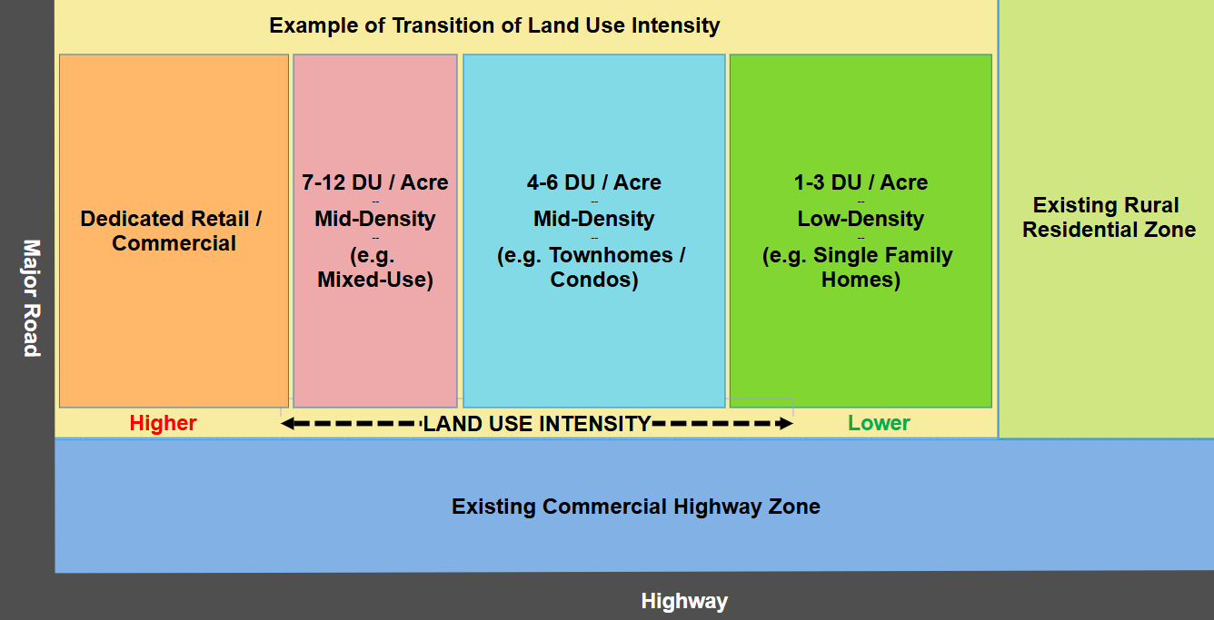
The figures below show conceptual examples of a multiple-use development in a rural town:
Figure 2:
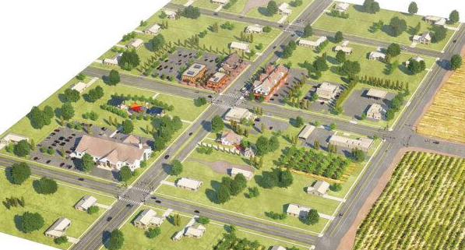
Figure 3:
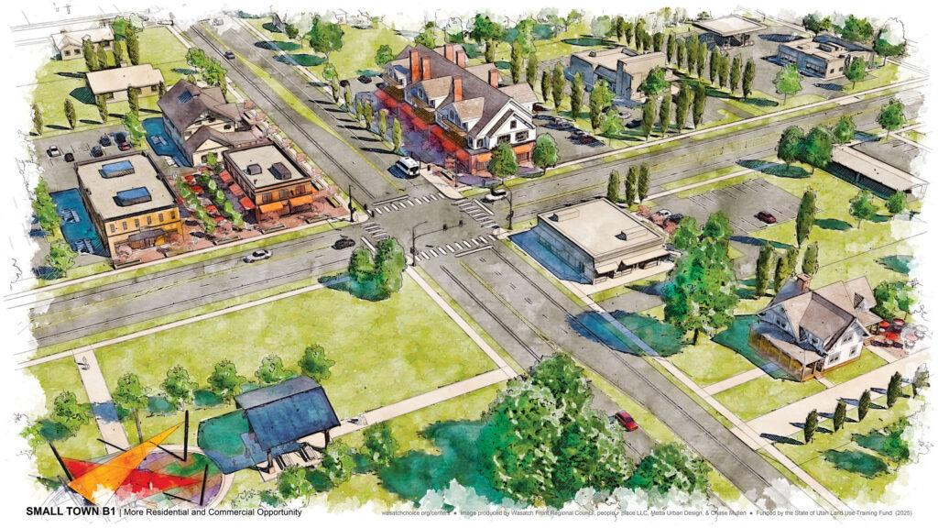
Figure 4:
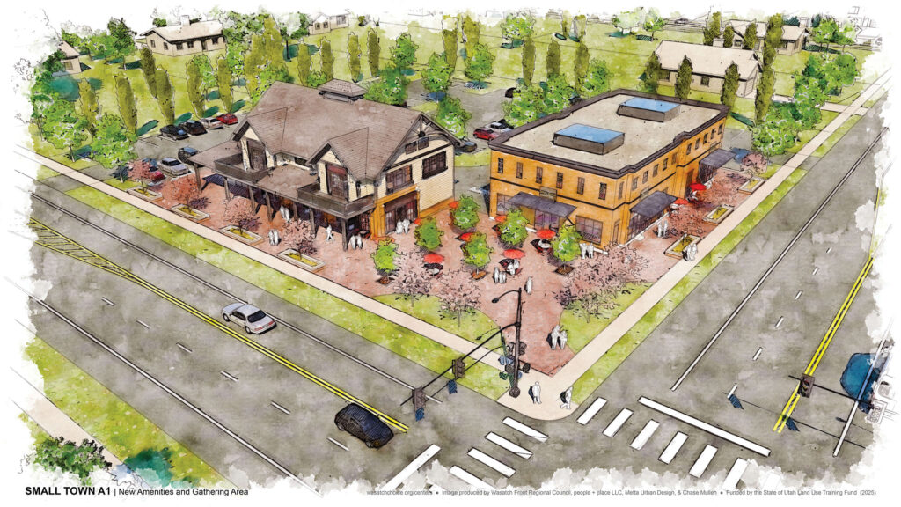
Figure 5:
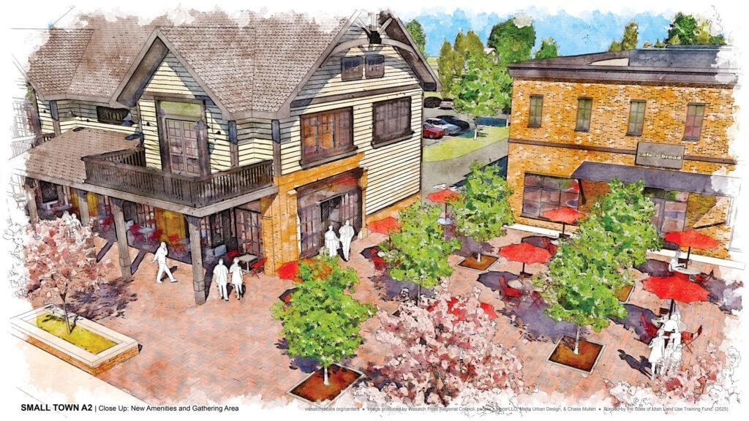
13.11.11 |  | Site Design and Development Standards
1 | Open Space: At least 20% of a multiple-use development shall be open space, including but not limited to landscaped areas and improved amenities (e.g. trails, benches, lighting, recreation features) supporting passive or active use.
2 | Maximum Lot Coverage: No more that 50% of a lot may be covered by building(s).
3 | Maximum building height in the multiple-use development shall be forty (40) feet, unless a greater height is approved through a development agreement or other process authorized by Lake Point Municipal Code.
4 | No uninterrupted wall length may exceed seventy-five (75) feet without façade articulation or architectural features.
5 | Building design shall comply with applicable design standards in Chapter 13. Buildings shall demonstrate a unified architectural style. Public street-facing façades shall use durable materials (e.g. stucco, fiber cement board, brick, stone). Vinyl, aluminum, and steel siding are prohibited on street-facing façades except soffits and fascia. Stucco-only façades are prohibited.
13.11.12 |  | Setbacks
1 | Setbacks shall comply with Chapter 13.2 for Residential and Chapter 13.5 for Commercial and Mixed-Use unless otherwise modified through site plan approval.
13.11.13 |  | Parking Standards
13.11.13.1 |  | Residential Parking
1 | Residential parking shall comply with Chapter 13.2 except as modified by this Section.
2 | Residential parking shall be designated and reserved for residential use and shall not be counted toward non-residential parking requirements.
13.11.13.2 |  | Non-Residential Parking
1 | Non-residential parking shall comply with Chapter 13.6 except as modified by this Section.
2 | Off-street parking shall be hard surfaced.
3 | Parking shall be located and designed to minimize conflicts with residential areas through separation, signage, striping, landscaping, and screening.
4 | Shared parking among non-residential uses shall not exceed 25% and is permitted only where the applicant demonstrates different peak demand periods and submits an analysis for approval through a development agreement and subsequent site plans.
4.1 | If a use is intensified or modified such that parking demand materially changes, previously approved reductions may be reevaluated for compliance.

FOR REFERENCE ONLY—ADDED MU COLUMN FOR DISCUSSION BY COMMISSION
# | Use | Neighbor-hood N* | Multi-Use MU | Highway H | General G | Industrial IND
Table 1.1. Agriculture, forestry and keeping of animals.
a | Accessory buildings and uses customarily incidental to permitted uses | Yes | Yes | Yes | Yes | Yes
b | Agriculture including grazing and pasturing of animals | Yes | Yes | Yes | Yes | Yes
c | Agricultural industries | No | No | No | No | Yes
d | Beauty shop for pets, dog grooming | Yes | Yes | Yes | Yes | Yes
e | Cannabis production establishment (see current state statute 4-41a-406(2) (not allowed within 1,000 feet of a community location or 600 feet of a primarily residential zone). (not allowed within 1,000 feet of a community location or 600 feet of a primarily residential zone). | No | No | No | No | Yes
f | Community gardens, fruit and vegetable stands, orchards, | Yes | Yes | Yes | Yes | Yes
g | Rooftop mounted solar arrays, for their own facility use | Yes | Yes | Yes | Yes | Yes
h | Tilling of the soil, raising of crops, horticulture and gardening | Yes | Yes | Yes | Yes | Yes
Table 1.2. Automobile, truck and recreational vehicle sales and services.
a | Accessory buildings and uses customarily incidental to permitted uses | No | No | Yes | Yes | Yes
b | Automatic car wash | No | No | Yes | Yes | Yes
c | Automobile or recreation vehicle sales, service, lease, rental and repair, new or used, conducted entirely within an enclosed building used, conducted entirely within an enclosed building | No | No | Yes | Yes | Yes
d | Automobile service station | No | No | Yes | Yes | Yes
e | Body and fender shop; tire recapping; motor vehicle, motorcycle, and recreation vehicle assembling, painting, upholstering and rebuilding. | No | No | No | Yes | Yes
f | Dismantling or wrecking of used motor vehicles and storage or sale of dismantled, inoperative or wrecked vehicles or their parts | No | No | No | Yes | Yes
g | Indoor auto parts sales | No | No | Yes | Yes | Yes
h | Parking lot not incidental to a use conducted on the premises - e.g. park and ride lot | No | No | No | Yes | Yes
i | Recreation vehicles, rentals, leases, sales and service, outdoor and indoor | No | No | Yes | Yes | Yes
j | Rooftop mounted solar arrays, for their own facility use | Yes | No | Yes | Yes | Yes
k | Truck and heavy equipment service station and repair facility | No | No | No | Yes | Yes
l | Truck wash | No | No | No | Yes | Yes
Table 1.3. Commercial sales and service.
a | Accessory buildings and uses customarily incidental to permitted uses | Yes | Yes | Yes | Yes | Yes
b | Animal hospital; In Neighborhood District only, no animals may be housed or treated outside of structure | Yes | Yes | Yes | Yes | Yes
c | Art needlework shop; art shop; art supply | Yes | Yes | Yes | Yes | Yes
d | Awing sales/repair | No | No | Yes | Yes | Yes
e | Baby formula service; baby diaper service; sitter agency | Yes | Yes | Yes | Yes | Yes
f | Bakery, retail sales | Yes | Yes | Yes | Yes | Yes
g | Bank | Yes | Yes | Yes | Yes | Yes
h | Barber shop | Yes | Yes | Yes | Yes | Yes
i | Bath and massage (not part of medical or health spa) | Yes | Yes | Yes | Yes | Yes
j | Beauty shop | Yes | Yes | Yes | Yes | Yes
k | Beer outlet, Class A, Class B | No | No | Yes | Yes | Yes
l | Bookstore | Yes | Yes | Yes | Yes | Yes
m | Building material sales, enclosed area | No | No | Yes | Yes | Yes
n | Building material sales yard, outside, with sale of rock, sand, gravel and the like as an incidental part of the main business, but excluding concrete mixing | No | No | No | Yes | Yes
o | Business incubator | Yes | Yes | Yes | Yes | Yes
p | Cafe, cafeteria, catering establishment, restaurant (not a drive-thru) | Yes | Yes | Yes | Yes | Yes
q | Candy, confectionery, nut shop | Yes | Yes | Yes | Yes | Yes
r | Carbonated and purified water sales; In Neighborhood District only, sales shall be limited to retail sales and not wholesale or delivery | Yes | Yes | Yes | Yes | Yes
s | Carpet and/or rug cleaning | Yes | Yes | Yes | Yes | Yes
t | Child or adult day care facility | Yes | Yes | Yes | Yes | Yes
u | China and/or silver shop | Yes | Yes | Yes | Yes | Yes
v | Clothes cleaning, dyeing, pressing, dry cleaners | No | Yes | Yes | Yes | Yes
w | Clothing store; In Neighborhood District only, stores shall be small boutique type stores and not department-type stores | Yes | Yes | Yes | Yes | Yes
x | Coal/fuel sales office | No | No | No | Yes | Yes
y | Convenience store with gasoline sales | No | Yes | Yes | Yes | Yes
z | Copy store, blueprinting, photostating, duplicating | Yes | Yes | Yes | Yes | Yes
A | Costume rental | Yes | Yes | Yes | Yes | Yes
B | Delicatessen | Yes | Yes | Yes | Yes | Yes
C | Department store | No | Yes | Yes | Yes | Yes
D | Dramatics school | Yes | Yes | Yes | Yes | Yes
E | Drapery-curtain store | Yes | Yes | Yes | Yes | Yes
F | Dressmaking | Yes | Yes | Yes | Yes | Yes
G | Drive-ins; refreshment stand, eating and/or drinking place (non-alcohol establishment) | Yes | Yes | Yes | Yes | Yes
H | Drugstore | Yes | Yes | Yes | Yes | Yes
I | Dry goods store | Yes | Yes | Yes | Yes | Yes
J | Electrical, appliance and fixtures, electronic instruments sales, repair and/or service | Yes | Yes | Yes | Yes | Yes
K | Employment agency or employment office | Yes | Yes | Yes | Yes | Yes
L | Fix-it shop, repair shop, for household items | Yes | Yes | Yes | Yes | Yes
M | Flooring, carpet repair and sales - small shop | Yes | Yes | Yes | Yes | Yes
N | Florist shop | Yes | Yes | Yes | Yes | Yes
O | Food Trucks | Yes | Yes | Yes | Yes | Yes
P | Fountain equipment supply, restaurant supply | No | No | Yes | Yes | Yes
Q | Frozen food lockers | No | No | Yes | Yes | Yes
R | Frozen food locker incidental to a main grocery store or food business | No | No | Yes | Yes | Yes
S | Fruit/fruit juice store; fruit and/or vegetable stand, or store; natural foods/health store | Yes | Yes | Yes | Yes | Yes
T | Furniture sales, and/or repair | Yes | Yes | Yes | Yes | Yes
U | Gift shop; hobby or crafts shop | Yes | Yes | Yes | Yes | Yes
V | Greenhouse, nursery; plant materials; soil & lawn service | Yes | Yes | Yes | Yes | Yes
W | Grocery; meat sales | Yes | Yes | Yes | Yes | Yes
X | Gunsmith | Yes | Yes | Yes | Yes | Yes
Y | Hardware store, not including the sale of lumber | Yes | Yes | Yes | Yes | Yes
Z | Hardware store, including the sale of lumber providing all lumber storage is in completely enclosed in a building | No | Yes | Yes | Yes | Yes
1 | Heating, ventilating, air conditioning; equipment (HVAC), sales/repair | No | Yes | Yes | Yes | Yes
2 | Hospital supplies | No | Yes | Yes | Yes | Yes
3 | Household cleaning/repair, household equipment sales and repairs | Yes | Yes | Yes | Yes | Yes
4 | Ice cream shop; ice sales, retail sales and rentals | Yes | Yes | Yes | Yes | Yes
5 | Ice manufacture, storage, and wholesale sales | No | Yes | Yes | Yes | Yes
6 | Ice vendor units and/or reach-in ice merchandise units, electric ice-maker; ice storage, not more than five (5) tons capacity | No | Yes | Yes | Yes | Yes
7 | Insulation sales | No | Yes | Yes | Yes | Yes
8 | Interior decorating store | Yes | Yes | Yes | Yes | Yes
9 | Jewelry store | Yes | Yes | Yes | Yes | Yes
10 | Kennel, conducted entirely within a soundproof and air conditioned building | No | Yes | Yes | Yes | Yes
11 | Laundry, automatic self-help; laundry agency | Yes | Yes | Yes | Yes | Yes
12 | Leather goods | Yes | Yes | Yes | Yes | Yes
13 | Linen shop | Yes | Yes | Yes | Yes | Yes
14 | Liquor and beer sales for on-premise consumption for restaurants, events | No | Yes | Yes | Yes | Yes
15 | Liquor and beer sales for on-premise consumption, bars, night clubs, social clubs, taverns | No | No | No | No | No
16 | Lithographing, including engraving, photo engraving | Yes | Yes | Yes | Yes | Yes
17 | Lumber yard | No | No | No | Yes | Yes
18 | Manufactured home sales and storage | No | No | No | Yes | Yes
19 | Medical/dental clinic, laboratories, infirmary, immediate care facility | No | Yes | Yes | Yes | Yes
20 | Military surplus store | No | Yes | Yes | Yes | Yes
21 | Milk distributing station; sale of dairy products, excluding processing/bottling | Yes | Yes | Yes* | Yes | Yes
22 | Mobile home sales and storage | No | No | No | Yes | Yes
23 | Monument sales, retail | No | Yes | Yes | Yes | Yes
24 | Mortuary, undertaking or funeral establishment | No | Yes | Yes | Yes | Yes
25 | Motorboat sales | No | No | Yes | Yes | Yes
26 | Music store | Yes | Yes | Yes | Yes | Yes
27 | Neighborhood market | Yes | Yes | Yes | Yes | Yes
28 | News stand; magazine shop; book store | Yes | Yes | Yes | Yes | Yes
29 | Novelty shop, variety store | Yes | Yes | Yes | Yes | Yes
30 | Nurses' agency, hospice and care service, excluding in-patient care | Yes | Yes | Yes | Yes | Yes
31 | Office, business or professional | Yes | Yes | Yes | Yes | Yes
32 | Office, supply; office machine sales, repair | Yes | Yes | Yes | Yes | Yes
33 | Optometrist; oculist | Yes | Yes | Yes | Yes | Yes
34 | Ornamental iron, sales only | Yes | Yes | Yes | Yes | Yes
35 | Package agency | No | No | No | Yes | Yes
36 | Painter/paint store | Yes | Yes | Yes | Yes | Yes
37 | Pest extermination and control office | No | No | No | Yes | Yes
38 | Pet shop | Yes | Yes | Yes | Yes | Yes
39 | Photographer or photography shop, sales and service | Yes | Yes | Yes | Yes | Yes
40 | Plumbing supply shop | Yes | Yes | Yes | Yes | Yes
41 | Popcorn and/or nut shop | Yes | Yes | Yes | Yes | Yes
42 | Printing, including engraving, photo engraving | Yes | Yes | Yes | Yes | Yes
43 | Printing and small paper reproduction service | Yes | Yes | Yes | Yes | Yes
44 | Radio and television sales and repair | Yes | Yes | Yes | Yes | Yes
45 | Reception center and/or wedding chapel | Yes | Yes | Yes | Yes | Yes
46 | Roofing sales | No | No | No | Yes | Yes
47 | Rooftop mounted solar arrays, for their own facility use | Yes | Yes | Yes | Yes | Yes
48 | Second-hand shop, antiques, conducted within a building or enclosure | Yes | Yes | Yes | Yes | Yes
49 | Seed/feed store | No | Yes | Yes | Yes | Yes
50 | Sewing machine shop | Yes | Yes | Yes | Yes | Yes
51 | Sexually oriented businesses | No | No | No | No | Yes
52 | Shoe shop; shoeshine; shoe repair | Yes | Yes | Yes | Yes | Yes
53 | Sign painting shop | Yes | Yes | Yes | Yes | Yes
54 | State liquor store | No | No | No | No | No
55 | Stationary and greeting card sales | Yes | Yes | Yes | Yes | Yes
56 | Tailor shop | Yes | Yes | Yes | Yes | Yes
57 | Taxidermist | Yes | Yes | Yes* | Yes | Yes
58 | Technical office for research and development, laboratory & research facility subject to the restrictions below: Limited manufacturing activity shall be considered an allowed accessory use to a technical research and development office, laboratory or research facility in a nonindustrial district provided that the following requirements are satisfied:
 | 1. Such manufacturing activity is related to research and development activities of the principal use. | No | No | No | Yes | Yes
 | 2. No manufacturing activity customarily occurs within 50 feet of a residence or residential district. | No | No | No | Yes | Yes
 | 3. All manufacturing activity customarily occurs inside of buildings; however, outside research work and incidental outside fabrication of equipment to conduct outside experimentation shall be permitted. | No | No | No | Yes | Yes
 | 4. Outside research in nonindustrial districts should not customarily involve noxious activity which creates disturbances off of the premises. | No | No | No | Yes | Yes
 | 5. Manufacturing activity, excluding incidental fabrication of outside experiments, shall not occupy an area in excess 60 percent of the gross floor area of a building or group of associated buildings owned by the same establishment. | No | No | No | Yes | Yes
59 | Tire shop, sales and repair | No | No | No | Yes | Yes
60 | Tobacco shop - Use may not be established within six-hundred feet (600'), measured from the parcel(s) perimeter(s), of any public or private schools, churches, libraries, public parks, or public recreational facilities. | No | No | No | Yes | Yes
61 | Towel and linen supply service | No | No | No | Yes | Yes
62 | Travel bureau | Yes | Yes | Yes | Yes | Yes
63 | Upholstery shop | Yes | Yes | Yes | Yes | Yes
64 | Variety store-retail only, notions | Yes | Yes | Yes | Yes | Yes
65 | Vehicle, equipment, and property auction sales | No | No | No | No | Yes
66 | Veterinary - providing operations are completely enclosed within an airconditioned and soundproof building; In Neighborhood District only, no animals may be housed or treated outside of structure | Yes | Yes | Yes | Yes | Yes
67 | Wallpaper store | Yes | Yes | Yes | Yes | Yes
Table 1.4. Dwellings, living quarters and long or short-term structures.
a | Accessory buildings and uses customarily incidental to permitted uses | Yes | Yes | Yes | Yes | Yes
b | Assisted Living/Nursing Home | Yes | Yes | Yes | Yes | Yes
c | Construction equipment and supply trailer, temporary (with an active Building Permit) | Yes | Yes | Yes | Yes | Yes
d | Bed & Breakfast | Yes | Yes | Yes | Yes | Yes
e | Construction field office, temporary (with an active Building Permit) | Yes | Yes | Yes | Yes | Yes
f | Hotel, motel, inn | No | No | Yes | Yes | Yes
g | Recreational vehicle park | Yes | Yes | Yes | Yes | Yes
h | Rooftop mounted solar arrays, for their own facility use | Yes | Yes | Yes | Yes | Yes
i | Temporary buildings for uses incidental to construction work, including living quarters for a guard or night watchman, which buildings must be removed upon completion or abandonment of the construction work | Yes | Yes | Yes | Yes | Yes
Table 1.5. Industrial uses - for large facility for mass production.
a | Accessory buildings and uses customarily incidental to permitted uses | No | No | Yes | Yes | Yes
b | Baking, ice cream making, and/or candy making (high volume, mass production) | No | No | No | Yes | Yes
c | Blacksmith shop | No | No | No | No | Yes
d | Boiler works | No | No | No | No | Yes
e | Bookbinding (large scale facility for mass production) | No | No | No | Yes | Yes
f | Bottling works | No | No | No | No | Yes
g | Breweries | No | No | No | No | Yes
h | Central mixing plant, related to construction industry for cement, mortar, plastering, or paving materials | No | No | No | No | Yes
i | Construction of building to be sold and moved off the premise Dairy - large facility mass production Fertilizer and soil conditioner manufacture, processing and/or sales, providing only non-animal products and by-products are used | No | No | No | No | Yes
j | Dairy - large facility mass production | No | No | No | No | Yes
k | Fertilizer and soil conditioner manufacture, processing and/or sales, providing only non-animal products and by-products are used | No | No | No | No | Yes
l | Foundry, casting light-weight non-ferrous metal | No | No | No | No | Yes
m | Honey extraction | No | No | No | No | Yes
n | Knitting mill | No | No | No | No | Yes
o | Laboratories | No | No | No | No | Yes
p | Laundry | No | No | No | No | Yes
q | Machine shop | No | No | No | Yes | Yes
r | Medical cannabis pharmacy (not allowed within 1,000 feet of a community location of 600 feet of a primarily residential zone). | No | No | No | No | No
s | Mobile/industrial food preparation | No | No | No | No | Yes
t | Monument works | No | No | No | Yes | Yes
u | Motion picture studio | No | No | No | Yes | Yes
v | Planing mill | No | No | No | Yes | Yes
w | Power generation (electrical) for on-site use, non-manufacturing: | No | No | Yes | Yes | Yes
 | 1. solar | No | No | Yes | Yes | Yes
 | 2. wind under 5,9 kva | No | No | Yes | Yes | Yes
 | 3. auxiliary, temporary, wind, with more than 6 kva, but less than 10 kva output | No | No | Yes | Yes | Yes
 | 4. steam, hydro, or reciprocating engine with more than 10.05 kva, but less than 150 kva output | No | No | Yes | Yes | Yes
 | 5. steam, hydro, or reciprocating engine with more than 150 kva | No | No | No | No | Yes
x | Publishing and contract printing | No | No | No | Yes | Yes
y | Rooftop mounted solar arrays, for their own facility use | No | No | Yes | Yes | Yes
z | Sandblasting | No | No | No | Yes | Yes
A | Saw mill | No | No | No | No | Yes
B | Solar energy systems - Manufacture of Solar systems. | No | No | No | No | Yes
C | Upholstering, including mattress manufacture rebuilding or renovating | No | No | No | No | Yes
D | Weaving | No | No | No | Yes | Yes
E | Welding shop | No | No | No | Yes | Yes
Table 1.6. Manufacturing, curing, compounding, processing, packaging, production and treatment.
a | Accessory buildings and uses customarily incidental to permitted uses | No | No | Yes | Yes | Yes
b | Automobiles and their associated parts | No | No | No | No | Yes
c | Bakery goods | No | No | No | Yes | Yes
d | Batteries | No | No | No | No | Yes
e | Billboards and commercial advertising structures | No | No | No | Yes | Yes
f | Blast furnace or foundry located at least 300 feet from any district boundary | No | No | No | No | Yes
g | Boats | No | No | No | No | Yes
h | Bone | No | No | No | No | Yes
i | Brass | No | No | No | No | Yes
j | Business machines | No | No | No | Yes | Yes
k | Cameras and photo equipment, film | No | No | No | Yes | Yes
l | Candles | No | No | No | Yes | Yes
m | Candy | No | No | No | Yes | Yes
n | Canvas, cloth, textiles, wood or yarn | No | No | No | Yes | Yes
o | Cast stone, cement, cinder, terra cotta; tile, brick, synthetic cast stone, pumice stone and gypsum products | No | No | No | No | Yes
p | Cellophane | No | No | No | No | Yes
q | Cereal | No | No | No | No | Yes
r | Cork | No | No | No | No | Yes
s | Cosmetics | No | No | No | No | Yes
t | Dairy Products | No | No | No | Yes | Yes
u | Electric or neon signs | No | No | No | Yes | Yes
v | Electrical, electronic and communication instruments | No | No | No | No | Yes
w | Engineering, laboratory and scientific instruments, temperature controls | No | No | No | No | Yes
x | Feathers | No | No | No | No | Yes
y | Food products (excluding fish, sauerkraut, pickles, vinegar, yeast, and rendering of fat) | No | No | No | Yes | Yes
z | Leather or hides | No | No | No | No | Yes
A | Meat products | No | No | No | Yes | Yes
B | Medical and dental instruments and supplies, optical instruments and lenses | No | No | No | No | Yes
C | Musical instruments | No | No | Yes* | Yes | Yes
D | Paint | No | No | No | No | Yes
E | Paper and paperboard products | No | No | No | No | Yes
F | Pharmaceuticals | No | No | No | No | Yes
G | Pipe for use in building construction or for sewer or drainage purposes (excluding rock or gravel crushing of raw materials except that which is incidental to the manufacture or fabrication of the above-described products) provided that such crushing facilities be located not closer than 200 feet to any property line | No | No | No | No | Yes
H | Plastics | No | No | No | No | Yes
I | Pottery, plaster, incidental plaster, plaster of paris, ceramic, and clay | No | No | No | Yes | Yes
J | Rooftop mounted solar arrays, for their own facility use | No | No | Yes | Yes | Yes
K | Rubber and metal stamps | No | No | No | No | Yes
L | Rubber or gutta-percha | No | No | No | No | Yes
M | Sheet metal products, light, (including heating and ventilation ducts and equipment, cornices and eaves, venetian blinds, window shades, awnings) | No | No | No | No | Yes
N | Sheet metal heavy | No | No | No | No | Yes
O | Shell | No | No | No | No | Yes
P | Straw | No | No | No | No | Yes
Q | Toiletries | No | No | No | No | Yes
R | Toys | No | No | No | Yes | Yes
S | Wood | No | No | No | Yes | Yes
Table 1.7. Public and quasi-public uses.
a | Accessory buildings and uses customarily incidental to permitted uses | Yes | Yes | Yes | Yes | Yes
b | Cemeteries | Yes | Yes | Yes | Yes | Yes
c | Church, synagogue, temple, mosque or place of worship | Yes | Yes | Yes | Yes | Yes
d | Clinics | No | Yes | Yes | Yes | Yes
e | College or university not exempt by statute | No | No | Yes | Yes | Yes
f | Dams and reservoirs | No | No | Yes | Yes | Yes
g | Hospital, public or private | No | No | Yes | Yes | Yes
h | Library | Yes | Yes | Yes | Yes | Yes
i | Museum | Yes | Yes | Yes | Yes | Yes
j | Noncommercial research facility | No | No | Yes | Yes | Yes
k | Parks, mini-golf, swimming pools and other recreation areas | Yes | Yes | Yes | Yes | Yes
l | Private road | Yes | Yes | Yes | Yes | Yes
m | Private/Charter schools | Yes* | Yes* | Yes | Yes | Yes
n | Public buildings | Yes | Yes | Yes | Yes | Yes
o | Radio/television transmitting towers | No | No | No | Yes | Yes
p | Rooftop mounted solar arrays, for their own facility use | Yes | Yes | Yes | Yes | Yes
q | Vocational or other schools not exempted by statute | Yes* | Yes* | Yes | Yes | Yes
Table 1.8. Recreation, camping and amusement.
a | Accessory buildings and uses customarily incidental to permitted uses | Yes | Yes | Yes | Yes | Yes
b | Archery shop/range, if conducted in enclosed building | Yes | Yes | Yes | Yes | Yes
c | Amphitheater | Yes | Yes | Yes | Yes | Yes
d | Athletic club; health club; athletic goods store; gymnasium | Yes | Yes | Yes | Yes | Yes
e | Bicycle shop and bicycle repair | Yes | Yes | Yes | Yes | Yes
f | Billiards or pool hall; commercial skating rink | Yes | Yes | Yes | Yes | Yes
g | Bowling alley | Yes | Yes | Yes | Yes | Yes
h | Bowing arena | Yes | Yes | Yes | Yes | Yes
i | Campground | Yes | Yes | Yes | Yes | Yes
j | Dance hall; dancing | Yes | Yes | Yes | Yes | Yes
k | Golf course; commercial miniature golf course; | Yes | Yes | Yes | Yes | Yes
l | Night club/social club | No | No | No | Yes | Yes
m | Recreational center, facilities or area that is private and/or commercial | Yes | Yes | Yes | Yes | Yes
n | Rooftop mounted solar arrays, for their own facility use | Yes | Yes | Yes | Yes | Yes
o | Rooftop mounted solar arrays, for their own facility use | Yes | Yes | Yes | Yes | Yes
p | Swimming pool, commercial | Yes | Yes | Yes | Yes | Yes
q | Theater, indoor | Yes | Yes | Yes | Yes | Yes
 | Theater, outdoor Drive-in Movie, providing: | No | No | No | Yes | Yes
 | a. A solid fence or masonry wall with a minimum height of six feet shall be constructed on all sides; | No | No | No | Yes | Yes
 | b. Driveways and parking areas shall be provided with property maintained dustless surfaces; | No | No | No | Yes | Yes
 | c. Automobile off-street storage areas for automobiles awaiting entrance to theater shall have a capacity of at least fifteen percent of the number of auto parking spaces provided inside the theater; | No | No | No | Yes | Yes
 | d. Maximum area for single screen theater shall be ten acres, and the maximum area for a two screen theater shall be twelve acres. | No | No | No | Yes | Yes
Table 1.9. Storage, shipping, transporting and warehousing.
a | Accessory buildings and uses customarily incidental to permitted uses | No | No | Yes | Yes | Yes
b | Bus terminal and railroad passenger station, intermodal terminal, public transit hub | No | No | No | No | Yes
c | Coal, fuel and wood yards | No | No | No | No | Yes
d | Contractors' equipment storage yard | No | No | No | No | Yes
e | Distribution center, parcel delivery center, delivery warehouse | No | No | No | No | Yes
f | Drive-it-yourself agency, car, equipment rental | No | No | No | Yes | Yes
g | Express office | No | No | No | Yes | Yes
h | Freight or trucking yard or terminal | No | No | No | Yes | Yes
i | Garage, public - such as airport parking, or specific to storage of vehicles | No | No | No | No | Yes
j | Impound lot with the following minimum conditions: | No | No | No | No | Yes
 | 1. A fence shall be constructed using non-view obscuring materials except if any side abuts a residential or rural-residential zoning district then a block wall is required; | No | No | No | No | Yes
 | 2. Minimum height of the fence shall be eight feet with a maximum height of 12 feet; | No | No | No | No | Yes
 | 3. All vehicles stored in impound lots shall be maintained on hard surfaces that are dustless and permanent; and | No | No | No | No | Yes
 | 4. Temporary storage of a vehicle shall be 6-months or less, except for the temporary storage of a vehicle being held by a law enforcement agency or the State Tax Commission. | No | No | No | No | Yes
k | Junk yard with the following minimum conditions: | No | No | No | No | Yes
 | 1. Every junkyard shall be enclosed by a continuous wall on the street sides that block the view from the street and a view obscuring fence on all other sides thereof; | No | No | No | No | Yes
 | 2. Minimum height of the wall eight feet with maximum height of 12 feet; | No | No | No | No | Yes
 | 3. No scrap or junk automobiles or other scrap or junk materials shall be stacked, stored, or piled to a height greater than the height of the wall enclosing the junkyard; | No | No | No | No | Yes
 | 4. Any openings in a fence or wall shall be fitted with a view-obscuring gate or door equipped with a least a key lock, or a combination padlock, or sliding bar, accessible only from inside the enclosure, located so as to lock the gate or door completely when not in use; | No | No | No | No | Yes
 | 5. No exterior display or storage of material or salvage parts or wrecked vehicles; | No | No | No | No | Yes
 | 6. There shall be no storage of tires except for tires that are on cars; | No | No | No | No | Yes
 | 7. No junkyard shall be used as a dumping area for refuse or as a place for the burning or disposal of trash; | No | No | No | No | Yes
 | 8. No hazardous wastes shall be stored within any junkyard; | No | No | No | No | Yes
 | 9. Any oil, grease, or gasoline, must following EPA, state, federal guidelines for storage. | No | No | No | No | Yes
 | 10. All fuels and other liquids shall be drained from any vehicle prior to storage or disposal; | No | No | No | No | Yes
 | 11. There shall be at least two off-street loading areas of no less than 14 feet x 40 feet located within the walls; and | No | No | No | No | Yes
 | 12. A fire access with compacted gravel surface shall be around the entire perimeter within the fenced area of the junkyard with a clearance of at least 20'. | No | No | No | No | Yes
l | Rooftop mounted solar arrays, for their own facility use | No | No | Yes | Yes | Yes
m | Storage units, self-service storage | No | No | No | Yes | Yes
 | 1. Without outside storage | No | No | No | Yes | Yes
 | 2. With off-premises outside self-service storage | No | No | No | Yes | Yes
 | 3. Dwelling unit for on-site manager with stipulations. | No | No | No | Yes | Yes
 | a. The manager/caretaker must reside in the residence. | No | No | No | Yes | Yes
 | b. The site must be landscaped so as to minimize the impact on neighboring properties and in order to retain the character of the neighborhood. | No | No | No | Yes | Yes
 | c. The establishment shall conform to all applicable fire, building, and health codes. | No | No | No | Yes | Yes
 | d. The housing shall be attached to the main structure and the exterior design shall be compatible with the existing main structure through architectural use of building forms, construction materials, colors, landscaping, or other methods that conform to acceptable construction practices. | No | No | No | Yes | Yes
 | e. The housing unit shall have the same address as the main structure. | No | No | No | Yes | Yes
 | f. The housing unit shall not be sold separately. | No | No | No | Yes | Yes
 | g. The maximum height restriction shall not exceed thirty-five (40) ft. | No | No | No | Yes | Yes
 | h. Two parking spaces shall be provided for the manager and caretaker. No off-site parking will be accepted for parking requirements. | No | No | No | Yes | Yes
 | i. No entrance/exit can lead directly into the manager/caretaker dwelling unit. | No | No | No | Yes | Yes
n | Terminal, parking and maintenance facilities | No | No | No | No | Yes
o | Transfer company | No | No | No | No | Yes
p | Warehouse | No | No | No | No | Yes
Table 1.10. Utilities and utility services.
A | Accessory buildings and uses customarily incidental to permitted uses | Yes | Yes | Yes | Yes | Yes
B | Essential service facilities | Yes | Yes | Yes | Yes | Yes
* Permitted uses marked with asterisk are permitted as small-scale establishments as defined by Lake Point ordinances.

