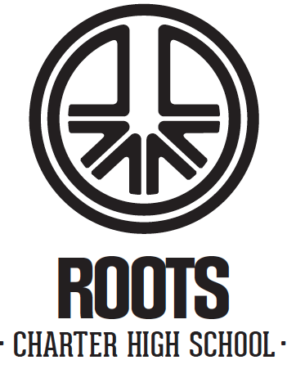
Board Meeting Agenda
Roots High School
2250 S 1300 West, WVC 84119

January 21, 2026, 4:00 pm
____________________________________________________________________________________

Item:

Call To Order/Roll Call/Welcome

Public Comments (10 minutes)

Review Minutes of the Previous Board Meeting Discussion/Approval

School Business
-Financial Review (Nov-Dec) Discussuon/Approval
-Executive Committee Discussion
-Fundraising Committee Discussion
-Finance Committee Discussion
-School Update Discussion

Closed Session to Discuss the character, competence, or physical or mental health of an
individual. Closed Session to Discuss the character, competence, or physical or mental health of an individual.

Discussion of the next Board Meeting

Adjournment

