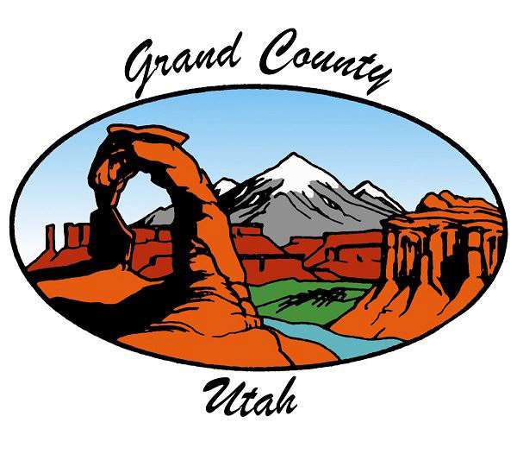
PUBLIC NOTICE IS HEREBY GIVEN THAT THE Grand County Commission WILL
MEET FOR A Regular Meeting IN THE
Grand County Commission Chambers 125 East Center Street, Moab, Utah
January 20, 2026 - 4:00 PM
Times in this agenda are approximate. Commission meetings allow for both in-person and virtual attendance. Remote participation is through Zoom, and meetings can be viewed live on YouTube. To call into the meeting dial: (669) 900 – 6833 Use Meeting ID: 851 7082 0571 #Password (if needed): 214317. To unmute press *6.
Zoom Meeting
YouTube (please note that we do not take public comments on YouTube, due to the delay in the video feed.)
To make a public comment, please do so in person or go through the Zoom link.

Workshop - 3:30 PM

Colorado River Negotiations Update

Marc Stilson, P.E. Colorado River Authority of Utah

Zoom And Youtube Meeting Information

Times in this agenda are approximate. Commission meetings allow for both in-person or virtual attendance. Remote participation is through Zoom and meetings can be viewed live on YouTube. To call the meeting dial: (669) 900 – 6833 Use Meeting ID: 851 7082 0571 #Password (if needed): 214317. To unmute press *6. Zoom Meeting YouTube (please note that we do not take public comments on YouTube, due to the delay in the video feed.) To make a public comment please do so in person or go through the Zoom link.

Remote Participation Is Through Zoom And Meetings Can Be Viewed Live On Youtube. To Call In To The Meeting Dial: (669) 900 – 6833 Use Meeting ID: 851 7082 0571 # Password (If Needed):
214317. To Unmute Press *6.
Grand County Utah Government Live On Youtube
Join The Zoom Meeting

Call To Order

Pledge Of Allegiance

Citizens To Be Heard At 4:00 PM And 6:00 PM

We are receiving public comments by phone and online through Zoom. Dial: (669) 900 - 6833 Meeting ID: 851 7082 0571 Password: 214317
Link: https://us02web.zoom.us/j/85170820571?pwd=M24yQjRIdElCejUxTUlFeXFoZHNQQT09 When joining the meeting, you will be placed in a waiting room and be added to the meeting by the moderator. Your comments will be recorded and on YouTube. (Unmute for public comment: *6)

Public Hearings

Four Corners Community Behavioral Health Annual Public Hearing

Presentations (15 Min)

2025 Employee Years Of Service Recognitions

Tess Barger, Personnel Services Director

​Grand County Sheriff Service Awards

Sheriff Wiggins

UDWR PILT Check Presentation To The County - Brief Update - Chris Wood Placeholder

Chris Wood

General Business - Action Items - Discussion And Consideration Of Approval

1. | Commission Member Disclosures And Future Considerations

2. | Approval Of Consent Agenda Items

a. | Approval Of Meeting Minutes For January 6, 2026

b. | Ratification Of Payment Of Bills

c. | Ratification Of Renewal Of I-70 Billboard Contract

d. | Ratification Of Online Letter In Support Of Continued Federal Funding For Trails

e. | Letter In Support Of Continued Federal Funding For Trails To The Utah Delegation

f. | Ratification Of Local Consent - Canyonlands PRCA Rodeo

g. | Cemetery Board Appointment

h. | Letter Of Support For Rural Utah Motion Picture Incentive Program To Legislators

i. | Purchase Of Inflatable River Boat For Search And Rescue

j. | Express Evaluations Subscription Renewal

k. | Contractor Agreement With Pronghorn Construction For Arroyo Crossing Ph. II - Using CDBG Grant Funds ​

MACLT

l. | CDBG Interagency Agreement Grand County, Arroyo Crossing

m. | Consulting Party Status With Bureau Of Land Management (BLM) For 2026 Oil And Gas Sale In Grand County

n. | Approval Of Lease Assumption Lot 118 CNY

o. | Low Income Housing Loan Contract

p. | Contract With Jones And Demille Engineering For Sand Flats Road BUILD (Better Utilizing Investments To Leverage Development) Planning Grant Application

q. | Bid Award, Notice To Proceed And Contract For ARFF Vehicle

r. | Consideration Of Approval Of Revised/Adopted Job Descriptions

3. | Community Wildfire Preparedness Plan

Kate Finley, Emergency Management Director

4. | Special Events Legacy Events

Jenibeth Jones, Chief Deputy Clerk

5. | 2026 Special Events High Impact Events Ready For Review

Jenibeth Jones, Chief Deputy Clerk

6. | Immediate Backfill Position Requests

Tess Barger, Personnel Services Director

s. | Assessor

t. | Recorder

u. | Sheriff

v. | Non-Elected Emergency Position Requests

w. | Attorney

7. | Ordinance - Grant Administration

Melisa Jeffers, Economic Development Coordinator

8. | Resolution - Vista Antigua Subdivision Amended Plat

Andrew Jackson, Planning and Zoning Director

9. | Approve Madden Media's Paid Media Plan For 2026

Michael Soleta, Assistant Marketing Director (Graphic Design & Website Management)

Discussion Items

General Reports - Time Permitting - Available Online

• | General Commission Reports And Future Considerations

• | Elected Official Reports

• | Commission Administrator Report

• | Fixed Guideway Tax Subcommittee Report

Closed Session(S) (If Necessary)

Adjourn

NOTICE OF SPECIAL ACCOMMODATION DURING PUBLIC MEETINGS. In compliance with the Americans with Disabilities Act, individuals with special needs requests wishing to attend Grand County Commission meetings/hearings and other Grand County Boards, Commissions, or Committees are encouraged to contact the County two (2) business days in advance of these events. Specific accommodations necessary to allow participation of disabled persons will be provided to the maximum extent possible. T.D.D. (Telecommunication Device for the Deaf) calls can be answered at:(435) 259-1346. Individuals with speech and/or hearing impairments may also call the Relay Utah by dialing 711. Spanish Relay Utah: 1 (888) 346-3162
It is hereby the policy of Grand County that elected and appointed representatives, staff and members of the Grand County Commission meetings/hearings and other Grand County Boards, Commissions, or Committees may participate in meetings through electronic means. Any form of telecommunication may be used, as long as it allows for real time interaction in the way of discussions,questions and answers, and voting.
At the Grand County Commission meetings/hearings and other Grand County Boards, Commissions, or Committees any citizen, property owner, or public official may be heard on any agenda subject. The number of persons heard and the time allowed for each individual maybe limited at the sole discretion of the Chair. On matters set for public hearings there is a three-minute time limit per person to allow maximum public participation. Upon being recognized by the Chair, please advance to the microphone, state your full name and address, whom you represent, and the subject matter. No person shall interrupt legislative proceedings.
Requests for inclusion on an agenda and supporting documentation must be received by 5:00 PM on the Tuesday prior to a regular Commission Meeting and forty-eight (48) hours prior to any Special Commission Meeting. Information relative to these meetings/hearings may be obtained at the GrandCounty Commission’s Office,125 East Center Street, Moab, Utah; (435)259-1346.

